This QRG outlines the steps to create calendars and submit calendars for review or to be processed, using the Summer Pay Tool. The business office can do this on behalf of the faculty member and then route for review and approval.

Access the Summer Pay Tool
Visit OneCampus and select SEEMLESS – Summer Pay | OneCampus https://one.purdue.edu/
Log in using Purdue Career Account ID and Password

Find Faculty
Once logged in, the Summer Pay Dashboard is displayed.
Click Faculty Management to find faculty member.
A list of all faculty belonging to assigned Cost Centers is displayed. | 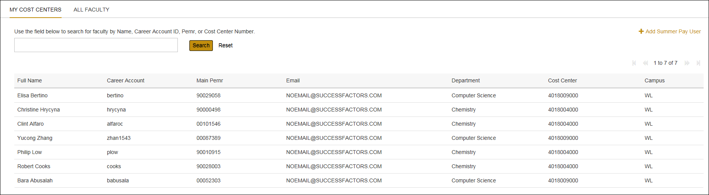
Enter faculty Name, Career account or PERNR in the Search text entry box under ALL FACULTY  Click Search. | 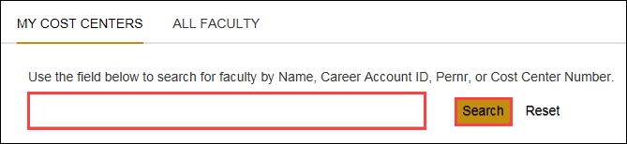
Click faculty to select.

Faculty Overview
The Faculty Overview is displayed.
Click Refresh Faculty Information to ensure data displayed is always the most current information.

A message returns stating “Success”

- Summer Calendars | Access to and overview of Summer calendars
- Faculty Subordinates | All subordinates who report to selected faculty member that can also be added to Summer Pay.
Click on Summer Calendars

Calendars
Click to select a calendar.  Calendars will be listed by Month or Pay Period.  Monthly calendars will be titled Month 20XX.  Pay Period calendars will be titled with WEYYYYMMDD 20XX; WE = Week Ending  Click on the pay period | 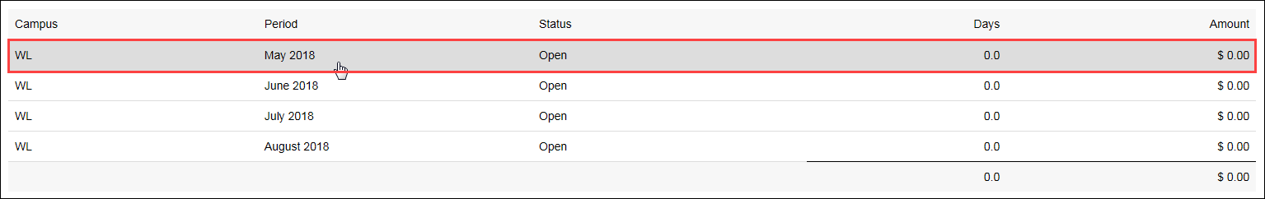  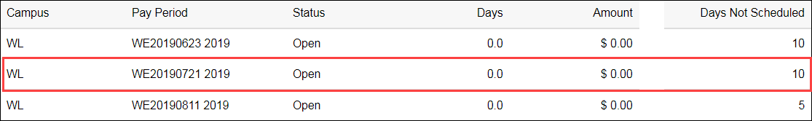
An overview of the calendar is displayed. | 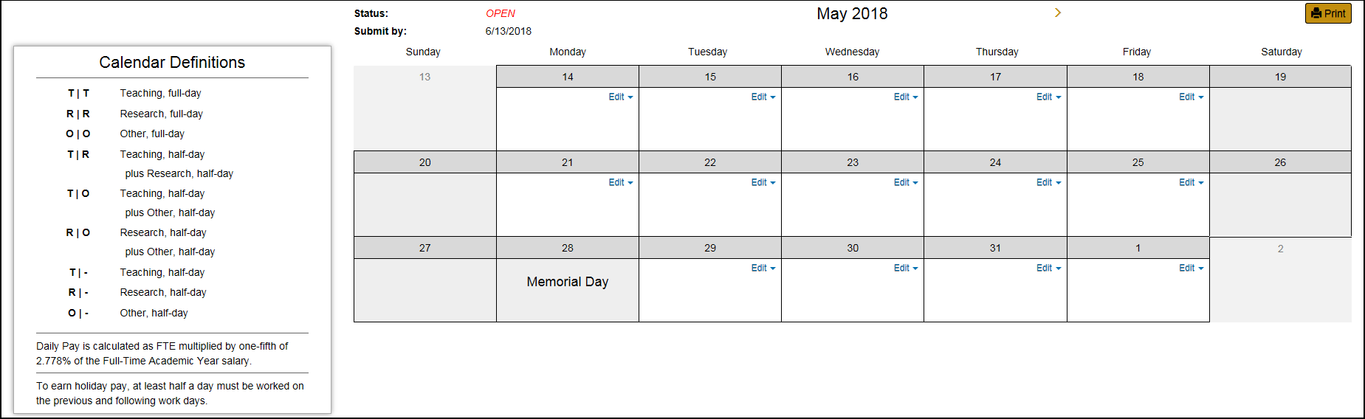
Definitions for calendar entries are displayed on the left of the page.  T, R, or O should be selected based on the type of duties being performed and not based off of the funding source. | 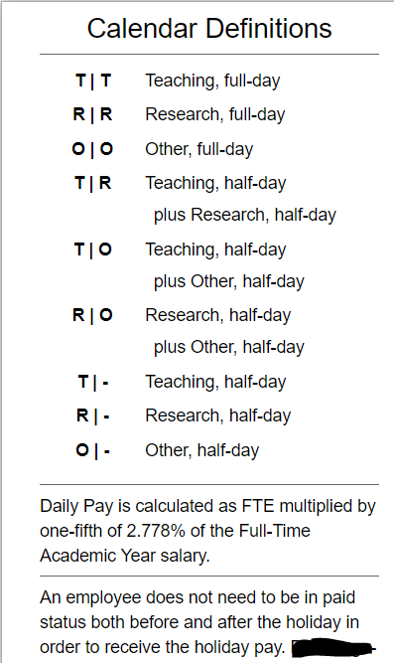
An editable calendar displaying all workdays for the selected month is displayed. | 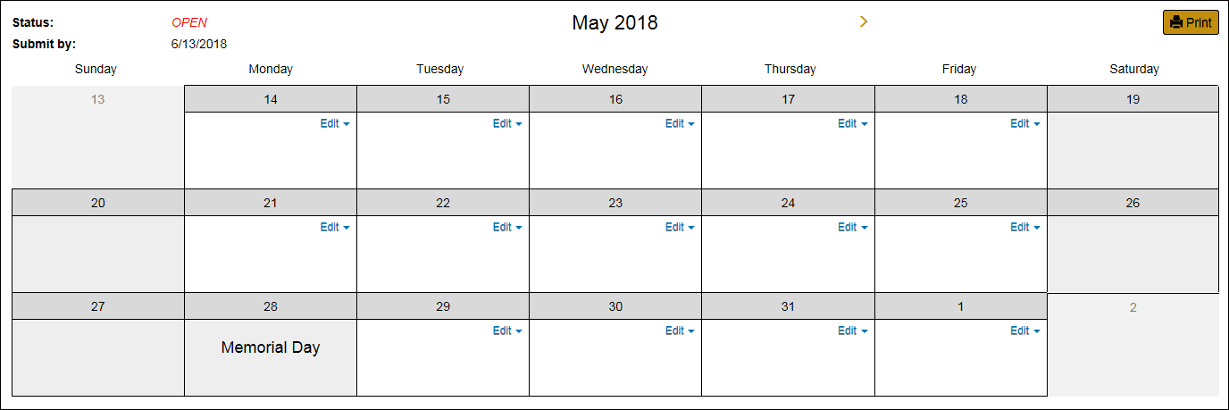
To enter time/pay, click the Edit button.  From the drop-down, and using the Calendar definitions, select the abbreviation for the type of work performed for the selected day. | 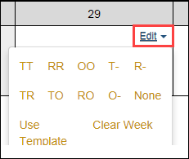
To apply a template, click Use Template.  Select a saved template and apply to the Week or Period.  -or-  Select a Work Type and apply it to the Period. | 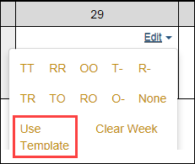  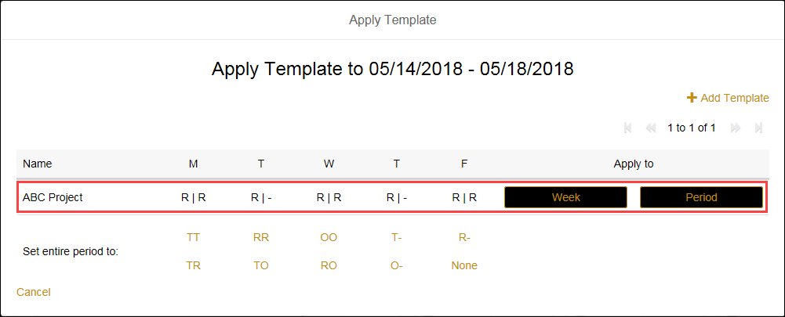  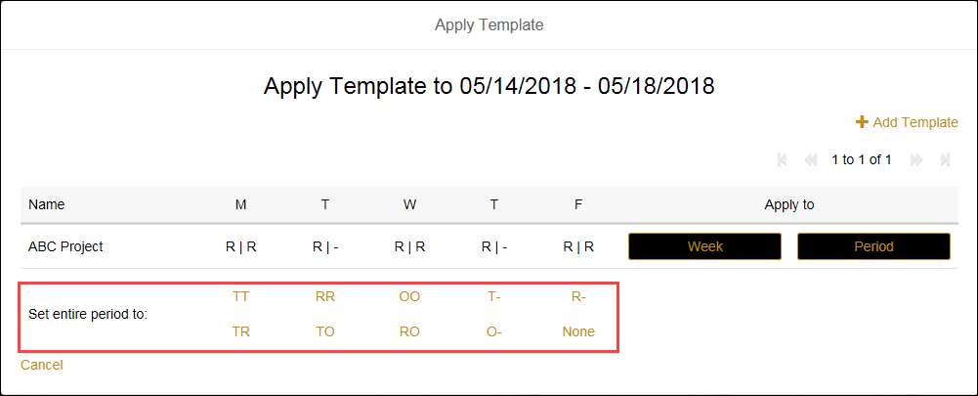
Repeat for each day or week that the faculty will receive Summer Pay.  When finished, the Pay Period Activity summary is displayed below the calendar. | 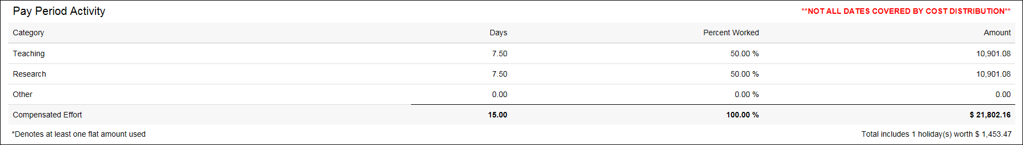

Pay Period Calculations
The rate of pay is calculated according to the individual’s FTE and the schedule worked for the selected month.
In this example the employee works 6 days during the summer session in May, but have a FTE of 1.  Full Time Annual Rate= Annual Salary/FTE  $99,600 /1.00 = $99,600  Daily Rate = Full Time Annual Rate x 2.778% /5 days x FTE.  $99,600 x 0.02778/ 5 x 1.0 = $553.38 (Rounded to the nearest cent)  Full Time Period Rate = Full Time Annual Rate/9 Months  $99,600 / 9 = $11,066.67  Amount to be paid = Daily rate x number of days (in half day increments)  $553.38 x 6 = $3320.28 | 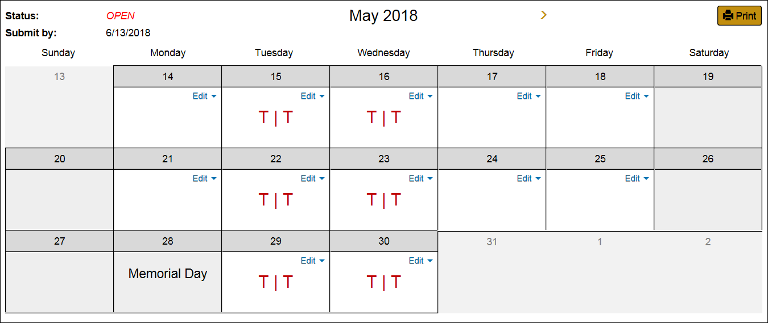  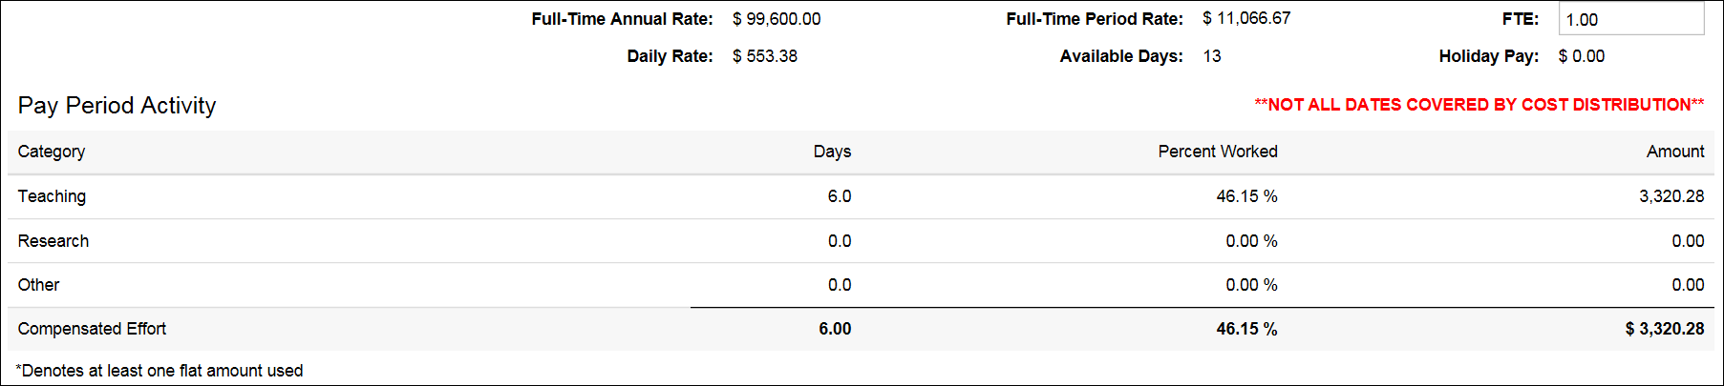
Another example, this employee has an FTE of .50 and is scheduled to work 6 days during the summer session.  BEST PRACTICE: Any time the FTE is less than 1, a full day should be used in the calendar.  Full Time Annual Rate = Annual Salary/FTE  $51,801/0.5 = $103,602  Daily Rate = Full Time Annual Rate x 2.778% /5 Days x FTE.  $103,602 x 0.02778/ 5 x 0.5 = $287.81 (Rounded to the nearest cent)  Full Time Period Rate = Full Time Annual Rate/9 Months  $103,602 / 9 = $11,511.33  Amount to be paid = Daily rate x number of days (in half day increments)  $287.81 x 6= $1,726.86 | 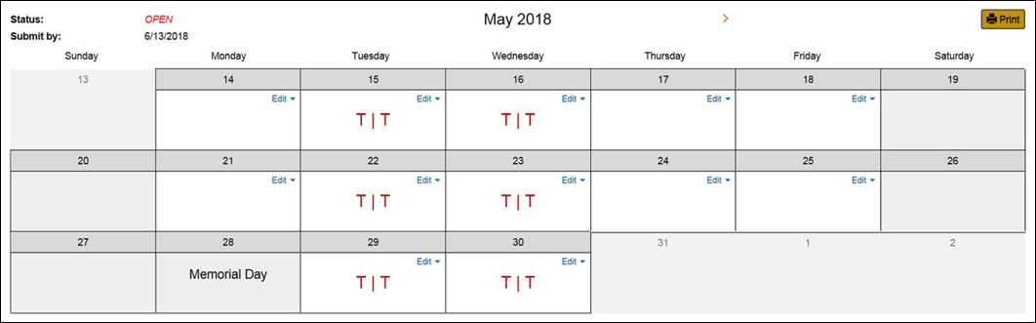  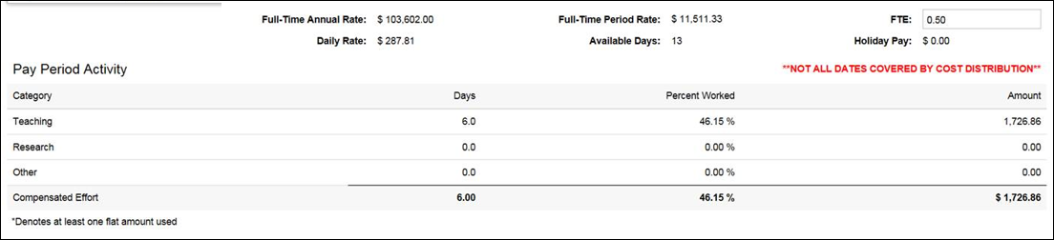

Concurrent Employment
Employees with concurrent employment in which the positions offer different rates of pay, each PERNR shows up and must be scheduled and handled separately. Both PERNRs cannot total more than 1 FTE and the Business office will need to monitor this. Concurrent employment where the rates of pay are the same, only the main appointment will be displayed.
From the Faculty Overview, click on the Faculty’s name to display all their PERNRs | 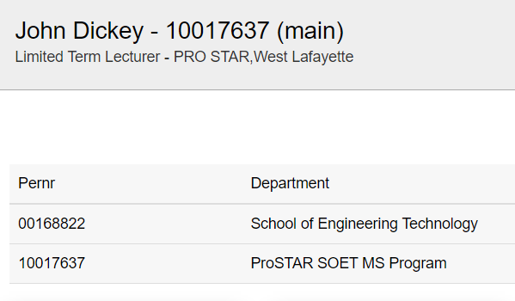
Click on the desired PERNR  Notice that after you click on the PERNR, it toggles to the faculty’s other PERNR under the faculty.  Then select the Summer Calendar tile to populate the calendar for this PERNR. | 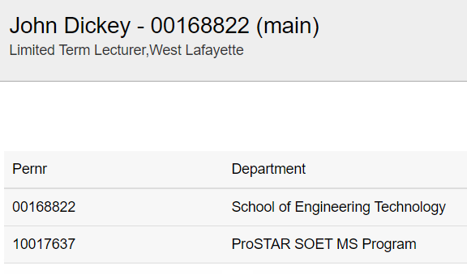

Submission
Click Send for Faculty Verification and send an email to the faculty member asking for review of the calendar.

Or Click Submit Directly to Payroll to skip faculty review and submit the calendar.
If the calendar is being routed to the faculty member for verification, they will review the calendar(s), make edits if needed, and it will route back to the business office for approval.
Once the Summer Pay Calendar has been submitted to Payroll, the status is changed to Processed in SEEMLESS. Any further edits to a Processed calendar must be done by the Business Office.

