Last Updated: 01/04/2021
This QRG outlines the steps to request to add or remove business roles on a position.
- Role requests are initiated by the employee’s supervisor or business office. An employee cannot request roles for themselves.
- Student system (i.e. Banner, Slate, etc.) roles are not requested through IDM. Student systems role request are available online at https://www.purdue.edu/em/esarolerequest/.
- The requestor must be on a VPN to connect to the SuccessFactors Employee Launchpad. For help setting up a VPN contact the ITAP Customer Service Center (West Lafayette Campus), Information Services (PNW Campus), or Technology Services (PFW Campus).
- A position number is needed when completing the request. Position numbers are included in the employee’s profile or the Position Org Chart under My Company Info. Position training resources are located online.

Access Role Request via SuccessFactors
From the OneCampus portal (https://one.purdue.edu/), launch Employee Launchpad – SuccessFactors.  Log in using Career Account and Password | 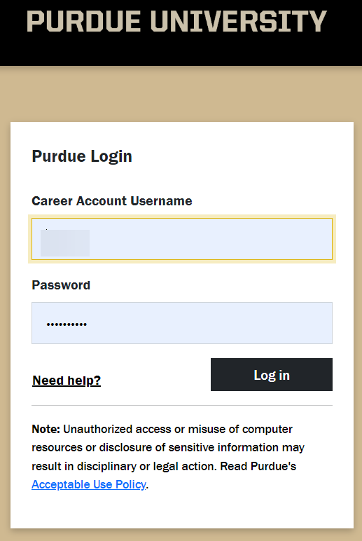
Under Organizational Updates - Additional Actions on the SuccessFactors Home screen, click the Role Request Information and request form tile. Role Request window opens with a link to review privileges as well as the link to the form.
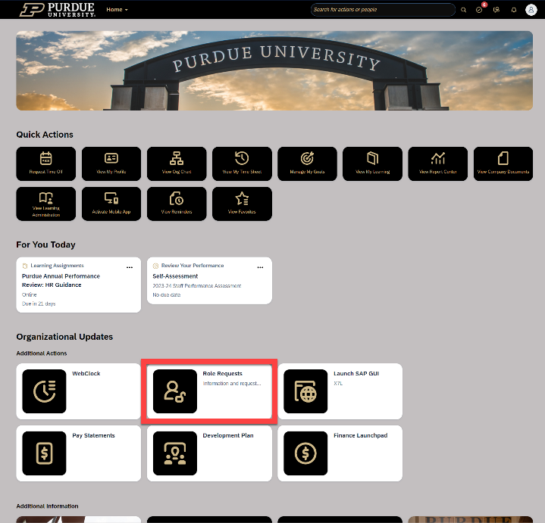
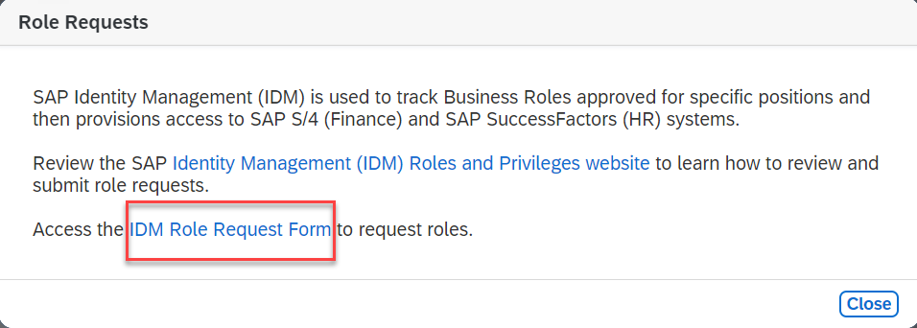
The request is displayed.  - Click Select, next to Position to search for employee’s position.  - Enter position number in the Find text entry  When searching, use the asterisk (*) before and after the term to perform a more accurate search.  - Click Search | 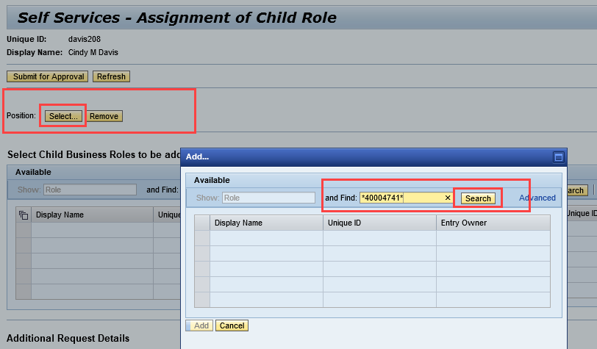
Click to select the desired position and click Add. | 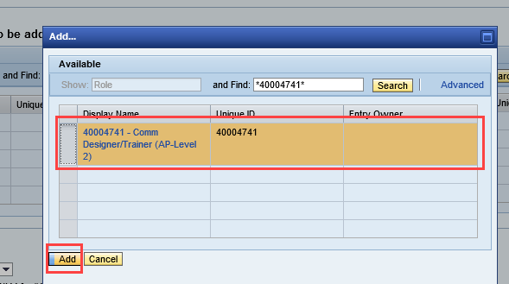
Select Add Role (or Remove Role, when applicable) from the Add or Remove drop-down menu under Additional Requests Details.  If restricting access to the role for a specific period of time, or delaying access to the role, enter Valid From and To dates.  NOTE: The dates will apply to all roles on the request, so if one role should be limited, it should be requested separately. | 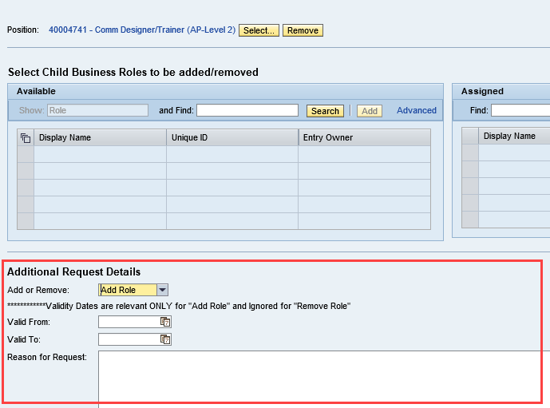
A Reason for Request should include:  - Name of the holder of the Position if applicable.  - Department  - If the position is grouped, note that here | 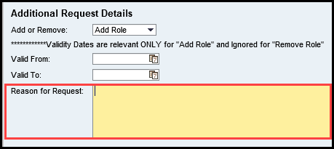
Locate business role by entering all or a portion of the business role display name in the search information in the Find text entry field.  When searching, use the asterisk (*) before and after the term to perform a more accurate search.  Click Search.  Business roles are listed online and available through the Roles and Privileges Information tile next to the Role Request Form tile. The website/tile contains the IDM Business Role list. | 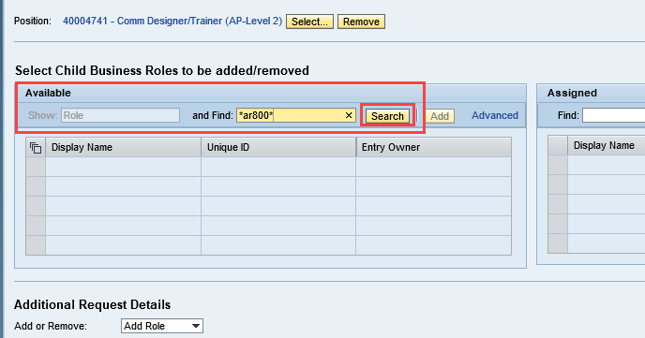
- Click to select desired role from search results within the Available table.
- Click Add to move to Assigned table.
- Click Submit for Approval.
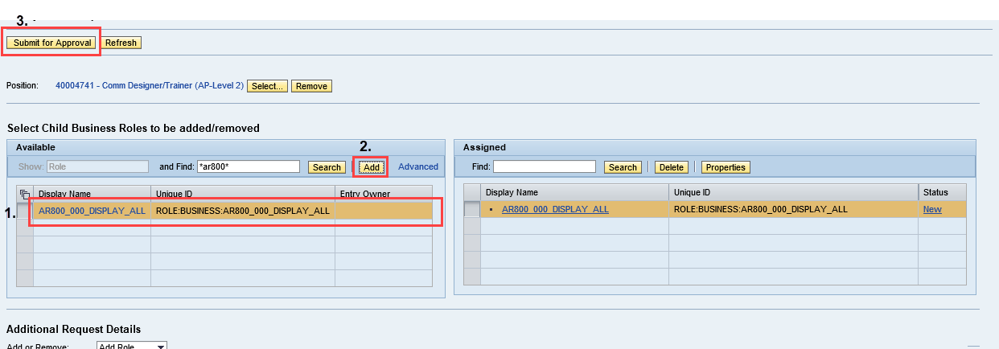

A message appears confirming the Child Role Assignment Request was Submitted. | 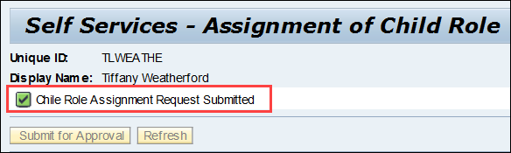

Approval Workflow
1st Level Approval | Individual responsible for approving the requested role. Varies based on role. If not approved within 5 days the request escalates to Compliance Approval.
Compliance Approval | Approval from Security after a check of separation of duties.

Who to Contact

HR/Payroll role questions – Contact hroperhelp@purdue.edu when needing assistance identifying what HR/Payroll roles are needed
- Finance role questions - Contact cmdt@purdue.edu when needing assistance identifying what Finance roles are needed
- Pending Requests/IDM Application – Contact OnePurdueSecruity@purdue.edu with questions related to a current or outstanding role request and questions related to the IDM application

Email Notifications
If approved, the requester receives an email that the selected role has been added to the selected position. | 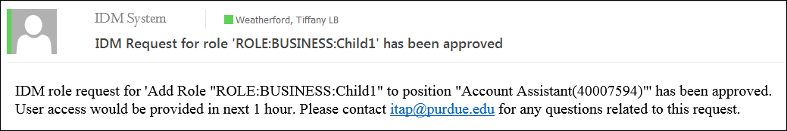
If denied, the requester receives an email that the selected role was denied | 