Taking Action on Time Off Requests in Success Factors Quick Reference Guide
Last Updated: 1/3/2019

This guide outlines the steps required to take action (approve or decline) on a Time Off request.
For additional information concerning Time Off policies and procedures, please refer to the Purdue Human Resources Benefits website: https://www.purdue.edu/hr/Benefits/currentEmployees/leaves/leaves.html
Note: The Time Off request feature does not replace conversations and planning between employees and supervisors.

Contents
Notification 1
Accessing SuccessFactors 2
Reviewing and Taking Action on Requests 2
Viewing Additional Request Details Before Declining or Approving 3
Supervisor – Delegating Requests 4

Notification
When a Time Off Request is submitted, approvers receive an email notification requesting review and action.  Click the link in the notificaiton to be taken directly to the request to be reviewed, or access SuccessFactors using the instrucitons in the next section of this document. | 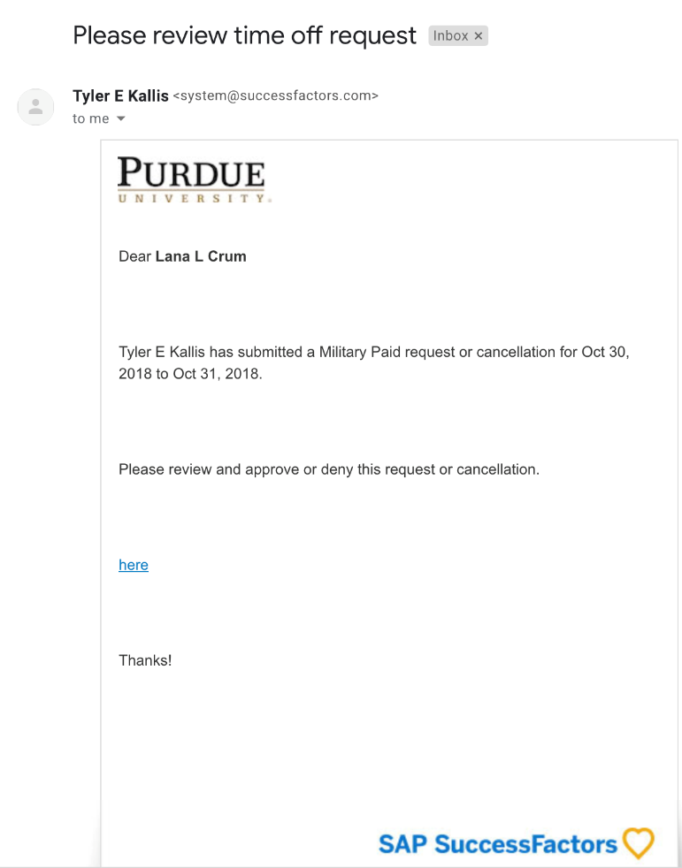

Accessing SuccessFactors
Visit OneCampus and select Employee Launchpad. |  | https://one.purdue.edu/  
Log in using Purdue Career Account ID and BoilerKey passcode.  For assistance using or stetting up BoilerKey, please contact ITaP at itap@purdue.edu or 765-494-4000. |  | 

Note for Supervisors with Multiple Appointments
Supervisors with more than one appointment will have to switch to other account(s) to view pending actions that fall under those appointments by clicking the Change Selected Employment icon on the Navigation bar. | 

Reviewing and Taking Action on Requests
After logging in to SuccessFactors, click the Approve Requests tile | 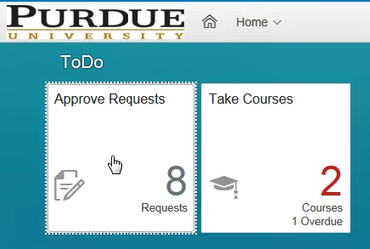
To view additional details of an individual request:  - Click the “Employee Time for…” link for the request. (See the next section of this guide for more information)  To approve without viewing additional details:  - Click Approve next to each request.  Tip: If you have many requests to process, click Go to Workflow Requests at the bottom of the screen to select all and approve. | 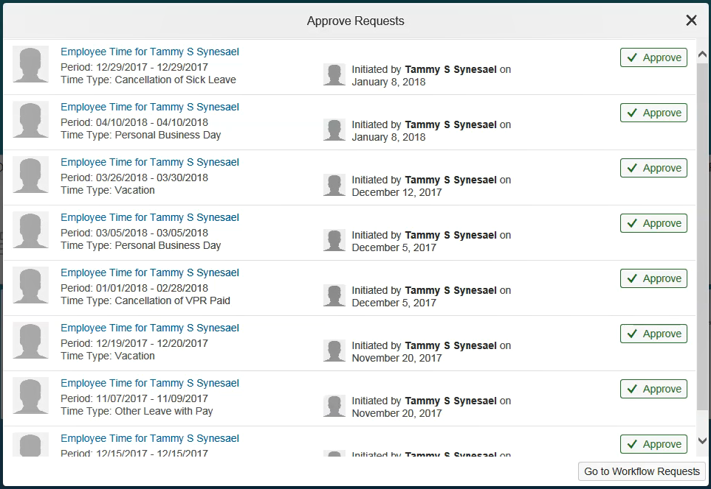

Viewing Additional Request Details Before Declining or Approving
View the details of the request by clicking on “Employee Time” request title.
All details of the request, any attachments, and the team calendar are displayed.  - The Comment feature can be used to send a note back to the employee. You must click Post to send the comment. A comment can be posted without Approving or Declining.  - When ready to take action, click Approve or Decline. The employee will be notified in SuccessFactors and via email. | 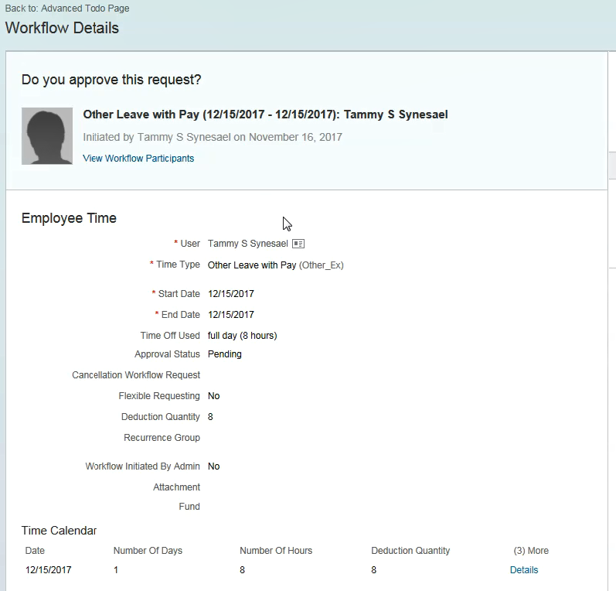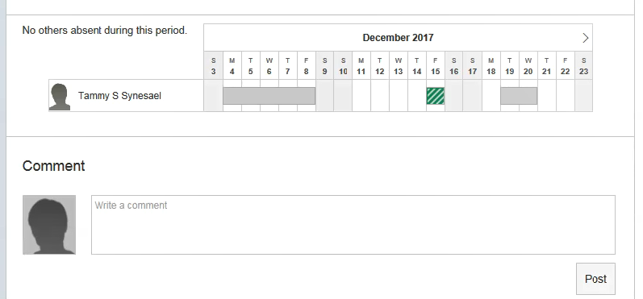  1  2

Supervisor – Delegating Requests
Click the “Employee Time for…” link for the request. | 
At the bottom of the details screen, click Delegate. | 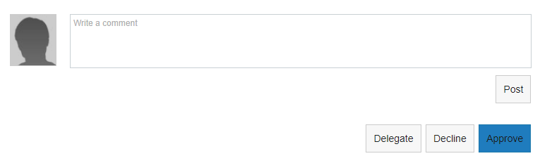
- Complete the field to indicate to whom you wish to delegate.  The field can be completed using the drop down menu, or by typing a name to perform a search.  - Click Send.  - On the next screen, verify that you would like to Delegate. | 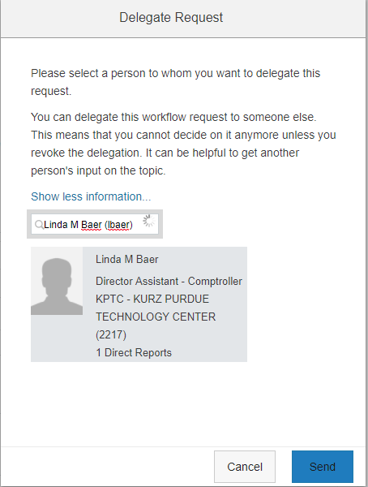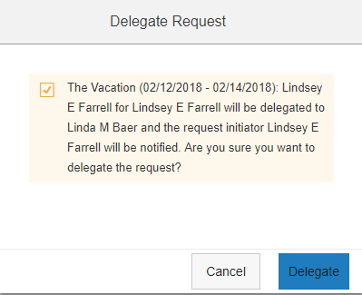  3  2  1
The supervisor to whom you delegated will see the request in their queue.  The request indicates from whom it has been delegated.  The employee will be notified that the request has been delegated and to whom. | 

