Requesting Business Time Off / Leave Quick Reference Guide
Last Updated: 9/8/2022

This guide outlines the steps required to request business leaves.
For additional information concerning Time Off policies and procedures, please refer to the Purdue Human Resources Benefits website: https://www.purdue.edu/hr/Benefits/currentEmployees/leaves/leaves.html

Note: The Time Off request feature does not replace conversations and planning between employees and supervisors.

Contents
Accessing SuccessFactors 1
Note for Employees with Multiple Appointments 1
Accessing Time Off Module / Screen Overview 2
Completing Initial Request Fields 4
Completing Additional Details 5
Reviewing Notification and Submitting the Request 7
Viewing the Status, Editing, and Cancelling Submitted Requests 8

Accessing SuccessFactors
Visit OneCampus and select Employee Launchpad. |  | https://one.purdue.edu/  
Log in using Purdue Career Account ID and BoilerKey passcode.  For assistance using or setting up BoilerKey, please contact ITaP at itap@purdue.edu or 765-494-4000. |  | 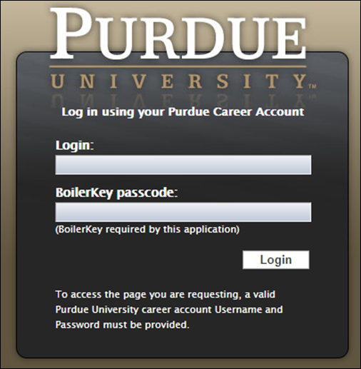

Note for Employees with Multiple Appointments
If you hold multiple positions, use the Change Selected Employment menu to select the position for which you would like to record time | 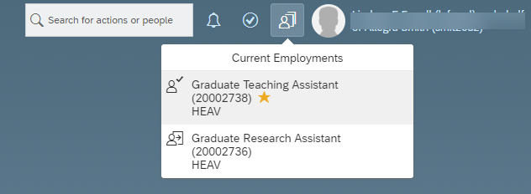
If you hold multiple positions and they are similarly named, click My Profile to validate that the correct position has been selected | 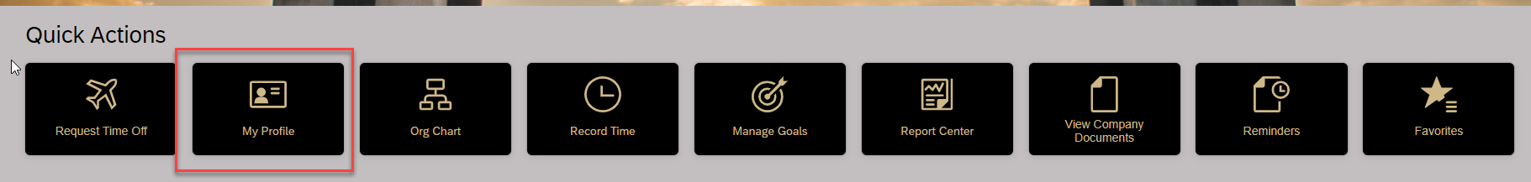
Then, click the Employment Information tab to view the details of the position selected in order to ensure time off is requested for the correct position.  Click the Home icon at the top of the page to return to the SuccessFactors home page. | 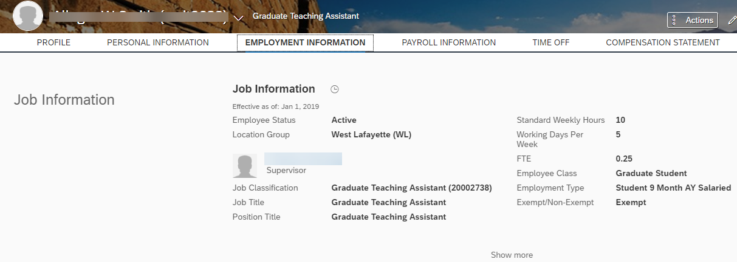  

Accessing Time Off Module / Screen Overview
After logging in to SuccessFactors and selecting the appropriate position (if applicable) click Request Time Off under Quick Actions. |  |  | 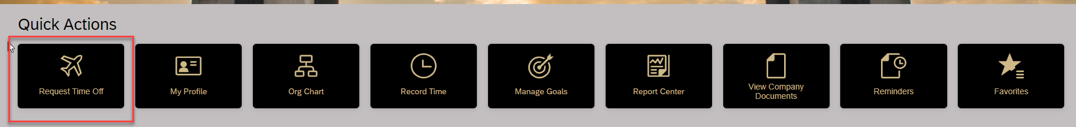
This provides the ability to quickly request time off. If you need to view calendar, account balances, etc, click Time Off.  You can create a business time off request from this main tile, however if this is your first time requesting and need guidance, please click Time Off outlined in red in order to open the full Time Off screen. |  |  | 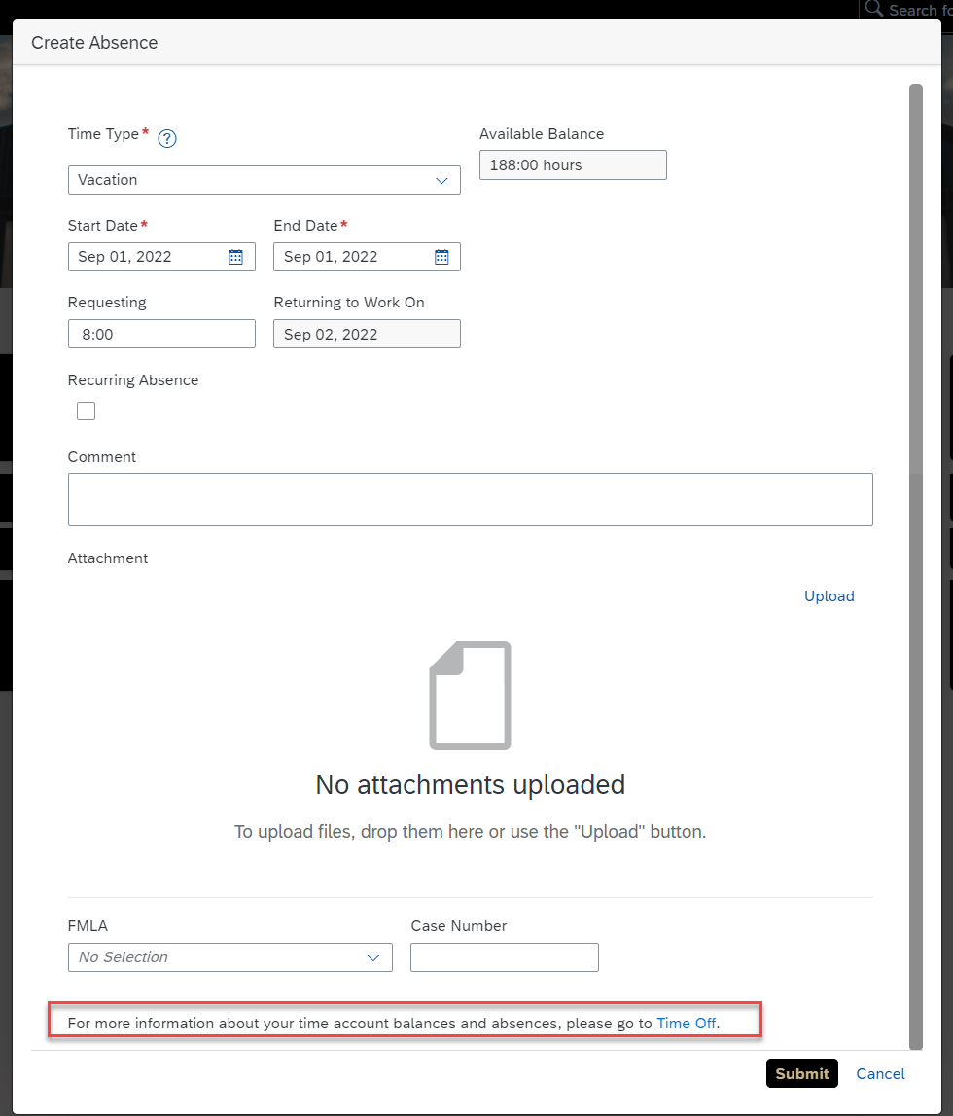
- Balances as of <<date selection>> are shown across the top of the screen.  - Use the Other drop down to view more leave types. All business leaves types are found here.  The appropriate leave types based on your employee class will be displayed.  Note: If you have approved leave requests in the future, change the Balances as of date to a date past those approved leaves to view your “true” balances (less any future takings). Moving the date will not add to the balances due to projected accruals.  The system will not allow you to request Time Off if you do not have, at the time that you are submitting the request, a sufficient balance (of the leave type you’ve chosen) to cover the request.  - Use the Team Absence Calendar link to view approved Time Off requests for your peers and direct reports. It may be helpful to view your team’s absence calendar to schedule time off strategically in order to ensure coverage of work responsibilities. |  |  | 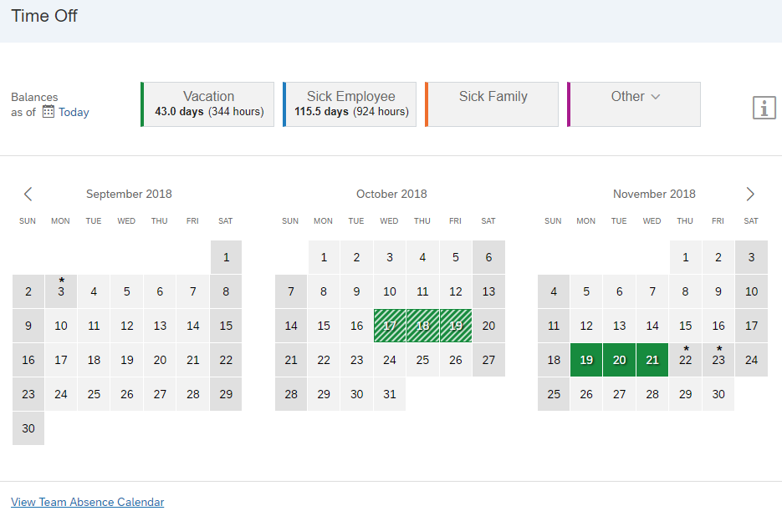  3  2  1

Completing Initial Request Fields
Complete all fields displayed – field order may vary slightly based on type of leave being requested.
When finished, click More Details to complete the additional required fields.
- Select Leave Type
Click on the “Other” box and then select the leave type you would like to take
- Complete all fields displayed.

Field | Guidance
Date/Time | Use the fields beneath the calendar (or use the paint brush to indicate on the calendar itself) to enter the details of your request. Notice that this is an “Expected Return Date” and not the end date for the time off
Upload Attachment | Add any supporting documentation (Example: Email exchanges granting approval of the time off
Address | Indicate the address of where you will be residing during the time off
Percentage on Leave (%) | Indicate the percentage for your time off
Will you be traveling internationally? | Indicate yes or no. If you indicate yes this will send a notification to the Risk Management department so they are aware of all international travel.
Comment | Enter any information you would like to provide to your supervisor.

- Details
Click on the “Details” link to finish completing the time off request. This opens additional fields to be completed.
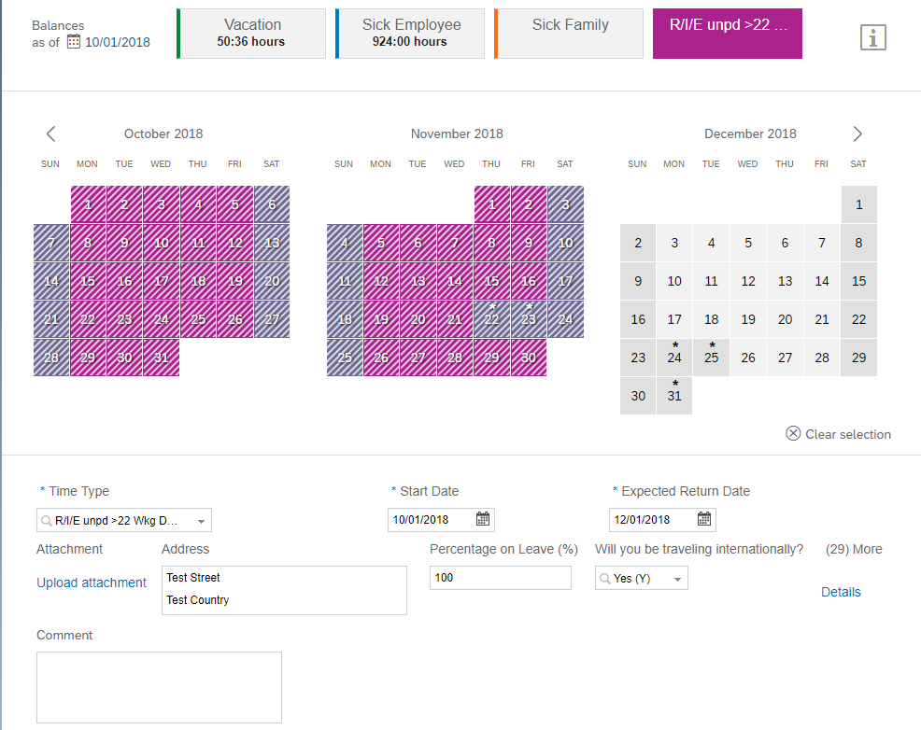
3. Click to complete additional fields
2. Complete all fields
- Click to select leave type

Completing Additional Details
After completing all steps found in the Completing Initial Request Fields section above, the following fields will appear and must be completed. Depending on the type of leave being requested, some fields will copy from the Initial Request Fields page.
New fields will appear for completion. (Visual is available on next page)
- All fields marked with an asterisk (*) in this document are required.
- Scroll to the bottom of the page and complete all required or applicable fields before clicking Done

Field | Guidance
*Primary country while on leave | Select the country you will primarily reside in during your time off
*Secondary country while on leave | Select the any other country you will traveling to during your time off
*Location(s) On Leave | Indicate all locations you will be at during your time off
*I have read and agree to Policy I.A.1 outlined on the Time Off screen | Indicate yes or no
*I have read and agree to the University Sabbatical Policy | Indicate yes or no
*Provide a description of the leave that includes the goal of the leave | Type description here or indicate “In attachment”
*Provide a description of how your campus duties will be covered while on leave (teaching, supervision of students, etc.): | Type description here or indicate “In attachment”
*Please provide a description of how the leave will benefit the University: | Type description here or indicate “In attachment”
*Will you continue to serve as a PI or Co-PI while on leave? | Indicate Yes, No or N/A
*In your attachment did you provide an oversight plan for each of your active sponsored projects? | Indicate Yes, No or N/A
*Will your leave cause a change in scope for your sponsored project? | Indicate Yes, No or N/A
*Compensation | Indicate Time Off is with partial pay, with pay or without pay
Effort | Indicate Full Time or Half Time
*WBSE 1, WBSE 2, WBSE 3, WBSE 4 (multiple fields) | Indicate up to four (4) Work Breakdown Structure Elements associated with this time off request
WBSE 1 Percent, WBSE 2 Percent, WBSE 3 Percent, WBSE 4 Percent (multiple fields) | Type the percentage associated with each WBSE entered
Internal Order 1, Internal Order 2, Internal Order 3, Internal Order 4 (multiple fields) | Indicate up to four (4) Internal Orders associated with this time off request
Internal Order 1, Internal Order 2, Internal Order 3, Internal Order 4 (multiple fields) | Type the percentage associated with each Internal Order entered
Admin Supplement | Indicate if you currently have an administrative supplement

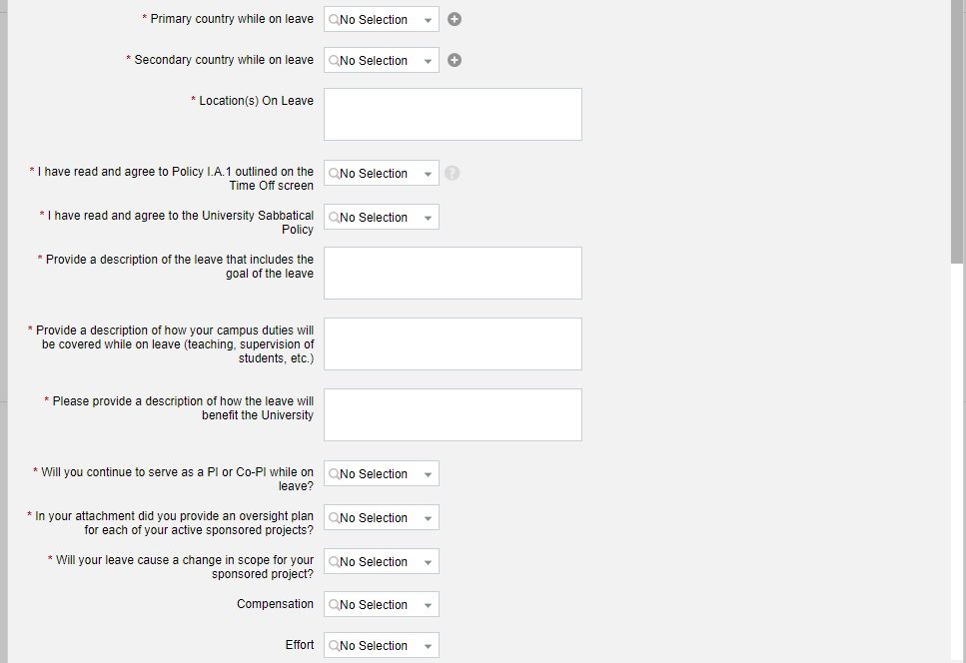
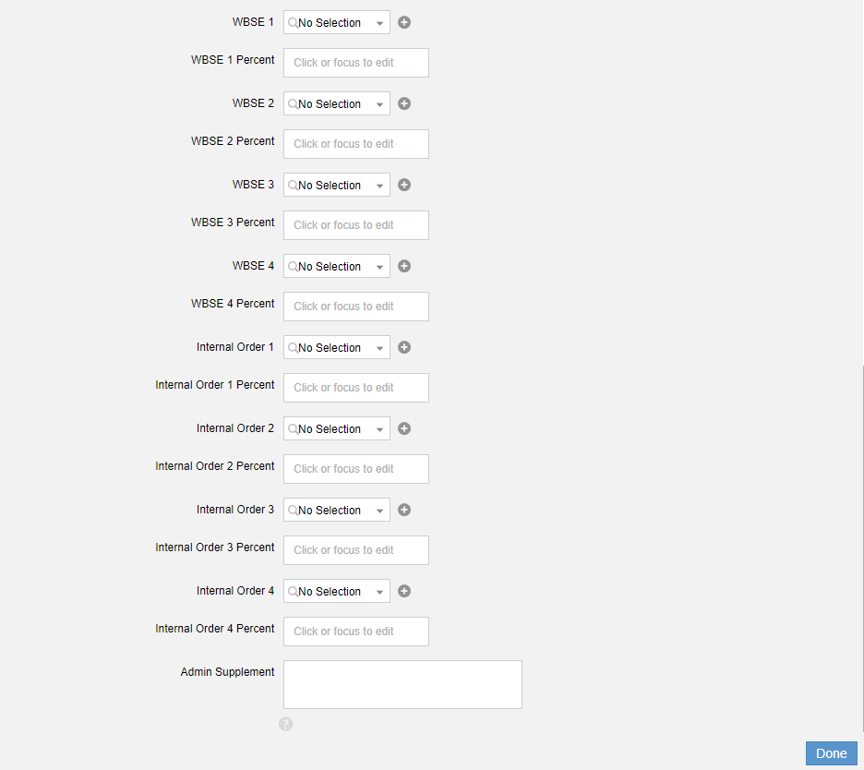
Click Done
Complete fields

Reviewing Notification and Submitting the Request
Depending on the type of request, a notification(s) will appear below the comment box. These notifications relate to policies for the type of time off request.
Review the notification and click Submit.
- The first approver within the workflow receives an email notification that your request has been submitted.
- All business leaves require several levels of approval as follows: Business Office, Department Head, DFA, Dean, Central HR (leaves group), Sponsored Programs and Provost.
To cancel the request (all completed field information will be lost), click Cancel.
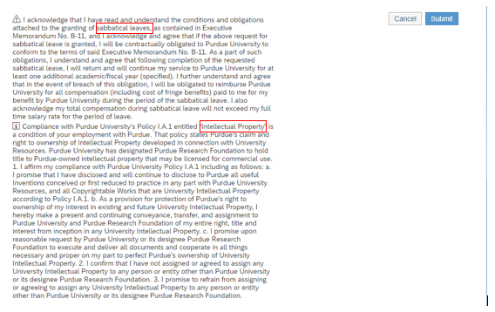

Viewing the Status, Editing, and Cancelling Submitted Requests
Previously submitted requests can be viewed on the main Time Off screen.  This screen is accessed by clicking the Time Off tile on the SuccessFactors home page.  All business leaves require several levels of approval: Business Office, Department Head, DFA, Dean, Central HR (leaves group), Sponsored Programs and Provost. | 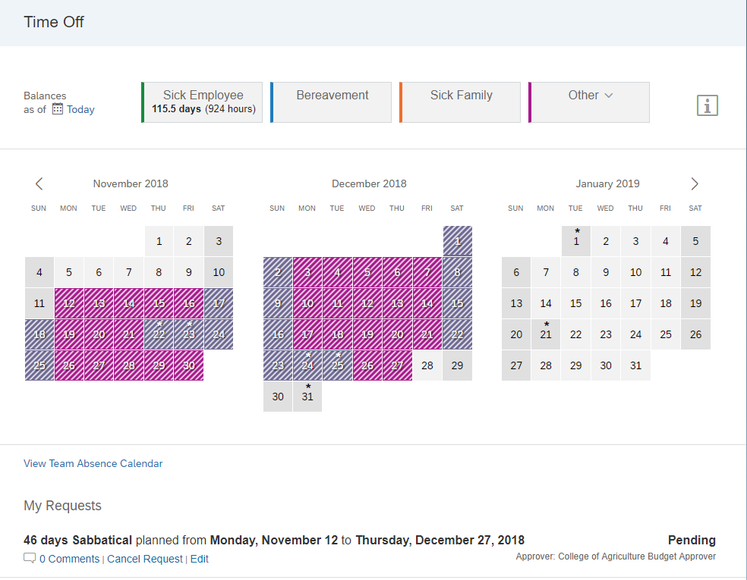
The approver or approval group that is currently reviewing the request is indicated. | 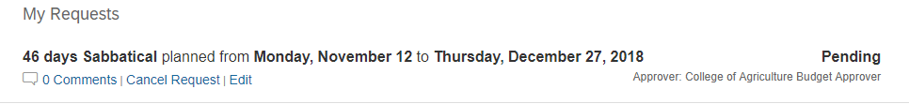
Click Cancel Request to cancel. The request will be re-routed to any approvers that have already approved.
Click Edit to edit the details of the request. The request will be re-routed to any approvers that have already approved.

