Managing Your Employee Profile in SuccessFactors Cheat Sheet Last Updated: 9/8/2022
This cheat sheet provides short instructions on common tasks performed by employees related to managing their employee profile. Detailed instructions and additional documentation can be found on the SuccessFactors Training Page, found at https://www.purdue.edu/hr/mgrres/sucfactors/sftraining/index.php.

Access SuccessFactors
Use an internet browser to visit the OneCampus Portal (https://one.purdue.edu/).
Click Employee Launchpad
Log in using Purdue Career Account User ID and BoilerKey passcode.
For assistance using or setting up BoilerKey, please contact ITaP at itap@purdue.edu or 765-494-4000.

View Your Pay Statement |  | Request Time Off
Scroll down to the Organizational Updates – Additional Actions section  Click Pay Statements tile  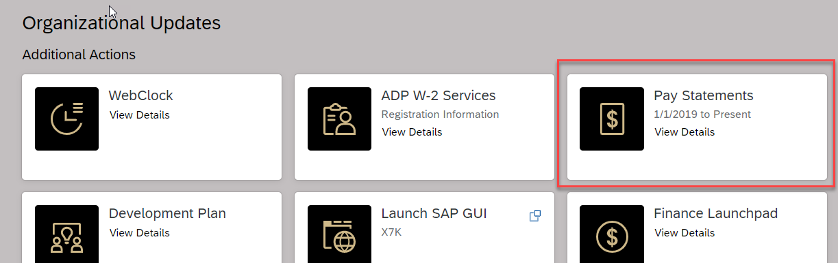 |  | For detailed resources and instructions for requesting Time Off, please visit www.purdue.edu/timehelp.
Select position (if holding multiple)
Click Request Time Off from Quick Action tiles
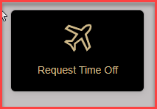
- Click the type of leave being requested
- Select from the calendar or enter the date(s) being requested
- In the Requesting field, select the amount of time being requested
- Optional: Enter a comment for your supervisor
- Click Submit

Record Time
For detailed resources and instructions for recording time, please visit www.purdue.edu/timehelp.
Time Entry Method | Definition | Getting Started
Negative Time Entry | Individuals assigned to negative time entry only record time worked outside of their regular schedule (e.g. overtime or call back), and enter comments to document flexed time. | Select position (if holding multiple)  Click Record Time from Quick Actions tiles  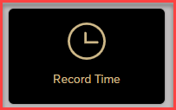
Positive Time Entry | Individuals assigned to positive time entry record all hours worked and enter comments to document flexed time. | Select position (if holding multiple)  Click Record Time from Quick Actions tiles
Webclock | Individuals assigned to Webclock time entry record time pairs (in and out punches) for each shift.  Note: There are multiple Webclock access points. Please visit www.purdue.edu/timehelp for more details. | Go to Organizational Updates – Additional Actions  Click the Webclock tile  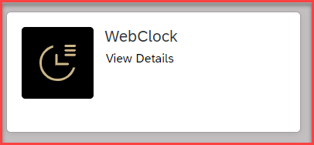

Edit Personal Information | Edit Bank Information | Edit Tax Information
Click the My Profile tile within Quick Action tiles
Click the PERSONAL INFORMATION tab  Only the following information is editable. To edit other information, contact your business office / center.  - Home Address  - Home Phone Number  - Emergency Contact  Use the pencil (edit) icon to change the fields needed. | Click the PAYROLL INFORMATION tab  Click Bank ESS  Click the Pencil icon to edit bank info  Click Other bank to add new bank | Click the PAYROLL INFORMATION tab  Click BSI TaxProfileFactory – Employee  Make any necessary adjustments and submit

