Tax withholdings are updated in ADP via SuccessFactors.

Accessing SuccessFactors
- Select New/Current Employee Self Service from https://www.purdue.edu/hr/global/index.php  - Click SuccessFactors in the first paragraph or go to System Access Section and click Employee Launchpad (SuccessFactors) and ADP  - Click Access Employee Launchpad  - Log in using your Purdue Career Account ID and Password. | 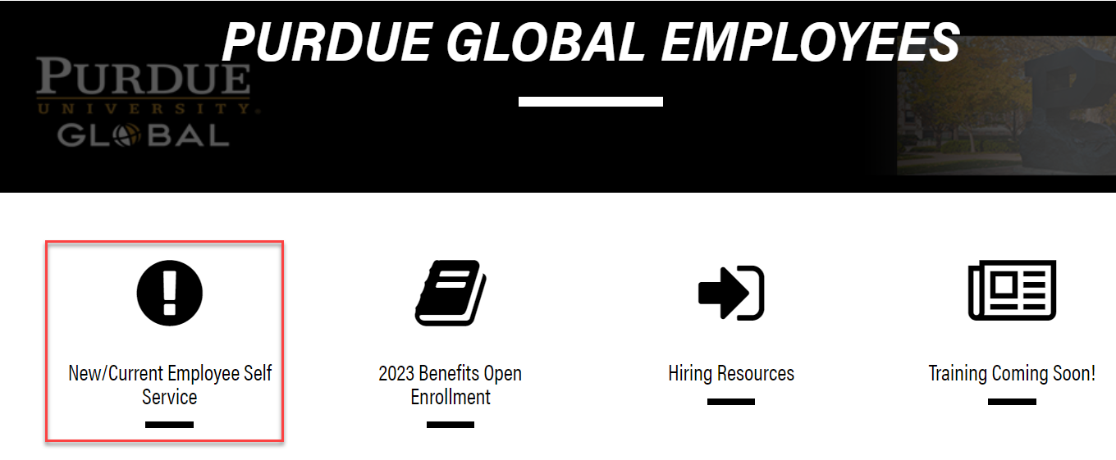  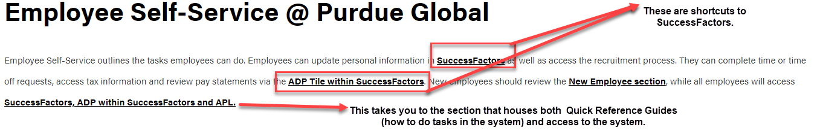  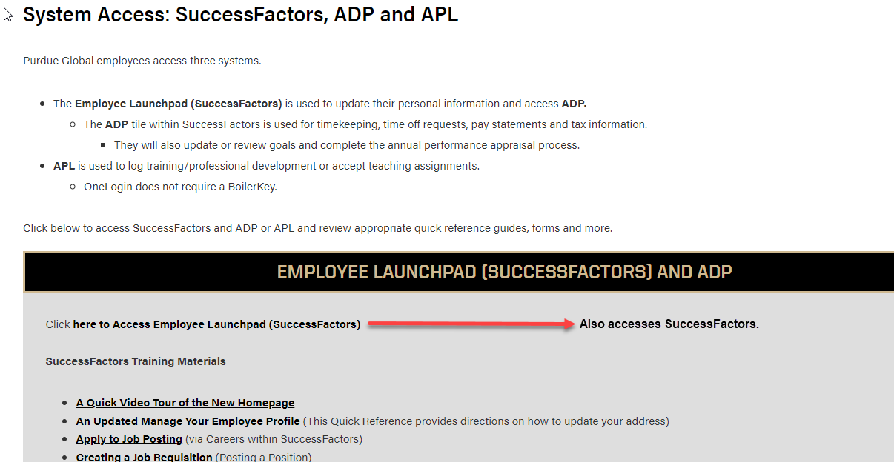
Locate and click the ADP tile

Update Tax Withholdings
Click Myself | 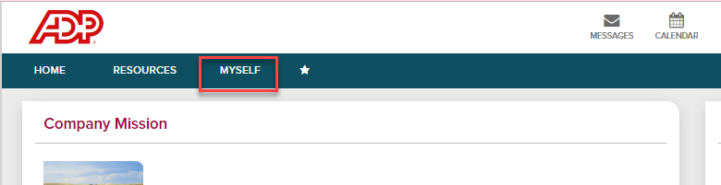
Click Pay  Select Tax Withholdings | 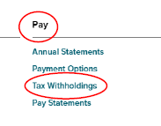  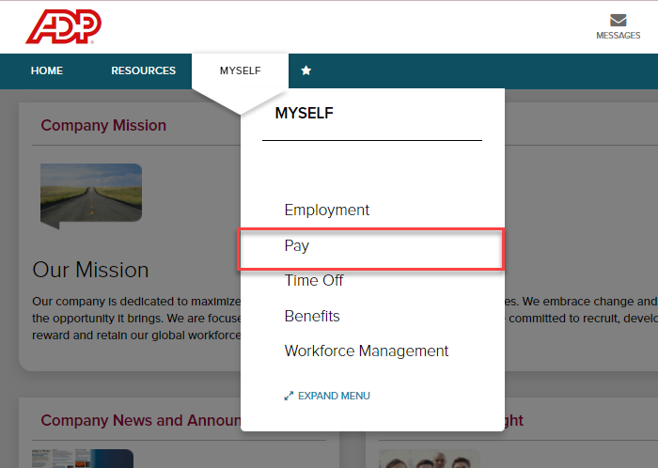
Click Start and follow the prompts to update your tax withholdings. Once you have completed the forms, you may download a copy of your tax forms for your records. | 