Last Updated: 03/27/2020

This guide outlines the steps to request the Emergency Leave or Emergency FMLA in SuccessFactors. According to the COVID-19 Purdue Website – FAQS related leave; emergency paid leave is outlined as followed:

 | Emergency FMLA | Emergency Leave
Eligible employees | Employees with more than 30 calendar days of service who cannot work or telework | Full and part-time employees who cannot work or telework
Qualifying need based on public health emergency | - Need to care for a child if the child’s school or place of childcare has been closed or the childcare provider is unavailable, due to a public health emergency. | - Self-isolation due to coronavirus  - Awaiting a medical diagnosis while experiencing symptoms of coronavirus  - Self-quarantine due to order of a public official or recommendation of medical provider due to:  - Coronavirus exposure or symptoms  - Care for family member with coronavirus exposure or symptoms  - To care for child due to school or childcare closure on account of coronavirus
Amount of paid leave | - Up to 50 days paid leave (follows the 10 days of Emergency Leave). | - Up to 10 days paid leave

Eligible employees that currently do not have time off benefits and do not request time off (i.e., Limited Term Lecturers or students currently working) should complete the Emergency FMLA DocuSign Form to request Emergency FMLA leave hours. The form requires the employee’s name, PUID, leave hours, start, and end date of leave. The form routes to the supervisor for approval and is processed in Human Resources.

Quick Links:
- Requesting Emergency Leave or Emergency FMLA
- Editing or Cancelling Emergency Leave or Emergency FMLA

Accessing SuccessFactors
Visit OneCampus and select Employee Launchpad.  Log in using Purdue Career Account ID and BoilerKey passphrase. |  | https://one.purdue.edu/  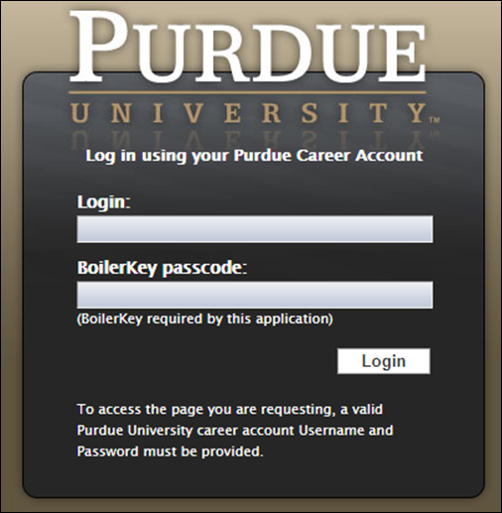
When you have multiple positions follow these directions (or skip to Requesting to Time Off)
If you hold multiple positions, use the Change Selected Employment menu to select the position for which you would like to record time | 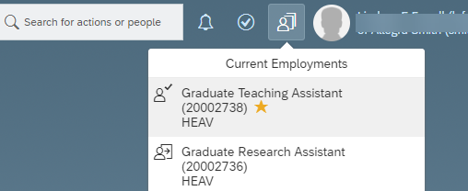
If you hold multiple positions and they are similarly named, click My Profile to validate that the correct position has been selected | 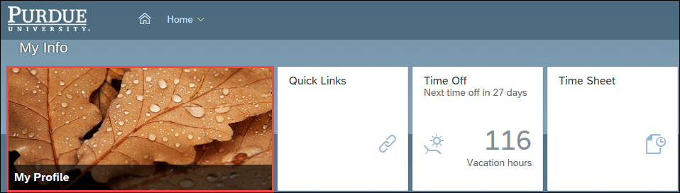
If you hold multiple positions and they are similarly named, click the Employment Information tab to view the details of the position selected in order to ensure time off is requested for the correct position.  Click the Home icon at the top of the page to return to the SuccessFactors home page. | 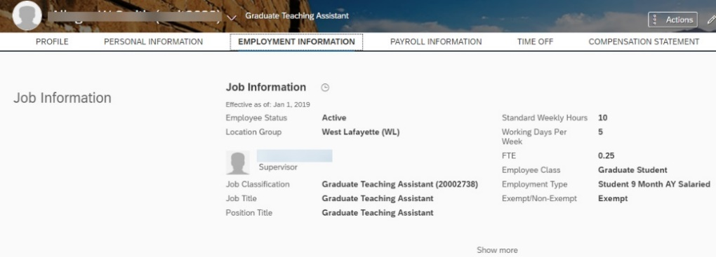

Requesting Emergency Sick Leave
After logging in to SuccessFactors and selecting the appropriate position (if applicable) scroll down to the My Info section and click the Time Off tile. | 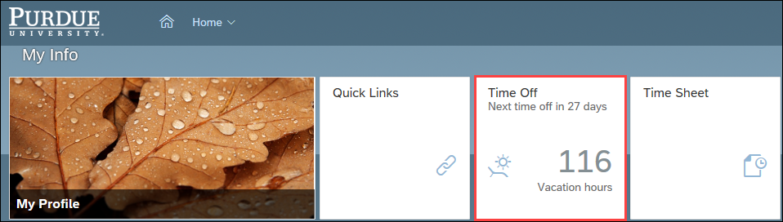
From the Time Off screen, click New Absence. | 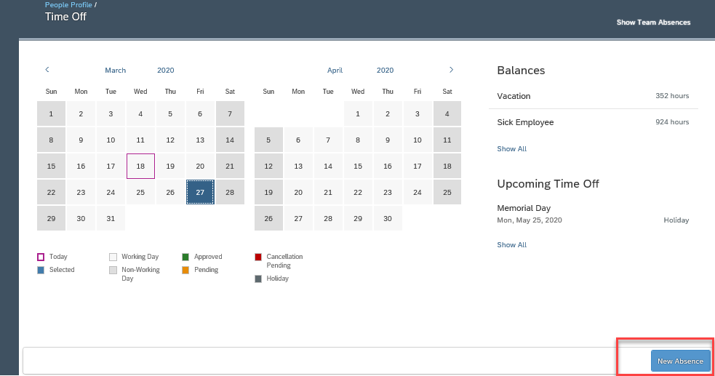
Select Other Leave with Pay leave from Time Type dropdown list.  - Complete date(s)  - Complete number of hours when not using the full day as Other Leave with Pay.  Select the appropriate notation from the Pandemic drop-down list. | 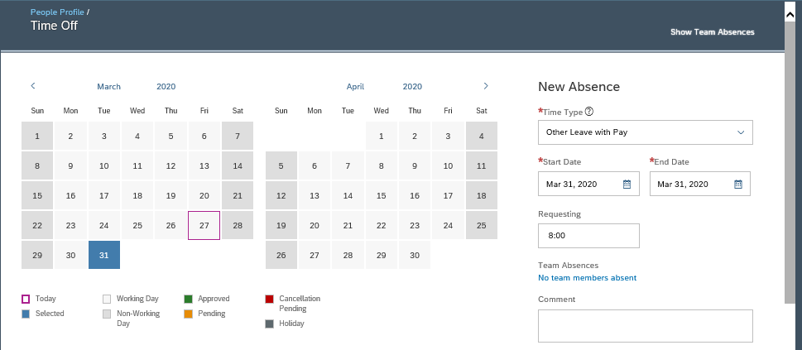  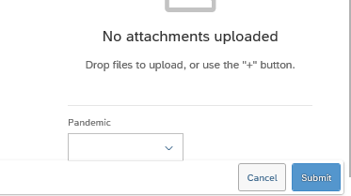  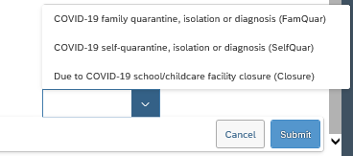
After submitting, the request is listed under the Upcoming Time Off heading with a status of Pending.  The employee’s supervisor receives an email notification that a request has been submitted.  The request is also now indicated as Pending with a gold line on the date on the Calendar.  Once a leave has been approved, the status will change from Pending to Approved. | 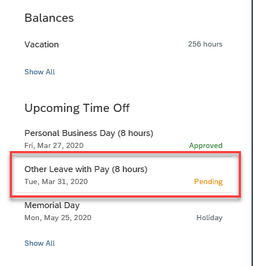

Time Off: Editing or Cancelling
The submitted request can be accessed by clicking the Date on the Calendar, or by clicking the Absence listed under the Upcoming Time Off heading.
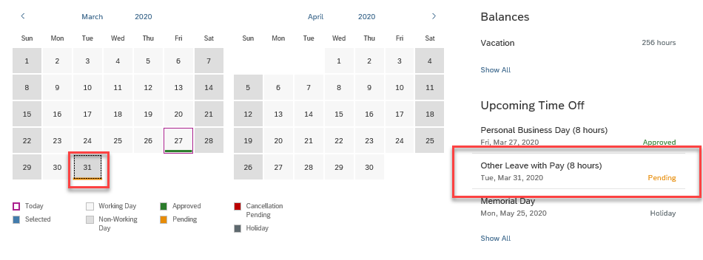
If using the Calendar, click the date and then the Pencil icon to edit. | 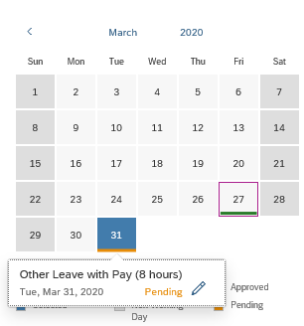
If accessing through Upcoming Time Off, click Edit Absence.  Make necessary edits to the request.  Click Submit.  NOTE: The edited request will be routed for approval only if the original request was already approved. | 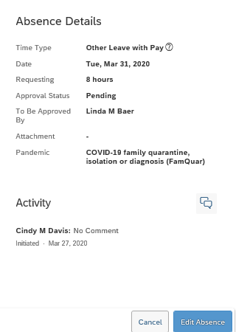
Make necessary edits or cancel the request.  Click Submit after editing or Cancel Absence if deleting or cancelling absence.  NOTE: The edited request will be routed for approval only if the original request was already approved. | 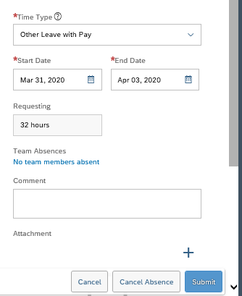
If cancelling, click Yes to confirm cancellation.  Click No to exit from the cancellation request without submitting. | 