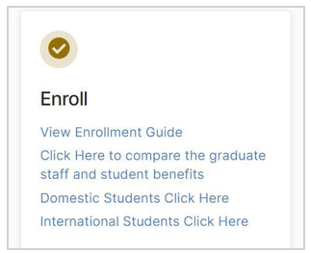
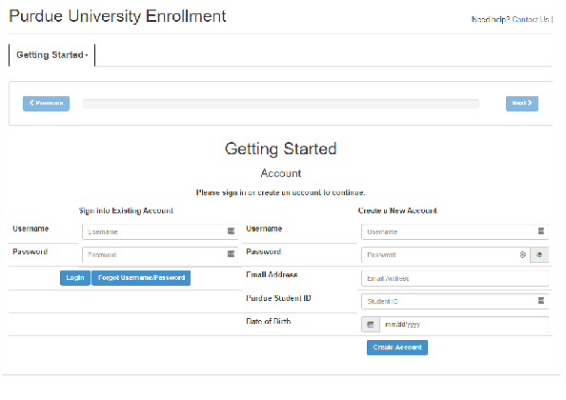

Go to purduega.myahpcare.com, scroll to the Enroll box and click the appropriate link to begin enrollment.
1
2
From the Getting Started page, you will need to Create a New Account or Sign into Existing Account.
Once your account is created or you’ve logged in, click
Start a new Enrollment Session to begin enrollment.
3

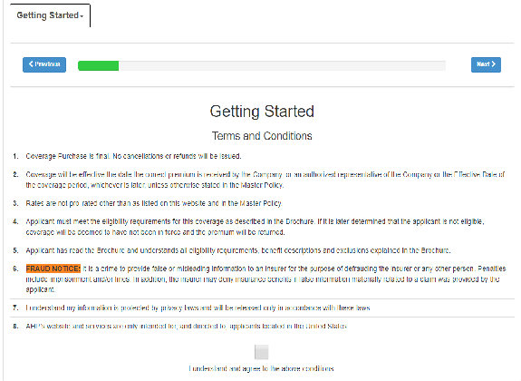

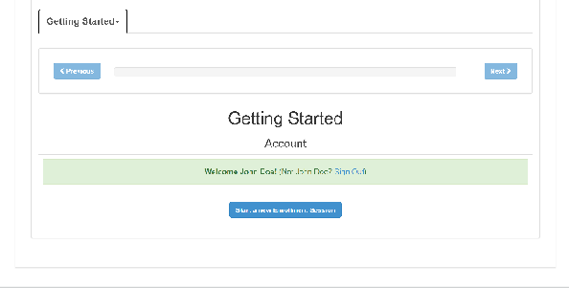

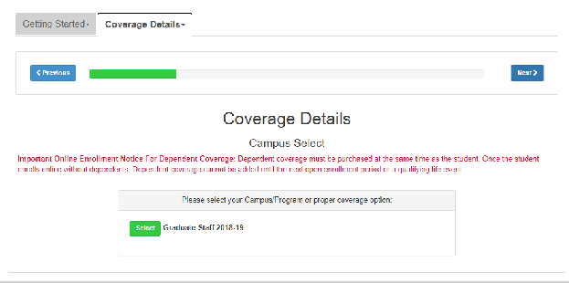
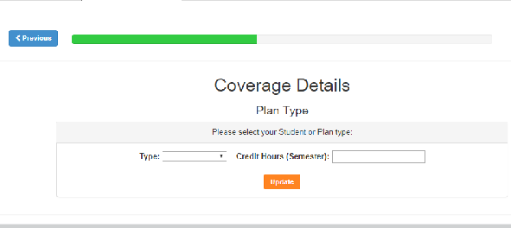
Review the Terms and Conditions, then click the box to check
Purdue University - Graduate Staff Domestic and International Enrollment User Guide
4
I understand and agree to the above conditions.
5 Click Select.
Select your Student or Plan Type and enter your credit hours.
Click Next
6

7 Select your Payment Option.
8
You will see the Pricing Details for your plan. If you want to add coverage for a dependent, click Add dependent.
If Applicable, enter dependent information and click Submit Dependent. Repeat for any additional dependents, then click next.

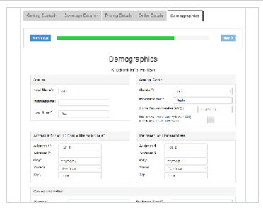

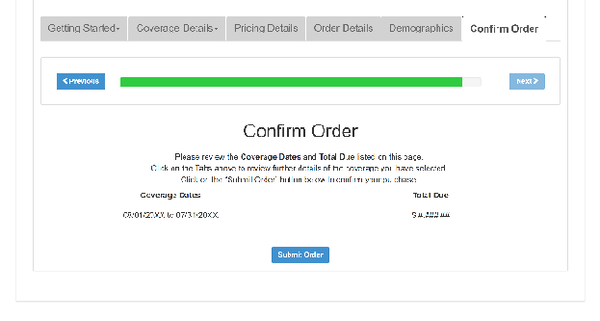

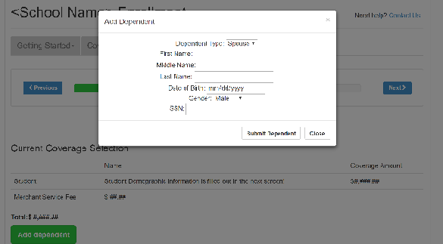
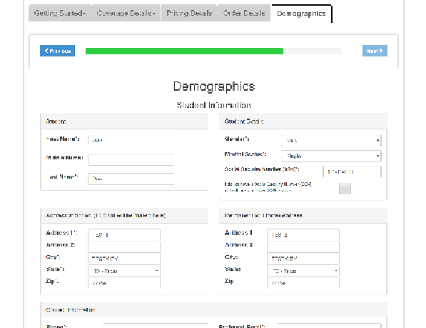
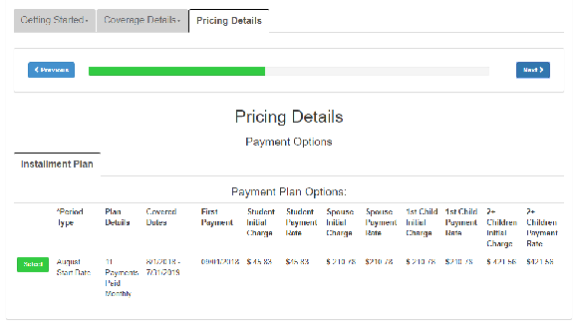
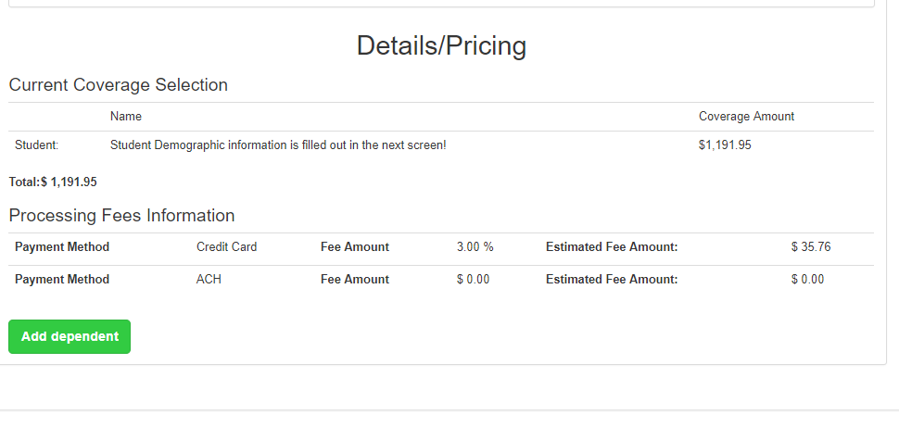

Enter Demographics and Student Information. Click Submit Demographics at the bottom of the page.
10
9
11
12
Review the Coverage Dates and Total Due listed on this page. If all appears correct, click Submit Order. Otherwise, use the tabs at the top to go back and change your selection.
Enter your payment with a credit card, bank draft or Web Pay. Click Submit Payment.

Upon successful payment, you will be provided a Coverage Purchase Confirmation with your Order ID and AHP Student ID. Click View Order Details to view a detailed summary and
13
14
confirmation of coverage.

This screen is a confirmation of your benefit choices and proof of your enrollment. Print a copy for your records. You can Access this page at any time by logging into your AHP Account.

To enroll in Dental, go to purduega.myahpcare.com and click on the Enhanced Products tab.
15
16 Click on the Dental dropdown and repeat steps 2-14.

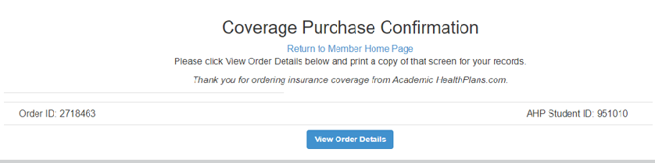
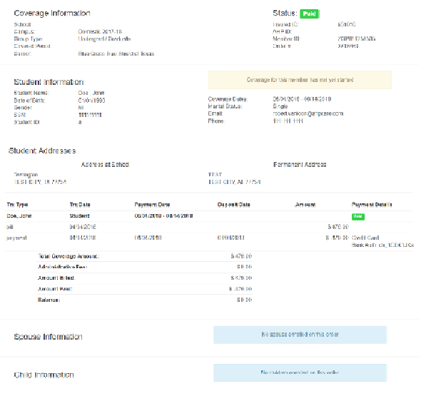
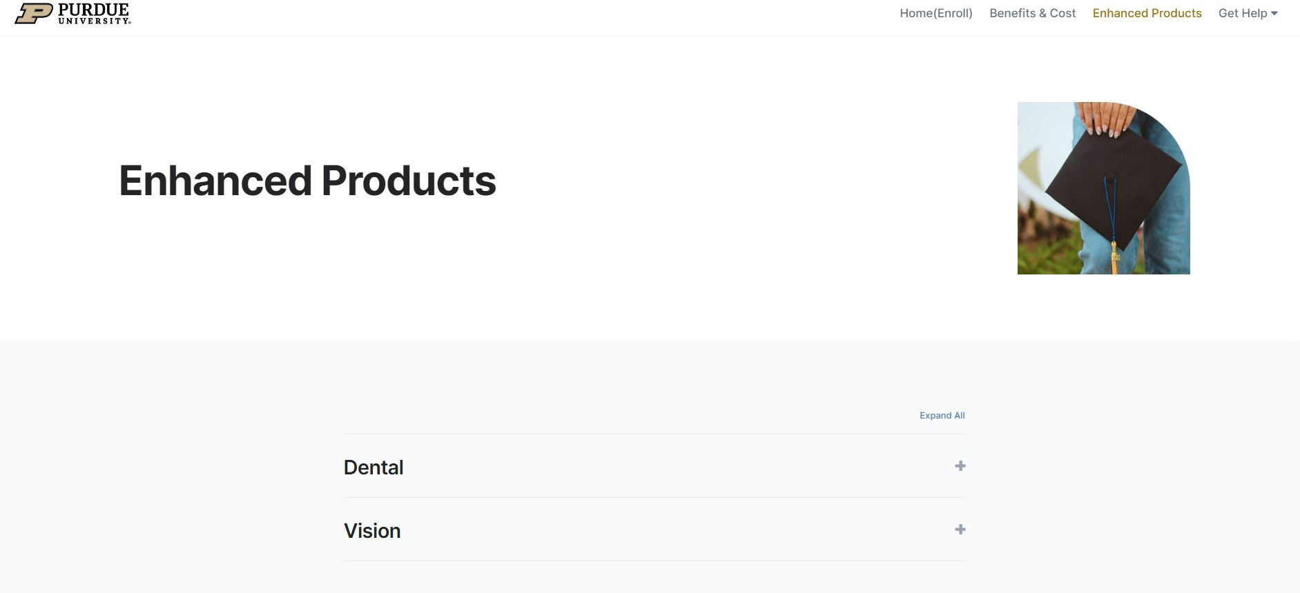
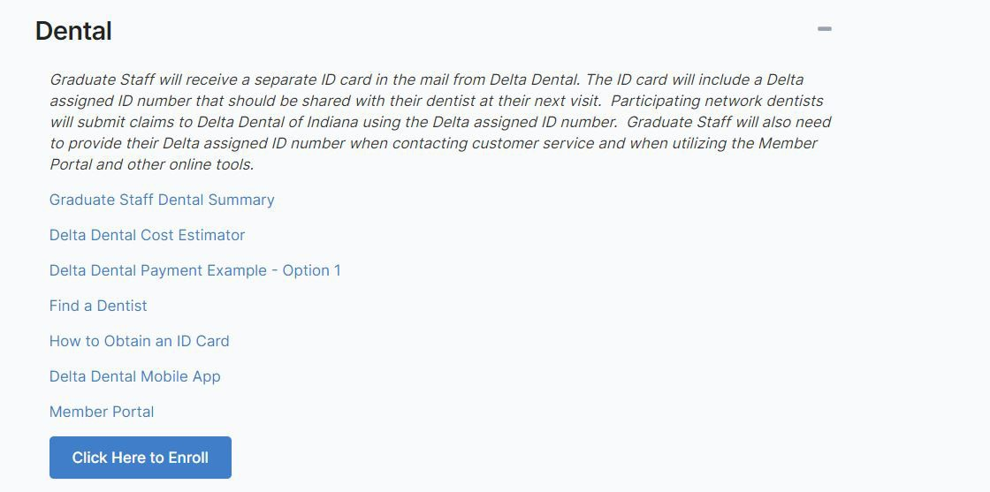
Questions? Please go to purduega.myahpcare.com and click on the "Get Help" dropdown

