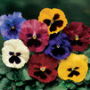
Pansy 1 Delta Premium Blotch Mix $5.00
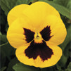
Pansy 2 Delta Premium Gold with Blotch $5.00
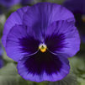
Pansy 3 Delta Premium Blue with Blotch $5.00
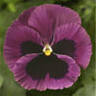
Pansy 4 Delta Premium Rose with Blotch $5.00
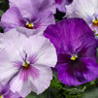
Pansy 5 Delta Premium Lavender Blue Shades $5.00
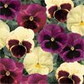
Pansy 6 Delta Premium Apple Cider Mix $5.00
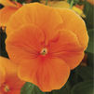
Pansy 7 Delta Premium Orange $5.00
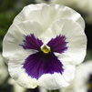
Pansy 8 Delta Premium White with Blotch $5.00
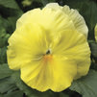
Pansy 9 Colossus Lemon Shades $5.00
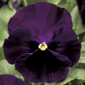
Pansy 10 Colossus Purple with Blotch $5.00
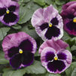
Pansy 11 Mammoth Pink Berry $5.00
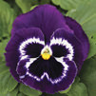
Pansy 12 Mammoth Viva La Violet $5.00
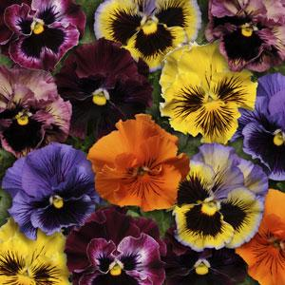
Pansy 13 Frizzle Sizzle Mix $5.00
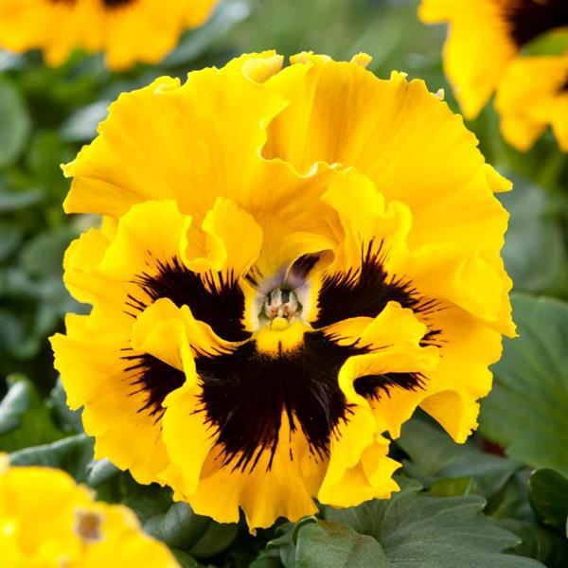
Pansy 14 Frizzle Sizzle Yellow $5.00
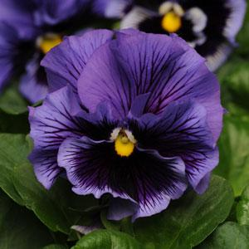
Pansy 15 Frizzle Sizzle Blue $5.00
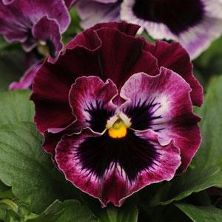
Pansy 16 Frizzle Sizzle Raspberry $5.00
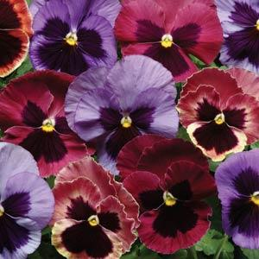
Pansy 17 Matrix Coastal Sunrise Mix $5.00
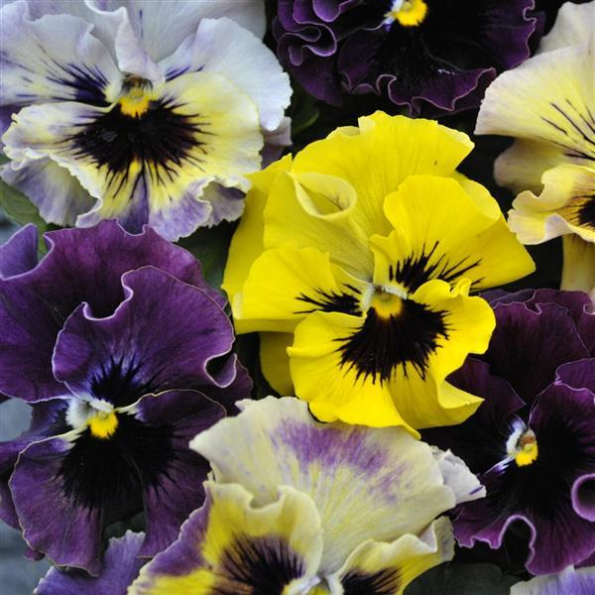
Pansy 18 Viola Frizzle Sizzle Mini Mixture $5.00
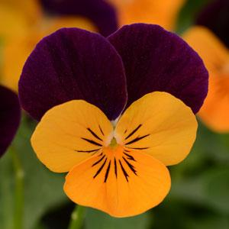
Pansy 19 Viola Sorbet Orange Jump Up $5.00
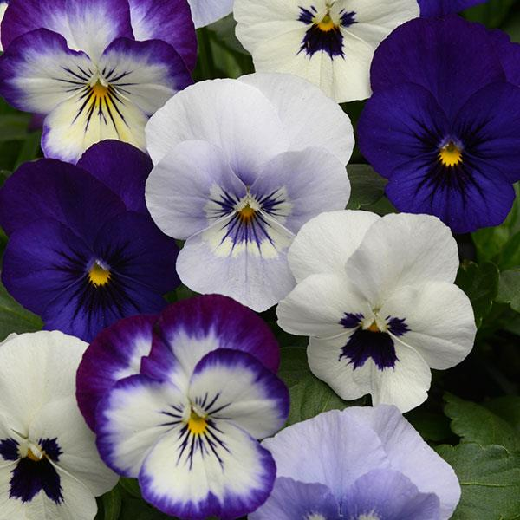
Pansy 20 Viola Sorbet Ocean Breeze $5.00

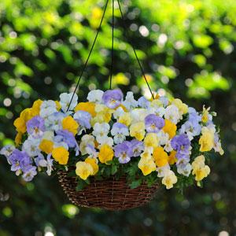
Pansy 21 Cool Wave Mix Pastel Hanging Basket $20.00

