Entrepreneurial Readiness Program for Farmers in Southern Tajikistan

Objectives

Learners demonstrate competence in
- Explaining a Business Plan
- Explaining a Business Model Canvas
- Developing a mission statement
- Describing attributes and benefits of main products and services
- Explaining a SWOT analysis
- Building a marketing plan for target customers
- Explaining a financial plan with capital requirements, key revenue streams and cost structure

THE BUSINESS PLAN
A business plan is a plan of how a business owner intends to organize an entrepreneurial endeavor and implement activities necessary and sufficient for the venture to succeed. Based on the mission statement, it is an essential tool for planning, direction and running a business. It clarifies the operational and financial objectives of a business and contains the detailed plans and budgets showing how the objectives are to be realized. It serves as an evaluation of business´s chances for success. It is a written summary of the business venture, its operational and marketing opportunities and strategy, as well as the skills and abilities of the manager and employees.
If you have a great plan, the business plan is the business!

Why should farmers should have a business plan?
A good plan maps the course of action to achieve your business goals and aspirations
- Write down forces them to define/refine their farm business
  - Assess current situation: Where I am now?
  - Set objectives for their business: Where am I going?
  - Establish their farm’s mission and vision
- A business plans help farmers to set goals for their farm
  - Set short and long-term planning
  - Evaluate market conditions
  - Determine the history and direction of their farm
  - Determine the key players in their operation
  - Evaluate their skills, talents, resources, etc.
- It allows them to effectively share and explain their goals and vision with others.
  - Bankers and investors may require a business plan before lending or investing
  - Before community leaders can help promote and support their farm they have to understand what they are trying to do
  - Nonprofits/granting agencies may require a business plan
  - Prove to anyone/yourself that your vision is realistic
- A business plan can help to identify potential issues/pitfalls before they begin, such as competition, legal concerns, liability issues, and labor needs.
- A business plan can protect the future women farmers from proceeding with an idea that doesn’t make good “business sense.” Moreover, understanding the potential issues beforehand can allow for proper planning.
- It provides the tools to quantify the success of your business.
  - Target sales
  - Growth and expansion
  - Market share
  - Profits

Components of a business plan
A business plan should contain a description and definition of who is involved, what consumer need will be met, what the saleable product/service is, and the market environment. It should also contain a plan for producing and marketing the product/service, a list of resources needed to achieve the plan and when they are needed, and a summary of anticipated results. So, it is a written summary of the business venture, its operational and financial details, marketing opportunities and strategy, as well as the skills and abilities of the manager and employees.
Most business plans contain the following sections:
- Executive Summary
A business plan should serve as a roadmap for the farm business.

- Mission Statement
- Business Description
- Management Plan
- Production Plan
- Marketing Plan
- Financial Plan

Moreover, it should include information that is important in taking the business where it is wanted to go. However, it should not include things that will not help to go where they want to go with the business. It should be noted that every plan is unique. Every single farm plan should relate to and be steered by the respective mission statement. Goals should be kept realistic. The real value is in the process of creating it.

- The executive summary
Gives a brief overview of the current situation and the aspirations for the future. It is one of the most important chapters of a business plan. On a maximum of two pages all information of crucial importance should be included. Above all, it has to be ensured that the offered services and the resulting customer benefit are stated clearly. A brief description of the market potential, the capital requirement, and the desired profitability should not be missing. Though this chapter is put in the beginning of the business plan, it usually is written last because it summarizes the overall business plan and presents the essentials so that at a glance the reader is able to capture the particular strengths and the most important success factors of the company. In case it is the only thing that a reader will read it needs to give a synopsis of what you want to do or achieve.

- The mission statements
A mission statement sets goals and standards. It looks at the future and defines what kind of business you want. It is a source of inspiration. Moreover, it provides clear decision-making criteria. A farm’s mission:
- Is a short concise statement that describes the core purpose of your business
- Is the initial measuring stick for making decisions
- Focuses on the business present
- Lists broad goals
- Identifies the company’s products, services, and customers
- Describes what consumer need will be met
- Should be short enough for people to easily remember it
A good mission statement:
- Is focused less on what activities happen on your farm and more on what the business will accomplish for its customers, employees, and owners.
- Highlights the unique philosophy and set of circumstances of your farm such as:
  - A production method, such as organic farming
  - A specific commodity such as greenhouse tomatoes.
  - A target market such as local consumers.
- The business description
It is a brief description of the business and where the business is located and what product or service women farmers are going to give to their clients or customers. This is akin to an extended elevator pitch and can help readers and potential investors quickly understand the goal of the business and its unique proposition. This part needs to relate to the introduction and objectives, here the women farmers need to indicate, for example, if they want to farm, when the planting season will be and when harvesting will take place. The following questions need to be answered in the business description
  - What is the current status of your farm business?
  - What makes your farm unique?
A final convincing statement makes clear why the author thinks she has a winning business venture
  - What are the key qualifications of the owner(s)?
  - What are the key qualifications of the employees?
  - Which is the long-term competitive advantage?
  - What key assets (greenhouses, buildings, trucks, orchards, etc.) are in place?
  - What does the farm business need to succeed?
  - Regarding business organization, the ownership structure has to be made clear

- Management plan
This is where your business plan gets to looking forward. You are going to formulate your farm strategy from now into the next five years or so.
- Gather information and research markets.
- Investigate and analyze industry trends, identify competitors, and define buyers.
- Generate a SWOT Analysis. This is an analytical tool that can be used in making decisions. SWOT stands for: strengths, weaknesses, opportunities, and threats.
- Look at all your strategies, then reread your mission statement. The ideal farm plan will fit your mission best.
- Write an implementation plan. This is where you write a plan that will make your new strategy happen.

- Production plan
Your production and operation plan includes a description of what crops you will produce, how you will produce them, and what technology and equipment you will use. It should also list other business activities such as growing other crops; selling production inputs to other producers; selling at the bazar; or starting agri-entertainment ventures.

- Marketing plan
A marketing plan is about defining your customers or target market. You should also tailor your product, pricing, distribution, and promotion strategies to satisfy your customers.
If your farm is product-oriented (you produce what you like without thinking about what your customers want) you risk growing crops won’t sell or will not sell at a good price. Instead, most successful farm businesses are customer-oriented: the marketing plan is built around customers’ needs.

- Financial plan
Financial analysis and planning is an important part of describing your business to someone else. Financial projections give some idea of where your business is headed in the next few years and describe the financial consequences of changes you plan for the future. It helps you evaluate alternative business investments. The financial section should also describe the assumptions used in making financial projections. These assumptions might include projected prices that will be received in the future, input costs, or production levels. You should keep these projections and compare them against your actual business performance.

THE BUSINESS MODEL CANVAS
The business model canvas is a tool developed by an American company called Strategyzer to help business owners to describe and think through the business model of your farm, your competitors, or any other farm business. This tool has been applied and tested around the world and is used in organizations such as IBM and many more.

Most business owners believe it is better to use a visual process when developing their business plans. The Canvas is described in 9 basic blocks that show the logic of how a business should make money. The 9 blocks cover 4 areas of a business: customers, products/services, infrastructure, and financial viability.

Customers relationships
Key activities
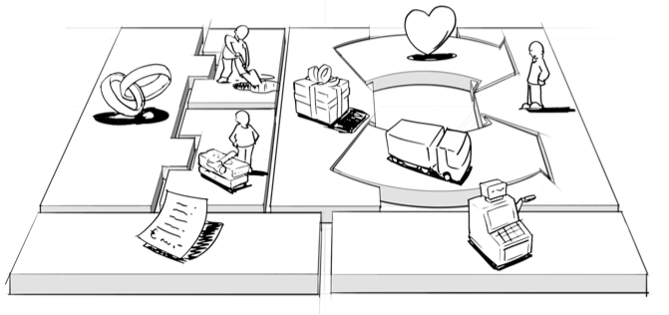
Key partners
Channels
Value propositions
Cost structure
Customers segments
Key resources
Revenue streams

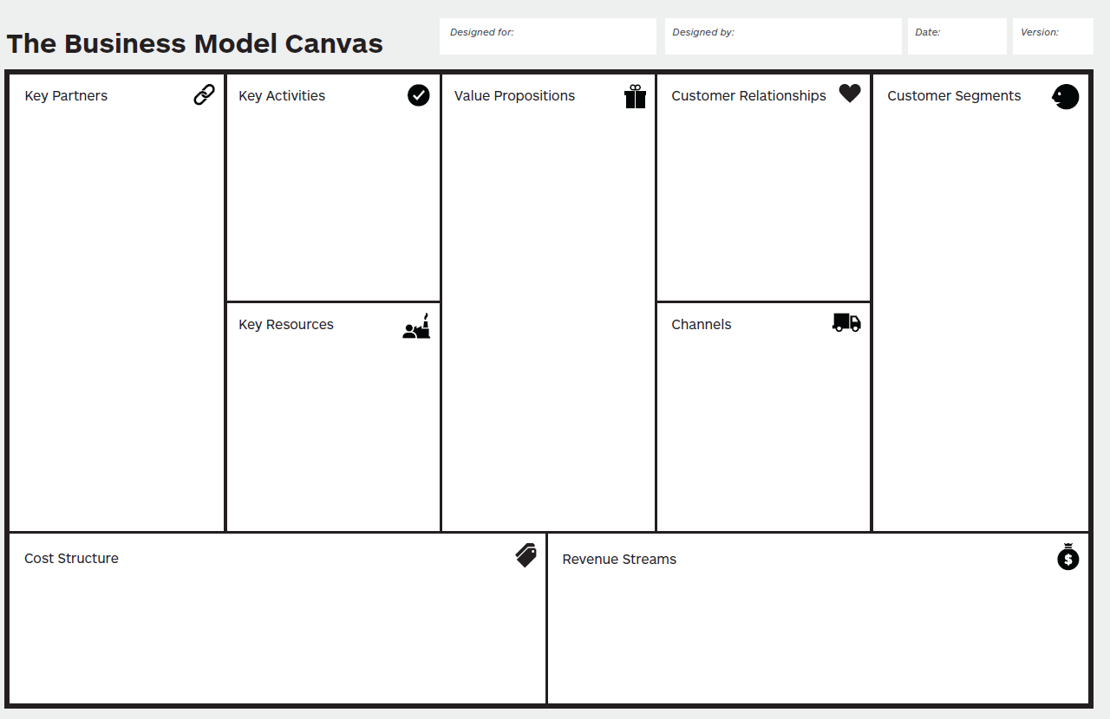
- How do we get, keep, and grow customers?
- Which customer relationships have we established?
- How are they integrated with the rest of our business model?
- How costly they are?
- How do we get, keep, and grow customers?
- Which customer relationships have we established?
- How are they integrated with the rest of our business model?
- How costly they are?
- For whom are we creating value?
- Who are our most important customers?
- What are the customer archetypes?
- Through which channels do our customer segments want to be reached?
- How do other companies reach them now?
- Which ones work best?
- Which ones are most cost-efficient?
- How are we integrating them with customer routines?
- What are the most important costs inherent to our business model?
- Which key resources are most expensive?
- Which key activities are most expensive?
- For what value are our customers really willing to pay?
- For what do they currently pay?
- What is the revenue model?
- What are the pricing tactics?
- For whom are we creating value?
- Who are our most important customers?
- What are the customer archetypes?
- Who are our key partners?
- Who are our key suppliers?
What activities do our
- value propositions require?
- Distribution channels?
- Customer relationships?
- Revenue streams?
- What value do we deliver to the customer?
- Which one of our customers’ problems are we helping to solve?
- What bundles of products and services are we offering to each segment of customers?
- Which customer needs are we satisfying?
- What is the minimum viable product?

- Through which channels do our customer segments want to be reached?
- How do other companies reach them now?
- Which ones work best?
- Which ones are most cost-efficient?
- How are we integrating them with customer routines?
What key resources do our ______require?
- Our value proposition
- Our distribution channels
- Customers relationships
- Revenue streams

- What are the most important costs inherent to our business model?
- Which key resources are most expensive?
- Which key activities are most expensive?
- For what value are our customers really willing to pay?
- For what do they currently pay?
- What is the revenue model?
- What are the pricing tactics?

BUILDING A MISSION STATEMENT

To develop your mission statement, first, you need to identify a market need and then offer products or services that satisfy that need, at a price customers are willing to pay while still returning a profit to the business. A good mission statement should explain what product or service your farm produces and also why consumers would want to buy that product or service.

Ask yourself:
- Why does my farm business exist?
- What is it purpose?
- What does my firm business do?
- Why does it do it?
- For whom does it do it?
Examples:
Dot’s farm is committed to the sustainable production of fruits of fresh, sweet and natural quality. We value our resources and do not apply any hormones to our crops, which protects the land and ensures that customers will receive goods that are long lasting, tasty, and healthy.

Jalma Farms is committed to a sustainable native fruits orchard while preserving open space and protecting sensitive fresh and salt water ecosystems.

B & B Livestock Farm, LLC, is a quaint family owned farm dedicated to recognizing our customers’ needs by producing healthy, superior-quality, all natural food for the local consumer. Our high standards and commitment to cleanliness, animal health, and environmental stewardship allow for a relaxed, stress free environment for our animals and visitors alike.

We grow healthy food for healthy people

Write down your mission statement:

______________________________________________________________________________
______________________________________________________________________________
______________________________________________________________________________

DESCRIPTION OF MAIN PRODUCTS AND/OR SERVICES
Your production and operation plan includes a description of what crops you will produce, how you will produce them, and what technology and equipment you will use. It should also list other business activities such as growing other crops; selling production inputs to other producers; selling at the bazar; or starting agri-entertainment ventures.
Ask yourself:
- What is my production plan?
- What crops will my farm business produce?
- How it will produce them?
- What technology and equipment will we use?
- What varieties will we produce?
- What other activities will my business perform: booth, bazaar, spraying for other farmers, selling other products
My farm activities will be:

Farm Recordkeeping
Farms require record-keeping to succeed and repeat those successes year after year. Before growing a crop or livestock enterprise, you should decide which records to keep. One set will be financial records, including costs of items such as plants, seed, fertilizers, containers, root substrate, labor, and utilities. Cultural and production records are also important to keep.

Cultural Records.
You should keep cultural records to: (1) provide a plan for repeating successful crops and (2) figure out what went wrong in unsuccessful crops so you can correct it in the next crop. Long before a crop is planted, you should write a cultural schedule, listing dates and labor budgets for tasks such as planting, fertilization, pesticide application, harvesting, and cleaning up. The cultural schedule record sheet gives you a daily reminder of the various tasks that must be performed.

Production Records.
You should also keep a set of production records. You should gather these records throughout the growth of the crop. You should write the condition of each crop and weather conditions weekly. Record visual observations, including things like species, height, maturity, and any disease conditions. This information lets you compare the present crop with previous crops. By looking at a poor crop afterwards, you can identify the stage of growth when trouble started. The production record should also include the yield, the harvest date, and the crop quality. These records are useful for budgeting.

What records will I need to keep?

Example
I will keep cultural and production records for each crop. This will include cultural schedule, listing dates and labour hours for each production operation such as root substrate preparation, planting, syringing, fertilization, pesticide application, pinching, pruning, chemical growth regulation, disbudding, harvesting, and cleaning up. This cultural schedule will be recorded in the greenhouse and maintained in the general manager’s office. Daily, the grower will assess the condition of each crop and record weather conditions.
After the crops are harvested and reach the market, we make note of the transactions in our records. We also keep record of when chemicals are applied and need to be applied again, and when all of the components of our system must be checked for safety and quality.

SWOT ANALYSIS
SWOT analysis is a useful technique for understanding your Strengths and Weaknesses, and for identifying both the Opportunities open to you and the Threats you face. What makes SWOT particularly useful is that, with a little thought, it can help you uncover opportunities that you are well-placed to exploit. And by understanding the weaknesses of your business, you can manage and eliminate threats that would otherwise hurt your farm business.

Farms face external opportunities and threats that are beyond their control. Farms also have strengths and weaknesses that are internal to their businesses such as location, skills of family members, and cash flow position. Performing an analysis of the business’s internal strengths and weaknesses and the business’s external opportunities and threats may uncover overlooked risks.

To be effective, a Strengths, Weaknesses, Opportunities, Threats (SWOT) analysis should be a very candid and honest assessment of the business. Always remember, some risks can also be opportunities.
- Strengths are attributes of a person or of a business that can contribute to achieving the objectives.
- Weaknesses are attributes of a person or of the business that can lead to not achieving the objectives.
- Opportunities are external conditions that will contribute to achieving the objectives.
- Threats are external conditions that can lead to not achieving the objectives.

Strengths and Weaknesses are factors internal to the business and within management control
- What are the abilities and limitations of the manager and key employees?
- How modern and efficient is the physical facility?
- How is the soil?
- How close are you to the market?
- What can you do better than your competitors?
- What is the cash flow position of the business?

Opportunities and Threats are factors, outside or externally, of the business and beyond management control
- Market trends
- Consumer demands, demographic, lifestyles
- Strong or weak currency
- Interest rates, inflation rate
- Government policies and regulations
- Labor markets

The goals of the SWOT Analysis are
- Matching the farm’s strengths and weaknesses to external opportunities and threats.
- Analyzing the key factors for success and analyze the competition.
- Build a successful business by magnifying strengths, and overcoming weaknesses.

Ask yourself:
- What production levels do you have now, or do you want to achieve?
- What is the location?
- Does it lend itself to direct marketing or wholesale marketing?
- How much land do you own or have access to?
- What machinery and facilities do you have?
- What is their age and conditions?
- Can they be better used?
- What is your financial condition?
- What is your cash position?
- What are the skills of the owner/manager?
- Do your skills and resources limit the alternatives?
- What are some marketing and production opportunities?
- Do your personal preferences or sense of social responsibility limit the alternatives?
- Can you form alliances with other businesses that could compliment yours?
- What marketing channels are possible?
- Does your strategic plan require greater competence or resources than you currently What skills and talents do employees possess?
- What family members will be involved in the business and what are their unique talents and interests?
- Who will be the next generation of management?
- How does the layout of the farming operation impact on production efficiencies?
- Do you have an adequate, cost effective water supply?
- possess?

THE MARKETING PLAN
A marketing plan is very important; it describes what your business will produce and how it is unique (product); how and when you will market the product (distribution and packaging); what distribution channel you will use (place); to whom (target customers), and for how much money (price) the you will sell your products; and how and what the you will communicate to the customers (promotion).

These are the four Ps of marketing: product, price, place, and promotion. If your farm provides services, you should think of your services as a “product” for the marketing plan.

Ask yourself “How will I develop my marketing plan?
- Product: What product will be offered and how is it unique? who are the target customers and what do they value?

- Place: where do buyers look for your product or service? How can you access the right distribution channels? Do you need to sell to retailers? Who are your competitors and how will you position ourselves to compete? Could there be new competitors?

- Prices: How will you price the product or service? What is the perceived value of your product to the consumer? Is your price in line with the market’s perceived value?

- Promotion: How and what will you communicate with buyers or customers? Do you have a marketing strategy with good promotional and branding strategies?
- Distribution: How and when will you move your product to market? What market channel will you use?
- Packaging: How will you present the product to the customer?

Who are the target customers and what do they value?
To figure out your target market and your marketing strategy, first you should identify the target market segment (who the customers are and what they value) and sales potential (how much those customers are willing to buy). Target markets are usually either individual households (direct marketing) or businesses (wholesale marketing). Direct marketing is usually more profitable than wholesale marketing. Developing customer profiles or segmenting the market can help you decide if a market segment is large enough to be profitable. If you identify and target specific market segments, you can also develop packaging, price, and promotional strategies that will appeal to those customers.

Market Segments
Markets can be segmented, or divided, in many ways. The most common form of segmentation is by demographics (age, gender, income, race, ethnicity, disabilities, travel, education, home ownership, and employment status). A market can also be segmented geographically, for example, domestic and international customers, various neighborhoods, or locations of different stores owned by wholesale buyers. It is important to ask yourself, “What are your customers needs?” This applies whether your product is going directly to the final consumer or not. Do they need convenience? A particular size? More availability? Unique product? High-value products? Large volumes?

One important way to segment the market is by age. You must realize that different generations communicate differently. The younger generations can (and sometimes prefer to) be reached on the Internet- through social media, email, texts, even ads on websites. Other generations may be more receptive to mailings, phone calls, and ads in newspapers or magazines. Consider the values and priorities of each generation that you are trying to reach, and adjust your marketing plan to appeal to each one. A single marketing plan will not appeal to each of your possible customers.

Size of the Market
To begin a business, you will need to ask, “How many potential customers are there? How often and how much will they buy? What is the total size of the market? Is the market emerging, growing, or shrinking? Will this market provide enough sales?” You can start answering these questions by analyzing government statistics, visiting potential buyers, and attending industry and university educational meetings to learn and network.

If you plan on selling wholesale, your deliveries should be limited to a distance that a truck can deliver and return in one day. New producers should visit potential customers (usually another business) to find out how much product they would be willing to buy. When approaching wholesale buyers, you should be knowledgeable about the market, have a price sheet or website prepared, project a professional image, work out the details of the sale with the buyer, and keep in touch with the buyer.

If you plan on direct marketing, you can estimate the potential size of a market by looking at a map to see how many towns or cities are within travel distance of your farm or market. If you know the population of these areas, you can estimate how many potential customers there are and how much money each customer might spend at your farm based on their demographics and your products.

Example
Information regarding healthy eating habits is readily available to people throughout Turkey, and more people are aware of the implications of eating healthily today than they ever have been. There are farmers in countries bordering the nation, and if the markets in Turkey would buy the crops from those farmers, keep them in Turkey, and resell them to other countries, farmers and the government would profit. This type of exchange market already exists in the country, but if it were executed on a large scale our business would be doing very well. Because it is possible to grow a great variety of plants in this country, the application of agricultural biotechnology has been successful in creating hardier, healthier strains of plants. If this continues, the crops exported from Turkey may have longer shelf lives, be supplemented with vitamins and nutrients, or just be a better all-around option, and this will cause demand for Turkish produce to rise. Turkish crops are of a very high standing in the world and are wanted by a majority who look for quality produce.
According to a press release given by the ministry of food, agriculture, and livestock for 2016 in Turkey, it was presumed that the production of fruits increased by 6.4%. If demand can compete with the increased output of fruits, then there will be no difficulty selling what we grow. If demand stays the same and the production of fruit continues to increase, then we will have a more difficult time selling our crops.

Outline your market analysis
Describe your product or service and what makes it unique

Becoming knowledgeable about the market
- Talk with other growers selling in that market. Try to find out individual buyers’ expectations of volumes and prices to see if they match your situation before approaching the buyer
- Select buyers whose expectations best match what you have to offer. Buyers often prefer to see a list of available products
- Be well informed about production, supply, and quality and be confident in the business’ ability to meet the buyers’ need

Who are the competitors and how will your business position itself?
Nearly every business or product has competition. It is important to know how you can differentiate your business from others. Finding out what your competitors are offering and how they offer it can help you to find your niche in the market.
Ask yourself:
- Who are the competitors and what do they offer?
- Where are they located
- What is their market share
- Who are the key minor player
A trip to the farm next door, grocery store, bazaar to research what your competition is offering may help you answer these questions. The idea is to find out everything possible about your competitors’ business or their buyers.

Pricing: How Is Product Price Determined?
The pricing strategy depends on whether you are selling direct or wholesale. In some markets (especially wholesale markets), you will be price taker. In other words, the market sets the price. In other markets, like retail, you can set your own prices based on what the customer is willing to pay. Even price takers can still do things to obtain a higher price. To have more control over pricing, you will need to differentiate your product.

Prices are usually set by determining how much it costs to produce the product and then adding a fair price for the benefits that the customer will enjoy. The cost of production/operation becomes the price floor, or the lowest price. The price ceiling is how much customers are reasonably willing to pay for the product based on the value it gives them. Most customers will be willing to pay a price somewhere between the price floor and the price ceiling.

To stay in business for the long your price has to cover your costs. To begin setting your prices, first you calculate the cost to produce the product or provide the service. The costs include all the fixed and variable costs—including production, marketing, and promotion—then you add a return for your time and investment. You can find out what price customers are willing to pay by researching what others are charging for similar products.

When you know market prices and costs of production, you are ready to begin setting your prices. Common pricing strategies for differentiated products are in the table below. Each has advantages and disadvantages. Depending on the business goals, vision, target market, and product strategy, you may want to consider more than one pricing strategy.
Promotion: How and What Will We Communicate to Our Buyers or Customers?
Promotion is important to make sure customers recognize your product. You should build promotional strategies around a message or your unique product value. The image you want to send to buyers should be seen in everything you do. This image should be clear on your business cards, invoices, landscaping, building design, signage, brochures, web sites, social media contacts, and vehicles.

You could use a brand or logo to identify your products and to separate yourself from competitors. Although establishing a brand can be expensive, many direct market farm businesses are concentrating their promotional efforts on image advertising—promoting the concept of locally produced, eco-friendly, or quality products.

The best approach to advertising is to think about different media and which media will be most effective in reaching the target market. Advertising media options include the Internet; television; radio; newspapers; magazines; billboards; bench/bus/subway ads; direct mail; newsletters; and cooperative advertising with wholesalers, retailers, or other businesses. You can set aside some of your advertising budget for each medium. Your advertising budget should include the cost of advertising and also estimate how much sales the advertising will bring in. Your business should also include some marketing material such as business cards, brochures, and pamphlets. Another way to promote your business is free publicity, like press releases, product launches, and special events.

FINANCIAL PLAN

As an owner of a farm or greenhouse, you have several ways of receiving returns:
- If you invest your own money in the business, that money should return interest. After all, if you invested that same money in a bank, you would receive interest.
- You should pay yourself a salary for managing your business and wages for your labor. Think of how much you would have to pay to have someone perform these same functions.
- Profit is what is left after subtracting all of the other costs including opportunity costs (interest) for using your own money in the business and a salary for your labor and any unpaid family labor. Profit is the return for taking the risk of running your business.

- Simplified Income Statement
An income statement summarizes the earnings and costs of a business for a given period of time (usually one year).
The costs can be grouped into two categories: variable costs and overhead costs.
- Variable costs change with the level of production. Examples of variable costs are the costs of seed and fertilizer.
- Overhead or fixed costs are spent regardless of the level of production and are common to all crops. These costs include depreciation of the farm structures, equipment, and other facilities and costs like interest, repairs, insurance, taxes, and salaries of overhead personnel (the manager, salespeople, growers, secretaries, bookkeepers, etc.).
- Your total cost of production is the sum of variable and overhead costs. Net income is earnings minus costs, including depreciation

Sales – Total Costs = Net Profit or Loss

Some tips for income statements:
- Do not assume that you will sell 100% of crops produced.
- Don’t forget to pay yourself. Many new business owners forget about this because income is low. However, the first few years of being in business often are not profitable, you need some source of income. Consider paying yourself what you would pay someone else to operate your business.
- Don’t forget to budget for retirement. At some point, you will no longer want to or be able to operate the farm. Start saving as early as possible.
- You also need health insurance, and should consider disability insurance in case an injury prevents you from working as well as life insurance if others are depending on your income.
- If you lack skills in certain areas, budget to hire consultants so that all jobs are done right. Look for professionals who have had experience with your industry.

Tomato statement
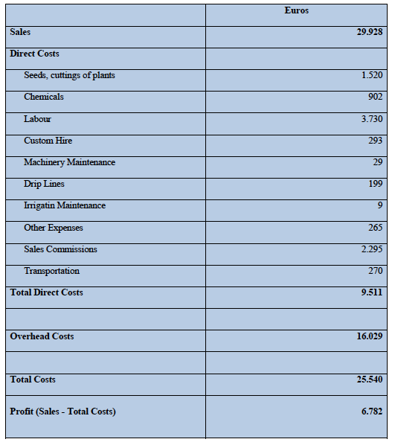

Capital Requirements and Reviewing Business Plans
Often, the most common reason for developing a business plan is to be able to present your business’s ideas for a new or expanded business to investors or lenders. After investors or lenders see the plan, they will want to know how much money is needed and how the money will be used.

You should think about what financial resources are needed for the following list:
- Equipment and facilities
- Lease versus purchase
- Suppliers: delivery schedules, beginning inventories, economic order quantities, cost of storage, and lead times for delivery
- Start-up costs: overhead components, incidental costs, initial advertising and promotions, utilities installation costs, renovations, working capital start-up, timing and source of investment, insurance, licensing, and accounting fees
- Typical annual and monthly estimates
- Desired mix of financing: equity, long-term loans, short-term or working capital loans, equipment or facilities loans, leases or rentals

Describe how you will acquire and manage capital assets.
- Will you purchase, lease, or custom-hire to meet equipment needs?
- If you plan to rent land or buildings, describe the lease arrangements.

You may want to include a summary of retirement or savings investments.

Sources: EMWOFA Program, Business Model Generation Strategyzer Series. Created by Prof. Dr. Ariana Torres, Purdue University, Indiana, United States

