DNP Executive Summary
Madison Plumer BSN, RN
Purdue University Graduate School of Nursing

Problem Statement
Human papillomavirus (HPV) is a virus that is spread through skin-to-skin contact. Certain strains of the virus, most of which are spread via sexual contact, are associated with cancers of the genitals, reproductive organs, and mouth/throat. It is estimated that as many as 4 out of every 10 cases of HPV-related cancers occur in males (CDC, 2020). However, males are significantly less vaccinated against HPV than their female counterparts. Reference?
Significance
HPV infection has been shown to cause genital warts, anal, penile, and oropharyngeal cancers in males. According to the U.S. Cancer Statistics Data Brief, 19,925 new HPV-related cases of cancer in males are reported annually; oropharyngeal cancers account for the majority of these, with 60,000 men affected annually worldwide (CDC, 2020; HPV and Cancer, 2021). Treatment for these cancers can require chemotherapy, radiation therapy, immunotherapy, and surgery. The United States spends approximately $1 billion dollars annually on treating HPV-related cancers in both men and women (Parton et al., 2018).
An effective prevention strategy against HPV and HPV-related cancers is the HPV vaccine. The vaccine, approved by the Food and Drug Administration (FDA), in June of 2006, consists of 2 or 3 doses depending on the age of series initiation (Gardasil, 2015). There are three types of HPV vaccines approved: bivalent, quadrivalent, and 9-valent- with only the 9-valent available for administration in the United States (UpToDate, 2021). The 9-valent vaccine provides individuals with protection against HPV strains that are known to cause 70% of all cervical cancers, 90% of all genital warts, as well as five more cancer-causing subtypes of HPV (Fuller & Hinyard, 2017; CDC, 2018).
Not only is the preventative vaccine effective, but the price of the vaccine is also substantially lower than the HPV-related burdens previously mentioned. The 9-valent HPV vaccine costs anywhere from $140 to $190 per injection, and according to the American Cancer Society, most insurances cover this cost (American, n.d.). From its inception, however, the HPV vaccine has been marketed more toward the female population. This is explained by the simple fact that HPV can be screened for in women but there is no screening tool for men (HPV test, 2020), and as a result, historically HPV has been thought of as more of a feminine disease (Daley et al., 2017). Current vaccination rates still reflect this initial misunderstanding as females still lead their male counterparts in HPV vaccination rates. Vaccine series completion is significantly higher in females than males. As of 2020, 61% of women reported completing the full HPV vaccine series, whereas only 56% of males reported the same (Jenco, 2021).
Many initiatives have attempted to address the inadequacy of the U.S. HPV vaccination rates to lessen the burden caused by HPV and cancers associated with it, but none have focused their efforts directly on adolescent males. Beasley et al. (2019) found that when implemented into a school vaccination program, a two-text message reminder system increased HPV vaccination rates equally in males and females up to 3.29% and did not report any differences in the outcomes of vaccination uptake when comparing different types of text messages (reminder, motivational, or self-regulatory.)
Feinberg and Keeshin (2017) conducted a similar study using text message reminders for HPV vaccination in HIV infected individuals, ages 16 to 26 years, both males and females. Similarly, this study found a significant increase in vaccination uptake with the text messaging system and argued that it increased rates of the first vaccine in the series, as well as entire series completion. Albertin et al. (2015) also found a 3% increase in the uptake of the first dose of the HPV vaccine series with electronic reminders sent to parent or guardian of publicly insured adolescents, aged 11 to 16 years, with no prior HPV vaccinations.
Evidence from past studies supports and even recommends further research into the idea of utilizing text message reminders as a method of increasing HPV vaccination rates. While studies have focused on different characteristics such as insurance status, individuals with specific ailments, ethnic backgrounds, and environment, no research has solely focused on adolescent males. This lack of data combined with the significantly lower HPV vaccination rate of males demonstrates the need for further investigation into methods that support improved vaccination rates. The purpose of his study was to determine if the use of text message reminders increases HPV vaccination rates of adolescent males.
Methodology
The study was conducted in four nurse-led Federally Qualified Health Centers in rural Indiana. At the time of the study, the clinics had 1,459 adolescent males enrolled for routine care. A convenience sample including only guardians of adolescent males, ages 11-18, who had not yet started the HPV vaccination series was selected for participation (n=975). A de-identified report using the clinic’s electronic health records was run by the Director of Quality Improvement to determine sample size and given to study personnel. Of note, while the HPV vaccine can be administered as early as 9 years of age, the health centers follow the CDC’s routine guidelines which recommend starting the vaccine series at 11 years of age (Vaccines, 2020). Participants were included in the study if they were a parent or guardian of a male adolescent, aged 11-18 who had not yet completed the HPV vaccine series, were enrolled in care at the rural, nurse-led clinic in Indiana, and had agreed to receive Care Messages as part of their routine care.
Following approval from the university’s IRB, Care Message reminders were sent by the clinic’s Patient Care Coordinator to the eligible participants. An initial 975 care messages were sent out. However, taking into consideration the 11 participants that chose to opt out of the study, the 453 incomplete messages recorded, and 179 duplicate messages, the final number of participants for this study was 332. The first Care Message prompted each child’s parent or guardian to call the clinic to schedule a vaccination appointment and included a link to the CDC website for further information regarding HPV and the HPV vaccine. Two weeks after the first message was sent, a follow up Care Message was sent to the same telephone numbers with a link to a survey that collected demographic and subjective data and information regarding if Care Messages may have influenced their decision to vaccinate or not. Guardians were given until the end of the study, July 2, 2021, to complete the survey. The exact Care Messages can be seen in Figure 1, and the survey questions are illustrated in Figure 2.
Measures
The primary outcome of this study was receipt of the HPV vaccination by eligible adolescent males. Secondary measures included race, ethnicity, education and income level of the adolescent’s parent or guardian, as well as further details on the efficacy of the Care Messages and possible barriers to vaccination. These secondary measures were collected using a survey linked in the final Care Message which questioned whether the Care Message impacted the decision to vaccinate or not.
Data Collection and Analysis
HPV vaccination rates are routinely monitored at the Health Centers as a quality measure. After the study time frame, the Health Center’s Director of Quality Improvement was responsible for data collection, de-identification, and dissemination to study personnel. Current vaccination rates for male patients enrolled at the clinic who were eligible for the HPV vaccine were collected, as were vaccination rates after the text message intervention implementation. Comparisons looked at vaccination rates during the study period and the same timeframes in 2019 and 2020 to determine if the Care Messages had an impact on rates.
Results
Study personnel sent Care Messages to 975 parents or guardians of adolescent males, ages 11 to 18 during this study. 11 parents opted out of participating in the study after receiving either Care Message 1 or 2. There were 453 incomplete Care Messages meaning that the number listed as the primary contact number was either an incorrect or blocked phone number. Lastly, there were 179 recorded duplicate Care Messages, which indicated that more than one child receiving care by one of the Health Centers was connected to the same phone number. The final number of participants was recorded at 332. A complete breakdown of these values is shown in Table 1.
Care Message 2 provided parents with a link to complete the follow-up survey mentioned previously and shown in Figure 2. The survey received minimal responses from participants. One respondent declined to participate in the survey. A second respondent answered that his/her son did not receive the HPV vaccine after receiving the reminder Care Messages. This respondent did not complete any further survey questions seeking additional information regarding their decision not to vaccinate but did answer some of the demographic questions. The respondent described their race as white, their education level as graduated college, and their annual income as more than $90,000. A breakdown of each survey question and number of responses is shown below in Table 4.
Upon data collection, during the study timeframe, May 31 to July 2, 2021, there were 59 scheduled appointments, no adolescent males received their first dose of HPV, three received their second dose, and one adolescent male received his third dose. The findings from this study were compared to the same timeframe in 2019 and 2020. HPV vaccination rates for adolescent males within the same age range during those years were slightly lower. In 2020, only one adolescent male received his second HPV dose while none received their first or third, and in 2019, no HPV vaccines were administered. This data is displayed in Table 2 and Table 3.
Discussion
During this quasi-experimental study, there were 517 adolescent males, aged 11 to 18, enrolled in care, three received their second HPV vaccination, and one adolescent male received his third HPV vaccination. Previous data from the clinics show that during the same timeframe, May 31 through July 2, 2019, there were 236 adolescent males, aged 11 to 18, enrolled in care and none of them received an HPV vaccine. During the same timeframe in 2020, which also coincided with the beginning of the COVID-19 pandemic, there were 340 adolescent males enrolled in care and only 1 received an HPV vaccine. From 2020 to 2021, there was a major increase in patients enrolled in care and scheduled appointments, and HPV vaccination rates followed this trend on a smaller scale. HPV vaccination rates were 0% in 2019, 0.2% in 2020, and 0.7% during the study timeframe in 2021. This also correlates with a major push from the Health Centers for patients to get caught up on wellness appointments, routine screenings, and vaccinations. However, the HPV vaccination rate remains below desired levels.
Implications
Systems Implications
The future of healthcare is continuously evolving with technology and the demand of patient populations for their healthcare providers to keep up with it. This has paved the way for various aspects of telehealth, including electronic reminder systems. Numerous studies have been conducted displaying the potential benefits electronic reminder systems have for healthcare and more specifically, HPV vaccination rates and the literature has shown positive responses to electronic reminder systems (Beasley et al., 2019; Feinberg & Keeshin, 2017; Albertin et al., 2015), but a gap was identified when looking specifically at HPV vaccination rates in adolescent males. This study sought to fill this gap in the literature. While this study demonstrated an increase in HPV vaccination rates in adolescent males in rural Indiana, its results are inconsistent with a national decline in HPV vaccination rates amid the COVID-19 pandemic (Daniels et al., 2021).
Without further intervention, the effects of the pandemic on National HPV vaccination rates pose a great risk to our population and healthcare systems. Low HPV vaccination rates in males in conjunction with the fact that there is currently no screening tool able to detect an HPV infection in males threaten to increase rates of HPV infection (HPV test, 2020), Furthermore, considering that most men will never develop symptoms or even realize that they are infected unless their infection progresses into a more serious disease or cancer increases their chances of unknowingly spreading HPV to their partners, increasing rates of infection, and further taxing our healthcare systems (STD facts, 2021).
Getting back on track to achieve the nation’s goal of reaching 90% vaccination rate by 2030, will require “healthcare systems and health providers to plan outreach to patients to encourage them to resume wellness visits as soon as it is safe to do so, and every health care visit should be viewed as an opportunity to review vaccination status and catch-up patients as needed (Daniels et al., 2021).” Continuing to reach out to patients about the importance of catching up on vaccination schedules and remaining up-to-date, while using this study methodology to facilitate vaccination rate recovery could be a great starting point.
Policy Implications
As the results of this study have followed trends in the literature, consideration should be given to creating policy changes surrounding HPV vaccination reminder systems as well as vaccine mandates. Both vaccine mandates and state-wide centralized reminder systems have shown potential in increasing HPV vaccination rates.
A state-wide policy implementing a multimedia approach could be the key for increasing HPV vaccination rates and in turn, preventing cancers associated with it. A simulation model of HPV transmission and progression in the United States looked at the possible outcomes of a state-wide initiation of centralized reminder systems utilizing calls, texts, emails, and mail for recommended vaccines. It found that the system could have an increase in vaccination series initiation of 6,993 adolescents and series completion of 9,230 adolescents, as well as a reduction of 76 cancer incidences, and result in 75 quality-adjusted life-years (QALY) gained. Furthermore, the simulation argues that reminder systems are cost effective at $13,183 per QALY gained (Spencer et al., 2020).
Vaccine mandates are controversial however, historical vaccine mandates have proven to be successful in reducing morbidity and mortality rates associated with diseases that are targeted by vaccinations. For example, diphtheria, measles, mumps, rubella, pertussis, tetanus, and haemophilus influenzae type b, all responded with greater than a 95% decrease in morbidity rates with the initiation of vaccine mandates, while polio and smallpox have been eradicated (Malone & Hinman, n.d.). While it is difficult to predict what morbidity rates could look like for HPV if a vaccine mandate was implemented in Indiana, simply looking at rates since the introduction of the vaccine seem promising. HPV infection rates in adolescent girls have fallen 88% since the introduction of the vaccine so it stands to reason that rates would only continue to fall with the implementation of state mandates (News Scan, 2021).
Economics Implications
Increasing HPV vaccination rates comes with the hope of a huge economic benefit, both individually and nationally. The 9-valent HPV vaccine costs anywhere from $140 to $190 per injection, and according to the American Cancer Society, most insurances cover this cost (American, n.d.). Genital warts are the most common manifestation of an HPV infection and can cause discomfort such as itching, burning, and pain. While treatments exist to help address an outbreak, genital warts often return because there is no cure for the virus itself (Genital warts, 2021). Treatment to improve levels of discomfort and to reduce the risk of spreading the virus to sexual partners can include topical medication, cryotherapy, electrocautery, surgical excision, and laser treatments (Genital warts, 2019).
While data shows that the vaccine has the potential to save individuals money spent on HPV-related treatments, the cost-effectiveness of the vaccine can also be evaluated through quality-of-life perspective. A study conducted on the current HPV vaccination program in the United States compared its cost-effectiveness to that of no vaccination and found favorable results. The study created at a 100-year time horizon and the comparison scenario showed $19.2 billion in estimated costs with a gain of 1.2 million QALY when compared to no vaccination. These results indicate that each QALY gained cost roughly $16,600 (Chesson et al., 2018). While there is no official cost per QALY threshold established by ACIP or the U.S. government to determine cost-effectiveness, many studies of this type compare results a conservative willingness-to-pay threshold of $50 000 per quality-adjusted life-year (Spencer et al., 2020).
Simply looking at the overt cost of the HPV vaccination series compared to the burden of treating HPV-related illnesses shows an economic benefit both individually and nationally, but economic benefits are much more in-depth than surface level finances. Investigating the impact that the HPV vaccine series and reminder systems can have on quality of life also supports their use and need for further refinement.
Practice Implications
Patients and providers agree, there is not enough time during visits to address all patient concerns, conduct a thorough exam, and provide adequate education (Robinson et al., 2020). The COVID-19 pandemic has only contributed additional stress to this already present issue through decreasing the number of appointments and as a result, “in April 2020 rates were approximately a quarter of historical rates in April 2018 and 2019 (Daniels et al., 2021).” The use of technology can help providers and their patients optimize their time together through the delivery of education and reminders about preventative care. Seamlessly incorporating technology into practice is critical for providing the highest quality of care possible now more than ever. Electronic reminder systems, like Care Message, provide practices with the tools necessary to reach out to their patients on a large scale with minimal effort (Reminder systems, 2013). Commands can be implemented to send reminders to the entire practice alerting patients that COVID vaccines have arrived or to specific populations within the practice like adolescent males who are eligible for or delayed in the HPV vaccine series.
There is never enough time during an office visit to provide thorough education on all aspects of health and inevitably providers are forced to pick and choose which topics they feel are most important to address with their patients. The COVID-19 pandemic has only furthered this issue, but reminder messages offer a possible solution as they give providers another mode of communication through incorporated educational links and additional information regarding key vaccination information and aid in overall healthcare quality and efficiency. The use of technology to increase vaccination rates has the potential to beneficially impact our entire population through decreased risk of HPV infection and related cancers, increased quality of life, and reduced financial burden (Fuller & Hinyard, 2017; CDC, 2018; Chesson et al., 2018; Spencer et al., 2020).

References
Anal cancer. (2019, July 31). Mayo Clinic. https://www.mayoclinic.org/diseases-conditions/anal-cancer/diagnosis-treatment/drc-20354146.
Ahluwalia, S. Lee, Y., Koopmeiners, S., McHugh, J., & Raveis, H. (2016). mHealth pilot study: Text messaging intervention to promote HPV vaccination. American journal of health behavior, 40(1), 67–76. https://doi.org/10.5993/AJHB.40.1.8
Albertin, C., Blumkin, A., Brill, H., Humiston, G., Rand, M., Schaffer, S., Shone, P., & Szilagyi, G. (2015). Effectiveness of centralized text message reminders on human papillomavirus immunization coverage for publicly insured adolescents. The Journal of adolescent health: official publication of the Society for Adolescent Medicine, 56(5 Suppl), S17–S20. https://doi.org/10.1016/j.jadohealth.2014.10.273
Beasley, M., Borg, K., Bragge, P., Faulkner, N., Halliday, J., Knott, C., Sutton, K., & Tull, F. (2019). Short message service reminders to parents for increasing adolescent human papillomavirus vaccination rates in a secondary school vaccine program: A randomized control trial. The Journal of adolescent health: official publication of the Society for Adolescent Medicine, 65(1), 116–123. https://doi.org/10.1016/j.jadohealth.2018.12.026
CDC director’s statement on Pfizer’s use of COVID-19 vaccine in adolescents age 12 and older. (2021, May 12). CDC. https://www.cdc.gov/media/releases/2021/s0512-advisory-committee-signing.html
Census bureau, Carroll County, Indiana. InDepth Profile: STATS Indiana. (2021). https://www.stats.indiana.edu/profiles/profiles.asp?scope_choice=a&county_changer=18181.
Census bureau, Delphi, Indiana Population 2021. Delphi, Indiana Population 2021 (Demographics, Maps, Graphs). (2021). https://worldpopulationreview.com/us-cities/delphi-in-population.
Census bureau, White County, Indiana. InDepth Profile: STATS Indiana. (2021). Retrieved from https://www.stats.indiana.edu/profiles/profiles.asp?scope_choice=a&county_changer=18181.
Chesson, H. W., Meites, E., Ekwueme, D. U., Saraiya, M., & Markowitz, L. E. (2018). Cost-effectiveness of nonvalent HPV vaccination among males aged 22 through 26 years in the United States. Vaccine, 36(29), 4362–4368. https://doi.org/10.1016/j.vaccine.2018.04.071
COVID-19 vaccine FAQ. (2021, April 16). American Academy of Family Physicians. https://www.aafp.org/dam/AAFP/documents/patient_care/public_health/COVID19-Vaccine-FAQs.pdf
Daley, E. M., Vamos, C. A., Thompson, E. L., Zimet, G. D., Rosberger, Z., Merrell, L., & Kline, N. S. (2017). The feminization of HPV: How science, politics, economics, and gender norms shaped U.S. HPV vaccine implementation. Papillomavirus research (Amsterdam, Netherlands), 3, 142–148. https://doi.org/10.1016/j.pvr.2017.04.004
Daniels, V., Saxena, K., Roberts, C., Kothari, S., Corman, S., Yao, L., & Niccolai, L. (2021). Impact of reduced human papillomavirus vaccination coverage rates due to COVID-19 in the United States: A model-based analysis. Vaccine, 39(20), 2731–2735. https://doi.org/10.1016/j.vaccine.2021.04.003
Feinberg, J., & Keeshin, S. (2017). Text message reminder-recall to increase hpv immunization in young HIV-I-infected patients. The Journal of the International Association of Providers of AIDs Care, 16(2) 110–113. DOI: 10.1177/2325957416682302
Fuller, K., & Hinyard, L. (2017). Factors associated with HPV vaccination in young males. Journal of Community Health, 42(6), 1127–1132. https://doi-org.ezproxy.lib.purdue.edu/10.1007/s10900-017-0361-4
Gardasil 9 protects against additional HPV types. National Cancer Institute. (2015, March 2). https://www.cancer.gov/types/cervical/research/gardasil9-prevents-more-hpv-types.
Genital warts. (2019, November 20). Mayo Clinic. Retrieved from https://www.mayoclinic.org/diseases-conditions/genital-warts/diagnosis-treatment/drc-20355240.
HPV and cancer. National Cancer Institute. (2021, January 22). Retrieved from https://www.cancer.gov/about-cancer/causes-prevention/risk/infectious-agents/hpv-and-cancer.
HPV cancers. CDC (2020, November 17). Retrieved from https://www.cdc.gov/hpv/parents/cancer.html.
HPV vaccination and cancer prevention: American Cancer Society (n.d.). Retrieved from https://www.cancer.org/healthy/hpv-vaccine.html
HPV vaccine schedule: 2 or 3 doses? (n.d.). Dosing Schedule for GARDASIL®9 (Human Papillomavirus 9-valent Vaccine, Recombinant). Retrieved from https://www.gardasil9.com/adolescent/hpv-vaccine-schedule/.
Human papillomavirus vaccination. UpToDate. (2021, May). Retrieved from https://www.uptodate.com/contents/human-papillomavirus-vaccination#H5967752.
Jenco, M. (2021, October 19). Survey: HPV vaccination rates continue to improve. American Academy of Pediatrics. Retrieved from https://www.aappublications.org/news/2021/09/02/teen-hpv-vaccine-rates-090221.
Kodner, C., & Nasraty, S. (2004, December 15). Management of genital warts. American Family Physician. Retrieved October 29, 2021, from https://www.aafp.org/afp/2004/1215/p2335.html.
Malone, K. M., & Hinman, A. R. (n.d.). Vaccination mandates: The public health imperative and individual rights. Centers for Disease Control. Retrieved November 13, 2021, from https://www.cdc.gov/vaccines/imz-managers/guides-pubs/downloads/vacc_mandates_chptr13.pdf.
Mayo Foundation for Medical Education and Research. (2020, May 22). HPV test. Mayo Clinic. Retrieved October 28, 2021, from https://www.mayoclinic.org/tests-procedures/hpv-test/about/pac-20394355.
More US adolescents up to date on HPV vaccination. CDC (2018, August 23). Retrieved from https://www.cdc.gov/media/releases/2018/p0823-HPV-vaccination.html
NCHS data brief no. 354, January 2020. CDC (2020, January 07). Retrieved from https://www.cdc.gov/nchs/products/databriefs/db354.htm
News scan for Mar 25, 2021. (2021, March 25). Center for Infectious Disease Research and Policy (CIDRAP). Retrieved from https://www.cidrap.umn.edu/news-perspective/2021/03/news-scan-mar-25-2021.
Parton Vogel, N., Appel, S. J., & Winker, G. (2018). Improving HPV vaccination rates among young males in rural areas of the United States. Nurse Practitioner, 43(1), 1–6. https://doi-org.ezproxy.lib.purdue.edu/10.1097/01.NPR.0000527572.74477.a5
Rand et al. 2014, July. Effectiveness of centralized text message reminders on human papillomavirus immunization coverage for publicly insured adolescents. The Journal of Adolescent Health.
Reminder systems for immunizations and preventive services. AHRQ. (n.d.). Retrieved from https://www.ahrq.gov/cahps/quality-improvement/improvement-guide/6-strategies-for-improving/health-promotion-education/strategy6r-reminder-systems.html.
Robinson, J., Porter, M., Montalvo, Y., & Peden, C. J. (2020, May 1). Losing the wait: Improving patient cycle time in primary care. BMJ Open Quality. Retrieved from https://bmjopenquality.bmj.com/content/9/2/e000910.
Spencer, J. C., Brewer, N. T., Trogdon, J. G., Weinberger, M., Coyne-Beasley, T., & Wheeler, S. B. (2020, December 1). Cost-effectiveness of interventions to increase HPV vaccine uptake. American Academy of Pediatrics. Retrieved October 29, 2021, from https://pediatrics.aappublications.org/content/146/6/e20200395.
Std facts - HPV and men. (2021, January 19). Centers for Disease Control and Prevention. Retrieved from https://www.cdc.gov/std/hpv/stdfact-hpv-and-men.htm.
Vaccines and preventable diseases: HPV (2020, March 17). Retrieved from https://www.cdc.gov/vaccines/vpd/hpv/hcp/recommendations.html
Yang, Y., Jia, C. W., Ma, Y. M., Zhou, L. Y., & Wang, S. Y. (2013). Correlation between HPV sperm infection and male infertility. Asian journal of andrology, 15(4), 529–532. https://doi.org/10.1038/aja.2013.36

Figure 1
Care Messages
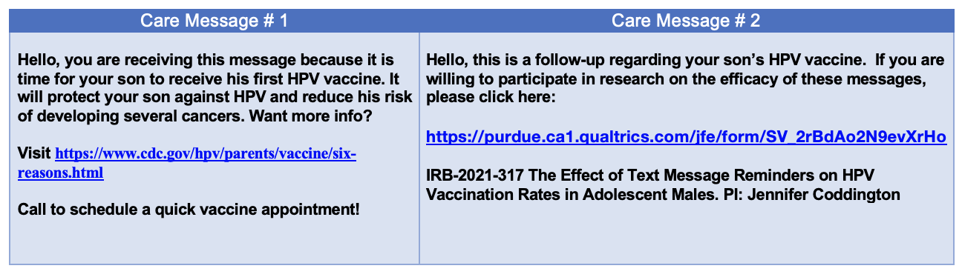

Figure 2
Survey Algorithm

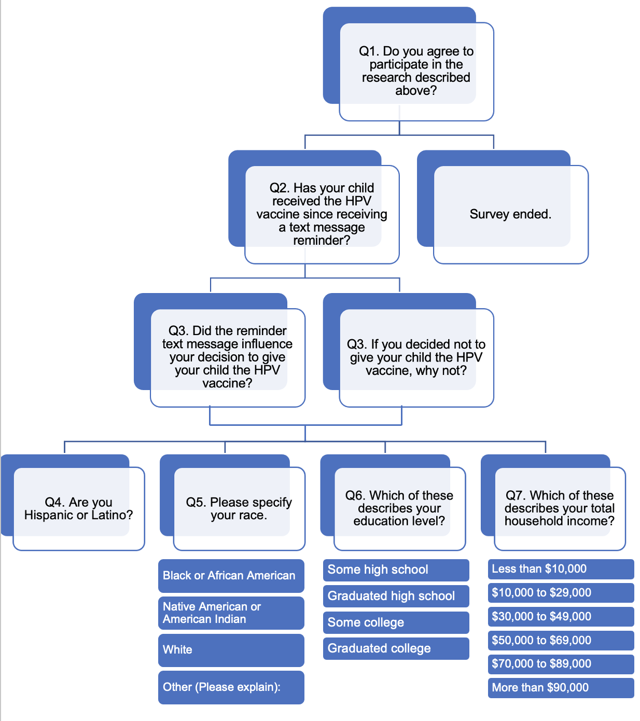

No
Yes

No
Yes

Table 1
Care Message Data
 | Total | Opted Out | Incomplete | Duplicates
Care Message # 1 | 975 | 5 | 240 | 77
Care Message # 2 | 970 | 6 | 213 | 102

Table 2
Adolescents Enrolled in Care, Appointments, and Vaccinations
 | Adolescent Males, 11-18 years, enrolled in care | With An Appt  (of Total Population) | Received an Immunization  (any kind) |  |  | Received an HPV Vaccine
May 31- July 2, 2021 | 517 | 59 | 34 |  |  | 4
May 31- July 2, 2020 | 340 | 10 | 2 |  |  | 1
May 31- July 2, 2019 | 236 | 9 | 6 |  |  | 0

Table 3
HPV Vaccinations
 | HPV Dose #1 | HPV Dose #2 | HPV Dose #3
May 31- July 2, 2021 | 0 | 3 | 1
May 31- July 2, 2020 | 0 | 1 | 0
May 31- July 2, 2019 | 0 | 0 | 0

Table 4
Survey Responses
Survey Question | Number of Responses
Do you agree to participate? | 2
Has your child received the HPV vaccine since receiving a text message reminder? | 1
Did the reminder text message influence your decision to give your child the HPV vaccine? | 0
If you decided not to give your child the HPV vaccine, why not? | 0
Are you Hispanic or Latino? | 0
Please specify your race. | 1
Which of these describes your education level? | 1
Which of these describes your total household income? | 1

