Executive Summary: Introduction of a Conversation Starter Tool to Improve Health Habits in Young Children

Rachel Knafel, MSN, RN, FNP-BC
Purdue University

Executive Summary: Introduction of a Conversation Starter Tool to Improve Health Habits in Young Children
Obesity rates in adults and children in the United States (US) continue to climb (Center for Disease Control and Prevention [CDC], 2021a; CDC, 2021c). Overweight in children is defined as a body mass index (BMI) at or above the 85th percentile, while BMI at or above the 95th percentile is considered obese (CDC, 2018). Currently, one in three children in the US is considered overweight or obese (American Academy of Pediatrics [AAP], 2020b). Children with obesity are more likely to suffer from hypertension, hyperlipidemia, insulin resistance, type 2 diabetes, asthma, sleep apnea, joint pain, fatty liver disease, cholelithiasis, gastro-esophageal reflux, orthopedic problems, and psychiatric disorders (Barlow, 2007; CDC, 2021b). Implementing individual and familial measures during early childhood development is essential, as treatment of obesity tends to become more difficult as the patient matures (Gortmaker et al., 2015; Wang et al., 2012). Unfortunately, many parents underestimate their child’s weight status, which may affect a parent’s motivation regarding changes that can be made in the home (Baughcum et al., 2000; Hackie & Bowles, 2007; Hernandez et al., 2017; Hidalgo-Mendez et al., 2019; Lydecker & Grilo, 2016; Mejia De Grubb et al., 2017; Pasch et al., 2016).

Problem Statement and Significance
A review of relevant literature reveals a significant public health issue, recommendations for treatment, and gaps in identifying effective, generalizable implementation strategies at the primary care level. The AAP has described the role of providers in the prevention and treatment of childhood obesity, citing the importance of becoming familiar with behavior modification techniques and general promotion of parenting interventions (Daniels & Hassink, 2015). For this study, a conversation starter tool was designed to assist providers in identifying health habits needed for improvement, educating parents on rationales for improvement, and assisting parents in setting a specific goal to implement a health habit needed for improvement. The purpose of this study was to determine whether the introduction of the conversation starter tool improved health habits in four-to eight-year-old children over four-to-six weeks. A secondary aim of this study was to determine whether the accuracy of parental perception of children’s weight status improved when providers were made aware of the parent’s perception before the visit.

Methodology
A pre-test, post-test quasi-experimental study was conducted between May and August 2021 to evaluate the effectiveness of a provider-initiated conversation starter tool in improving health habit adherence in four-to eight-year-old children. The tool included a questionnaire and an educational handout, called “Healthy Habits for Kids.” The questionnaire, available in English and Spanish, was utilized to gather demographic information, parental perception of children’s weight status, and current health habit adherence (Figure 1). The handout, also available in English and Spanish, was developed to address the health habits identified in the questionnaire (Figure 2). Because not all parents are concerned about their child’s weight status, the handout was created to identify a myriad of health benefits that may be motivating to parents. These health benefits include improved school performance, health, behavior, memory, mental health, focus, self-esteem, and flexibility, as well as a decreased risk of heart disease, obesity, diabetes, stress, behavior issues, anger, and school problems (AAP, 2013; AAP, 2020a; AAP, 2020c; AAP, 2020d; Hassink, 2014; Lobelo et al., 2020; “Media Use in School-Aged Children and Adolescents,” 2016; Rethy, 2020).
Participants included in the study were parents of four-to eight-year-old children who presented to the clinic for a well-child exam. Patients were assigned to control or intervention based on which pediatrician they saw. The control group contained 45 participants, and the intervention group contained 46 participants. The control arm received the questionnaire and standard care. Standard care included distributing a “95210” handout, which encouraged nine hours of sleep per night, five servings of fruits and vegetables, two hours or less of screen time, one hour or more of physical activity, and zero sugar-sweetened beverages. The intervention arm received standard care plus the provider-initiated conversation starter tool. Pediatricians were given a brief training on the rationale for the study and how to use the conversation starter tool. Using the conversation starter tool, pediatricians reviewed questionnaire items assessing the parental perception of children’s weight status and health habit adherence, identified where health habit adherence may be lacking, and targeted a brief overview of health habits via the “Healthy Habits for Kids” handout. After reviewing the handout, pediatricians asked the parent which goal they would like to work on. The goal was marked on the handout for the parent to take home. The pediatrician marked the chosen goal on the questionnaire and returned it to the investigator. If the child was reported to be adhering to all of the health habits, parents were given the handout to reinforce current behavior, but no specific goal was selected.
The investigator gave the second questionnaire to all participants via telephone four-to-six weeks later to re-assess perception of children’s weight status and adherence to the same key health habits from the first questionnaire. Success was measured by parent report of adherence to the agreed-upon health habit goal.

Results
There was a 13% attrition rate for each group, for a total of 79 participants. Demographics are described in Table 1. Health habits needed for improvement were totaled for all participants. In all, there were 96 unhealthy habits needed for improvement among the 79 participants. There were 46 unhealthy habits in the control group, and 50 unhealthy habits in the intervention group. Nine participants in the intervention group identified that they were already adhering to all of the health habits, so no goal was selected, meaning that 31 participants had 50 unhealthy habits needed for improvement. The intervention group was further separated into two categories: intervention and intervention chosen goal. The intervention chosen goal category included the 31 health habits selected as a goal among the 31 remaining participants in the intervention group who were not adhering to all of the health habits. The intervention group category consisted of all health habits needed for improvement but were not selected by the parent as the primary goal for improvement (n=19).
Crosstabulation was completed on all health habits and is shown in Table 2. The control group habits demonstrated a 30.4% improvement in overall health habits. The intervention group showed a 15.8% improvement in health habits. The intervention chosen goal group demonstrated a 41.9% improvement in health habits.
Due to the small sample size, a Fisher’s exact test was used to determine the association between group (control versus goal group) and adherence (non-adhering at baseline to non-adhering at follow-up and non-adhering at baseline to adhering at follow-up) for screen time, sugar-sweetened beverages, and fruit and vegetable intake. Physical activity and sleep were not independently evaluated as no parent chose those goals. The results are demonstrated in Table 4. Study personnel was unable to reject the null hypothesis that there is no association between the assigned group and adherence of health habit at the .05 significance level. The Fisher’s exact values for sugar-sweetened beverages, fruits and vegetables, and screen time were p = .607, p = .102, and p = .459, respectively.
Perception of children’s weight status was assessed pre-and-post survey to determine if the intervention affected the parental perception of children’s weight status. No parent in either group changed their perception of their child’s weight status at the follow-up survey. For this reason, the results were analyzed together (Table 5). Only one parent overestimated their child’s weight, while 24 parents underestimated their child’s weight. There were 27 children identified as “overweight.” Only five parents (18.5%) correctly identified their child as “overweight,” while 22 parents (81.5%) underestimated their child’s weight status as “healthy weight.”

Discussion
The Expert Committee on the treatment of childhood and adolescent obesity advises providers to complete behavior assessments and work with parents on identifying reasonable goals that families can work on (Barlow, 2007). This study evaluated the use of a newly created conversation starter tool to improve health habits in young children. A handout on health habits identifying benefits to children’s health was created following recommendations from the expert committee (Barlow, 2007). The pediatricians worked with parents to select a goal to work on. Overall, 42% of the selected goals were met, according to the parent report at the follow-up survey. Our study demonstrated that children’s health habits could improve with the use of a conversation starter tool.
Pediatricians seeing children in the intervention group were made aware of the parent’s perception of their child’s weight status before entering the room, but this did not affect the parent’s perception at follow-up. Some parents mentioned that the pediatrician said their child was overweight, but they still identified their child as “healthy weight.” In all, we found that 81.5% of parents of overweight children underestimated their child’s weight status as “healthy weight,” and this did not change at follow-up despite the pediatrician knowing the parent perception before starting their education. These findings support Pasch et al. (2016), who identified that many parents misperceive and prefer a heavier body size, and working too hard to correct the misperception may affect overall rapport with the parent. The authors recommended that pediatricians focus on overall health habit improvements (Pasch et al., 2016). These are important for all children, as normal and underweight children should adopt these habits for obesity prevention and other overall health benefits previously described. While this study addressed weight status, it also moved beyond that to identify health benefits apart from weight to motivate parents who may not perceive their child’s weight status as a motivator for improved habits.

Limitations
As with all studies, several limitations were identified. First, providers have different styles and communication methods, which can alter the outcomes of educational tools. Additionally, this study used a convenience sample of pediatricians at a local pediatric clinic. There were no nurse practitioners or family physicians included in this study. The survey method created additional limitations. The control group completed a questionnaire on health habits. This is not typical standard care. This could have affected the overall results and inflated the improvement demonstrated in the control group to make the difference between the control and intervention groups smaller. Parents in the control group were told that their answers on the questionnaire would remain anonymous, while parents in the intervention group were told that the pediatrician would see the results. This could have created social desirability bias in the intervention group which may have lowered the effect of the intervention, as demonstrated in the analysis. Finally, while there were 79 participants included in the study, the analysis would have been more robust if there had been a larger number of participants in the intervention group.

Implications

Systems
This study took place in a pediatric primary care office that performs many well-child examinations yearly. This study differs from other studies in that it included children of all weight statuses, rather than focusing on children who are already overweight or obese. As previously mentioned, prevention is a key step in combatting the obesity epidemic. Making early lifestyle changes to prevent obesity has far-reaching implications for the future health of children. The National Institute for Children’s Health Quality (NICHQ) recommends a two-generation approach to initiatives to improve children’s health (Berns, n.d.). NICHQ advocates for interventions aimed at improving parental and child health, as children are greatly impacted by their parents (Berns, n.d.).
When families improve health habits together, children and parents may realize health benefits (Fruh et al., 2021). Nurse practitioners (NPs) working in the primary care setting are well-positioned to work with families on improving these health habits (Fruh, et al., 2021). While this intervention focused on improving children’s health, further study should be done to take a family systems approach to improve health habits. Healthcare systems that care for patients across the lifespan have the potential to create interventions at all levels of service in order to make maximum community change.
“Let’s Go” is an example of a successful obesity prevention initiative that partners with community centers, schools, and primary care offices to bring a joint message on improving health habits to children and families (Maine Health, n.d.). The goal of “Let’s Go” is to reduce obesity rates by improving health behaviors. The organization promotes policies to make health behaviors easier for families in the local community. These types of community initiatives are essential, as partnerships sharing similar messages will have a greater impact on improving health behaviors than messages delivered in silos.

Policy
Nurse practitioners have the education and training to impact policy by drawing attention to the childhood obesity epidemic and highlighting the importance of a multifactorial community-wide approach at affecting change within families. Beyond interventions at the primary care level, Daniels and Hassink (2015) advise providers to be involved in their communities, assessing the various needs and providing guidance on how to improve community-based initiatives aimed at preventing childhood overweight and obesity. Nurse practitioners should advocate for policies that improve nutrition and physical activity in children (Daniels & Hassink, 2015).
Improving health habits in the home is an important step in improving the long-term health of children, but many children spend much of their time outside of the home. Schools have a major influence on the nutrition and activity level in children, as children spend most of their days at school (Frieden et al., 2010). At least 55 million students attend school in the US, and 35-40% of their daily energy is consumed at school ("Snacks, Sweetened Beverages, Added Sugars, and Schools," 2015). Policies aimed at increasing physical activity and removing sugar-sweetened beverages at schools have been suggested (Frieden et al., 2010; "Snacks, Sweetened Beverages, Added Sugars, and Schools," 2015). Nurse practitioners should also ask families about their home environment to identify barriers and possible solutions ("The Built Environment: Designing Communities to Promote Physical Activity in Children," 2009). NPs can advocate for programs to support physical activity, such as after-school clubs, sports, and the availability of safe bicycle trails and playgrounds (Daniels & Hassink, 2015).
Policies aimed at restricting access to certain food products have strong opponents. The beverage industries have strongly opposed increased taxation of sugar-sweetened beverages (Frieden et al., 2010). Historically, there have been successful policy changes against strong opponents in the tobacco and alcohol industries, and some argue that similar policies in schools and communities aimed at decreasing access to sugar-sweetened beverages can make a positive impact on the obesity epidemic (Couch, 2011). These efforts, like previous efforts to decrease tobacco use rates, must start at the grassroots level to change social norms which spur policy change (Couch, 2011). Gorski and Roberto (2016) argue that without major policy interventions, the US will be unlikely to see improvement in diet patterns. They describe a variety of policy initiatives that can offer effective solutions, including mandates, restrictions, economic incentives, marketing limits, information provision, and environmental defaults (Gorski & Roberto, 2015).

Economics
Childhood obesity among youths aged 11 to 17 is estimated to cost the US around $9.85 billion annually (Biener et al., 2020). Without an interruption in these increasing rates, we can expect the overall health of the US to continue to decline while healthcare costs skyrocket. This represents a significant burden for the US health care system. Drastic measures are needed to halt this progression. Changes must be made at the individual, community, and societal levels. Relative to a normal weight child, childhood obesity costs between $16,310 and $19,350 per person in annual medical costs throughout the lifespan (Finkelstein et al., 2014). Prevention of childhood obesity could yield a major cost savings. This cost is an important consideration as policymakers grapple with financing initiatives aimed at preventing childhood obesity.
The cost of implementation of the conversation starter tool is nominal, as paper products are the only supplies needed. Each tool consists of one questionnaire and one educational handout. The materials cost may be offset by eliminating the standard handout that is currently being delivered to families.
Interventions aimed at the primary care setting should be timely, as time is an important cost consideration for most providers (Barlow, 2007). The conversation starter tool may save time in the exam room if parents complete the survey portion prior to the provider entering the room. Rather than taking the time to assess each health habit individually, the tool can assist providers in focusing the conversation on health habits needed for improvement and simply reinforcing the adherent ones using the “Healthy Habits for Kids” handout. Saving time has the potential to increase clinic revenue by allowing providers to see more patients.

Practice
This intervention is very feasible for use in the primary care setting. In 2007, practice recommendations for the prevention and treatment of childhood overweight and obesity were published (Barlow). Providers were urged to move beyond prescriptive language to motivational interviewing (Barlow, 2007). The recommendations cited the importance of assessing individual motivating factors for change and using these to help parents and children take steps toward improving health habits. Rather than focusing these conversations on children who are already overweight or obese, it is important to start when children are in their adiposity nadir and while parents have much more involvement in the children’s health habits (Barlow, 2007).
The American Academy of Pediatrics published updated recommendations in the prevention of obesity (Daniels & Hassink, 2015). The report cited multiple studies that have demonstrated improved health behaviors in children through primary care interventions (Daniels & Hassink, 2015). Utilizing the conversation starter tool would require a simple practice change requiring the clinic staff to hand out the six-item health habit questionnaire before the provider enters the room. This would allow the provider to quickly review the answers and target health habits needed for improvement. The tool should ultimately save the provider time in the exam room, as review of the health habits can be tailored to what the questionnaire identifies as most important to address.

Conclusion
The American Academy of Pediatrics has advocated for interventions to prevent obesity in children by improving health habits through primary care interventions (Daniels & Hassink, 2015). This study introduced a simple intervention to improve health habits in young children that is very feasible for use in the primary care setting. The conversation starter tool is an example of a primary care intervention that guides providers through various motivating factors for improved health habits to improve parent motivation for change. Furthermore, it can help parents make a specific health improvement goal for their child. Overall, using the intervention did demonstrate improvement in health habits in young children. Future research is needed to develop longitudinal studies of health habits and correlate with weight status in children.

References
American Academy of Pediatrics. (2013, October 10). Kids need fiber: Here's why and how. healthychildren.org. Retrieved September 20, 2021, from https://www.healthychildren.org/English/healthy-living/nutrition/Pages/Kids-Need-Fiber-Heres-Why-and-How.aspx
American Academy of Pediatrics. (2020a, August 5). Making physical activity a way of life: AAP policy explained. healthychildren.org. Retrieved September 20, 2021, from https://www.healthychildren.org/English/healthy-living/fitness/Pages/Making-Fitness-a-Way-of-Life.aspx
American Academy of Pediatrics. (2020b, August 20). Childhood Nutrition. www.healthychildren.org. Retrieved January 27, 2021, from https://www.healthychildren.org/English/healthy-living/nutrition/Pages/Childhood-Nutrition.aspx
American Academy of Pediatrics. (2020c, November 16). Healthy sleep habits: How many hours does your child need? healthychildren.org. Retrieved September 20, 2021, from https://www.healthychildren.org/English/healthy-living/sleep/Pages/healthy-sleep-habits-how-many-hours-does-your-child-need.aspx?_gl=1*50qzn6*_ga*MTk0MzYyMjA3NS4xNjExNzU4MDc5*_ga_FD9D3XZVQQ*MTYzMjE1MDA3OS4xMC4xLjE2MzIxNTAyMzMuMA..&_ga=2.136060209.1491847471.1632150080-1943622075.1611758079
American Academy of Pediatrics. (2020d, November 30). How to make a family media use plan. healthychildren.org. Retrieved September 20, 2021, from https://www.healthychildren.org/English/family-life/Media/Pages/How-to-Make-a-Family-Media-Use-Plan.aspx
Barlow, S. E. (2007, December 1). Expert committee recommendations regarding the prevention, assessment, and treatment of child and adolescent overweight and obesity: Summary report. Pediatrics, 120, S164–S192. https://doi.org/10.1542/peds.2007-2329C
Baughcum, A. E., Chamberlin, L. A., Deeks, C. M., Powers, S. W., & Whitaker, R. C. (2000, December 6). Maternal perceptions of overweight preschool children. Pediatrics, 106(6), 1380–1386. https://doi.org/10.1542/peds/106.6.1380
Berns, S. D. (n.d.). Taking a two-generation approach to children's health. Retrieved September 29, 2021, from https://www.nichq.org/insight/taking-two-generation-approach-childrens-health#video
Biener, A. I., Cawley, J., & Meyerhoefer, C. (2020). The medical care costs of obesity and severe obesity in youth: An instrumental variables approach. Health Economics, 29(5), 624–639. https://doi.org/10.1002/hec.4007
Center for Disease Control and Prevention. (2018, July 3). BMI for children and teens. www.cdc.gov. Retrieved March 11, 2021, from https://www.cdc.gov/obesity/childhood/defining.html
Center for Disease Control and Prevention. (2021a, February 21). Childhood obesity facts. Retrieved March 29, 2021, from https://www.cdc.gov/obesity/data/childhood.html
Center for Disease Control and Prevention. (2021b, March 19). Childhood obesity causes and consequences. Retrieved September 27, 2021, from https://www.cdc.gov/obesity/childhood/causes.html
Center for Disease Control and Prevention. (2021c, June 7). Adult obesity facts. Retrieved July 24, 2021, from https://www.cdc.gov/obesity/data/adult.html
Couch, K. A. (2011). Introduction: Health policy and sugar-sweetened beverages. Journal of Policy Analysis and Management, 30(3), 644–655. https://doi.org/10.1002/pam.20581
Daniels, S. R., & Hassink, S. G. (2015). The role of the pediatrician in primary prevention of obesity. PEDIATRICS, 136(1), e275–e292. https://doi.org/10.1542/peds.2015-1558
Finkelstein, E. A., Graham, W. K., & Malhotra, R. (2014). Lifetime direct medical costs of childhood obesity. PEDIATRICS, 133(5), 854–862. https://doi.org/10.1542/peds.2014-0063
Frieden, T. R., Dietz, W., & Collins, J. (2010). Reducing childhood obesity through policy change: Acting now to prevent obesity. Health Affairs, 29(3), 357–363. https://doi.org/10.1377/hlthaff.2010.0039
Fruh, S., Williams, S., Hayes, K., Hauff, C., Hudson, G. M., Sittig, S., Graves, R. J., Hall, H., & Barinas, J. (2021). A practical approach to obesity prevention. Journal of the American Association of Nurse Practitioners, Publish Ahead of Print. https://doi.org/10.1097/jxx.0000000000000556
Gorski, M. T., & Roberto, C. A. (2015). Public health policies to encourage healthy eating habits: Recent perspectives. Journal of Healthcare Leadership, 81. https://doi.org/10.2147/jhl.s69188
Gortmaker, S. L., Long, M. W., Resch, S. C., Ward, Z. J., Cradock, A. L., Barrett, J. L., Wright, D. R., Sonneville, K. R., Giles, C. M., Carter, R. C., Moodie, M. L., Sacks, G., Swinburn, B. A., Hsiao, A., Vine, S., Barendregt, J., Vos, T., & Wang, Y. (2015). Cost effectiveness of childhood obesity interventions. American Journal of Preventive Medicine, 49(1), 102–111. https://doi.org/10.1016/j.amepre.2015.03.032
Hackie, M., & Bowles, C. L. (2007, October 26). Maternal perception of their overweight children. Public Health Nursing, 24(6), 538–546. https://doi.org/10.1111/j.1525-1446.2007.00666.x
Hassink, S. (2014). Pediatric obesity: Prevention, intervention, and treatment strategies for primary care (Second ed.). American Academy of Pediatrics.
Hernandez, D. C., Reesor, L., & Kabiri, L. S. (2017, August 1). Maternal concerns and perceptions of elementary school-age children’s weight status. Journal for Specialists in Pediatric Nursing, 22(4), 1–9. https://doi.org/10.1111/jspn.12191
Hidalgo-Mendez, J., Power, T. G., Orlet Fisher, J., O’Connor, T. M., & Hughes, S. O. (2019, July 29). Child weight status and accuracy of perceived child weight status as predictors of Latina mothers’ feeding practices and styles. Appetite, 142, 1–7. https://doi.org/10.1016/j.appet.2019.104387
Lobelo, F., Muth, N. D., Hanson, S., & Nemeth, B. A. (2020). Physical activity assessment and counseling in pediatric clinical settings. Pediatrics, 145(3), e20193992. https://doi.org/10.1542/peds.2019-3992
Lydecker, J. A., & Grilo, C. M. (2016, February 24). The apple of their eye: attitudinal and behavioral correlates of parents’ perceptions of child obesity. Pediatric Obesity, 24(5), 1124–1131. https://doi.org/10.1002/oby.21439
Maine Health. (n.d.). Let's Go. Retrieved August 23, 2021, from https://www.mainehealth.org/Lets-Go
Media use in school-aged children and adolescents. (2016). Pediatrics, 138(5), e20162592. https://doi.org/10.1542/peds.2016-2592
Mejia De Grubb, M. C., Salemi, J. L., Kihlberg, C., Gonzalez, S., Zoorob, R., & Levine, R. (2017). Disparities in accuracy of maternal perceptions of obesity among Hispanic children, 28(3), 1208–1221. https://doi.org/10.1353/hpu.2017.0106
Pasch, L. A., Penilla, C., Tschann, J. M., Martinez, S. M., Deardorff, J., de Groat, C. L., Gregorich, S. E., Flores, E., Butte, N. F., & Greenspan, L. C. (2016, March 25). Preferred child body size and parental underestimation of child weight in Mexican-American families. Maternal and Child Health Journal, 20, 1842–1848. https://doi.org/10.1007/s10995-016-1987-z
Rethy, J. (2020, January 27). Choose water for healthy hydration. healthychildren.org. Retrieved September 20, 2021, from https://www.healthychildren.org/English/healthy-living/nutrition/Pages/Choose-Water-for-Healthy-Hydration.aspx
Snacks, sweetened beverages, added sugars, and schools. (2015). PEDIATRICS, 135(3), 575–583. https://doi.org/10.1542/peds.2014-3902
The built environment: Designing communities to promote physical activity in children. (2009). PEDIATRICS, 123(6), 1591–1598. https://doi.org/10.1542/peds.2009-0750
Wang, Y., Orleans, C., & Gortmaker, S. L. (2012). Reaching the healthy people goals for reducing childhood obesity: Closing the energy gap. American Journal of Preventive Medicine, 42(5), 437–444. https://doi.org/10.1016/j.amepre.2012.01.018

Figure 1.

Health Habit Questionnaire

Figure 2.

“Healthy Habits for Kids” handout

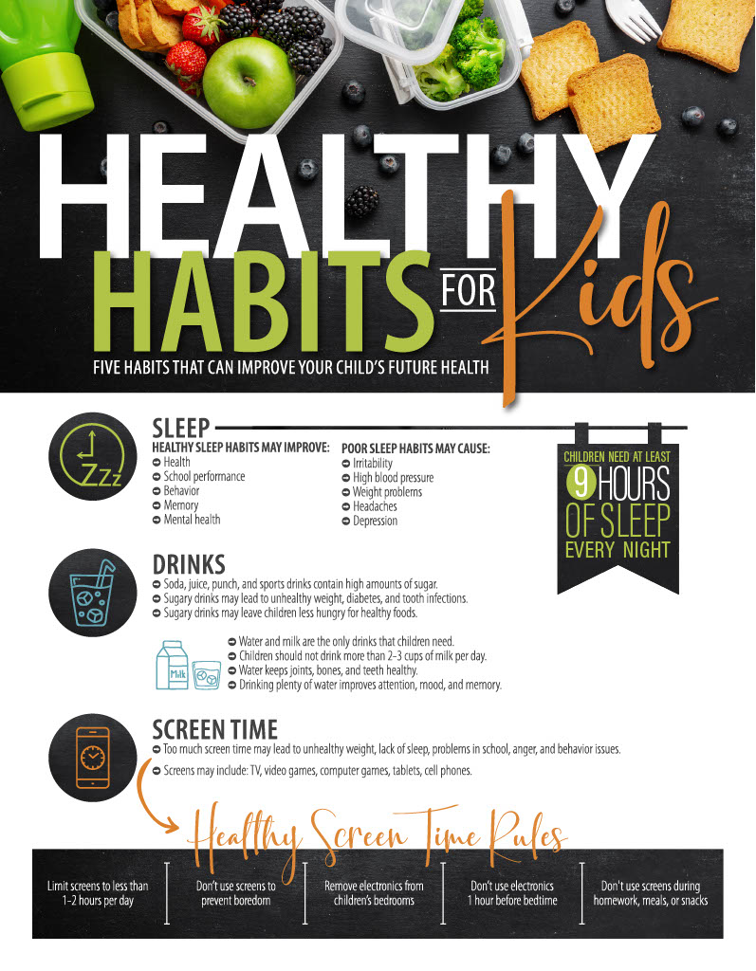
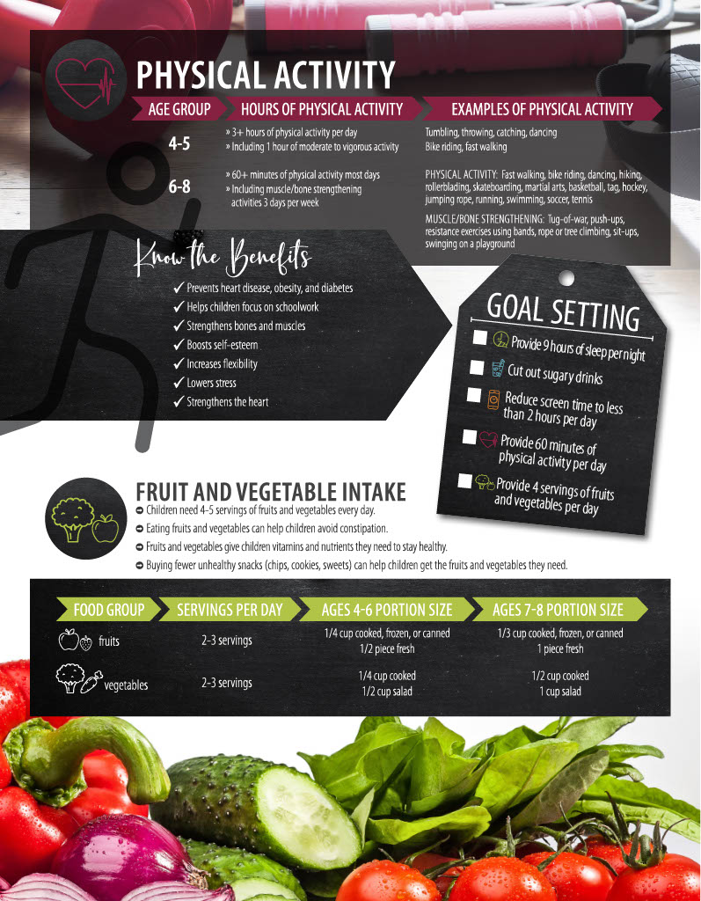

Table 1.

Demographics
 |  |  | Control |  | Intervention
 |  |  | n=39 |  | n=40
child age, y |  |  | 5.4 |  | 5.8
child gender, male |  |  | 43.6% |  | 50.0%
child race/ethnicity
 | non-Hispanic white |  | 74.4% |  | 92.5%
 | Hispanic |  | 15.4% |  | 2.5%
 | non-Hispanic black |  | 5.1% |  | 0.0%
 | other/prefer not to answer |  | 5.1% |  | 5.0%
Language preference
 | English |  | 94.9% |  | 100.0%
 | Spanish |  | 5.1% |  | 0.0%
Income
 | less than $35, 000 |  | 15.4% |  | 5.0%
 | $35,000-50,000 |  | 12.8% |  | 12.5%
 | $50,001-75,000 |  | 12.8% |  | 20.0%
 | $75,001-100,000 |  | 15.4% |  | 27.5%
 | more than $100,000 |  | 38.5% |  | 35.0%
 | prefer not to answer |  | 5.1% |  | 0.0%
Education
 | grades 1-11 |  | 5.1% |  | 0.0%
 | high school/GED |  | 20.5% |  | 12.5%
 | some college |  | 12.8% |  | 17.5%
 | trade/tech school |  | 2.6% |  | 2.5%
 | associate's degree |  | 7.7% |  | 7.5%
 | bachelor's degree |  | 38.5% |  | 42.5%
 | master's degree |  | 12.8% |  | 15.0%
 | doctorate degree |  | 0.0% |  | 2.5%

Table 2.

Comparing Health Habit Improvement with Group Assignment

Group | Outcome | 1→1 | 1→0 | Total
Control |  | 32 (70%) | 14 (30%) | 46
Intervention |  | 16 (84%) | 3 (16%) | 19
Goal |  | 18 (58%) | 13 (42%) | 31
 | Total | 66 | 30 | 96
Note:  1→1 | indicates nonadherence to health habit at baseline and follow-up
1→0 | indicates nonadherence to health habit at baseline and adherence at follow-up

Table 3.

Comparing Health Habit Adherence Outcomes to Participant Group
 |  | Sugar-Sweetened Beverages
Group | Outcome | 0→0 | 1→1 | 1→0 | 0→1 | Total
Control |  | 21 (54%) | 10 (26%) | 7 (18%) | 1 (3%) | 39
Intervention |  | 18 (56%) | 4 (13%) | 1 (3%) | 9 (28%) | 32
Goal |  | 0 (0%) | 5 (63%) | 3 (38%) | 0 (0%) | 8
 | Total | 39 | 19 | 11 | 10 | 79
 |  | Fruit and Vegetable Intake
Group | Outcome | 0→0 | 1→1 | 1→0 | 0→1 | Total
Control |  | 28 (72%) | 9 (23%) | 2 (5%) | 0 (0%) | 39
Intervention |  | 21 (68%) | 6 (19%) | 1 (3%) | 3 (10%) | 31
Goal |  | 0 (0%) | 4 (44%) | 5 (56%) | 0 (0%) | 9
 | Total | 49 | 19 | 8 | 3 | 79
 |  | Screen Time
Group | Outcome | 0→0 | 1→1 | 1→0 | 0→1 | Total
Control |  | 21 (54%) | 13 (33%) | 5 (13%) | 0 (0%) | 39
Intervention |  | 17 (65%) | 6 (23%) | 1 (4%) | 2 (8%) | 26
Goal |  | 0 (0%) | 9 (64%) | 5 (36%) | 0 (0%) | 14
 | Total | 38 | 28 | 11 | 2 | 79
 |  | Physical Activity
Group | Outcome | 0→0 | Total
Control |  | 39 (100%) | 39
Intervention |  | 40 (100%) | 40
Goal |  | 0 (0%) | 0
 | Total | 79 | 79
 |  | Sleep
Group | Outcome | 0→0 | 1→1 | 1→0 | 0→1 | Total
Control |  | 37 (95%) | 2 (5%) | 0 (0%) | 0 (0%) | 39
Intervention |  | 37 (93%) | 0 (0%) | 0 (0%) | 3 (8%) | 40
Goal |  | 0 (0%) | 0 (0%) | 0 (0%) | 0 (0%) | 0
 | Total | 74 | 2 | 0 | 3 | 79
Note:  0→0 | indicates adherence to health habit at baseline and follow-up
1→1 | indicates nonadherence to health habit at baseline and follow-up
1→0 | indicates nonadherence to health habit at baseline and adherence at follow-up
0→1 | indicates adherence to health habit at baseline and nonadherence at follow-up
Table 4.

Fisher’s Exact Test Determining Relationship Between the Control Group and the Goal Group

 |  | Sugar-Sweetened Beverages
Group | Outcome | 1→1 | 1→0 | Total
Control |  | 10 (59%) | 7 (41%) | 17
Goal |  | 5 (62.5%) | 3 (37.5%) | 8
 | Total | 15 | 10 | 25
 | Fisher's exact test: p = .607
 |  | Fruit and Vegetable Intake
Group | Outcome | 1→1 | 1→0 | Total
Control |  | 9 (82%) | 2 (18%) | 11
Goal |  | 4 (44%) | 5 (56%) | 9
 | Total | 13 | 7 | 20
 | Fisher's exact test: p = .102
 |  | Screen Time
Group | Outcome | 1→1 | 1→0 | Total
Control |  | 13 (72%) | 5 (28%) | 18
Goal |  | 9 (64%) | 5 (36%) | 14
 | Total | 22 | 10 | 32
 | Fisher's exact test: p = .459
Note:  1→1 | indicates nonadherence to health habit at baseline and follow-up
1→0 | indicates nonadherence to health habit at baseline and adherence at follow-up

Table 5.

Parental Perception of Children’s Weight Compared to Actual Weight
Actual Weight | Perceived weight | Underweight | Healthy Weight | Overweight | Total
Underweight |  | 3 (75%) | 1 (25%) | 0 (0%) | 4
Healthy weight |  | 2 (4.2%) | 46 (95.8%) | 0 (0%) | 48
Overweight |  | 0 (0%) | 22 (81.5%) | 5 (18.5%) | 27
 | Total | 5 | 69 | 5 | 79

