Doctor of Nursing Practice Inquiry Project

Executive Summary

Screening of Postpartum Depression and Stress among Mothers of Infants in a Pediatric Cardiovascular Intensive Care Unit: A Pilot Study

Alessi Miller

Julian Gallegos, PhD, MBA, FNP-BC, FAUNA

Deborah Spoerner, DNP, MSN, APRN, CPNP

Gabriela Centers, MD

Purdue University School of Nursing

Problem Statement and Significance
Postpartum depression (PPD) is defined as depression after having a baby (CDC, 2020). According to a meta-analysis by Shorey et al. (2018), the prevalence of PPD among mothers with no previous history of depression to infants without congenital anomalies is 12%. PPD screening is recommended by the American Academy of Pediatrics (AAP) at 1-, 2-, 4-, and 6-month well-child visits (Earls et al., 2019). Mothers of hospitalized, critically ill infants may never see these routine well-child visits. Therefore, this is a missed opportunity to screen and refer mothers for postpartum depression within the hospital.
It is estimated that 11 to 18 percent of childbearing women suffer from PPD symptoms (AAP, 2019). The incidence increases up to 40 percent for mothers of children in the neonatal intensive care unit (NICU) (Vaughn & Hooper, 2020). Currently, PPD screening within a NICU is not considered the standard of care (Mounts, 2009; Hollen, 2018). According to Hynan et al. (2013), routine screening should be done in the NICU due to the potential trauma of having an infant hospitalized in the NICU. PPD can have long-term consequences and affect the child, mother, and family’s health, finances, cognitive and social well-being (Earls et al., 2019). Recent research by the National Institutes of Health (2020) suggests that postpartum depression may persist up to 3 years after birth. The cost of maternal health care is 90% higher for those with PPD due to the use of mental health services and emergency room visits by both mother and child (Dagher et al., 2012). According to a meta-analysis by Slomian et al. (2017), PPD has negative consequences for the mother and the child until age three. Some of the negative effects include lack of mother-to-infant bonding, discontinuation of breastfeeding, increased infant health concerns, and decreased infant motor, language, social and emotional development (Slomian et al., 2017). Research also indicates that 42% of children of mothers with PPD during the early postpartum period were evaluated as depressed themselves by the age of 16 (Murray et al., 2011, as cited in Hynan et al., 2020).
Mothers of neonates admitted to a NICU are a population at increased risk for PPD and stress. Mothers of fetuses with confirmed anomalies for which they will be hospitalized after birth are at increased risk for postpartum distress (Cole et al., 2018). In a study done by Solberg et al., 2011 severe congenital heart defects were a predictor of heightened symptoms of PPD. Parental stress due to their child’s admission to an intensive care unit (ICU) is expected; however, assessment of parental psychological status during ICU admission is limited. Still, screening, support, and referral may help minimize the traumatic reactions of parents and the possible adverse effects of those outcomes on children (Hynan et al.,2013). According to Miles et al. (1993), a NICU environment may be a significant factor that contributes to parent’s distress and can potentially affect parenting behaviors. This project aimed to develop a PPD screening program within the cardiovascular intensive care unit (CVICU). The main objectives of this project were to assess the utility, feasibility, and effectiveness of a PPD screening program in a busy CVICU.
Methodology
Design
This study was a pilot project to establish the utility and feasibility of a PPD screening program for mothers whose infants are admitted to a cardiac intensive care unit for a prolonged (>1 week) hospital stay. This cross-sectional observational research study used survey methodology combined with descriptive data.
The following variables were collected for each participant:
Age, race, socioeconomic status, previous history of depression, the first eligible screening date for Edinburg Postnatal Depression Scale (EPDS) and Parental Stressor Scale: Neonatal Intensive Care Unit (PSS: NICU), PSS: NICU scores, whether or not a recommendation for an obstetrician and gynecologist (OBGYN) was indicated, recommendation information given based on EPDS score PPD screening score, whether or not participant acted on the recommendation information provided by the research team (documentation of appointment made). In addition, if participants failed to obtain an appointment as indicated, barriers to scheduling this appointment were assessed. Furthermore, the following infant-related variables were collected: severity of the cardiac diagnosis and need for ECMO during current hospitalization.
Setting and Population
Following institutional board review (IRB) approval from Purdue University and Indiana University, this study was conducted in a cardiovascular intensive care unit at a large pediatric academic medical center between April and September 2021. This pediatric cardiovascular unit manages patients with congenital and acquired heart disease and treats more than 540 inpatients and 250 cardiopulmonary bypass patients yearly. The heart center is made up entirely of private rooms; it has 36+ beds, with 18 being CVICU rooms. Inclusion criteria for the sample included English speaking mothers age 18 or older who gave birth to a child in the last 12 months and who had cardiac surgery in the last one to five days. Exclusion criteria for the sample include mothers under the age of 18, mothers who do not speak English and whose child is older than 12 months, and those who have not had cardiac surgery in the last one to five days.
Tools
This study utilized the Edinburg Postnatal Depression Scale (EPDS) and the Parental Stressor Scale: Neonatal Intensive Care Unit (PSS: NICU). The EPDS is a ten-item self-report questionnaire encompassing both antenatal PPD and anxiety (Cox et al., 1987) (see Appendix C). The EPDS measures emotional and cognitive symptoms of PPD and is the most widely used screening tool for PPD (Boyd et al., 2005). The internal consistency of the EPDS was 0.83 using Cronbach’s alpha coefficient, the EPDS sensitivity was 92%, and the specificity was 73% (Bunevicius et al., 2009). According to Cox et al. (1987), a score greater than nine or ten on the EPDS is an appropriate scale for routine use by health care workers and therefore indicates a high risk for PPD. The EDPS is not diagnostic of PPD but identifies risk based on the score.
The Parental Stressor Scale: NICU was created to measure the stress experienced by parents during their child’s treatment in the intensive care unit (see Appendix D). The PSS: NICU is a 46-item self-report questionnaire used to measure parents’ perceptions of stress within the NICU (Miles et al., 1989). The internal consistency of the PSS: NICU was .94 and .89, respectively (Dudek-Shriber, 2004). According to Miles et al. (1989), there are multiple ways to score the PSS: NICU. All are important for identifying stress in the NICU; they also recommended using the PSS: NICU to provide guidelines for improving nursing practice.
Study Procedure
The research team surveyed 28 mothers of infants for PPD using the EPDS. The research team consisted of Alessi Miller and Amy DeHeer. Additionally, this study investigated mothers of infants within the CVICU for stress using the PSS: NICU. The PSS: NICU and EPDS were distributed between days one to five to mothers of infants one day to one year in age. A release of information and a demographic sheet was required to be filled out and returned with the questionnaires. In addition, all participants were given a PPD education sheet and a PPD resource brochure. Grading of the EPDS and PSS: NICU was done within 24 hours by the research team.
The grading for the EPDS used the EPDS step one and step two flowsheet (Appendix E & F). Those who scored greater than ten on the EPDS were informed of the significance of the results and recommended to make an appointment with their OBGYN. An in-house referral to social work was made if there were specific needs to be addressed. In addition, those who scored greater than 19 on the EPDS were instructed to call the provided crisis line, and social work was consulted. A member of the research team made referrals to the social workers. Follow-up was done within one to two weeks, either directly if their infant was still admitted to the hospital or via phone if discharged, to see if an OBGYN or mental health provider appointment was obtained or if the mother attend a support group. If the participant failed to obtain an appointment, barriers to scheduling this appointment were assessed. Question ten on the EPDS looked at suicidal ideation and was reviewed individually using the EPDS Step two flowsheet. For those mothers who scored ten or greater on the EPDS and were discharged before referral could be arranged, reasonable attempts were made by the research team to contact the mother by phone, and appropriate information/ referral resources were given.
Results
Participant Characteristics
28 mothers were screened out of 87 eligible mothers, with 44 mothers approached and 16 refusing screening. Analysis of demographic data using descriptive statistics revealed that 96% of participants were white, 4% were African American, 37% had greater than one child, and 44% were on Medicaid. Participants ranged from 27 to 36 years old, with a mean age of 31. The age at time of surgery ranged from 15 days to 219 days, with a mean of 137 days. About 32% of participants’ child’s surgery was performed at less than 31 days of age—participants whose child has single ventricle anatomy made up 38% of participants (Table 1A).
Analysis
Statistical analyses were carried out using SAS 9.4 edition. All analyses were conducted using a 5% type I error rate. Mean +/- SD and percentages were used to describe the sample and data where appropriate.
Internal Consistency
Using Cronbach’s alpha, the internal consistency reliability of the PSS: NICU in our study was found to be good to excellent. Internal consistency was 0.72 for sights and sounds, 0.94 for infant appearance, 0.89 for parental role, and 0.93 for staff communication. This is compared to the internal consistency done by Miles et al. (1993), which is 0.73 for sights and sounds, 0.83 for infant appearance, 0.83 for parental role. The staff communication subscale was not validated in Miles et al. (1993) due to two-thirds of parents not experiencing the items.
Means
Participants were screened for both PPD using the EPDS and stress using the PSS: NICU. Out of the 28 mothers screened, one did not complete the PSS: NICU (N=27). The PSS: NICU has four subscales and an overall stress of hospitalization scale. The score range is 0 to 5 using Miles et al., 1993 metric two scoring. The means and standard deviations were attained for each subscale of the PSS: NICU comparing positive vs. negative screens (Table 2A). There was ultimately no statistical significance of the scores on the PSS between those with positive and negative EPDS screens.
Correlation
Spearman correlation was used to assess the strength and direction of EPDS screening related to the PSS: NICU. There is a moderate positive correlation between the numeric EPDS and numeric PSS: NICU ($r_{s}$=0.49, p= 0.008, 95% CI 0.14-0.74).
The Fisher’s z transformation was used to look at correlations between the EPDS and PSS: NICU subscales. Subscale sights and sounds was fairly correlated to the EPDS (r= 0.443, 95% CI 0.075- 0.704, p=0.017). The infant appearance subscale was also fairly correlated to the EPDS (r=0.556, 95% CI 0.223-0.773, p=0.002). The third subscale of parental role was similarly correlated to the EPDS (r=0.500, 95% CI 0.149-0.740, p=0.006). The final subscale is staff communication, and it was not correlated with the EPDS (r=0.157, 95% CI -0.0237-0.507, P0.427) (Table 1B).
Using exact logistic regression, there was a positive association between PPD and PSS (OR 1.54, 95% CI 0.6-4.3, p=0.4) however, note that this is still not statistically significant (Table 2B). When controlling for other variables (low SES, non-married, history of depression, and high school education level), it was found to increase the positive correlation between PPD and PSS (OR 1.90, CI 32- 520%, p=0.237). Meaning for each one-point increase in the PSS: NICU, the odds of having a positive PPD screen increase by 90%.
Using a two-tailed t-test, the average PSS score is lower in PPD negative mothers compared to PPD positive mothers; however, the results were not statistically significant (p=0.4). While not statistically significant, this shows that those with positive PPD screens tend to have higher stress screens.
Overall, this pilot study found that 39% of mothers screened were at risk for PPD (95% CI 21-57%). With 33% of mothers successfully following up with an OBGYN or mental health provider (95% CI 2-63%).
Limitations
While implementing this pilot study, a few limitations were discovered. Only one researcher was used to keep track of eligible mothers each week, screen, and follow up. This is a limitation due to limited resources and time constraints. Some mothers were at the bedside, but the screener could not approach them due to time constraints. Ultimately, the design of this study would need to be modified to implement a PPD screening program effectively. Suggested modifications would include doing education with bedside nursing to implement screening, scoring, and PPD education. Having the bedside nurse implement screening and giving mothers their score and PPD education/resources would be more feasible with less likelihood of missing mothers. Due to nurses commonly being the first to contact postpartum mothers, PPD screening by nurses and supportive counseling can be helpful (Bina et al., 2018). A study by Segre et al. (2010) found women across a broad economic spectrum would accept nurse-delivered care for postpartum symptoms and revealed nurses were who they preferred to turn to when experiencing depression during the postpartum period.
The second limitation is the use of the PSS: NICU within a pediatric CVICU. While this tool works, as shown by the internal consistency in this study, it was not created for a CVICU but specifically a NICU. Certain questions were more specific to NICU rather than a pediatric CVICU. There also could be stressful questions specific to a pediatric CVICU that were missed. While the mean score of the PSS is 2.23, the mean score on the question of overall stress of hospitalization is 3.44. This indicates those mothers were more stressed than the PSS questions indicated. There is currently no Parental Stress Scale designed for a pediatric CVICU. In future studies, this screening tool could be modified to fit this unique population.
Another barrier to screening was the limitation of screening within neonatal postoperative days one to five. This was determined as eligibility criteria to keep the amount of stress the mother was under consistent. However, this limited the time frame that screening was possible. For future studies mitigating the limitation such as neonatal postoperative days would be recommended to increase the likelihood of screening.
The final barrier is that of a successful referral. This study used PPD resources, including a brochure with PPD support groups and mental health providers; however, a successful referral was still low. Suggestions for increased referral include having a unit-based psychologist (Hynan et al., 2013). Having a unit-based psychologist would be a recommended modification to this study to increase successful referrals.
Discussion
This pilot project aimed to assess the feasibility, utility, and effectiveness of a PPD screening program within a CVICU. This study was six months in length, with 87 mothers being eligible for participation. Out of those 87 mothers, 44 were approached. In this study, only three mothers obtained screening and follow-up. The rate of PPD is increased in the NICU setting and ranges from 28% to 70% (Mounts, 2009). This study found that 39% of mothers screened were at increased risk for PPD; this matches closely with a similar pilot study done by Vaughn & Hooper (2020). A positive screen indicated a recommendation for the mother to follow up with her OBGYN or use the resources provided to contact a mental health provider or attend a support group. This study found that only 33% of mothers successfully obtained some type of follow-up. This is a well-documented barrier when implementing PPD screening programs. There are no clear guidelines to address follow-up and referral. However, these numbers fall within the documented data as successful for the rate of PPD and referral follow-up.
Despite low screening and referral numbers, universal screening is still recommended. The literature recommends screening for various reasons, including the ability to assess PPD during the early stages (Cherry et al., 2016). According to Chaudron et al. (2007), due to the limited data on PPD screening, more studies need to be done in diverse cultures, ethnic groups, socioeconomic groups, and diverse pediatric settings. These two reasons validate continuing a screening program within the CVICU with some modifications as mentioned above.
Implications
Systems
Those in the NICU make up a unique population that may have increased PPD due to increased environmental and medical risks. The rates of PPD in NICU are markedly increased compared to the general population at 39% within the first week (Hynan et al., 2013). The primary benefit of screening mothers within a NICU setting is earlier recognition rather than waiting for outpatient screening (Cherry et al., 2016). Earlier recognition and treatment can prevent suffering for the mother and potentially lower harmful long-term effects on the infant (Beck, 2003). While there has been significant research in PPD and PPD screening, there remains a lack of consensus regarding screening methods, screening tools, the timing of screening, and best referral practices. With a wide variety of methods for implementation, screening programs must be designed with common barriers in mind.
Policy
Perinatal depression is recognized as the most common obstetrics complication in the United States, with a long list of long-term consequences. Consequences include lower cognitive function in children, increased emergency room visits, delayed immunization rates, early discontinuation of breastfeeding, child abuse, and neglect (Dagher et al., 2012; Slomian et al., 2017; Earls et al., 2019). The AAP recommends screening for PPD at all well-child visits up to 6 months (Earls et al., 2019). The American College of Obstetrics and Gynecology recommends screening for PPD at least once during the perinatal period (ACOG, 2015). While universal screenings are recommended, there is a lack of guidelines for the implementation of screening programs. Our study demonstrated similar results to other studies done within NICU settings. While there are definite strides to be made in this area, the recommendation of universal screening holds fast. This is especially true in the NICU setting due to a greater chance for early detection and increased risk for PPD.
Economics
The consequences of untreated PPD range from economic to cognitive impairment. The financial cost ranges from the cost of treatment for mothers with PPD to increased healthcare costs for children of mothers with PPD. In a study by Wilkinson et al. (2016), it was found that screening for and treating PPD is a cost-effective intervention. Another study found that over two years, children of mothers with PPD have 12% higher healthcare costs than those of children whose mothers did not have PPD (Simas et al., 2020). The economic burden of untreated PPD is ultimately significantly higher than the cost of early screening and treatment.
Practice
While there is great recognition for the burden untreated PPD places on mothers and families, there is still a lack of guidelines for screening programs and treatment within NICU settings. The barriers to screening within a NICU setting are well documented and similar to outpatient barriers. Mounts (2009) breaks down barriers into three categories of patient-centered, staff-centered, and system-centered. Patient-centered includes social stigma, access to services, inability to disclose feelings, and lack of knowledge or myths about PPD. Staff-centered barriers include lack of time, worry of liability, unfamiliarity with screening tools, and lack of community resources for referrals. The final barrier is system-centered and is the lack of available and accessible mental health resources. According to Beck (2003), given the risk of PPD within a NICU setting, universal screening should be done with the added benefit of enhanced awareness, normalization of the process, and increased comfortability and competency for staff. Another goal of a screening program is to normalize emotional distress (Hynan et al., 2013). This study found barriers to the long-term implementation of a PPD screening program; despite those barriers, with some modifications, a PPD screening program is recommended due to the benefits listed above.

References

American Academy of Pediatrics. (2019). Clinical report: Incorporating recognition and management of perinatal and postpartum depression into pediatric practice. Pediatrics, 143(1). https://doi.org/10.1542/peds.2018-3259

American College of Obstetricians and Gynecologists (2018, Nov). Screening for perinatal depression. https://www.acog.org/-/media/project/acog/acogorg/clinical/files/committee-opinion/articles/2018/11/screening-for-perinatal-depression.pdf

Bina, R., Glasser, S., Honovich, M., Levinson, D., & Ferber, Y. (2019). Nurses perceived preparedness to screen, intervene, and refer women with suspected postpartum depression. Midwifery, 76, 132–141. https://doi.org/10.1016/j.midw.2019.05.009

Chaudron, L.H., Szilagyi, P.G., Campbell, A. T., Mounts, K.O., & McInerny, T.K. (2007). Legal and ethical considerations: risks and benefits of postpartum depression screening at well-child visits. Pediatrics, 119(1), 123–128. https://doi.org/10.1542/peds.2006-2122

Cherry, A.S., Blucker, R.T., Thornberry, T.S., Hetherington, C., McCaffree, M.A., & Gillaspy, S.R. (2016). Postpartum depression screening in the neonatal intensive care unit: program development, implementation, and lessons learned. Journal of Multidisciplinary Healthcare, 6(9), 59-67.
Center for Disease Control and Prevention. (2020, May 14). Depression among women. https://www.cdc.gov/reproductivehealth/depression/index.htm
Cole, J., Olkkola, M., Zarrin, H.E., Berger, K., & Moldenhauer, J.S. (2018). Universal postpartum mental health screening for parents of newborns with prenatally diagnosed birth defects. Journal of obstetric, gynecologic, and neonatal nursing, 47(1), 84–93.

Cox, J., Holden, J., & Sagovsky, R. (1987). Edinburg Postnatal Depression Scale (EPDS).
British Journal of Psychiatry, 150, 782-786.

Dagher, R., McGovern, P., Dowd, B. & Gjerdingen, D. (2012). Postpartum depression and health services expenditures among employed women. Journal of Occupational and Environmental Medicine, 54(2), 210-215. Doi: 10.1097/JOM.0b013e31823fdf85.
Earls, M. F., Yogman, M. W., Mattson, G., & Rafferty, J. (2019). Incorporating recognition and management of perinatal depression into pediatric practice. Pediatrics, 143(1), 1-9. https://doi.org/10.1542/peds.2018-3259
Hollen, R., Smith-Gagen, J., & Olguin, S. (2018). Case report of the incidence of maternal depression at the community level III, 39-bed NICU. Clinical Lactation, 9(3), 125-129.
Hynan, M.T., Mounts, K.O., & Vanderbilt, D.L. (2013). Screening parents of high-risk infants for emotional distress: rationale and recommendations. Journal of Perinatology, 33, 748-753.
Ip, S., Chung, M., Raman, G., Chew, M., Magula, N., DeVine, D., Trikalinos, T., & Lau, J. (2007). Breastfeeding and maternal and infant health outcomes in developed countries. Agency for Health Research and Quality, 130–131.
Miles, M., Funk, S. & Carlson, J. (1993). Parental stressor scale. Nursing Research, 42(3), 148-152.
Mounts, K.O. (2009). Screening for maternal depression in the neonatal ICU. Clinics in Perinatology, 36, 137-152.
National Institutes of Health. (2020, Oct 27). Postpartum depression may persist three years after giving birth. https://www.nih.gov/news-events/news-releases/postpartum-depression-may-persist-three-years-after-giving-birth
Riley Health Medical Specialties Annual Report. (2021, Dec). Critical care cardiac critical care. https://rileychildrens.s3.amazonaws.com/resources/34405_RileyMedicalOutcomes19_FNL_LO.pdf

SAS 9.4 Guide to Software Updates Copyright 2013, SAS Institute Inc., Cary, NC, USA. All rights reserved. Produced in the United States of America.

Segre, L., O'Hara, M., Arndt, S. & Beck, C. (2010). Screening and counseling for postpartum depression by nurses. The American Journal of Maternal/Child Nursing, 35(5), 280-285.

Shorey, S., Chee, C., Ng, E.D., Chan, Y.H., Tam, W., & Chong, Y.S. (2018). Prevalence and incidence of postpartum depression among healthy mothers: A systematic review and meta-analysis. Journal of psychiatric research, 104, 235–248. https://doi.org/10.1016/j.jpsychires.2018.08.001

Slomian, J., Honvo, G., Emonts, P., Reginster, J. Y., & Bruyère, O. (2019). Consequences of maternal postpartum depression: A systematic review of maternal and infant outcomes. Women's health (London, England), 15, 1-55. https://doi.org/10.1177/1745506519844044

Solberg, Ø., Dale, M. T., Holmstrøm, H., Eskedal, L. T., Landolt, M. A., & Vollrath, M. E. (2011). Emotional reactivity in infants with congenital heart defects and maternal symptoms of postnatal depression. Archives of women's mental health, 14(6), 487–492. https://doi.org/10.1007/s00737-011-0243-1
Vaughn, A. T., & Hooper, G. L. (2020). Postpartum depression screening program in the NICU. Neonatal Network, 39(2), 75–82.

Appendix A

Table 1A
Demographic Variables
Variables | Screened N=28 | Refused N=16 | P-Value
Infant Characteristics
Surg. In days | 137 (15,219) | 14 (7,54) | 0.04
Less than 31 days at surgery | 9 (32) | 10 (62) | 0.15
Single Ventricle Anatomy | 10 (38) | 1 (6) | 0.09
Mother Characteristics
Race:
White | 27 (96) | 15 (94) | 0.02
AA | 1 (4) | 1 (6) | 0.44
Hispanic | 0 (0) | 0 (0) | 0.12
Other | 0 (0) | 0 (0) | 1
Age | 31 (27, 36) | 30 (24, 33) | 0.5
>1 child | 21 (75) | 6 (37) | 0.03
Medicaid | 12 (46) | 7 (44) | 0.08

Table 2A
EPDS related to PSS
Variable | Positive Screen  N= 11 | Negative Screen  N= 16 | P Value
PSS Score | 2.4 (0.8) | 2.1 (0.8) | 0.4
Sights and Sounds Subscale | 2.2 (0.6) | 1.9 (0.8) | 0.2
Infant Appearance Subscale | 2.7 (1) | 2.2 (0.9) | 0.19
Parent Role Subscale | 3 (1) | 2.6 (0.9) | 0.3
Staff Communication Subscale | 1.1 (1, 2.2) | 1.1 (1, 1.9) | 0.7

Appendix B

Table 1B
Correlation between EPDS and PSS: NICU
Variable | Sample Correction | Fisher's z | Bias Adjustment | Correlation Estimate | 95%  Confidence  Limits | 95%  Confidence  Limits | P-Value for H0:Rho=0
Sights and Sounds Subscale | 0.44968 | 0.48430 | 0.00865 | 0.44275 | 0.075429 | 0.704271 | 0.0177
Infant Appearance Subscale | 0.56352 | 0.63797 | 0.01084 | 0.55608 | 0.223238 | 0.772788 | 0.0018
Parent Role Subscale | 0.50771 | 0.55964 | 0.00976 | 0.50043 | 0.148687 | 0.739760 | 0.0061
Staff Communication Subscale | 0.16068 | 0.16209 | 0.00309 | 0.15767 | -0.236516 | 0.507288 | 0.4272

Table 2B
Exact Odds Ratio
Parameter | Estimate | 95% Confidence Limits | 95% confidence Limits | P-Value
PSS Subscales | 1.902 | 0.684 | 6.249 | 0.2367
>High School | 1.099 | 0.116 | 15.793 | 1.000
Low SES | 3.732 | 0.102 | 343.442 | 0.7888
Non-Married | 7.232 | 0.243 | 891.171 | 0.4837
History of Depression | 1.578 | 0.238 | 13.890 | 0.9563

Appendix C
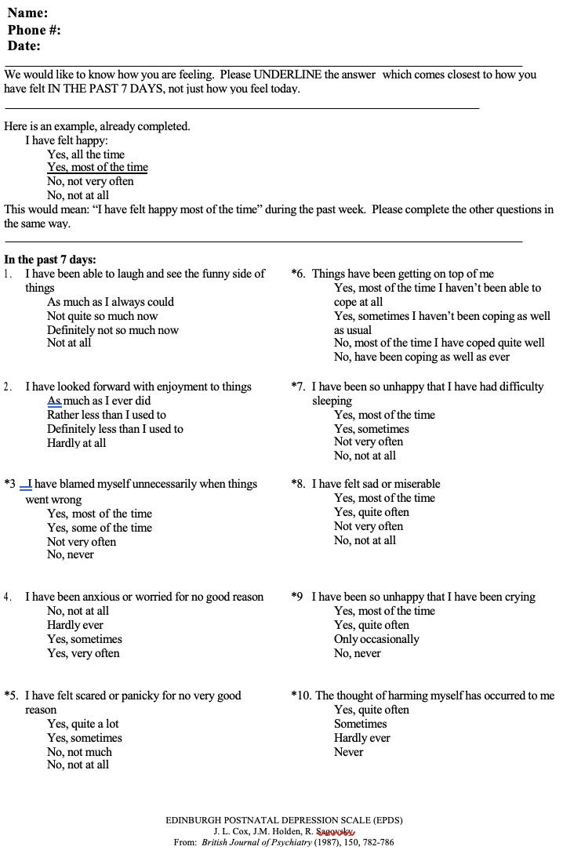

Appendix D
Parental Stressor Scale: NICU



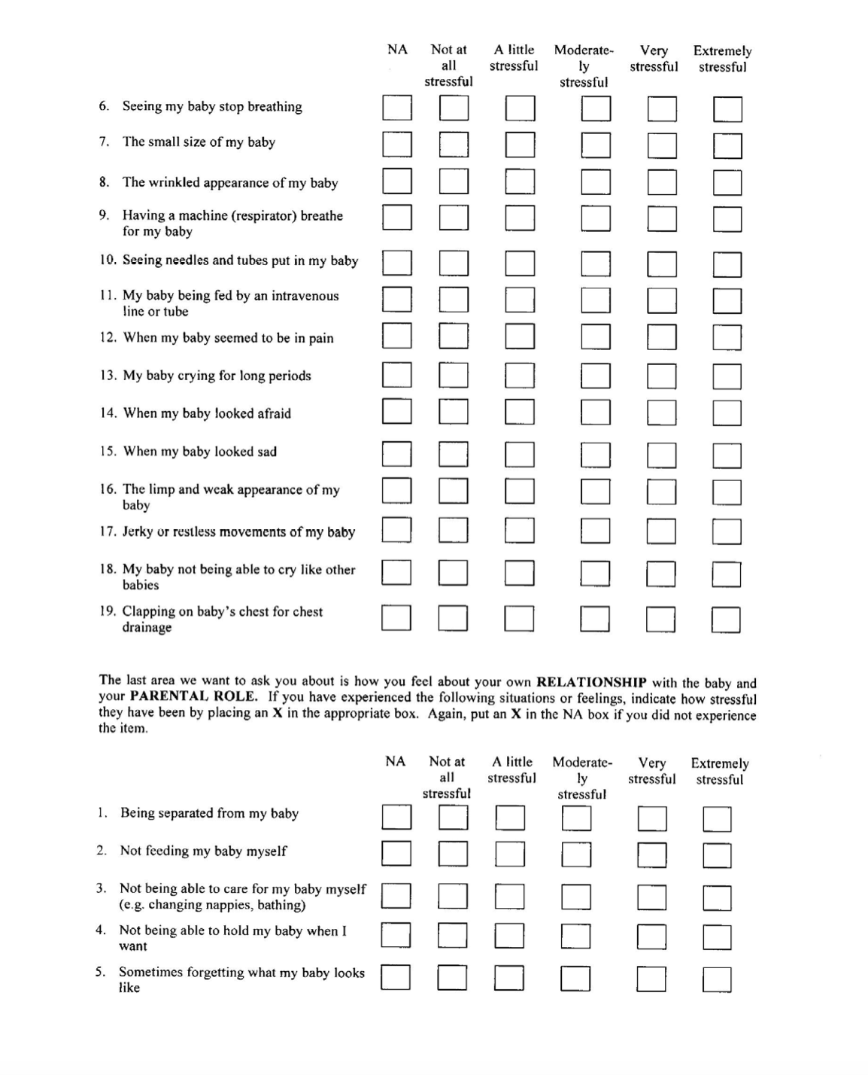

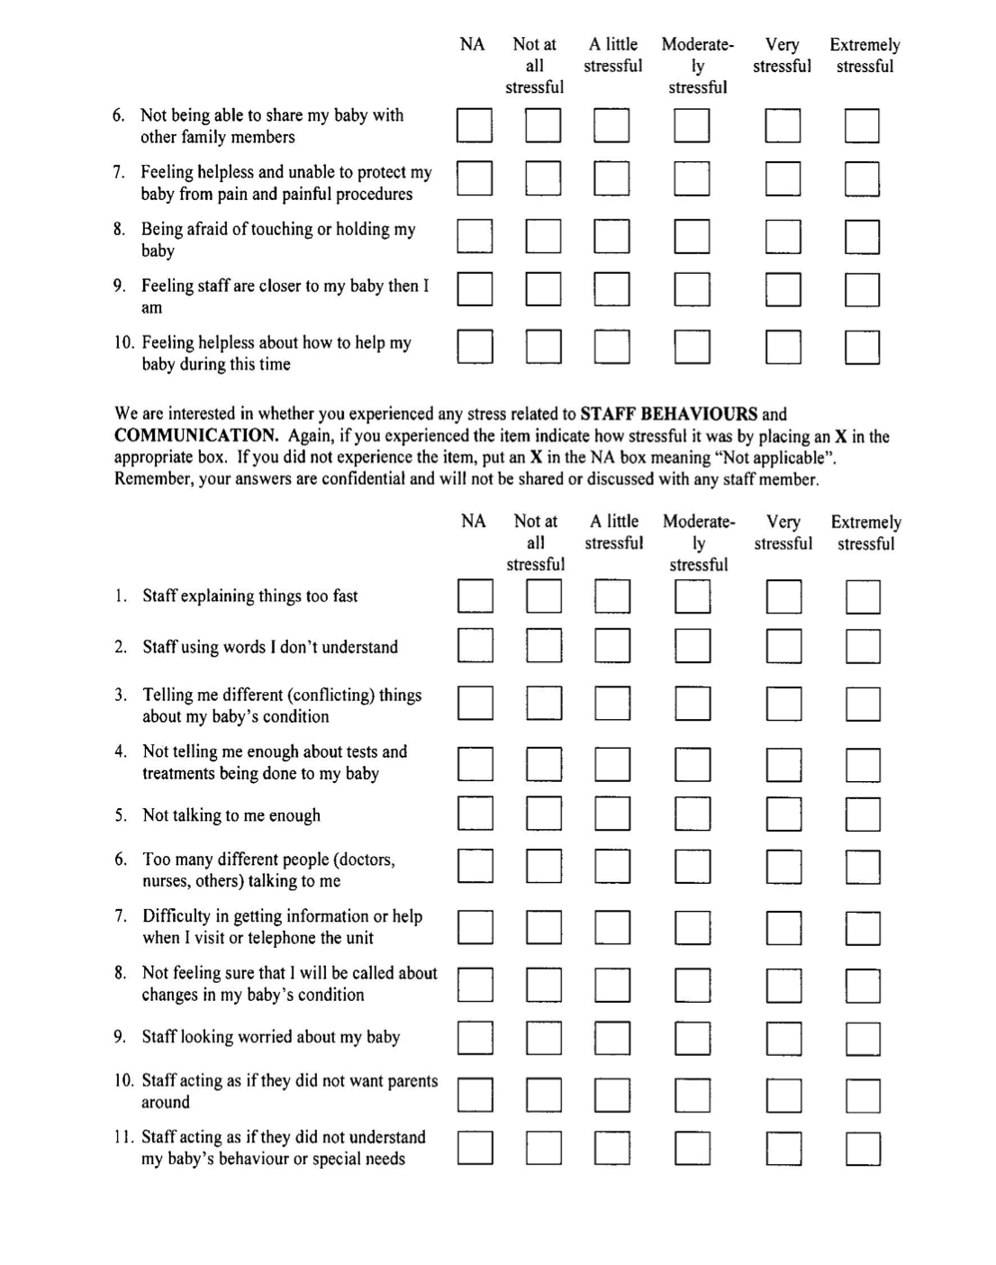



Appendix E
EPDS Step 1 Flowsheet

Appendix F
EPDS Step 2 Flowsheet

