Levers Experimental Investigation Data Sheet for Students 1.2

Student Name:

Levers Investigation (ICP.3.5, 3.7, POE-3, 6)
Investigation Purpose
In this experiment, we will examine how a lever can be used to convert a small input force into a larger output force. We will accomplish this by balancing a flat surface (lever) on a stationary fulcrum and add mass to either end of the lever. Using magnitude of mass and distance to fulcrum, we will derive a testable mathematical representation of equilibrium. If our equation for describing equilibrium holds true, then it will accurately describe the magnitude and placement of a secondary mass in order to balance the placement of an initial mass.
Key Concepts
- equilibrium – The condition of equal balance between opposing forces
- Force – any interaction that, when unopposed, will change the motion of an object
- Newton’s 1st Law of Motion – An object at rest stays at rest and an object in motion stays in motion with the same speed and in the same direction unless acted upon by an unbalanced force.
- Newton’s 2nd Law of Motion – the acceleration of an object is dependent upon two variables - the net force acting upon the object and the mass of the object ($F=ma$)
- Work – a measurement of the force required to cause an object to move ($W=F×d$)
Design it Yourself
Step 1 – Log onto Tinkercad.com and click Create new design. Rename your design Mechanical Equilibrium Model.
Step 2 – Design your fulcrum. Normally, a fulcrum is visualized as a triangle shape located below the lever. This is done to represent the point on which the lever will balance.
Fulcrum
Lever
Mass m₁
Mass m₂
l₁
l₂
One way to successfully do this would be to build a fulcrum that would allow a 12-inch ruler to balance on a triangular shaped object as illustrated above.
In the image below the triangular shaped fulcrum is incorporated into the lever and a platform was created upon which the fulcrum could balance.
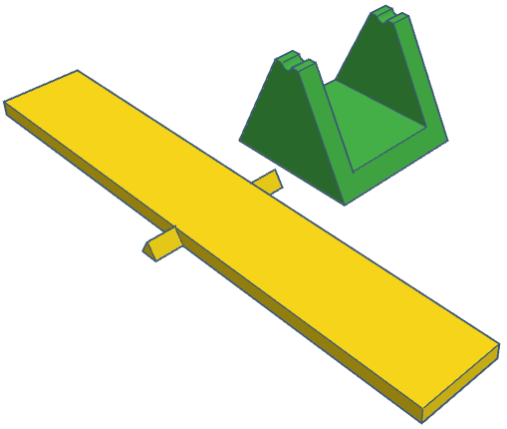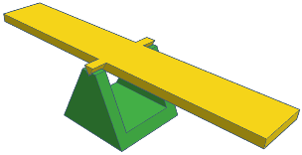
Fulcrum
Your fulcrum may be any shape or design, provided that the point at which the lever and fulcrum interact is as small as possible.
Step 3 – Once you have completed your model, make your model public and share the link with your instructor.
Step 4 – Once your instructor has approved your model, export an STL file of your model and submit this digital file to your instructor.
Build and Investigate
In order to investigate the use of levers for doing work, and determine the mathematical rule for equilibrium, you will need to 3D print your finalized fulcrum model. This can be done by opening your STL file in a slicing application software like Ultimaker Cura, and then sending this file to a 3D printer for printing.
The final assembly of the fulcrum illustrated above can be seen in the image below.
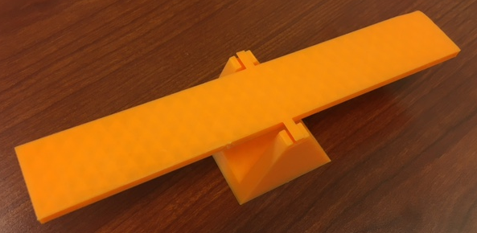
A list of the supplies needed to construct this apparatus are:
- Model .STL file – downloadable version of the model illustrated can be found at https://www.tinkercad.com/things/bKzOmRjJrWn
- 3D Printer with filament
Investigation resources include:
- Ruler or small tape measure
- Hex Nuts (5/16” – 18)
- Scale
Background Information
Some sort of force is required to make an object move, when a force causes the movement of an object it is said that work ($W$) was done upon the object. In order for a force to qualify as having done work on an object, there must be a displacement and the force must cause a displacement.
In its simplest form we can calculate the amount of work done by multiplying the force applied to an object by the distance in which the object moves.
$W=F×d$
where $F$ is the force, $d$ is the displacement
In the model illustrated above, the fulcrum will remain stationary while an input force causes the lever to rotate around the fulcrum. A second mass will be added to counter this movement and balance the lever.
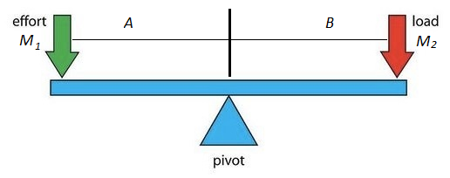
The key concept at work in the lever is that the work done on one side of the fulcrum will manifest as an equivalent amount of work on the other side of the fulcrum.
Investigation Objectives
The overall objective of this experiment is to learn how a simple lever can perform work on an object and to determine the mathematical rule for equilibrium. This is accomplished using the experimental test apparatus and manipulating the placement of objects of known mass on the balanced board, so that they are on either side if the fulcrum.
During this investigation you will use the design process to:
- Model and assemble a free-standing balance beam, for examining the equilibrium rule of a lever.
- Use your model to determine the relationship between the work input required on one side of a fulcrum and the work output on the other side of the fulcrum. Masses and distances can then be plotted on a graph to determine a relationship.
- Repeat the experiment by doubling the mass on only one side of the fulcrum.
- Repeat the experiment by moving the location of the fulcrum closer to one end of the lever and adding mass until the lever is balanced.
First Experiment
- Determine the mass of two individual hex nuts. Record their masses in your data table.
- Place one hex nut on the lever to the left of the fulcrum.
- Place the second hex nut on the right side of the fulcrum such that the lever is balanced.
- Measure the distance from the fulcrum to the hex nut on the left side of the fulcrum and the distance from the fulcrum to the hex nut on the right side of the fulcrum. Record these values in your data table.
- Repeat steps 1-4 two more times by moving the hex nut on the left to a new location and then rebalance the lever by changing the location of the hex nut on the right. Record the new locations of the hex nuts in your data table.
- Determine the mass of two hex nuts. Record their mass in your data table under $m_{1}$.
- Stack two of the three hex nuts on top of each other and place them on the left side of the lever.
- Relocate the hex nut on the right side of the lever so that the lever is balanced. This may require adjustments to stacked hex nuts as well.
- Measure the distance from the fulcrum to the stacked hex nuts and the distance from the fulcrum to the single hex nut. Record these values in your data table.
- Move either the single hex nut or the stacked hex nuts to a new location on their side of the balanced lever and then rebalance the lever. Record the new locations of the hex nuts in your data table.
NOTE: While this experimental protocol will provide you with initial data, you may need to collect data from additional trials to accurately determine relationships between masses and distances.

Data Table
Trial using 2 hex nuts | Mass m₁ | Distance l₁ | m₁ x l₁ | Mass m₂ | Distance l₂ | m₂ x l₂
1
2
3
Trial using 3 hex nuts
1
2
3
Data Analysis
- Use experimental data to create a graph comparing the mass distance relationship on the left side of the fulcrum with the mass distance relationship on the right side of the fulcrum.

- How does the mass times distance value on one side of the balanced beam compare to the mass times distance value on the other side of the balanced beam?

- How does the location of the mass on one side of the balanced beam compare to the location of the mass on the other side of the balanced beam?

- What is the mechanical equilibrium rule for a balanced beam?

Explorations
Now that you have completed your first experiment, you have all of the tools necessary to answer more questions concerning levers and equilibrium. Here are some questions that would be interesting to explore:
- What would happen if mass was added to only one side of the balanced lever? Would you still be able to balance the lever and if so, how would that be done? How would you need to modify your experimental setup? Would the amount of work on either side of the fulcrum change?
- Mechanical advantage is the ratio of output to input force magnitudes for any simple machine. Does the mechanical advantage change with the placement of masses on the balanced lever? Does the mechanical advantage change with the placement of the fulcrum?
- There are three types of levers. Research the three types of levers and design and experiment that will allow you to compare all three types of levers. Compare the work input and work output for each type of lever. Compare the mechanical advantage for each type of lever.
These are just a few of the what-if questions that you can ask. Use your imagination – there are many more questions. Any of these questions above (or the ones you have thought up) would be a good science fair project.
Homework Problems
- Draw a diagram of your testing apparatus. Identify all the forces acting on your test apparatus when the board is balanced.
- Write a 100-word summary of your investigation and what was learned.

