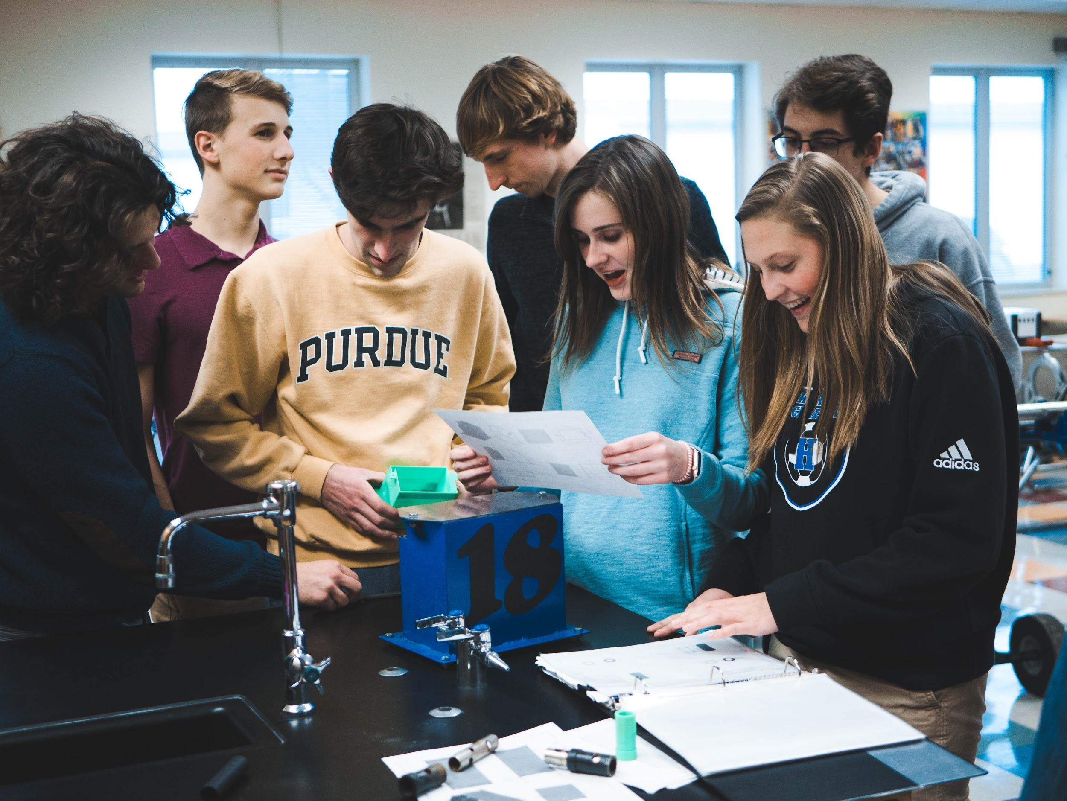
Application of the Design Process
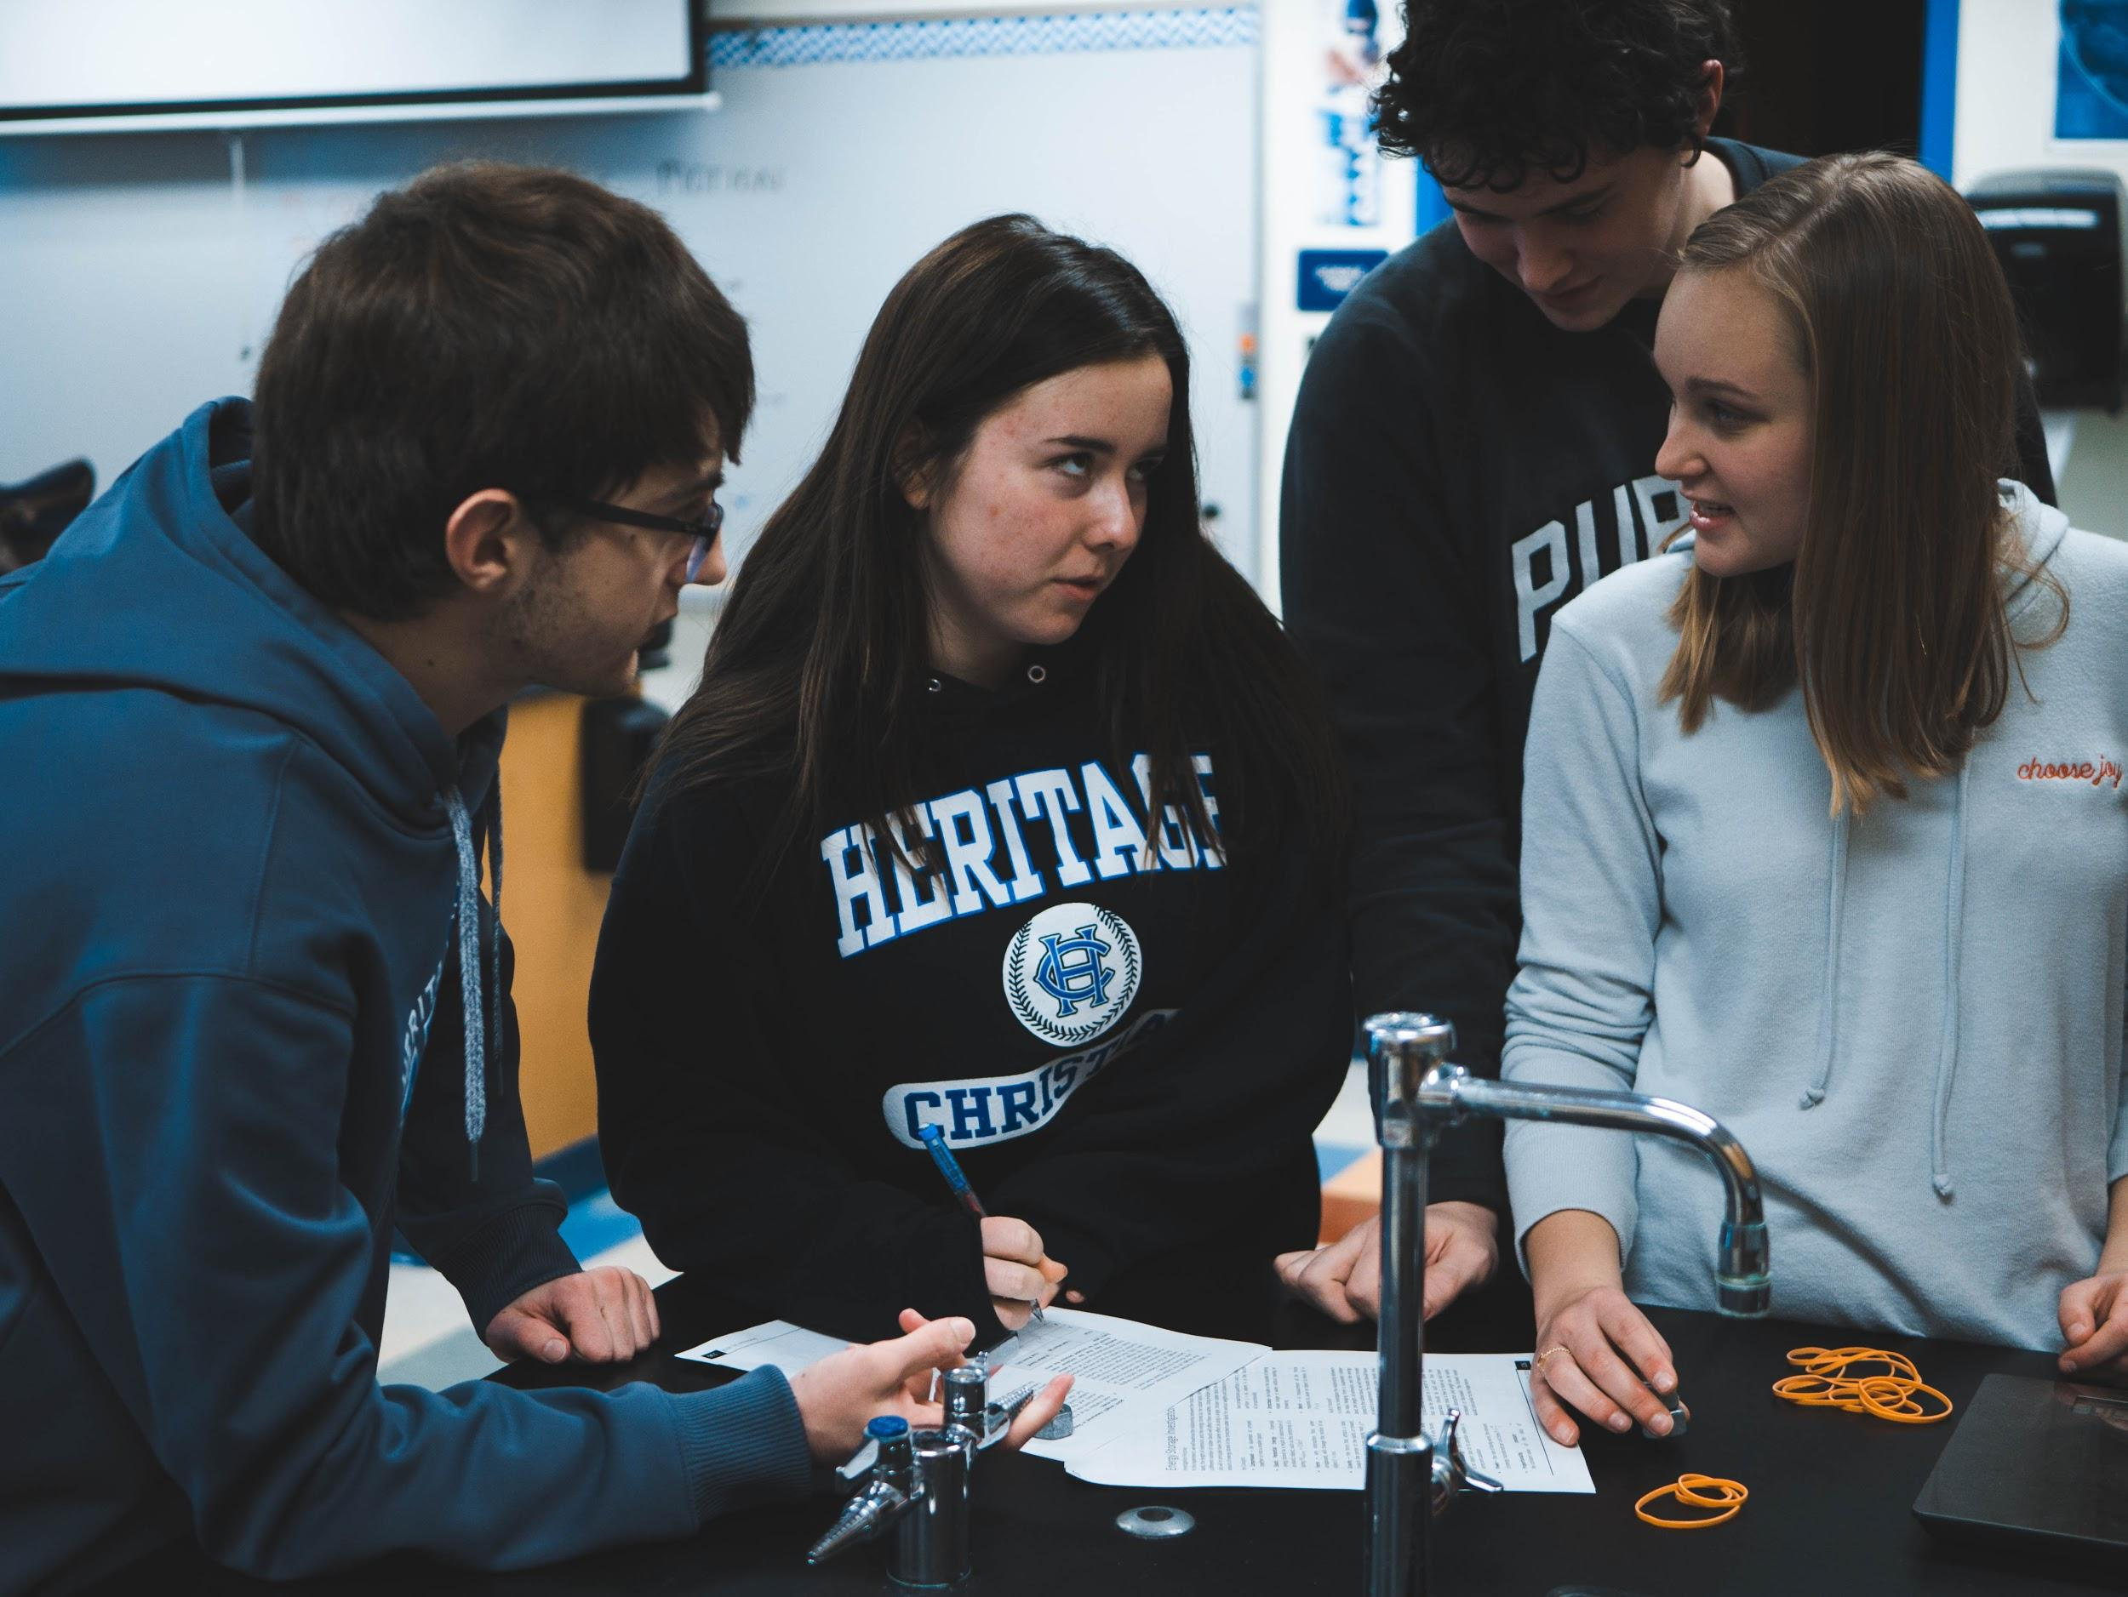
Engaging students in the STEM disciplines requires students to gain an understanding of the primary focus of each core subject. Science is focused on conducting controlled experiments to gain further insight into a phenomenon. Engineering on the other hand centers on developing ways to integrate scientific processes into mainstream society. As such engineers and technicians focus on improving processes and application of science. The engineering design process is a series of steps that guides engineering teams as we solve problems. The design process is iterative, meaning that we repeat the steps as many times as needed, making improvements along the way as we learn from failure and uncover new design possibilities to arrive at great solutions.
Overarching themes of the engineering design process are teamwork and design. Strengthen your students’ understanding of open-ended design as you encourage them to work together to brainstorm new ideas, apply science and math concepts, test prototypes and analyze data—and aim for creativity and practicality in their solutions. Project-based learning engages learners of all ages—and fosters STEM literacy.
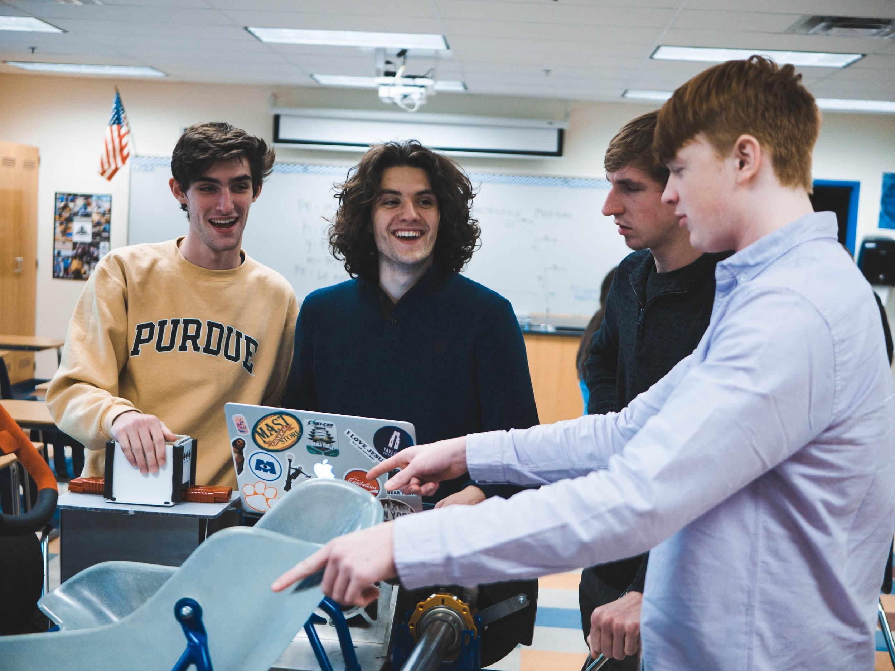
This fits in with the key components of the Go-Kart Science Technology & Entrepreneur program being lessons that include basic making skills, integration of all components of STEM (Science, Technology, Engineering, Math), and providing real world applications in manufacturing, construction, motorsports, and the skilled trades as a means of encouraging student engagement. In order to address the wide variety of topics as part of a one-year introductory physical science, intro to engineering, transportation, or engineering technology course these making activities require certain types of material and specific equipment found in what has become known as Maker Spaces. While many of these items may be purchased using traditional funding models, other specialized equipment and materials will need to be purchased through nontraditional means. This could be through school/program sponsors or partners. The business content relates directly to the programs second goal of engaging students with the STEM disciplines by encouraging students to become active participants in their education.
Prototyping, building, testing, and producing usable products is a major job description of engineers and technicians today. The Engineering Design lessons were developed to provide students with first hand experience with the design process, and the fundamental career tasks of an engineer. Each lesson will focus on one particular aspect of the engineer career field, culminating in the development of a usable model for conducting scientific investigations throughout the remainder of the Go-Kart Science Technology & Entrepreneur program.
The Go-Kart Science Technology & Entrepreneur STEM centered lessons and activities provide students and educators with hands-on build projects, basic making skills, integration of all components of STEM (Science, Technology, Engineering, Math), and the application of content to an authentic collaborative design process based platform, similar to what engineers and technicians use in their everyday careers and occupations.
Purpose and Learning Objectives
Statement of Purpose
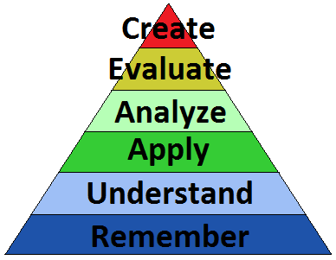
Students will apply the Engineering Design Process by participating in an engineering design challenge to create a model for studying translational motion and its causes. Students will begin with an introduction to the design challenge and given an opportunity to experience the importance of a budget-centered design approach to creating educational technology. Students will first sketch several MSTEM Accel Car chassis in preparation for creating 3D models using CAD software and then 3D printing their experimental model chassis. Using a checklist of final functional requirements for the MSTEM Accel Car chassis, students will assess their sketches’ accuracy and effectiveness in meeting those design requirements. Next, students will explore orthographic projections in preparation for using CAD software to develop 1:1 scale drawings of their proposed MSTEM Accel Car chassis. Students will begin this process by familiarizing themselves with Tinkercad software, creating a chess piece of their own design. Once students are familiar with the tinkercad software they will design and print their MSTEM Accel Car chassis. Students will participate in the iterative nature of the engineering design process to help them gain a sense of the role this process plays in industry, as this is a major skill for 21st century engineers and designers to acquire and apply.
Guiding Question
How do 3D modeling software and 3D printing provide an effective tool for engineers to develop working prototypes and models?
Learning Objectives (SWBAT)
Apply the engineering design process to solve problems within established constraints and materials specifications.
Repeat 3D modeling attributes and activities to design and model a unique variation to a previously modeled 3D object.
Describe the steps used for the creation of a simple 3D modeled object.
Execute the engineering design process from conception of idea to 3D printing of prototype model.
Utilize a final checklist of functional requirements for the assembled MSTEM Accel Car with a chassis that was modeled and 3D printed in the previous lesson.
Deliverables
Modeling Translational Motion Student Activity Sheet
Orthographic Projection Student Activity Sheet
Tinkercad and 3D Modeling Student Activity Sheet with Design Link
MSTEM Accel Car 3D Modeling Student Activity Sheet
Final MSEM Accel Car Models
MSTEM Accel Car Design Checklist
Topics Covered
Science | Technology | Engineering | Math | Polytechnic Skills
- Units  - Variables  - Scientific Method | - Hand tools  - Modeling Software  - Prototyping Materials | - Design Process  - Question Storming  - SCAMPER Acronym | - Measurement  - Tolerance | - Idea Documentation  - Collaboration  - Resources Management
Lesson Timeframe
Traditional Classroom – 6 Days (45-55 minutes)
Key Concepts
- Measurements and dimensions
- Tolerance within product dimensions
- Prototyping/Modeling
- Engineering Design Process
- 3D Printing
Global/Local Issue
In this lesson students will engage in activities and topics related to the engineering design process as it relates to the development of working models and prototypes. Specifically students will learn about the importance of creating preliminary sketches that provide critical design information used to make key development and modeling decisions. Student teams will design an educational model for studying translational motion in the form of speed and acceleration data collection. Their model must be designed for additional component integration as part of a series of studies into causes of translational motion resulting from different powertrain systems.
Students throughout this lesson will learn critical skills related to budget-centered approaches to engineering design and competencies in an iterative design process. These skills will benefit students in all fields within technology and engineering and will apply to broader career and occupational pathways such as: Manufacturing, UX Design, Electrical Engineering, Design Computer Engineering, Mechanical Engineering, Programming, and Computer Science. Indiana-based employers with career opportunities utilizing the skills taught in this lesson include: AES Corporation, Delta Faucet Company, Nidec Motor Corporation, and CrowdSourced LLC.
Enduring Understanding
Students will understand that the engineering design process is an application of scientific knowledge and technology to solve problems in production and manufacturing of components and systems. Students will be able to identify the modeling stages of the engineering design process and apply them to problem solving activities. Students will be aware of the need to iterate the design process to organizations and individuals effectively in order to meet a common goal, and that cultivating this communication process is ongoing. Students will acknowledge that submitting ideas for review by peers allows one to refine an idea and gain insights that improve products and processes. Students will understand that creative ideas may move quickly through the planning process of development so that organizations may begin product turnaround time and meet the demands of quality control to ensure product usefulness and marketability.
Required Prior Knowledge & Skills
- Basic computer skills (typing, using Internet search engines, etc.)
- Some experience media presentations (using camera, video equipment, public speaking, etc.)
- Some experience drawing (using a ruler, etc.)
- Experience with CAD
Assessment
- MSTEM Accel Car Model, to assess student learning and understanding of the design process through the development, design, and 3D Printing of their MSTEM Accel Car that will be utilized during the Seed Velocity Acceleration Module. Each group is scored by averaging peer evaluations using the MSTEM Accel Car Design Checklist.
Instructional Sequence and Duration – 6 Days (Classroom duration assumed to be 45-55 minutes in length)
Engage: Students will apply the engineering design process to create a preliminary solution to the design challenge of creating an educational model for investigating translational motion. Students will be given design constraints and asked to generate 3 to 4 sketches of different chassis consistent with the design constraints. Students will evaluate preliminary sketches in order to decide upon a final chassis design proposal to submit for further development in 3D modeling software, and eventual 3D printing of the modeled proposed chassis design. (Classroom Duration: 45-55 minutes) (SEPS.2, IED-1.5, 6.10, POE-5.3, STEM-T.2, 3)
Lead In: 10 – 15 minutes
- Objective - Apply the engineering design process to solve problems within established constraints and materials specifications. (This should be written in a prominent location within the classroom and easily identifiable by students.) Provide students with a copy of the Lesson Log as they enter the classroom.
- Bell Assignment/Affirmations/Good News/Objectives (7-10 minutes)
- Warm Up - (4-5 minutes)
- Display the example design sketches. Have students use the images to answer the following questions in the Warm-up/Do Now section of their daily lesson log, their engineering notebook, or their science journal/notebook.
- What do all three images have in common? Explain reasoning. (Answers vary, may include things like - descriptive words, pencil generated, done of graph paper, etc.)
- How are these images able to convey important information? (Answers vary, may include things like - how parts fit together, relative size relationships, etc,)
- What stage of the engineering design process would these images be most valuable? Explain reasoning. (accept the ask and image phases of the design process)
- Agenda/Activities – Point out the objective and have students record this in their Lesson Log/Notes. Point out key activities that directly relate to the stated objective. Connect student prior knowledge with the day’s objective and build upon student background knowledge. Explain what students will need to complete, and turn in, by the end of the class period.
Activity: 30 – 35 minutes
- Classroom Discussion, Translational Motion Modeling, Explain to the students that they will be continually asked to create designs of prototypes and experimental models used during investigations and laboratory activities. Often this will rely upon the engineering design process. In this activity students will work on a real-world problem within education. Distribute the Modeling Translational Motion activity worksheet (Modeling Translational Motion Activity Sheet for Students 3.3a). Use the image provided of a toy car chassis with electrical components attached while explaining the problem of providing high quality experimental models with limited financial resources. Educators and researchers are looking for a chassis platform on which to conduct multiple types of experimental investigations. The product must be able to accept modular propulsion systems. The chassis must be designed such that each propulsion system is easily attached, to ensure user safety. Ensure students understand the list of constraints placed upon their model designs.
- Classroom Activity, Modeling Translational Motion, Have students brainstorm design ideas about the experimental chassis design project. Students should refine their design concept based on the list of constraints and ideas developed during the class discussion, adding to their list as they develop their ideas. Students should list why they think certain aspects are necessary and their reasoning behind using specific design elements. During this brainstorming process students should develop 4-5 sketches of their thought process. Finally, students should create a design concept for their chassis based on the sketches and brainstorming activities. Students should summarize their thinking process in the Classroom Activity section of their daily lesson log, their engineering design notebook, or their science journal. Each student should complete all sections of worksheet 2.3a, including a summary of the reason for their final design.
- They must have 3 deliverables by the end of the design period:
  - a list of attributes under consideration;
  - at least 5 sketches of various ideas, including the final design;
  - a summary explaining reasons for final design.
With the time provided, the final sketches should be of a high quality. Students will work on their chassis design for 25-30 minutes in their teams. Students should use the provided worksheet (Modeling Translational Motion Activity Sheet for Students 3.3a). For students with greater knowledge in using the design process, their attribute lists could be highly detailed and specific. For those students that lack in-depth knowledge of the design process, they can keep their attribute lists very basic with a focus more on size and materials and component locations.
End the discussion and the day by explaining that to participate in a creative problem-solving process where we are engaged in various types of design, we need to be willing to test our assumptions. We need to stand back and look at different angles of the issue. Explain that the perspective the students have gained today will be built upon in the next several days.
Wrap-up: 5 – 8 minutes
- Close and Launch – Direct student attention to the daily objective. Ask for a student to volunteer to read the day’s objective and discuss how they were able to meet the day’s objective. (Take a moment to review the day’s activities and how they relate to the stated objective)
- Exit Ticket/Assessment – Have students answer the following questions in the Exit Ticket section of their Daily Log, their engineering notebook, or their science journal/notebook.
- What constraints were the most challenging to meet? Explain reasoning. (Answers vary)
- What other information would have been helpful to making your preliminary sketches? Explain reasoning. (Answers vary)
- Collect – Modeling Translational Motion Worksheet, Lesson Log, This should contain the questions from the warmup activity, Lesson Objective, Notes taken during classroom discussion, Classroom Activity, and answers to the Exit Ticket. (End each lesson with a positive and encouraging statement for students to remember as they leave the classroom)
Explore: Students will investigate orthographic projections as a means of communicating design concepts to peers and colleagues. Students will complete a web activity to learn about orthographic projections - how to create them and their value in discriminating information to design consultants, engineers, and technicians. Students will model fundamental orthographic projection features such as line types, reference planes, and image manipulation. Students will utilize tinkercad.com (or CAD software of your choice) to create a chess pawn model, after completing a lesson to familiarize students to the basic modeling functions inherent within CAD software programs. (Classroom Duration: 75-85 minutes) (SEPS.2, IED-1.5, 6.10, POE-5.3, STEM-T.2, 3)
Lead In: 10 – 15 minutes
- Objective - Repeat 3D modeling attributes and activities to design and model a unique variation to a previously modded 3D object. (This should be written in a prominent location within the classroom and easily identifiable by students.) Provide students with a copy of the Lesson Log as they enter the classroom.
- Bell Assignment/Affirmations/Good News/Objectives (7-10 minutes)
- Warm Up - (4-5 minutes)
- Have students answer the following questions in the Warm-up/Do Now section of their daily lesson log, their engineering notebook, or their science journal/notebook.
- How engineers and designers communicate object size measurements? (Answers vary, but should have something to do with dimensions and tolerances discussed in previous lessons)
- How can the dimensions of an image be determined when no measurements are provided? (Answers vary, may include comparing relative sizes of features, comparing to similar objects, scaling)
- How can 3 dimensional objects be represented on a piece of paper? (Answers vary, accept all logical conclusions and ideas, praising students who use the terms orthographic projections/drawing correctly)
- Agenda/Activities – Point out the objective and have students record this in their Lesson Log/Notes. Point out key activities that directly relate to the stated objective. Connect student prior knowledge with the day’s objective and build upon student background knowledge. Explain what students will need to complete, and turn in, by the end of the class period.
Activity: 55 – 60 minutes
- Classroom Activity, Orthographic Projection, Explain to students that when designing 3D objects in 2D, such as in sketching, designers use orthographic projections and isometric views. To learn more about these concepts, students will use a computer to access an online, interactive learning module that will provide activities to help students gain an understanding of varying projections and views (link to online module is here:
https://sulis.ul.ie/access/content/user/anthony.rynne/orthographic_projection_fyp/orthographic_projection_fyp/webpages/home.html
Provide each student with a copy of the Orthographic Projection Student Activity Sheet 3.3b. Students should be given approximately 45 minutes to complete this activity. Students may work in pairs or small groups at the teacher’s discretion and/or based on the number of computers.
- Classroom Activity, TinkerCad 3D Modeling, Distribute the TinkerCad and 3D Modeling Student Activity Sheet 3.3c and discuss the activity overview. Assist students in creating TinkerCad accounts or creating file saving ability within the CAD software of your choice. Assist students as needed to complete all three activities associated with this assignment. Ensure students share their Chess Pawn links so that you can print this as time permits. It may be helpful to create one file with multiple student models to reduce overall printing time.
Note to Teacher: This lesson uses the Autodesk TinkerCad software as a reference for design modeling, TinkerCad software will be utilized throughout the program curriculum as it is free and beginner user friendly. However, any CAD software that the students are familiar with and provides easy transference of files to a 3D printer is recommended. This part of the lesson is intended to help students become more familiar with modeling software within the realm of prototyping and design development.
Explain that the ensuing activity is for students to gain firsthand experience with modeling in TinkerCad [or CAD software of choice] using an online video tutorial (please see the following “Note to Teacher”). Explain also that this tutorial activity is meant to help them create their own 3D printable model so they can efficiently and accurately draw their MSTEM Accel Car chassis. Students can be in pairs or small groups based on level of understanding or access to computers. Students should be given approximately 45 minutes to review modeling.
Note to Teacher: It should also be noted that this lesson plan cannot link all of the possible video tutorials that would be helpful in learning and practicing modeling. Software and their associated tutorials are constantly being updated and a link here would become irrelevant. It is left to the teacher’s discretion, based on student experience, needs, and knowledge of any computer access restrictions to find tutorials that would best help students understand the modeling process as it relates to the CAD software of choice. It is also suggested as an alternative to having students watching online tutorials, is to provide an in-person, in-class walk-through. Display the CAD software onto a projector screen from the teacher’s computer and walk students through the process of how to model an object. You may choose to have students upload their three slides to a classroom shared slideshow, making it easier and more efficient to complete presentations in the upcoming Explain Lesson.
Wrap-up: 5 – 8 minutes
- Close and Launch – Direct student attention to the daily objective. Ask for a student to volunteer to read the day’s objective and discuss how they were able to meet the day’s objective. (Take a moment to review the day’s activities and how they relate to the stated objective)
- Assignment - Tinkercad 3D Modeling, Assign students/groups to complete their 3D Chess Pawn models and link submission and 3-slide presentation if not completed during class.
- Exit Ticket/Assessment – Have students answer the following questions in the Exit Ticket section of their Daily Log, their engineering notebook, or their science journal/notebook.
- What is one thing you learned today? (Answers vary. Look for specific details of learning taking place)
- Why is this information important? (Answers vary, look for specific details that relate to sponsors and funding)
- How will the use of modeling software help you clarify and present design ideas and elements? (Answers vary)
- Collect – Orthographic Projection Worksheet, Lesson Log, This should contain the questions from the warmup activity, Lesson Objective, Notes taken during classroom discussion, Classroom Activity, and answers to the Exit Ticket. (End each lesson with a positive and encouraging statement for students to remember as they leave the classroom)
Explain: Students will create a short presentation of their 3D modeled Chess Pawn and provide reasoning for the design elements they incorporated. Presentations will provide a sequence used during the modeling process of their chess pawn. Students will next engage in a discussion of 3D printing. Students will learn a quick, abbreviated history of 3D printing and then role play through the use of 3D printing with the world of theatrical productions. Finally, students will connect 3D printing to the modeling/prototyping stages of the engineering design process. (Classroom Duration: 45-55 minutes) (SEPS.2, IED-1.5, 6.10, POE-5.3, STEM-T.2, 3)
Lead In: 10 – 12 minutes
- Objective - Describe the steps used for the creation of a simple 3D modeled object. (This should be written in a prominent location within the classroom and easily identifiable by students.) Provide students with a copy of the Lesson Log as they enter the classroom.
- Bell Assignment/Affirmations/Good News/Objectives (7-10 minutes)
- Warm Up - (4-5 minutes)
- Four Squares Graphic Organizer, Have students complete the graphic organizer for the term Orthographic Projection. Students should be familiar with this type of graphic organizer - in one box students provide a definition, one box contains an image, one box uses the term in a sentence, and a final box contains synonyms and antonyms. The graphic organizer is free of specific instructions allowing you to dictate the information you wish to provide the students.
- Agenda/Activities – Point out the objective and have students record this in their Lesson Log/Notes. Point out key activities that directly relate to the stated objective. Connect student prior knowledge with the day’s objective and build upon student background knowledge. Explain what students will need to complete, and turn in, by the end of the class period.
Activity: 30 – 35 minutes
- Peer Review, Chess Pawn 3D Model Presentations, Create a shared slideshow and ask students to upload their 3-slide presentations to the shared slideshow. Once students have completed the uploading process have students share the Chess Pawn design models with peers.
- Classroom Discussion, Prototyping with 3D Printers, Use the Prototyping with 3D Printers Slideshow 3.3d to lead a discussion on the role of 3D printing in industry and its role prototyping. Strengths and weaknesses of using a 3D printer over other materials-- i.e. cardboard, wood, paper, foam, etc.--as a prototyping tool are also presented in the PowerPoint.
Explain to students that the process of developing a prototype can be long and iterative. CAD software is one way of creating a digital, 3D model of a product of design. Computer modeling has not always been around and neither has the option of taking that computer model and printing it in 3-Dimensions. Explain that to appreciate this ability we now enjoy and to learn how it is being used in industry, you will share a presentation with some small activities.
Note to Teacher: The speaker notes of the PowerPoint contain suggested questions, helpful definitions, and suggestions for quick hands-on activities.
Wrap-up: 5 – 8 minutes
- Close and Launch – (End each lesson with a positive and encouraging statement for students to remember as they leave the classroom)
- Exit Ticket/Assessment – Have students answer the following questions in the Exit Ticket section of their Daily Log, their engineering notebook, or their science journal/notebook.
- What features did your designed chess pawns have in common? (Answers vary)
- Which chess pawn features did you find the most interesting? (Answers vary)
- What is one modeling step done during the modeling of a peer’s chess pawn do you find interesting? (Answers vary)
- What would you do differently if you designed a second chess pawn? (Answers vary)
- Collect – Tinkercad 3D Modeling Worksheet, Lesson Log, This should contain the questions from the warmup activity, Lesson Objective, Notes taken during classroom discussion, Classroom Activity, and answers to the Exit Ticket. (End each lesson with a positive and encouraging statement for students to remember as they leave the classroom)
Engineer: Students are organized into design teams of 2 or 3 individuals (depending upon class size) and tasked with modeling and 3D printing an MSTEM Accel car chassis based off of their individual sketches and the design constraints inherent in the problem. Design teams must present their proposed model for instructor approval prior to modeling within tinkercad.com (or CAD software of choice). Once 3D modeling is completed, design teams must submit their STL file to the instructor prior to 3D printing of chassis. Design teams are encouraged to utilize all phases of the engineering design process to ensure that models are ready for prosecution. (Classroom Duration: 75-85 minutes) (SEPS.2, IED-1.5, 6.10, POE-5.3, STEM-T.2, 3)
Lead In: 10 – 12 minutes
- Objectives - Execute the engineering design process from conception of idea to 3D printing of prototype model. (This should be written in a prominent location within the classroom and easily identifiable by students.) Provide students with a copy of the Lesson Log as they enter the classroom.
- Bell Assignment/Affirmations/Good News/Objectives (7-10 minutes)
- Warm Up - (4-5 minutes)
  - Vocabulary/Reading Strategy, #Hashtag, Have students complete hashtag vocabulary/reading strategy by creating 10 different #hashtag statements that they might find within a twitter thread covering the engineering design process.
- Agenda/Activities – Point out the objective and have students record this in their Lesson Log/Notes. Point out key activities that directly relate to the stated objective. Connect student prior knowledge with the day’s objective and build upon student background knowledge. Explain what students will need to complete, and turn in, by the end of the class period.
Activity: 55 – 60 minutes
- Small Group Activity, MSTEM Accel Car 3D Modeling, Organize students into Design Teams made up of 2-3 individuals based on class size and availability of computers. Distribute the MSTEM Accel Car 3D Modeling Student Activity Sheet 3.3e. Explain that students will use their final hand-sketches of their MSTEM Accel Car Chassis created earlier as a reference as they draw a 1:1 scale version in the CAD software of your choice. It may be helpful to have one team per computer and have each team member take a turn at drawing in the software at timed intervals or by having the students assign (amongst themselves) which student will handle drawing certain parts of the chassis. Student teams can also be divided in half with one half working on the chassis and the other working on a topper for the MSTEM Accel Car electrical components. For STL examples of a chassis and topper, look at the resources below:
- MSTEM Accel Car Body Chassis Example.stl
- MSTEM Accel Car Topper Example.stl
Upon completion of their CAD drawings, they will export, and 3D print their MSTEM Accel Car chassis.
Wrap-up: 5 – 8 minutes
- Close and Launch – Direct student attention to the daily objective. Ask for a student to volunteer to read the day’s objective and discuss how they were able to meet the day’s objective(Take a moment to review the day’s activities and how they relate to the stated objective)
- Assignment - MSTEM Accel Car 3D Modeling, Assign students to complete all aspects of the design process not completed in class, and submit a link to the instructor.
- Exit Ticket/Assessment – Have students answer the following questions in the Exit Ticket section of their Daily Log, their engineering notebook, or their science journal/notebook.
- What design feature did you contribute to your team's final MSTEM Accel Car chassis? (Answers vary)
- What design element was added to your teams final MSTEM Accel Car chassis did you find unique? (Answers vary)
- Why is it important to share each team member's design ideas prior to deciding upon a final design? (Answers vary - students should mention something about developing a better more complete model by collaborating with others)
- Collect – Lesson Log, This should contain the questions from the warmup activity, Lesson Objective, Notes taken during classroom discussion, Classroom Activity, and answers to the Exit Ticket. (End each lesson with a positive and encouraging statement for students to remember as they leave the classroom)
Evaluate: Student design teams will present their completed, and assembled MSTEM Accel Car to classroom peers, and community experts if possible. Each model will be evaluated using the MSTEM Accel Car Design Checklist. Design teams will then display their assembled MSTEM Accel Car alongside their design process documentation, for a gallery walk activity and discussion. The discussion will focus on comparing models to expected constraints and design feature outcomes. Community partners experienced in modeling, prototyping, product development or other related career fields could be used as impartial judges and provide real-world feedback and commentary. (Classroom Duration: 45-55 minutes) (SEPS.2, IED-1.5, 6.10, POE-5.3, STEM-T.2, 3)
Lead In: 10 – 12 minutes
- Objectives - Utilize a final checklist of functional requirements for the assembled MSTEM Accel Car with a chassis that was modeled and 3D printed in the previous lesson. (This should be written in a prominent location within the classroom and easily identifiable by students.) Provide students with a copy of the Lesson Log as they enter the classroom.
- Bell Assignment/Affirmations/Good News/Objectives (7-10 minutes)
- Warm Up - (4-5 minutes)
- Have students organize themselves into their design teams and put final touches on their MSTEM Accel Cars. After allowing students to work for 3-4 minutes complete the agenda discussion and review objective.
- Agenda/Activities – Point out the objective and have students record this in their Lesson Log/Notes. Point out key activities that directly relate to the stated objective. Connect student prior knowledge with the day’s objective and build upon student background knowledge. Explain what students will need to complete, and turn in, by the end of the class period.
Activity: 30 – 35 minutes
- Peer Evaluation, MSTEM Accel Car Design Checklist, Organize students back into their design teams from the previous lesson. Design teams will assemble their MSTEM Accel Car with the axles and wheels, then utilize the MSTEM Accel Car Design Checklist to complete a self-evaluation of their Chassis. Student teams will trade their 3D printed chassis with another team for peer evaluation using the MSTEM Accel Car Design Checklist Student Activity Sheet 3.5b. Complete a review once student teams have finished the peer review using the teacher sign off area. The peer review should be conducted with the axle and wheels attached to the chassis. Assembly of MSTEM Accel Car not required for the checklist to be completed. Approximately 15 minutes is given for the peer and teacher evaluation. However, if any revisions need to be made to the chassis to meet the requirements on the checklist, student teams should make those changes in their CAD drawing and reprint.
It is recommended that after all student teams have finished printing their respective chassis, that students present their final designs to the class. Explain that the students are going to perform what is commonly called a “gallery walk.” As students do this, they are to observe the range of variation in the designs compared to their own.
Written on the chalkboard/whiteboard are the following questions (these can be written up before class):
- How are the other MSTEM Accel Car designs different from my own?
- How are they the same?
- What advantages or disadvantages are there to having differences in these designs?
Have students consider the answers to these questions as they walk around the room and consider other MSTEM Accel Car chassis designs. This activity will take approximately 7 minutes. After students have viewed the other designs, they should return to their original seats. Lead a discussion based on the previous questions written on the board. Students should summarize their discussion in the Classroom Activity section of their Daily Log, Engineering Notebook, or Science Journal/Notebook.
Wrap-up: 5 – 8 minutes
- Close and Launch – Direct student attention to the daily objective. Ask for a student volunteer to read the day’s objective and discuss how they were able to meet the day’s objective. (Take a moment to review the day’s activities and how they relate to the stated objective)
- Assignment – Ensure students with specific tasks of reaching out to potential sponsors understand requirements and due dates.
- Exit Ticket/Assessment – Have students answer the following questions in the Exit Ticket section of their Daily Log, their engineering notebook, or their science journal/notebook.
- What design elements did the groups have in common? (Answers vary)
- What design elements were unique? (Answers vary)
- How did feedback with your design process help with developing a model? (Answers vary)
- Collect – Sponsorship Presentation Evaluation, Lesson Log, This should contain the questions from the warmup activity, Lesson Objective, Notes taken during classroom discussion, Classroom Activity, and answers to the Exit Ticket. (End each lesson with a positive and encouraging statement for students to remember as they leave the classroom)
Tools / Materials / Equipment: Required tools, materials, and equipment to fully utilize the lesson plan.
- Blackboard or Overhead Projector
- Computers with Internet access
- 1/4 plywood (2-1/4 inches wide) (1/4” x 2 x 2 ACX Handi-Panel, $5.19 @ Menards)
- 4 – (1/4 x 3/4) #6 Screw Spacer (Midwest Fastener® #6 x ¼” x ¾” Aluminum Spacer for $0.79 @ Menards)
- EUDAX 82 pcs Plastic Gear Set with Wheels and Axles ($8.99 @
https://www.amazon.com/EUDAX-Plastic-Assortment-accessories-Bushings/dp/B0776ZPP7V?ref_=ast_sto_dp) This set will be used for future investigations into gears, and during the Chemistry and Electricity Modules
- Hand Saw with Miter Box base (MasterForce® 14” Hand Back Saw with Miter Box, $7.98 @ Menards)
- Tape measure (Performax 12 foot, $4.99 @ Menards)
- Optional Materials
  - 3-D Printed M-STEM Accel Car Body (STL file found at hardwarestorescience.org This file will open using Ultimaker Cura software, a free software download. The File can also be found at Tinkercad.com by searching M-STEM Accel Car Body)
  - 3-D Printed M-STEM Wheels (STL file found at hardwarestorescience.org This file will open using Ultimaker Cura software, a free software download. The File can also be found at Tinkercad.com by searching M-STEM Wheels)
  - Wire Clothes hanger (10 pack, $1.44 @ Walmart)
  - #20 O-Ring (1-3/16” O.D. x 1” I.D., $0.79 @ Menards) (Qty – 4)
Resources (Student, Teacher, & Assessment): List of assessment tools, worksheets, or other teacher resources needed to assess the work done by students.
- Documents
  - Daily Lesson Log
  - Four Square Graphic Organizer
  - #Hashtag Vocabulary/Reading Strategy
  - Modeling Translational Motion Student Activity Sheet 3.3a
  - Orthographic Projection Student Activity Sheet 3.3b
  - Tinkercad and 3D Modeling Student Activity Sheet 3.3c
  - MSTEM Accel Car 3D Modeling Student Activity Sheet 3.3e
  - Practice Problems Answer Key 3.5a
  - Scamper Reference Sheet Student Activity Sheet 3.5b
  - MSTEM Accel Car Design Checklist Student Activity Sheet 3.5c
- Slideshow Presentations
  - Prototyping with 3D Printers 3.3d
- Additional Resources
  - MSTEM Accel Car Body STL file - (The File can also be found at Tinkercad.com by searching M-STEM Accel Car Body)
  - MSTEM Accel Car Topper STL file - (The File can also be found at Tinkercad.com by searching M-STEM Accel Car Body)
Vocabulary: List of necessary, and unique, vocabulary for this lesson.
- Dimensions - a numerical value expressed in appropriate units of measurement and used to define the size, location, orientation, form or other geometric characteristics of a part
- Engineering Design Process - a series of steps that engineers follow to come up with a solution to a problem
- Engineering Tolerances - an allowable amount of variation of a specified quantity, especially in the dimensions of a machine or part
- Measurement - the determination of the size or magnitude of something
- Orthographic Projection – a method of projection in which an object is depicted or a surface mapped using parallel lines to project its shape onto a plane
- Prototype - the act of organizing people to accomplish the desired goals and objectives
Indiana Academic Standards
- Science and Engineering Process Standards:
  - SEPS.2 Developing and using models and tools
  - SEPS.3 Constructing and performing investigations
  - SEPS.5 Using mathematics and computational thinking
- Math Process Standards
  - PS.6 Attend to precision – Communicate precisely, use terms and symbols appropriately, specify units of measure, and calculate accurately and efficiently
  - PS.7 Look for and make use of structure - Explain patterns and structures, know and explain properties that apply (cumulative, for example)
  - PS.8 Look for and express regularity and repeated reasoning - Look for repetition in problems, explore and find short cuts, take repetitions and generalize into new situations using newfound shortcuts, check answers for reasonableness
- Introduction to Engineering Design Standards
  - IED-1.5 Students perform the steps of the design process to develop and analyse products and systems – Generate a valid and justifiable problem, Create a design brief by constructing a problem and design statement and identifying problem constraints, Discuss how the design process impacts the outcome when designing solutions to problems, assess and refine original design solutions based upon reflection, critique, practice, and research.
  - IED-6.10 Students create designs using a variety of modeling techniques to communicate information – Formulate methods of communicating designs using various forms of modeling such as conceptual, graphical, mathematical, physical, or computer modeling.
- Principles of Engineering non-PLTW Standards
  - POE-5.3 Students apply the laws of motion as they apply to principles of engineering – Explain how gravity impacts motion.
- Technology Standards related to STEM Careers
  - STEM-T.2 Students use a variety of technologies within a design process to identify and solve problems by creating new, useful or imaginative solutions.
  - STEM-T.5 Students use digital tools to broaden their perspectives and enrich their learning by collaborating with others and working effectively in teams locally and globally.
Additional Resources: Go Kart Science & Technology Entrepreneur Program Introduction
Reading Strategies
These reading tools will help students learn the material in this unit: Science Terms, Mathematical Language, and Concept maps.
Vocabulary Terms, Many words used in business and marketing are familiar words from everyday speech. However, their meanings are often different from or are more precise than the everyday meanings. As students pay attention to the definitions of these words their correct use of them in business and marketing contexts will improve. Have students set up a table in their scientific/engineering notebooks with three columns as seen below. As students are introduced to vocabulary, have them complete the table for the new term.
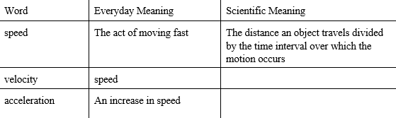
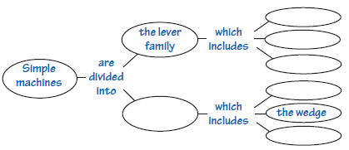
Concept Maps, A concept map is a diagram that helps you see relationships between the key ideas and categories of a topic. To construct a concept map, do the following: Select a main concept for the map. List all of the other related concepts. Build the map by arranging the concepts according to their importance under the main concept. Add linking words to give meaning to the arrangement of concepts.
Printable Resources
The following resources are found in the additional teacher resources file shared with this module.
Daily Lesson Log
Online Resources
The following resources are found online, and can be accessed through their individual websites or in a word document version at the Hardware Store Science website. One advantage of using the word document version of this article is that educators are able to download and edit the document with questions, writing prompts or other student suggestions.

