Levers Experimental Investigation Data Sheet for Students 1.2

Student Name:

Levers Investigation (ICP.3.5, 3.7, POE-3, 6)
Investigation Purpose
In this experiment, we will examine how a simple lever can perform work on an object. We will accomplish this by placing weights, of different mass, at various locations on a balanced board (i.e. a seesaw). Using weight and placement measurements, we will calculate the work required on one side of a balanced board to lift an object of greater mass on the other side of the balanced board. We will also determine the mathematical rule for equilibrium.

Key Concepts
- Balanced forces – two forces acting in opposite directions on an object, and equal in size
- equilibrium – The condition of equal balance between opposing forces
- Force – any interaction that, when unopposed, will change the motion of an object $F=ma$
- Mass – the quantity of matter in a body regardless of its volume or of any forces acting on it.
- Newton’s 1st Law of Motion – An object at rest stays at rest and an object in motion stays in motion with the same speed and in the same direction unless acted upon by an unbalanced force.
- Newton’s 2nd Law of Motion – the acceleration of an object is dependent upon two variables - the net force acting upon the object and the mass of the object.
- Unbalanced forces – two forces acting in opposite directions on an object, and not equal in size
- Work – A measurement of the force required to cause an object to move. $W=F×d$

Build it Yourself
In order to investigate the use of levers for doing work, and determine the mathematical rule for equilibrium, you will need a model on which to experiment. Your model should consist of rigid MDF board and a fulcrum made up of a piece of 1/8 inch aluminum sandwiched between two 2x4s. One way to successfully do this would be to build a model that would allow a stationary fulcrum to support a 36 inch piece of MDF board in a manner that would allow the MDF board to balance of the edge of the aluminum plate sandwiched between the 2x4 boards.
The final assembly of your seesaw should look similar to the image below.
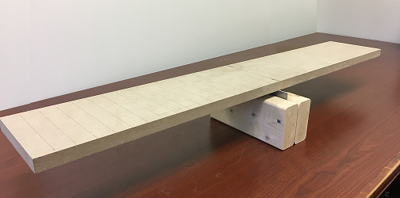
The fulcrum can be constructed by placing a short piece of 1/8 a flat aluminum between two pieces of 2x4 lumber and securing it in place with screws. By allowing the aluminum to extend above the surface of the 2x4 material you now effectively created a 1/8 inch wide platform on which to balance you MDF board.
A list of the supplies needed to construct the apparatus are:
- 1x3 MDF board
- 2x4 lumber
- Screw
- 1/8 inch flat aluminum
Tools that will be needed include:
- Wood cutting saw
- Metal cutting saw (Hacksaw)
- Electric drill
- Screw driver or bit for drill
- Drill bits
- Tape measure
- Scale
Background Information
Some sort of force is required to make an object move, when a force causes the movement of an object it is said that work was done upon the object. There are three key ingredients to work - force, movement (or equivalently the displacement), and cause. In order for a force to qualify as having done work on an object, there must be a displacement and the force must cause a displacement. There are several good examples of work that can be observed in everyday life - a horse pulling a plow through the field, a father pushing a shopping cart down the aisle of a grocery store, a student lifting a backpack full of books upon her shoulder, a weightlifter lifting a barbell above his head, an Olympic athlete launching the shot-put, etc. In each case there is a force exerted upon some object to cause that object to be displaced (moved).
In it’s simplest form we can calculate the amount of work done by multiplying the force applied to an object by the distance in which the object moves.
$W=F×d$ where F is the force, d is the displacement
Using the equation above would tell us that 30 N·m of work was done when a force of 10 Newtons (N) is applied to an object and moves that object 3 meters.
$$10N x 3m=30N∙m$$
A lever is a simple machine made up of a beam or solid rod and a fulcrum or pivot point. The beam is placed so that some part of it rests on top of the fulcrum. In a traditional lever, the fulcrum remains in a stationary position, while an input force is applied somewhere along the length of the beam. The beam then pivots on (or around) the fulcrum, exerting the output force on some sort of object that needs to be moved.
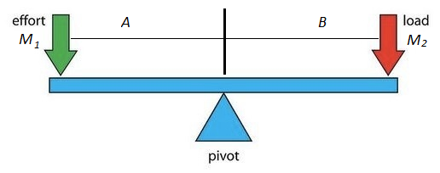
The key concept at work in the lever is that the work done on one end of the lever will manifest as an equivalent amount of work at the other end.
If the distances from the fulcrum are the same (a = b) then the lever is going to balance out if the weights are the same (m₁ = m₂). If you use known weights on one end of the scale, you can easily determine the weight on the other end of the scale when the lever balances out.
The situation gets much more interesting when m₁ does not equal m₂. In that situation there is a precise mathematical relationship between the product of the mass and the distance on both sides of the lever:
$$M_{1}A=M_{2}B$$
While the assumption discussed above is that there are objects of a given mass sitting on the beam, this object could be replaced by anything that exerts a physical force upon the lever.
Construction procedure
Read through the Construction Procedures then create a detailed diagram showing how you will build your fulcrum and assembled lever testing apparatus. Include measurements on the dimensions of each item needed. Your drawing should look similar to the one below.
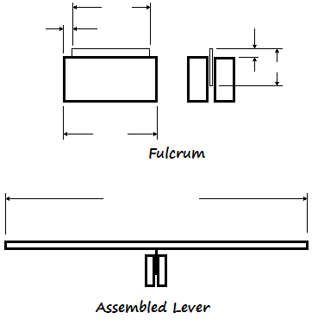
- Use the tape measure to accurately measure 36 inches of 1x3 MDF board.
- Use the hand saw to cut the MDF board to length. Note ensure the accuracy of your cut. If cut correctly the board will balance when centered on the stationary fulcrum.
- Use the hand saw to cut two pieces of 2x4 that are at least 8 inches long.
- Use the hacksaw to cut a piece of 1/8 inch flat aluminum that is a maximum of 5 inches long.
- Place the aluminum between the 2x4 pieces centered within the length dimension. There should be a minimum of 1 inch between the edge of the aluminum and the edge of the 2x4 material.
- Extend the top surface of the plate aluminum at least ½ inch above the surface of the 2x4 pieces so that it looks similar to the diagram below.
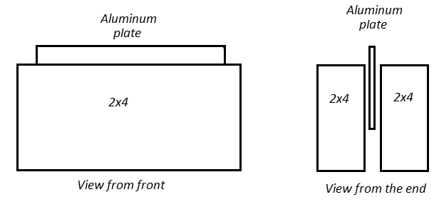
- Insert two screws through the 2x4 pieces so that the screws are on either side of the plate aluminum. Screws should extend from the front of the fulcrum to the back of the fulcrum, without protruding through the back of the fulcrum. Place a third screw directly below the aluminum plate. Pre-drilling these locations with a small drill bit will allow the screws to be driven through the lumber more easily, and secure the fulcrum together without splitting the 2x4 pieces.
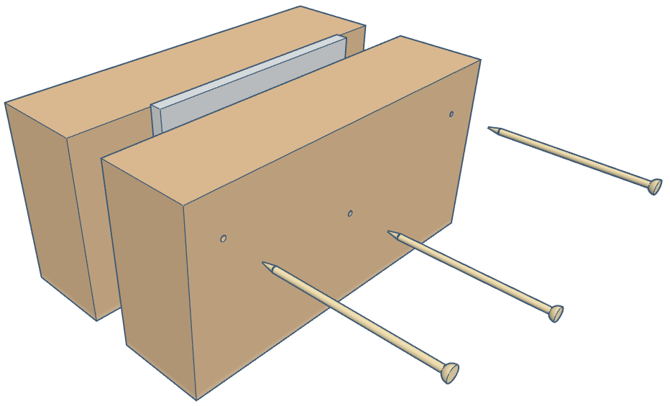
- Measure the 1x3 MDF board’s overall length and determine the center. Scribe a line across the 1x3 MDF board to clearly mark the center. Place lighter marks across the 1x3 MDF board every 1 inch from the center line, until you reach either end. Your 1x3 MDF board should look similar to the image below.
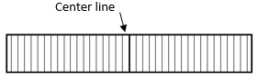
- Place the 1x3 MDF board on the fulcrum so that the center line is directly above the aluminum plate of the fulcrum. The board should balance, if not, adjust the board from side to side until the board balances.
Investigation Objectives
The overall objective of this experiment is to learn how a simple lever can perform work on an object and to determine the mathematical rule for equilibrium. This is accomplished using the experimental test apparatus and the manipulating the placement of objects of known mass on the balanced board, so that they are on either side if the fulcrum.
Another key objective of this hands-on project is to build the experimental set-up from materials that are available from the local hardware store. This is the way that many, if not most, novel scientific discoveries are made – from an apparatus that is made by the scientist to test something that has never been accurately measured before. If the experimental apparatus comes from a kit, then it will probably just allow one to repeat a measurement that is already known. Thus, the making of your apparatus is an important learning experience in its own right.
In principle, this experiment can be completed, with a reasonable amount of accuracy, using a single piece of 2x4 as a fulcrum. However, by using a thin piece of metal as the fulcrum one is able to increase the accuracy of the measurements in order to clearly define the mathematical rule for equilibrium and accurately assess the work done within the lever action of the balanced board. If a single 2x4 is used as the fulcrum, these instructions must be modified such that all data collected must be analyzed with the assumption that the seesaw action of the balanced board is hindered by the width of the 2x4 and thus the distances that objects are placed on the balanced board, in relation to the fulcrum, will be much greater than expected. This will then change the expected work done within the lever system dramatically.
During this investigation you will:
- Build free standing balance beam (or seesaw), and examine how a simple lever can perform work on an object.
- Use the seesaw apparatus to determine the mathematical rule for equilibrium and calculate the work required on one side of a balanced board to lift an object of greater mass on the other side of the balanced board. The masses and distances can then be plotted on a graph to determine a relationship.
- Repeat the experiment by placing a mass on only one side of the seesaw.
- Repeat the experiment by moving the fulcrum to a new location and using weights to balance the seesaw.
The experiment can be modified by using any type of lumber for the balanced board. The experiment would need to be modified by obtaining the center of balance for the balanced board rather than measuring the center of the board lengthwise. This can be achieved by placing the board, to be used as the balance beam, on the fulcrum and adjusting its position until it is balanced. You can then mark the location of the fulcrum and scribe that line across the board from one side to the other. This then becomes the point of measurement for all calculations.
First Experiment
- Determine the mass of two individual hex nuts. Record their masses in your data table.
- Place one hex nut on the 1x3 MDF board to the left of the fulcrum.
- Place the second hex nut on the seesaw such that the seesaw is balanced.
- Measure the distance from the fulcrum to the hex nut on the left side of the fulcrum and the distance from the fulcrum to the hex nut on the right side of the fulcrum. Record these values in your data table.
- Repeat steps 1-4 two more times by moving either the hex nut on the left or the hex nut on the right to a new (2nd) location on their side of the balanced seesaw and then rebalance the seesaw. Record the locations of the hex nuts in your data table.
- Determine the mass of three individual hex nuts. Record their masses in your data table.
- Stack two of the three hex nuts on top of each other and place them on one side of the balanced seesaw.
- Place the third hex nut on the seesaw such that the seesaw is balanced.
- Measure the distance from the fulcrum to the stacked hex nuts and the distance from the fulcrum to the single hex nut. Record these values in your data table.
- Move either the single hex nut or the stacked hex nuts to a new (2nd) location on their side of the balanced seesaw and then rebalance the seesaw. Record the locations of the hex nuts in your data table.
- Use the formula for calculating the work done by the lever, in the background section above, to determine the work input from the left side of the fulcrum and the work output from the right side of the fulcrum.

Data Table
Trial using 2 hex nuts | Mass m₁ | Distance l₁ | m₁ x l₁ | Mass m₂ | Distance l₂ | m₂ x l₂
1
2
3
Trial using 3 hex nuts
1
2
3
Data Analysis
- Use Equation for equilibrium above to determine the relationship between mass and location for a balanced beam.

- How does the mass times distance value on one side of the balanced beam compare to the mass times distance value on the other side of the balanced beam?

- How does the location of the mass on one side of the balanced beam compare to the location of the mass on the other side of the balanced beam?

- What is the mechanical equilibrium rule for a balanced beam?

Explorations
Now that you have completed your first experiment, you have all of the tools necessary to answer more questions concerning levers and equilibrium. Here are some questions that would be interesting to explore:
- What would happen if mass was added to only one side of the balanced beam? Would you still be able to balance the beam and if so how would that be done? Does that have any effect on the work done on the balanced beam?
- What if the fulcrum was not stationary? What would need to be done to the beam to get the beam to balance? Would the amount of work done on either side of the fulcrum change?
- Mechanical advantage is the ratio of output to input force magnitudes for any simple machine. Does the mechanical advantage change with the placement of masses on the balanced beam? Does the mechanical advantage change with the placement of the fulcrum?
- There are three types of levers. Research the three types of levers and design and experiment that will allow you to compare all three types of levers. Compare the work input and work output for each type of lever. Compare the mechanical advantage for each type of lever.
These are just a few of the what-if questions that you can ask. Use your imagination – there are many more questions. Any of these questions above (or the ones you have thought up) would be a good science fair project.
Homework Problems
- Draw a diagram of your testing apparatus. Identify all the forces acting on your test apparatus when the board is balanced.
- Write a 100 word summary of your investigation and what was learned.

