Engineering Design Process Student Activity Sheet 3.3a

Student Name: .

Modeling Translational Motion
Question for Analysis
how can speed, velocity, and acceleration be modeled in a classroom setting?
Key Concepts
- Engineering Design Process – a series of steps that guides engineering teams as they solve problems.
Instructions
Design a toy car model that can be used to explore causes of translational motion. Your model must be 3D printable. Your model must be able to accept different types of propulsion systems, as they are studied throughout this course. Model must adhere to the design constraints listed:
Design Constraints
- Axle dimensions - 2mm x 65mm
- Chassis maximum length - 7 inches
- Must allow for the addition of pulleys on axle
- Must allow for the addition of mini rectangular DC motor mounting bracket attached using 3mm screw
- Must allow for the attachment of AA battery pack using 3mm screw
- Must allow for the attachment of 16 oz water bottle.
Use the space provided on the next page for your attribute list. Images are provided to help you form the list. Page 3 of this packet is for your 5 sketches. The final page is for your final sketch.

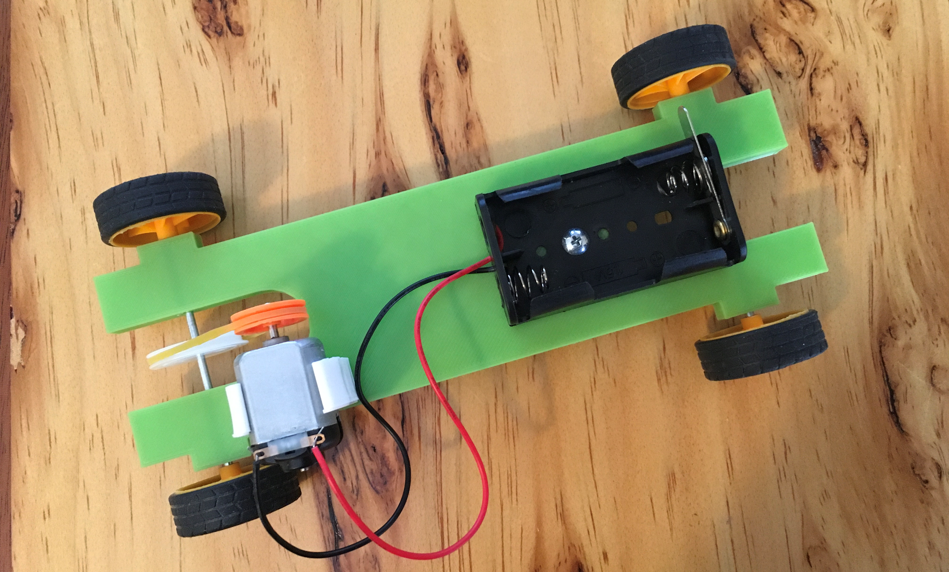

Complete the following tasks:
- Create a detailed list of attributes of experimental model

- Create at least 4 sketches of various solutions you brainstorm

- Create one large (should fill the paper) final sketch to show to the class. Annotate or label your sketch!

- Summary providing reasoning for final design.

