Levers Background Information and Activity Sheet for Students 1.3d

Student Name:

Action-Reaction (ICP.4.4)
Question for Analysis
How does force affect the interactions of object in motion? (ICP.3.7)

Key Concepts
- Action – the force acting in one direction
- Force – any interaction that, when unopposed, will change the motion of an object $F=ma$
- Interaction – reciprocal action or influence
- Newton’s 1st Law of Motion – An object at rest stays at rest and an object in motion stays in motion with the same speed and in the same direction unless acted upon by an unbalanced force.
- Newton’s 3rd Law of Motion – For every action, there is an equal and opposite reaction.
- Reaction – the force acting in the opposite direction.
Background
Because forces always come in pairs identifying and describing action-reaction force pairs is a simple matter of identifying the two interacting objects and describing the direction of the action and reaction.
In the example below, the action-reaction pair is shown by the arrows (vectors), and described in words.
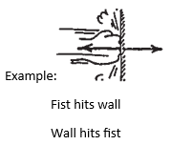

Practice Problems
- In (a) through (g) draw the other arrow (vector) and state the reaction to the given action. Then make up your own example in (h).

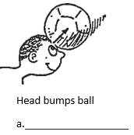
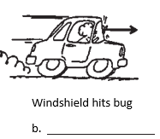
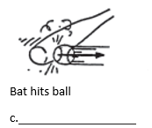
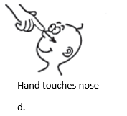
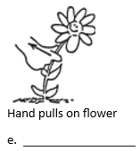
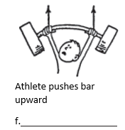
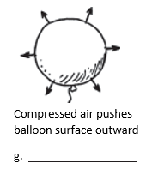

h.

- Consider the interaction depicted below between foot A, ball B, and foot C. The three objects interact simultaneously (at the same time). Identify the two pairs of action-reaction forces. Use the notation "foot A", "foot C", and "ball B" in your statements.
