Levers Background Information and Activity Sheet for Students 1.3b

Student Name:

Balanced and Unbalanced Forces (ICP.3.2)
Question for Analysis
What are balanced and unbalanced net forces? (ICP.3.2)

Key Concepts
- Balanced forces – two forces acting in opposite directions on an object, and equal in size
- equilibrium – The condition of equal balance between opposing forces
- Force – any interaction that, when unopposed, will change the motion of an object
- Inertia – the resistance an object has to a change in its state of motion
- Mass – the quantity of matter in a body regardless of its volume or of any forces acting on it.
- Unbalanced forces – two forces acting in opposite directions on an object, and not equal in size
Background
To determine if the forces acting upon an object are balanced or unbalanced, conducted an analysis to determine what forces are acting upon the object and in what direction. The forces are said to be balanced, if the two individual forces are of equal magnitude and opposite direction. An unbalanced force acts upon an object only when there is an individual force that is not balanced by a force of equal magnitude, and in the opposite direction.
Sample Problem
Describe the forces acting on objects A, B, and C as balanced or unbalanced, and then determine the net force acting on each object.
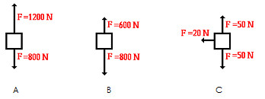
Object A: Unbalanced – the force pushing the object up is greater than the force pulling the object down.
Object B: Unbalanced – the force pulling the object down is greater than the force pushing the object up.
Object C: Unbalanced – the force pulling the object down is the same as the force pushing the object up while the force pushing the object to the left is not paired with a force pushing the object to the right.
The net force ($F_{net}$) is the result of all of the forces added together. Forces going up or to the right are given a positive value while forces going down or to the left are given a negative value.
Object A: $1200N-800N=400N$pushing up
Object B: $800N-600N=200N$ pulling down
Object C: $50N-50N=0N$ up and down $20N-0N=20N$ to the left

Homework Problems
- Below are free-body diagrams for four situations. For each situation, determine the net force acting upon the object.
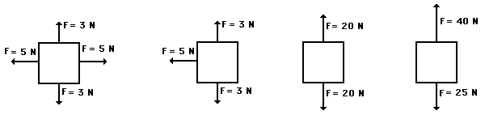

- Below are free-body diagrams for three situations. The magnitudes of a few of the individual forces are not known (A, B, C, D, E). Analyze each situation individually and determine the magnitude of the unknown forces.
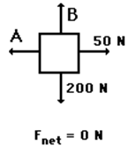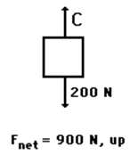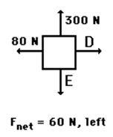

- A skydiver is descending with a constant velocity. Consider air resistance. Draw a free-body diagram for this situation.

- A 4,000N car is coasting to the right with a force of 40N and slowing down due to a resistance force of 5N. Draw a free-body diagram for this situation. Include at least four forces and their magnitudes.

