PPDA Monthly Board Meeting Minutes (October)
Time: 4 – 5 pm EDT, Oct 28, 2021
Location: Zoom

Agenda and Minutes:

1. Update PPDA Website (Youngwoo and Anke)
- Photos of current Board members and roles (done)
- Meeting notes need to uploaded on PPDA website after each board meeting (Youngwoo, Dezhi)
After meeting, Dezhi send the minutes to Youngwoo

- Events also need to be updated on PPDA website; flyers need to be stored on google drive
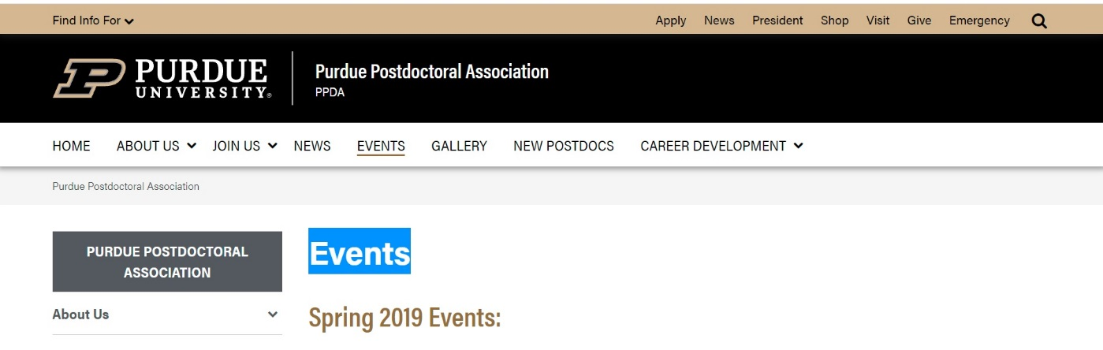

Whoever lead an event send flyers to Anke to Youngwoo

- Other thoughts
Share Google Drive files to every board member
2. Summary of diversity event (Oct 15) and professional development event (Oct 21) - Pan will give a brief summary and suggestions for further events planning
Pan will upload the summary to Drive.

3. Events for the Nov and Dec
- Professional development events (Tauqeer, Tu, Amit)
Advice for Academic Job Application (Health science and related fields, 1st of December): This event has been put in the registration system; we need to send the event this details and registration link through newsletter and PPDA emails
- How to become a better reviewer: Anke emailed Ria and Dezhi to see if they have suggestion for the speaker
Ideas:
- (Dezhi) Brainstorming the potential fields in which we will have this event,contacting prospective speakers and finding a proper time slots.
- (Tu) I think we should share with PPDA some useful resources for self-training to be a reviewer, such as:
- Focus on Peer Review by Nature: https://masterclasses.nature.com/focus-on-peer-review-online-course/16605550
- ACS Review Lab by American Chemical Society: https://www.acsreviewerlab.org
- Certified Peer Reviewer Course by Elsevier: https://researcheracademy.elsevier.com/navigating-peer-review/certified-peer-reviewer-course
- Reviewing courses by Clarivate: https://webofscienceacademy.clarivate.com/learn
- (Tu) We can invite some instructors in those courses to share their experiences with Purdue postdocs.
- (Tu) Beside inviting professors, editors and instructors to be speakers at our reviewer events, we can also organize some meetings where speakers will be Purdue postdocs who have interesting experience to share. It will be more interactive and more engaged among us.

- Coffee hour: We asked Lisa about coffee hours and providing coffee for events PPDA
Lisa Nielsen’s response “I think that is a great idea for the PPDA to start offering coffee hours again. However, the caveat is that the event cannot have people actively eating or drinking while in the room with other people. Your coffee hour or other events may offer individually packaged food/snacks for people to take with them, but attendees are not allowed to sip coffee during the event, unfortunately. They could get coffee with to take with them on their way out, though”.

4. Other discussions:
- Whether we have a chance to reach out Lisa. Easy to reach out. Email Lisa and cc Fanfei.
- How to have new postdoc receiver our email.
- A potential channel (webpage) where all postdocs can get access, and post and discuss issues that they would be interested.
Potential suggestions:
- Postdoc position information for potential postdocs
- Life information for new postdocs
- Experience sharing for current postdocs
- Social events for current postdocs
- Job opportunity information for current postdocs

