Instructions for ordering student insurance for study abroad.
All departmental programs must order the insurance for students through Risk Management.
#1. Download the student list from your program leader page under “Program Forms” and then “Insurance”:
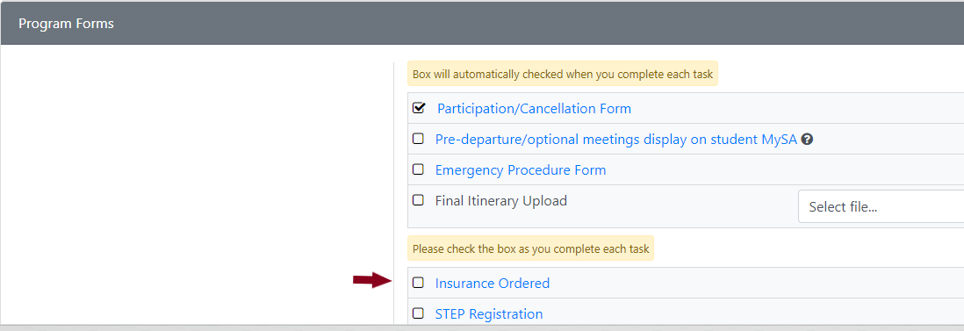
#2. Open the list of students and save to your computer.
#3. Open the appropriate form: RM23 located on the Risk Management forms site.
#4. Complete the top section of the form entering the program/department/account information.
#5. Click the “Submit” button. You will receive a notification that an incident has been submitted and you will need to “attach a file”. Please attach the list of participants that you saved to your computer.
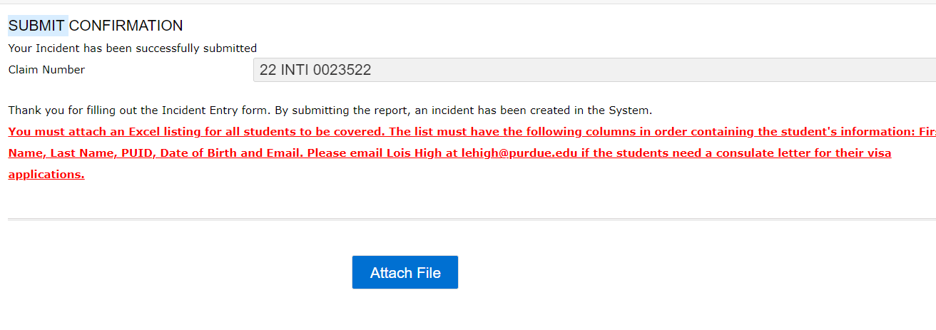
#7. The person listed in the “Prepared by” section will receive an email confirmation from noeply@riskconnect.com that the form was successfully submitted.
#8. Please check off the “Insurance Ordered” tab on your Program Leader page once ordered and confirmation email received– this needs manually checked to confirm that the order has been placed.
#9. The person listed in the “Send ID Card To” section will receive an email with the insurance card ID information 48 hours prior to departure.
#10. Notify PL leader or students that the insurance has been ordered and students should carry the Insurance ID card with them during their travels.
REMINDER: Program leaders’ international insurance is ordered by entering their pre-trip request in CONCUR.

