ME 323: Mechanics of Materials Quiz 5

Name:_____________________

Q1 (10 Points): A beam of a T-shape cross section is subject to a linearly distributed load shown below. b=2 in., h=6 in. Determine the moment in the middle section of the beam (i.e., 6 ft from A). Also, within this cross section, find:
- The location of the neutral axis of the cross section.
- The second area moment of the cross section.
- The largest magnitude of stress in the cross section

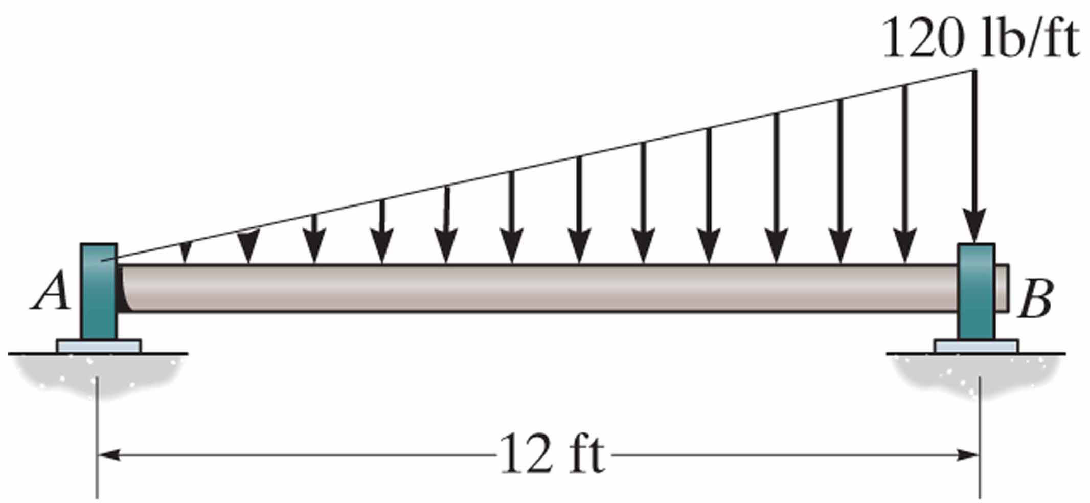

(i)
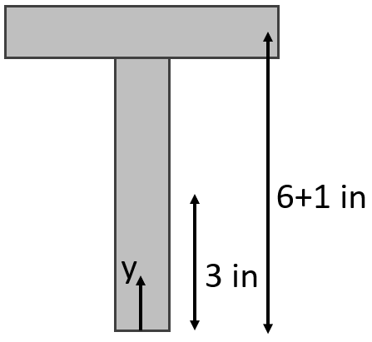

$\overline{y}=\frac{{(A}_{1}\overline{y_{1}}+A_{2}\overline{y_{2}})}{A_{1}+A_{2}}=\frac{\left(2*6\right)\left(3\right)+\left(6*2\right)\left(7\right)}{2*\left(2*6\right)}=5 in$ from the bottom of the cross-section

(ii)
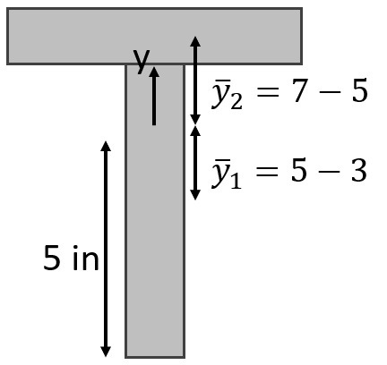

$I={\left(I_{1}\right)}_{0}+{\left(I_{2}\right)}_{0}$
$I=\frac{2*6^{3}}{12}+\left(6*2\right){\left(5-3\right)}^{2}+\frac{6*2^{3}}{12}+\left(2*6\right){\left(7-5\right)}^{2}$
$I=136 in^{4}$

(iii) First find reactions:

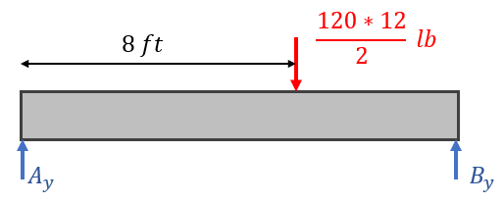
$ΣF_{y}=A_{y}+B_{y}-720=0$
${\left(ΣM\right)}_{A}={12B}_{y}-8*720=0$

$B_{y}=480 lb$
$A_{y}=240 lb$

Find reactions at cross section at 6 ft:
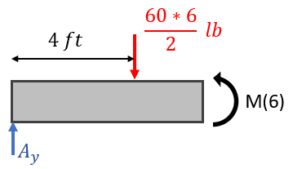

$ΣM=M\left(6\right)-6A_{y}+2*180=0$
$→M\left(6\right)=1080 lb*ft=12960 lb*in$

Find max flexural stress:
Max distance from origin will be at the bottom ($\left|y\right|=5$)

$σ_{max}\left(x=6 ft\right)=\frac{M\left(6\right)y}{I}=\frac{12960*5}{136}=426.5 psi$

