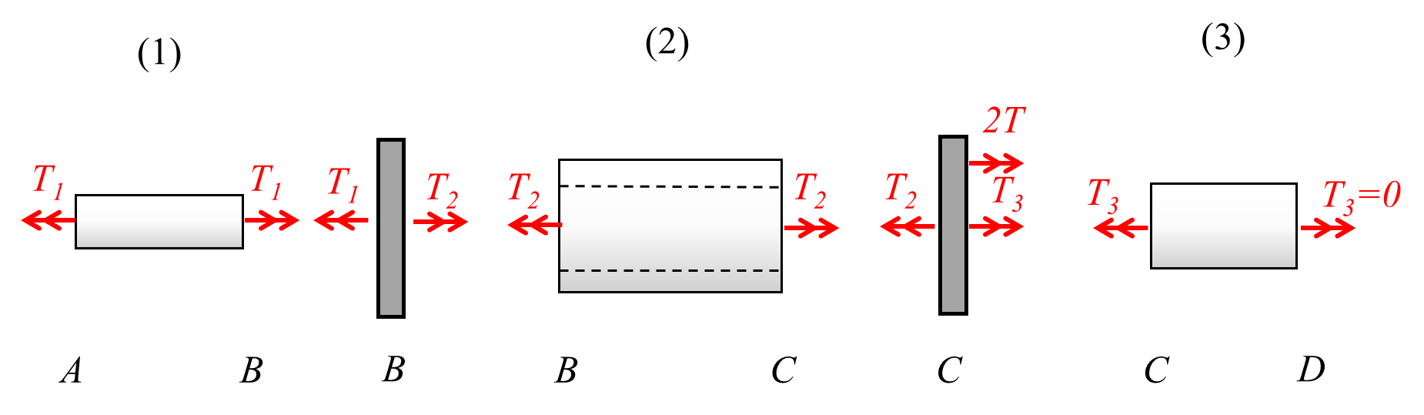
Equilibrium:
a) Shaft (3) is free at end D. ${⇒T}_{3}=0$
Connector C: $T_{3}+2T-T_{2}=0{⇒T}_{2}=2T (1)$
Connector B: $T_{2}-T_{1}=0{⇒T}_{1}=T_{2}=2T (2)$
Where,$T_{1}, T_{2}, T_{3}$ are the torques carried by the three shafts.
Polar moments are represented here as J_{i}. (They can also be denoted as I_{p})
b) $θ_{1}=\frac{T_{1}L_{1}}{G_{1}J_{1}}=\frac{\left(2T\right)\left(L\right)}{\left(2G\right)\left(J_{1}\right)}=\frac{32TL}{πGd^{4}}; { θ}_{2}=\frac{T_{1}L_{1}}{G_{1}J_{1}}=\frac{\left(2T\right)\left(1.5L\right)}{\left(G\right)\left(J_{2}\right)}=\frac{96TL}{65πGd^{4}}$
, where $θ_{1},θ_{2}$ are rotations between the ends of shafts (1) and (2) respectively. Note that$θ_{3}=0$, since torque carried by shaft (3) is 0.
Compatibility:
$$θ_{A}=0 (wall) (3)$$
$$θ_{B}=θ_{A}+θ_{1}=θ_{1} (4)$$
$$θ_{C}=θ_{B}+θ_{2}=θ_{1}+ θ_{2} (5)$$
$$θ_{D}=θ_{C}+θ_{3}=θ_{C} (6)$$
From (4): $θ_{B}=\frac{32TL}{πGd^{4}}$
From (5): $θ_{C}=θ_{B}+θ_{2}=\frac{32TL}{πGd^{4}}+\frac{96TL}{65πGd^{4}}=\frac{2176}{65}\frac{TL}{πGd^{4}}= θ_{D}$

