A magnesium-alloy rod $(E_{1}=E_{m}=6.5×{10}^{3}ksi)$ of diameter $d_{1}=1.5 in.$ is encased and securely bonded to a brass sleeve $(E_{2}=E_{b}=15×{10}^{3}ksi)$ with outer diameter${ d}_{2}=2 in$; the length $L_{1}=L_{2}=L=20 in.$ The two rods are connected to an aluminum rod $(E_{3}=E_{a}=10×{10}^{3}ksi)$ with diameter${ d}_{3}=1.75 in$. and length $L_{3}=40 in.$ as shown in the Figure. A load $P=10 kips$ is applied at point C.
- Determine the axial stresses $σ_{1}, σ_{2},{and σ}_{3},$ in the three rods, and
- Determine the displacement $U_{C }$of point C.

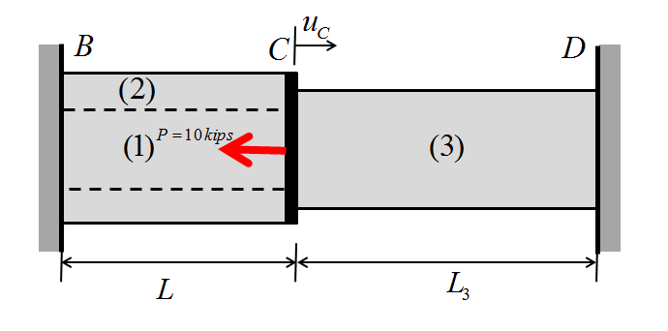

FBD:
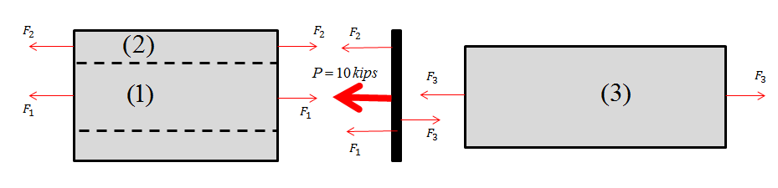

Force Balance Equation:
$$P+F_{2}+F_{1}-F_{3}=0$$
$$=>F_{1}+F_{2}-F_{3}=-10 kip$$

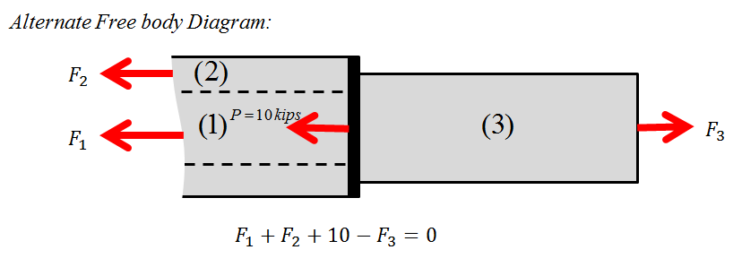
Geometric Compatibility:
$$δ_{1}=δ_{2}=-δ_{3}$$
Force Deformation:
$$δ_{1}=\frac{F_{1}L_{1}}{A_{1}E_{1}};δ_{2}=\frac{F_{2}L_{2}}{A_{2}E_{2}};δ_{3}=\frac{F_{3}L_{3}}{A_{3}E_{3}}$$
$$\frac{F_{3}-F_{2}-10}{A_{1}E_{1}}=\frac{F_{2}}{A_{2}E_{2}}$$
$1.795 F_{3}-2.795 F_{2}=17.95$ ……………………………………………………………………..(1)

$$\frac{F_{2}}{F_{3}}=-\left(\frac{L_{3}}{L_{2}}\right)\left(\frac{A_{2}}{A_{3}}\right)\left(\frac{E_{2}}{E_{3}}\right)=\left(\frac{40}{20}\right)\left(\frac{1.75}{{1.75}^{2}}\right)\left(\frac{15}{10}\right)=-1.7143$$
$F_{2}=-1.7143F_{3}$………………………………………………………..(2)
From (1) and (2),
$$F_{3}=2.725 kips$$
$F_{2}=-4.672 kips$
$F_{1}=-10-F_{2}+F_{3}=-2.608 kips$
$δ_{c}=\frac{F_{1}L_{1}}{A_{1}E_{1}}=\frac{-2.608*20}{\frac{π}{4}*{1.5}^{2}*6.5x{10}^{3}}=-4.54x{10}^{-3} in$
Displacement of point C
$u_{c}=-4.54x{10}^{-3}in$

Axial stress:
$$σ_{1}=\frac{F_{1}}{A_{1}}=-\frac{2.608}{\frac{π}{4}*{1.5}^{2}}=-1.476 ksi$$
$$σ_{2}=-\frac{4.672}{\frac{π}{4}*1.75}=-3.39 ksi$$
$$σ_{3}=\frac{2.725}{\frac{π}{4}*{1.75}^{2}}=1.133 ksi$$

