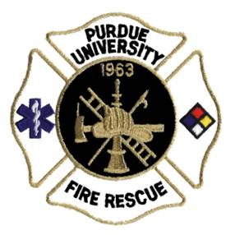
Off-Campus Housing Pre-Inspection Checklist
___ | Fire and Life Safety Resource Guidebook shall be current - showing all records of the past two years.
___ | No candles/open flames in any sleeping or dwelling room.
___ | No extension cords. Extension cords should not be used as permanent wiring and should not run through doorways, ceilings, or walls. Power strips with 15AMP protection are acceptable as long as no extension cords are plugged into them.
___ | Emergency exit maps shall be posted in all sleeping/dwelling rooms and designated locations. All doors outside of rooms should be properly numbered.
___ | The chapter should have documented fire drills and discuss emergency plan (EP).  Emergency plan shall be present in Tab 1 of Fire & Life Safety Resource Guidebook.
___ | All fire doors in hallways and (or) stairwells shall be in the closed position, unless on automatic closer.
___ | All fire doors shall be able to close and latch on their own. DO NOT PROP DOORS OPEN.
___ | All hallways and stairwells shall be free of all trash, storage and any obstructions.
___ | No combustibles shall be stored in or under any enclosed stairwell.
___ | All illuminated exit signs and emergency lights must be in working order with back- up power/ battery.
___ | Place new batteries in battery – operated smoke alarms at the beginning of each semester, or as needed. All battery – operated smoke alarms should be in working order.
___ | Combustible/flammable liquids (gas, motor oils, paint, etc.) should be stored in approved flammable cabinet or in an outdoor storage shed. Mechanical rooms (Electrical, Boiler, and Furnace) are not storage rooms.
___ | Regular housekeeping in laundry rooms, including cleaning lint traps and around dryers. Do not let it build up. Keep house clean and free of debris and trash.
___ | Keep all (interior and (or) exterior) exits clean and free of obstructions, trash or snow and ice.
Shall have regular inspections and maintenance on the following:
___ | Fire Extinguishers (annually)
___ | Fire Alarm System (annually)
___ | Sprinkler System (annually)
___ | Standpipe System (visual once a year/ Hydro tested every 5 years)
___ | Kitchen Hood Suppression System (every 6 months)
___ | Kitchen Hood Cleaning (6 months or more often as needed)
___ | Boiler/Pressure Vessel State Inspection (every 2 years)
___ | Wood Burning Fireplace Cleaning/Inspection (annually)
___ | Knox Box (keys should be up-to-date)
___ | Exterior emergency escapes shall be maintained and unobstructed (every 5 year examination)
 | Revised 12.2014

