Protecting Yourself against Coronavirus, Flu, and other Respiratory Illnesses
Updated March 12, 2020
For the past several weeks, the world’s attention has been focused on the novel (new) coronavirus (COVID-19) outbreak that has sickened nearly 130,000 people worldwide.
The Centers for Disease Control and Prevention (CDC) considers the disease a serious public health threat. Government, schools and universities, corporations, and organizations across the U.S. have implemented seemingly drastic measures to prevent the spread of the disease. Steps have included cancelling or postponing countless events, recommending “virtual work” from home or online education, and restricting travel. There is currently no vaccine for the COVID-19 coronavirus strain. The best way to prevent becoming infected continues to be to avoid being exposed to the virus.
Prevention methods for coronavirus are the same as those recommended for influenza and other illnesses. These methods include:
- Proper hygiene and sanitation
- Maintaining “social distance” to prevent spreading infection.
Hygiene & Sanitation
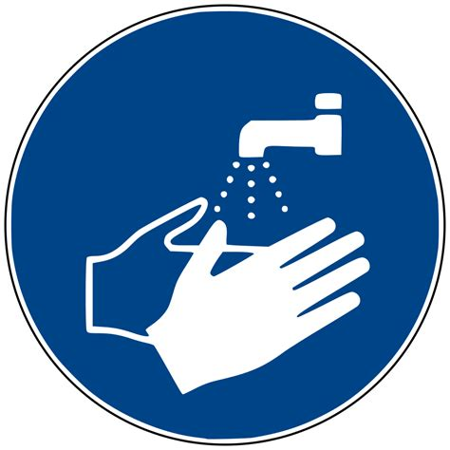
The CDC recommends the following everyday actions to reduce the risk of spreading coronavirus or other respiratory infections:
- Wash your hands often with soap and water for at least 20 seconds!!!
- Use an alcohol-based hand sanitizer that contains at least 60% alcohol if soap and water are not available.
- Avoid touching your eyes, nose, and mouth with unwashed hands.
- Cover your cough or sneeze with a tissue, then throw the tissue in the trash.
- Clean and disinfect frequently touched objects and surfaces.
Fig. 1. Regular handwashing is the most effective way to prevent illnesses from spreading!
Social Distancing
- Respect local, state, and federal government recommendations for self-quarantine, travel, attendance at work or recreational events, or school.
- Avoid close contact with people who are sick.
- Stay home from work, school, or social engagements when you are sick, and respectfully ask others to do the same.
- While the outbreak is flourishing, eliminate handshaking as a form of greeting, as disease pathogens are commonly carried on hands (Dietz and Black, 2012).
Fig. 2. Avoid unnecessary contact that allows disease spread.

Masks are NOT Usually Recommended to Prevent Infection
During disease events such as the current COVID-19 pandemic, or earlier outbreaks such SARS and MERS, news reports often feature images of people going about their daily business wearing surgical or dust masks to prevent illness. The current coronavirus outbreak has actually caused a shortage of such masks in many areas.
However, does wearing some type of surgical or dust mask really prevent infection? In most cases, the answer is no.
Typical surgical masks or dust masks simply do not fit tight enough to the wearer’s face to stop inhalation of airborne particles carrying the infectious virus. Any gaps will allow unfiltered, possibly contaminated air, to be inhaled. Also, dust “comfort” masks or surgical masks may not effectively filter small particles, even if fitted well to the wearer (U.S. Food and Drug Administration).
Surgical or dust “comfort” masks may be useful in helping prevent an already infected person from spreading a disease pathogen through sneezing or coughs. However, staying home and away from others if possible while sick is more effective!
There are respirator masks available that may have some effectiveness against coronavirus and other airborne infectious disease organisms, but only if worn correctly! The most common mask that has some effectiveness against airborne particles is known as the N-95 respirator. Although N-95 respirators may appear similar to nuisance dust masks, they have been certified by the National Institute for Occupational Safety and Health (NIOSH) to filter at least 95% of very small particles if properly fitted.
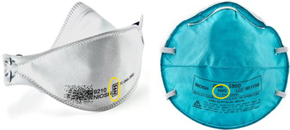
Various manufacturers produce N-95 respirators. NIOSH certified N-95 masks will be marked with a NIOSH logo. All are single-use, disposable devices. Follow manufacturer’s directions to ensure proper fit.
Respirator use may actually present health hazards to the wearer, as they make breathing more difficult. If you have any type of chronic respiratory or cardiac condition, please check with your doctor before using any type of respirator! If you are an employer, under current OSHA regulations you cannot assign your employees to wear an N-95 respirator without a physical examination or proper fit testing.
Fig. 2. Examples of NIOSH-approved N-95 respirators that may provide some protection against infection. Consult your doctor before using a respirator if you have cardiac or respiratory issues, and always follow manufacturer’s directions for proper fit.
In addition, wearing a respirator for an extended period of time (or not replacing disposable masks regularly) creates a moist “breeding ground” for bacteria. These germs are then recirculated through the wearer’s lungs, possibly increasing the chance for pneumonia or other illnesses.
Even if you do choose to wear a respirator, remember the most effective means of preventing the spread of coronavirus, the flu, or even the common cold, are regular handwashing and avoiding contact with infected people!
References:
Centers for Disease Control and Prevention, 2020, 2019 Novel Coronavirus, Wuhan, China. Accessed on January 31, 2020, at https://www.cdc.gov/coronavirus/2019-nCoV/index.html
U.S. Food & Drug Administration, Masks and N95 Respirators. Accessed January 31, 2020 at https://www.fda.gov/medical-devices/personal-protective-equipment-infection-control/masks-and-n95-respirators
Dietz, Eric J. and David R. Black, Editors. Pandemic Planning. Taylor & Francis, 2012.

