Step 1: Decision Tree

Determine whether you are looking for a service-learning course partnership, interns for your organization or volunteers to support your work. If it is service-learning, then you are in the right place!
- Service-Learning 101: Course-based, blend of learning and service, i.e., students apply classroom learning in a community setting to meet community needs.
- Internship 101: Learning-focused, i.e., job training and career networking. Learn more.
- Volunteering 101: Service-focused, i.e., serve a community or organization to further their mission. Learn more.

Step 2: Visit the Project Bulletin Board

The next step is to visit our Project Bulletin Board where you can find a partner looking to be matched with a course or instructor. Want to post to our Project Bulletin Board? To do so, share about your course via our Bulletin Board Submission Form, so we can make a post for you!

Step 3: Learn the Process

When setting up a service-learning course, it is critical to plan ahead. Like all successful relationships, service-learning partnerships take time and energy to truly grow into mutually beneficial, reciprocal relationships.
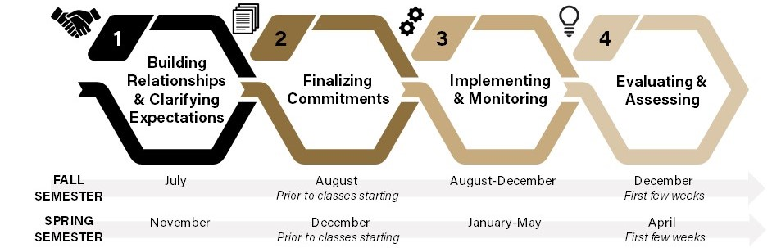

Partnership Checklist
Building Relationships & Clarifying Expectations
____ Connect with instructor/partner and foster a meaningful relationship
____ Share course/partner goals and clarify expectations, i.e., time commitments, classroom/site visits, level of students, draft syllabus
____ Establish communication plan, i.e., student contact frequency, instructor contact frequency, platform
____ Discuss funding, research opportunities, and IRB as needed
____ Connect with the Director of Service-Learning as needed for additional support

Finalizing Commitments
____ Complete appropriate forms and share with all partners, i.e., syllabus, learning contract, photograph release, background checks, etc.

Implementing & Monitoring
____ Conduct bi-weekly check-in's for new partnerships; mid-semester check-in's for advanced partnerships (instructor)
____ Meet with students to evaluate/adjust service (instructor)
____ Meet with partner to evaluate/adjust service (instructor)

Evaluating & Assessing
____ Conduct evaluation surveys, interviews, etc. with students, partners, instructor and for the partnership (Instructor evaluation; Student evaluation; Community Partner evaluation; and Partnership evaluation)
____ Host partnerships brief with all partners
____ Continue to build and foster the relationship as needed

