Standard Operating Procedure
Sodium Azide
This is an SOP template and is not complete until: 1) lab specific information is entered into the box below 2) lab specific protocol/procedure is added to the protocol/procedure section and
3) SOP has been signed and dated by the PI and relevant lab personnel.
Print a copy and insert into your Lab-Specific Chemical Hygiene Plan.

Section 1 – Lab-Specific Information
Building/Room(s) covered by this SOP: | Click here to enter text.
Department: | Click here to enter a date.
Principal Investigator Name: | Click here to enter text.
Principal Investigator Signature: | Click here to enter text.
Section 2 – Hazards
Sodium azide may be harmful if inhaled. It may cause respiratory tract, skin, and eye irritation and may be fatal if absorbed through skin or swallowed. Sodium azide can react with metal spatulas and metal lab equipment to form shock sensitive salts. Sodium azide reacts with Lead, Copper, Silver, Gold and metal halides to form heavy metal azides which are explosive. Additionally, contact with acids liberates toxic gas.
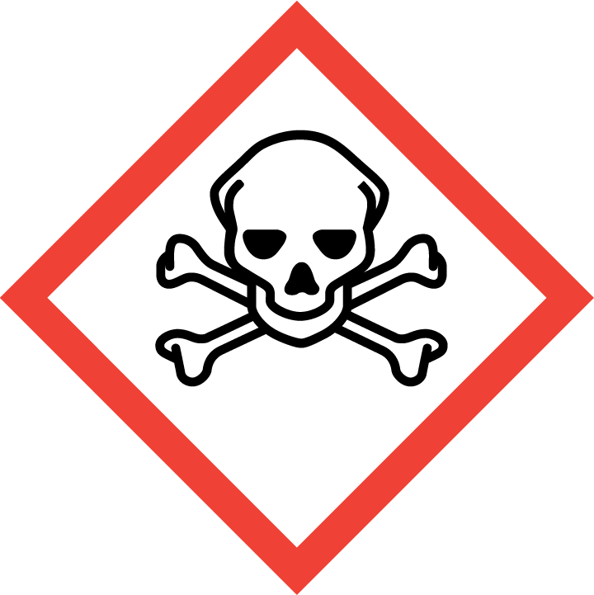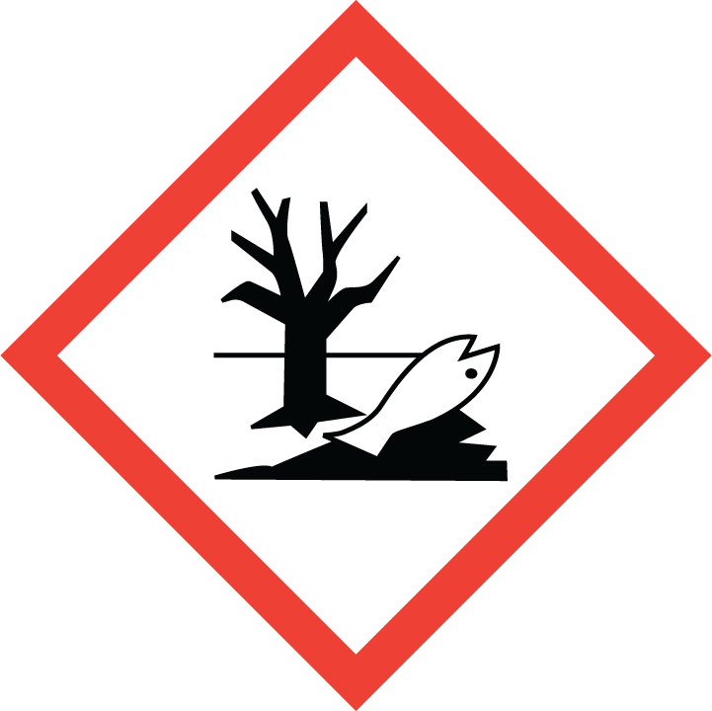
Section 3 – Engineering Controls and Personal Protective Equipment (PPE)
Engineering Controls: Use of sodium azide should be conducted in a properly functioning chemical fume hood whenever possible. The chemical fume hood must be approved and certified by REM and have a face velocity between 80 – 125 feet per minute.
Hygiene Measures: Avoid contact with skin, eyes, and clothing. Wash hands before breaks and immediately after handling the product.
Hand Protection: Chemical-resistant gloves must be worn, nitrile or chloroprene gloves are recommended. Double-gloving is recommended when working with pure sodium azide or sodium azide solutions greater than 5%. NOTE: Consult with your preferred glove manufacturer to ensure that the gloves you plan on using are compatible with the specific chemical being used.
Eye Protection: ANSI approved properly fitting safety glasses or chemical splash goggles are required. A face shield may also be appropriate depending on the specific application.
Skin and Body Protection: Laboratory coats must be worn and be appropriately sized for the individual and buttoned to their full length. Personnel must also wear full length pants, or equivalent, and close-toed shoes. Full length pants and close-toed shoes must be worn at all times by all individuals that are occupying the laboratory area. The area of skin between the shoe and ankle must not be exposed.
Respiratory Protection: If sodium azide is being used outside of a chemical fume hood, respiratory protection may be required. If this activity is necessary, contact REM (4-6371) so a respiratory protection analysis can be performed.
Section 4 – Special Handling and Storage Requirements
- Do not over purchase; only purchase what can be safely stored in the laboratory.
- Any expired or unnecessary sodium azide should be properly disposed of as hazardous waste.
- Pure sodium azide should be clearly labeled with the original manufacturer’s label, which should have the chemical name, hazard labels, and pictograms. The label should not be defaced in any way.
- Make stock solutions of 10%, if possible, to minimize potential accidents.
- Whenever handling pure sodium azide powder or concentrated solutions of ≥10% that may require assistance in case of a spill or accident, it is recommended that a second trained individual be present in the lab or in the vicinity.
- Store sodium azide in secondary containment with “Acute Toxin” label on the primary container, secondary containment and the storage location.
- Do not store on metal shelves or use metal items (spatulas) to handle sodium azide.
- Keep containers tightly closed. Store in a cool, dry, and well-ventilated area away from incompatible substances such as metals, acids, carbon disulfide, bromine, chromyl chloride, sulfuric acid, nitric acid, hydrazine, and dimethyl sulfate.
- Avoid contact with skin, eyes, and inhalation. Avoid formation of dusts and aerosols.
Section 5 – Spill and Accident Procedures
Immediately evacuate area and ensure others are aware of the spill. If there is an imminent threat of a fire, pull the nearest fire alarm station to evacuate the building and dial 911. If personnel have become exposed and need medical assistance, dial 911. If the spill is minor and does not pose a threat to personnel, contact REM at 49-40121 during normal business hours (Monday – Friday, 7 AM – 4 PM) for spill cleanup assistance (dial 911 if spill occurs after hours and assistance is needed).
Section 6 – Waste Disposal Procedures
Store hazardous waste in closed containers that are properly labeled, and in a designated area (flammable cabinet is recommended) away from incompatible chemicals such as metals and those listen above. Complete a Chemical Waste Pickup Request Form to arrange for disposal by REM; detailed instructions are provided at the following link: http://www.purdue.edu/ehps/rem/hmm/chemwaste.htm.
Section 7 – Protocol (Additional lab protocol may be added here)
Click here to enter text.
NOTE: Any deviation from this SOP requires approval from PI.
Section 8 – Documentation of Training (signature of all users is required)
Prior to conducting any work with sodium azide, the Principal Investigator must ensure that all laboratory personnel receive training on the content of this SOP.
I have read and understand the content of this SOP:
Name | Signature | Date
Click here to enter text. |  | Click here to enter a date.
Click here to enter text. |  | Click here to enter a date.
Click here to enter text. |  | Click here to enter a date.
Click here to enter text. |  | Click here to enter a date.
Click here to enter text. |  | Click here to enter a date.
Click here to enter text. |  | Click here to enter a date.
Click here to enter text. |  | Click here to enter a date.
Click here to enter text. |  | Click here to enter a date.

