Standard Operating Procedure
Propylene Oxide
This is an SOP template and is not complete until: 1) lab specific information is entered into the box below 2) lab specific protocol/procedure is added to the protocol/procedure section and
3) SOP has been signed and dated by the PI and relevant lab personnel.
Print a copy and insert into your Lab-Specific Chemical Hygiene Plan.
Section 1 – Lab-Specific Information
Building/Room(s) covered by this SOP: | Click here to enter text.
Department: | Click here to enter a date.
Principal Investigator Name: | Click here to enter text.
Principal Investigator Signature: | Click here to enter text.
Section 2 – Potential Hazards
Propylene oxide is an extremely flammable liquid that is also an acute toxin. Exposure to propylene oxide is extremely harmful. Causes skin irritation and serious eye damage. May cause genetic defects and cancer. Propylene oxide is toxic to lungs, mucous membranes, and repeated or prolonged exposure can produce targeted organ damage. Chronic exposure may cause nausea, vomiting, headache, and/or dizziness.
Exposure Limits and Toxicity Data:
ACGIH TLV/TWA: 2 ppm
LD-50 (oral, rat): 380 mg/kg
LD-50 (inhalation, rat): 4,000 ppm
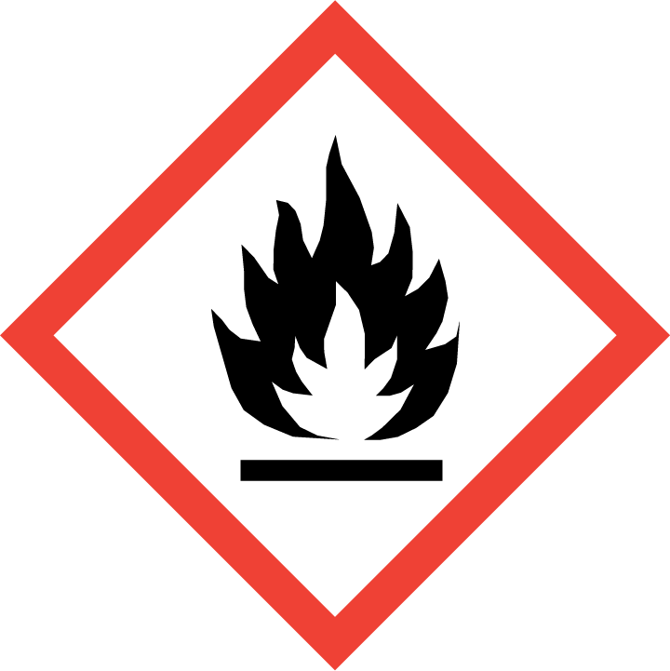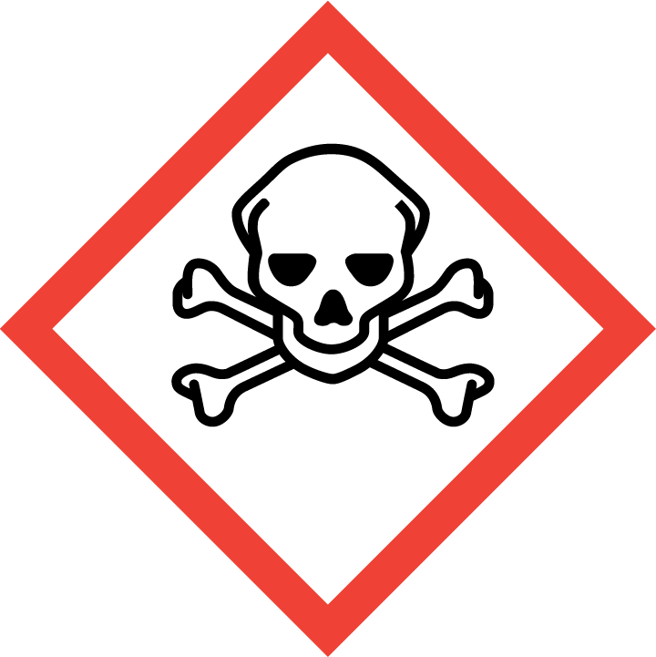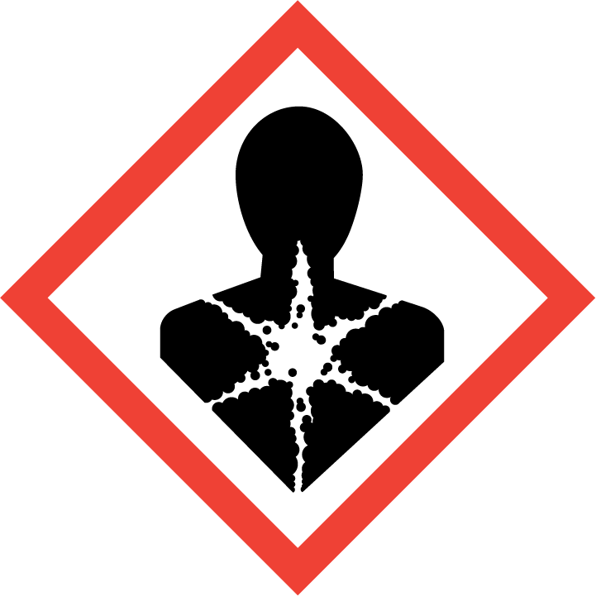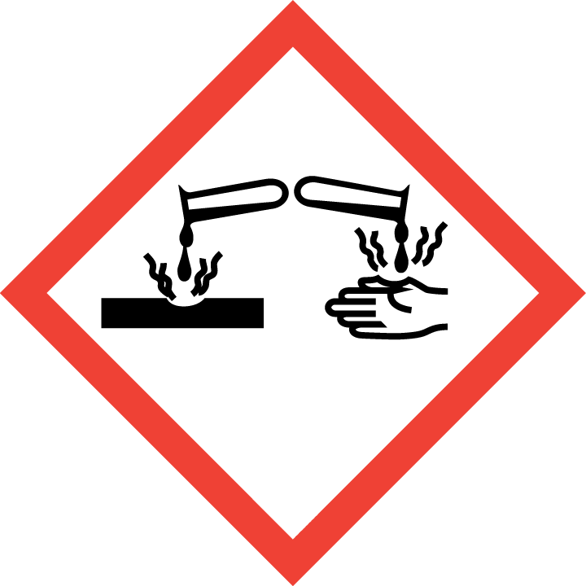
Section 3 – Engineering Controls and Personal Protective Equipment (PPE)
Engineering Controls: Use of propylene oxide must be conducted in a properly functioning chemical fume hood. The chemical fume hood must be approved and certified by REM and have a face velocity between 80 – 125 feet per minute.
Hygiene Measures: Avoid contact with skin, eyes, and clothing. Wash hands before breaks and immediately after handling the product.
Hand Protection: Chemical-resistant gloves must be worn, nitrile gloves are recommended for low volume applications. . Butyl rubber gloves are recommended for larger quantities. NOTE: Consult with your preferred glove manufacturer to ensure that the gloves you plan on using are compatible with the specific chemical being used.
Eye Protection: ANSI approved properly fitting safety glasses or chemical splash goggles are required. A face shield may also be appropriate depending on the specific application.
Skin and Body Protection: Laboratory coats must be worn and be appropriately sized for the individual and buttoned to their full length. Flame resistant lab coats should be worn if handling more than 1 liter of propylene oxide. Personnel must also wear full length pants, or equivalent, and close-toed shoes. Full length pants and close-toed shoes must be worn at all times by all individuals that are occupying the laboratory area. The area of skin between the shoe and ankle must not be exposed.
Respiratory Protection: If chemical is being used outside of a chemical fume hood, respiratory protection may be required. If this activity is necessary, contact REM (4-6371) so a respiratory protection analysis can be performed.
Section 4 – Special Handling and Storage Requirements
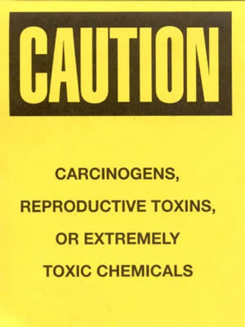
- A designated storage area must be established for propylene oxide and the area should be posted with a “Caution, Carcinogen, Reproductive Toxins, or Extremely Toxic Chemicals” label provided by REM (as shown to the right).
- Avoid contact with skin and eyes and inhalation.
- Avoid formation of vapors, mists, or gas.
- Keep away from sources of ignition.
- Take precautionary measures against static discharge.
- Keep containers tightly closed.
- Store in a cool, dry and well-ventilated area away from incompatible substances such as oxidizers.
- A suitable storage location is a flammable storage cabinet that does not contain incompatibles such as oxidizers, strong acids and bases, amines, and copper.
Section 5 – Spill and Accident Procedures
Immediately evacuate area and ensure others are aware of the spill. If there is an imminent threat of a fire, pull the nearest fire alarm station to evacuate the building and dial 911. If personnel have become exposed and need medical assistance, dial 911. If the spill is minor and does not pose a threat to personnel, contact REM at 49-40121 during normal business hours (Monday – Friday, 7 AM – 4 PM) for spill cleanup assistance (dial 911 if spill occurs after hours and assistance is needed).
Section 6 – Waste Disposal Procedures
Store hazardous waste in closed containers that are properly labeled, and in a designated area (flammable cabinet is recommended) away from incompatible chemicals. Complete a Chemical Waste Pickup Request Form to arrange for disposal by REM; detailed instructions are provided at the following link: http://www.purdue.edu/ehps/rem/hmm/chemwaste.htm.
Section 7 – Protocol (Add lab specific Protocol/Procedure here)
Click here to enter text.
NOTE: Any deviation from this SOP requires approval from PI.

Section 8 – Documentation of Training (signature of all users is required)
Prior to conducting any work with propylene oxide, the Principal Investigator must ensure that all laboratory personnel receive training on the content of this SOP.
I have read and understand the content of this SOP:
Name | Signature | Date
Click here to enter text. |  | Click here to enter a date.
Click here to enter text. |  | Click here to enter a date.
Click here to enter text. |  | Click here to enter a date.
Click here to enter text. |  | Click here to enter a date.
Click here to enter text. |  | Click here to enter a date.
Click here to enter text. |  | Click here to enter a date.
Click here to enter text. |  | Click here to enter a date.
Click here to enter text. |  | Click here to enter a date.
Click here to enter text. |  | Click here to enter a date.
Click here to enter text. |  | Click here to enter a date.
Click here to enter text. |  | Click here to enter a date.

