Standard Operating Procedure
Potassium Cyanide
This is an SOP template and is not complete until: 1) lab specific information is entered into the box below 2) lab specific protocol/procedure is added to the protocol/procedure section and
3) SOP has been signed and dated by the PI and relevant lab personnel.
Print a copy and insert into your Lab-Specific Chemical Hygiene Plan.
Section 1 – Lab-Specific Information
Building/Room(s) covered by this SOP: | Click here to enter text.
Department: | Click here to enter a date.
Principal Investigator Name: | Click here to enter text.
Principal Investigator Signature: | Click here to enter text.
Section 2 – Hazards
Potassium cyanide is an acute and chronic toxin. It is extremely harmful, possibly fatal, if inhaled, ingested, or in contact with the skin or eyes. It causes damage to organs through prolonged or repeated exposure. It presents toxicity by skin absorption through open wounds and by inhalation or dust. This substance inhibits cellular respiration, which leads to anoxia and may be corrosive to metals. Potassium cyanide exposed to acid liberates hydrogen cyanide, which is an acutely toxic and deadly gas.
If swallowed, can cause tissue anoxia characterized by weakness, headache, dizziness, confusion, cyanosis (bluish skin due to deficient oxygenation of the blood), weak and irregular heartbeat, collapse, unconsciousness, convulsions, coma and death. Inhalation of high concentrations may cause central nervous system effects and can be fatal. Prolonged/repeated exposure may cause skin necrosis and ulceration of the skin. Cyanide acts by inhibiting cytochrome oxidase impairing cellular respiration. Chronic exposure to cyanide solutions may lead to “cyanide rash” with itching and vesicular eruptions with secondary infection. Small amounts of cyanide over long periods of time cause loss of appetite, headache, weakness, and respiratory irritation.
Exposure Limits:
OSHA PEL (8 HR. TWA): 5 mg/m³
IDLH: 25 mg/m³

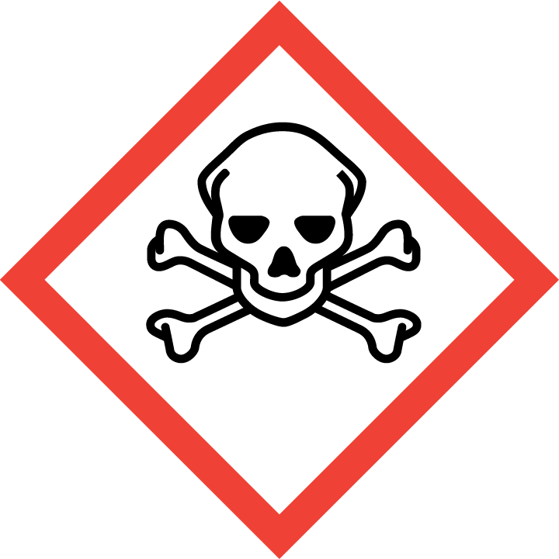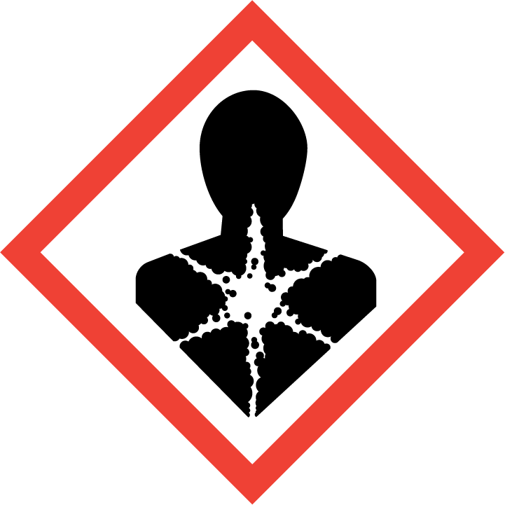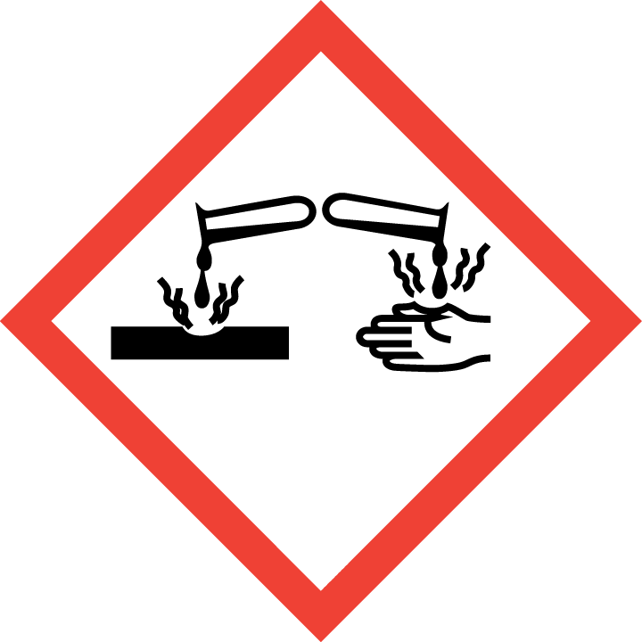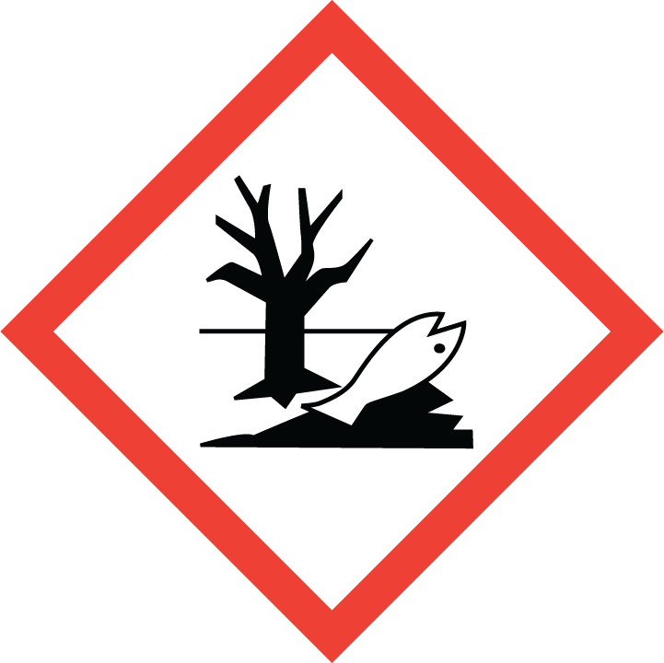

Section 3 – Engineering Controls and Personal Protective Equipment (PPE)
Engineering Controls: Use of potassium cyanide must be conducted in a properly functioning chemical fume hood. The chemical fume hood must be approved and certified by REM and have a face velocity between 80 – 125 feet per minute.
Hygiene Measures: Wash thoroughly and immediately after handling. Remove any contaminated clothing and wash before reuse.
Hand Protection: Gloves must be worn. Nitrile gloves are recommended and have been shown to provide excellent protection against potassium cyanide. The user should wear two pairs of gloves as a precautionary measure. NOTE: Consult with your preferred glove manufacturer to ensure that the gloves you plan on using are compatible with the specific chemical being used.
Eye Protection: ANSI approved properly fitting safety glasses or chemical splash goggles are required. A face shield may also be appropriate depending on the specific application.
Skin and Body Protection: Lab coats must be worn and be appropriately sized for the individual and buttoned to their full length. Laboratory coat sleeves must be of sufficient length to prevent skin exposure while wearing gloves. Personnel must also wear full length pants, or equivalent, and close-toed shoes. Full length pants and close-toed shoes must be worn at all times by all individuals that are occupying the laboratory area. The area of skin between the shoe and ankle must not be exposed.
Respiratory Protection: If potassium cyanide is being used outside of a chemical fume hood, respiratory protection may be required. If this activity is necessary, contact REM (4-6371) so a respiratory protection analysis can be performed.
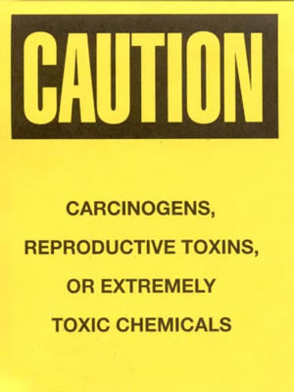
Section 4 – Special Handling and Storage Requirements
- A designated storage area must be established for potassium cyanide and the area should be posted with a “Caution, Carcinogen, Reproductive Toxins, or Extremely Toxic Chemicals” label provided by REM (as shown to the right). The container(s) should be placed into secondary containment.
- All personnel working in the lab should be made aware of the storage location and the hazards associated with potassium cyanide.
- Potassium cyanide must only be used in a properly functioning chemical fume hood.
- Avoid contact with skin and eyes and inhalation.
- Avoid dust formation or breathing vapors, mists, or gas.
- Keep away from acids.
- Keep containers tightly closed.
- Store in a cool, dry and well-ventilated area away from incompatible substances such as acids, strong oxidizing agents, iodine, permanganates, peroxides, metallic salts, chloral hydrate, alkaloids, and chlorates.
- Containers which are opened must be carefully resealed and kept upright to prevent leakage.
- A suitable storage location is a lab cabinet that does not contain incompatible chemicals.
Section 5 – Spill and Accident Procedures
Immediately evacuate area and ensure others are aware of the spill. If there is an imminent threat of a fire, pull the nearest fire alarm station to evacuate the building and dial 911. If personnel have become exposed and need medical assistance, dial 911. If the spill is minor and does not pose a threat to personnel, contact REM at 49-40121 during normal business hours (Monday – Friday, 7 AM – 4 PM) for spill cleanup assistance (dial 911 if spill occurs after hours and assistance is needed).
Section 6 – Waste Disposal Procedures
Store hazardous waste in closed containers, and in a designated area (flammable cabinet or lab cabinet is recommended). Never combine cyanide waste streams with acid waste streams as this will generate an acutely toxic gas. Do not combine cyanide waste with other waste streams such as organic solvent waste; the disposal cost is extremely high. Keep cyanide waste separated from other wastes as much as possible. Complete a Chemical Waste Pickup Request Form to arrange for disposal by REM; detailed instructions are provided at the following link: http://www.purdue.edu/ehps/rem/hmm/chemwaste.htm.
Section 7 – Protocol (Add lab specific Protocol here)
Click here to enter text.
NOTE: Any deviation from this SOP requires approval from Principal Investigator.
Section 8 – Documentation of Training (signature of all users is required)
Prior to conducting any work with potassium cyanide, the Principal Investigator must ensure that all laboratory personnel receive training on the content of this SOP.
I have read and understand the content of this SOP:
Name | Signature | Date
Click here to enter text. |  | Click here to enter a date.
Click here to enter text. |  | Click here to enter a date.
Click here to enter text. |  | Click here to enter a date.
Click here to enter text. |  | Click here to enter a date.
Click here to enter text. |  | Click here to enter a date.
Click here to enter text. |  | Click here to enter a date.

