Standard Operating Procedure
Peroxide-Forming Chemicals
This is an SOP template and is not complete until: 1) lab specific information is entered into the box below 2) lab specific protocol is added to the protocol section and
3) SOP has been signed and dated by the PI and relevant lab personnel.
Print a copy and insert into your Lab-Specific Chemical Hygiene Plan.

Section 1 – Lab-Specific Information
Building/Room(s) covered by this SOP: | Click here to enter text.
Department: | Click here to enter a date.
Principal Investigator Name: | Click here to enter a date.
Principal Investigator Signature: | Click here to enter text.

Section 2 – Important Definitions
The following information is taken from Appendix C of the Chemical Hygiene Plan (CHP). The CHP is available on the Purdue REM web-site: https://www.purdue.edu/ehps/rem/documents/programs/chp2014.pdf
Autoxidation in common laboratory solvents can lead to unstable and potentially explosive peroxide formation. The reaction can be initiated by exposure to air, heat, light, or contaminants. Most of these solvents are available with inhibitors to slow the peroxide formation. Examples of inhibitors include BHT (2,6-di-tert-butyl-4-methyl phenol) and Hydroquinone. There are three categories of peroxide formers:
Group A chemicals are those which form explosive levels of peroxides after prolonged storage, especially after exposure to air without concentration. Test these for peroxide formation before using and discard 3 months after opening.
Table C.1 – Group A Chemicals
Butadiene | Isopropyl ether
Chloroprene | Tetrafluoroethylene
Divinylacetylene | Vinylidine chloride

Group B chemicals form peroxides that are hazardous only on concentration by distillation or evaporation. Test these before distillation and discard after 12 months.
Table C.2 – Group B Chemicals
Acetal | Dicyclopentadiene | Methyl isobutyl ketone
Acetaldehyde | Diethyl ether | 4-Methyl-2-pentanol
Benzyl alcohol | Diethylene glycol dimethyl ether | 2-Pentanol
2-Butanol | Dioxane | 4-Penten-1-ol
Cumene | Ethylene glycol dimethyl ether | 1-Phenylethanol
Cyclohexanol | 4-Heptanol | 2-Phenylethanol
2-cyclohexen-1-ol | 2-Hexanol | 2-Propanol
Cyclohexene | Methylacetylene | Tetrahydrofuran
Decahydronaphthalene | 3-Methyl-1-butanol | Tetrahydronaphthalene
Diacetylene | Methylcyclopentane | Vinyl ether
Group C chemicals consist of monomers which form peroxides that can initiate explosive polymerization. Inhibited monomers should be tested before use and discarded after 12 months. Uninhibited monomers should be discarded 24 hours after opening.
Table C.3 – Group C Chemicals
Acrylic acid | Styrene
Acrylonitrile | Tetrafluoroethylene
Butadiene | Vinyl acetate
Chloroprene | Vinyl acetylene
Chlorotrifluoroethylene | Vinyl chloride
Methyl methacrylate | Vinyl pyridine

Section 3 – Hazards
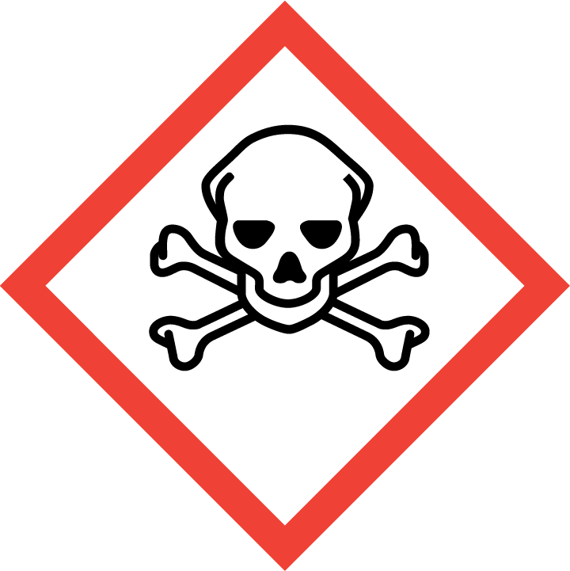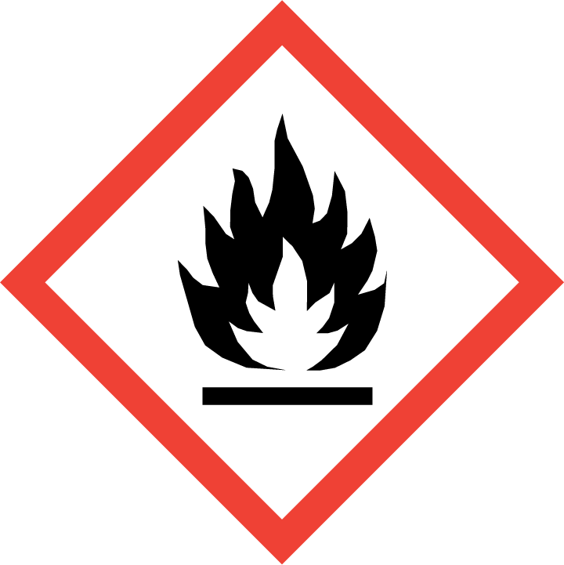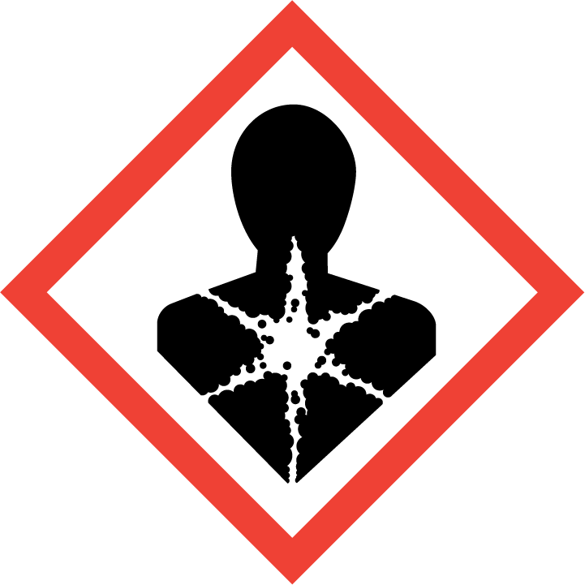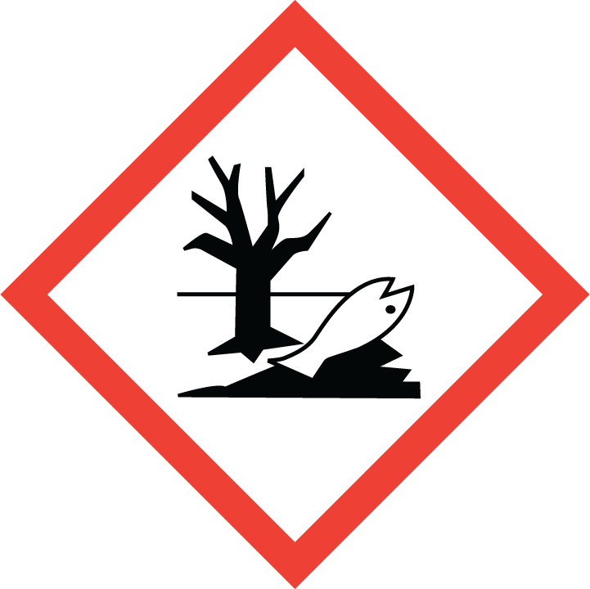
Hazards can vary based on the specific peroxide-forming solvent. Review the SDS for that chemical for accurate information.
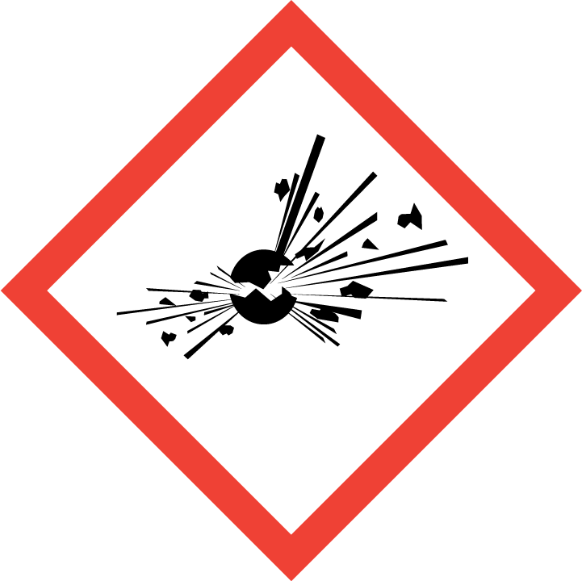
If organic peroxides have formed, an explosive hazard may be present.

Section 4 – Engineering and Personal Protective Equipment (PPE)
Engineering Controls: Use of any solvent should be conducted in a properly functioning chemical fume hood whenever possible. The chemical fume hood must be approved and certified by REM and have a face velocity between 80 – 125 feet per minute.
Hygiene Measures: Avoid contact with skin, eyes, and clothing. Wash hands before breaks and immediately after handling the product.
Hand Protection: Chemical-resistant gloves must be worn, nitrile gloves are recommended for low volume applications. For high volume applications, disposable gloves are not appropriate; a heavy-duty glove is required such as butyl rubber, Viton, or equivalent. NOTE: Consult with your preferred glove manufacturer to ensure that the gloves you plan on using are compatible with the specific chemical being used.
Eye Protection: ANSI approved properly fitting safety glasses or chemical splash goggles are required. A face shield may be required for high volume applications.
Skin and Body Protection: Laboratory coats must be worn and be appropriately sized for the individual and buttoned to their full length. For high volume applications, additional PPE such as a chemical-resistant apron may be required. Personnel must also wear full-length pants, or equivalent, and close-toed shoes. Full-length pants and close-toed shoes must be worn at all times by all individuals that are occupying the laboratory area. The area of skin between the shoe and ankle must not be exposed.
Respiratory Protection: If peroxide-forming chemicals are being used outside of a chemical fume hood, respiratory protection may be required. If this activity is necessary, contact REM (49-46371) so a respiratory protection analysis can be performed.

Section 5 – Special Handling and Storage Requirements
Purchasing
- Do not over purchase; only purchase what can be safely stored in the laboratory. Peroxide-forming chemicals typically have a short shelf life. They should only be purchased in quantities than can be used within a short time-period.
- Whenever possible, purchase peroxide-forming compounds with inhibitors.
- Mark the receipt and opening dates on the container.
Storage
- If possible, store peroxide-forming solvents at low temperatures. These chemicals should never be frozen.
- These should be stored in air-tight, light-resistant containers.
- Containers should be stored upright and all efforts should be made to ensure evaporation cannot occur.
- Separate peroxide-forming chemicals from light, heat, direct sunlight, sources of ignition, oxidizers, and oxidizing agents.
Testing
- Peroxide-forming chemicals should be regularly tested for organic peroxides. The lab should determine a testing schedule that is applicable to the chemicals used in the lab.
- Obtain test strips for the range of 0-100 ppm peroxide.
- Record the test results on the bottle.
- If the test results are 100 ppm or greater, contact REM at (765) 494-0121 for proper disposal.

Section 6 – Spill and Accident Procedures
Immediately evacuate area and ensure others are aware of the spill. If there is an imminent threat of a fire, pull the nearest fire alarm station to evacuate the building and dial 911. If personnel have become exposed and need medical assistance, dial 911. If the spill is minor and does not pose a threat to personnel, contact REM at 49-40121 during normal business hours (Monday – Friday, 7 AM – 4 PM) for spill cleanup assistance (dial 911 if spill occurs after hours and assistance is needed).

Section 7 – Waste Disposal Procedures
Peroxide forming chemicals should be submitted as hazardous waste when they have expired. Do not move or open any peroxide-forming chemical or container of unknown age or origin. If solid is present in the container, contact REM at (765) 494-0121 immediately for guidance.
Store hazardous waste in closed containers that are properly labeled, and in a designated area. Complete a Chemical Waste Pickup Request Form to arrange for disposal by REM; detailed instructions are provided at the following link: https://www.purdue.edu/ehps/rem/waste/hazwaste.html.

Section 8 – Protocol (Additional lab protocol may be added here)
Click here to enter text.
NOTE: Any deviation from this SOP requires approval from Principal Investigator.

Section 9 – Documentation of Training (signature of all users is required)
Prior to conducting any work with peroxide formers, the Principal Investigator must ensure that all laboratory personnel receive training on the content of this SOP.
I have read and understand the content of this SOP:
Name | Signature | Date
Click here to enter text. |  | Click here to enter a date.
Click here to enter text. |  | Click here to enter a date.
Click here to enter text. |  | Click here to enter a date.
Click here to enter text. |  | Click here to enter a date.
Click here to enter text. |  | Click here to enter a date.

