Standard Operating Procedure
Perfluorodecyltrichlorosilane (FDTS)
This is an SOP template and is not complete until: 1) lab specific information is entered into the box below 2) lab specific protocol/procedure is added to the protocol/procedure section and
3) SOP has been signed and dated by the PI and relevant lab personnel.
Print a copy and insert into your Lab-Specific Chemical Hygiene Plan.

Section 1 – Lab-Specific Information
Building/Room(s) covered by this SOP: | Click here to enter text.
Department: | Click here to enter a date.
Principal Investigator Name: | Click here to enter text.
Principal Investigator Signature: | Click here to enter text.

Section 2 – Hazards
FDTS is corrosive and reacts violently with water. It is harmful if inhaled, ingested, or absorbed through the skin. Inhalation may cause irritation to the respiratory tract with burning pain in the nose and throat, coughing, wheezing, shortness of breath, and pulmonary edema. Decomposition products include toxic, corrosive gases such as hydrogen fluoride and hydrogen chloride. Contact with skin causes burns and irritation. Blistering may occur. Progressive ulceration may occur if treatment is not immediate. Eye contact causes burns, irritation, and may cause permanent damage. Ingestion may cause corrosive burns to appear around the lips. Blood may be vomited. There may be bleeding from the mouth or nose. Permanent damage to the digestive tract could occur. FDTS is destructive to the tissue of the mucous membranes and upper respiratory tract.
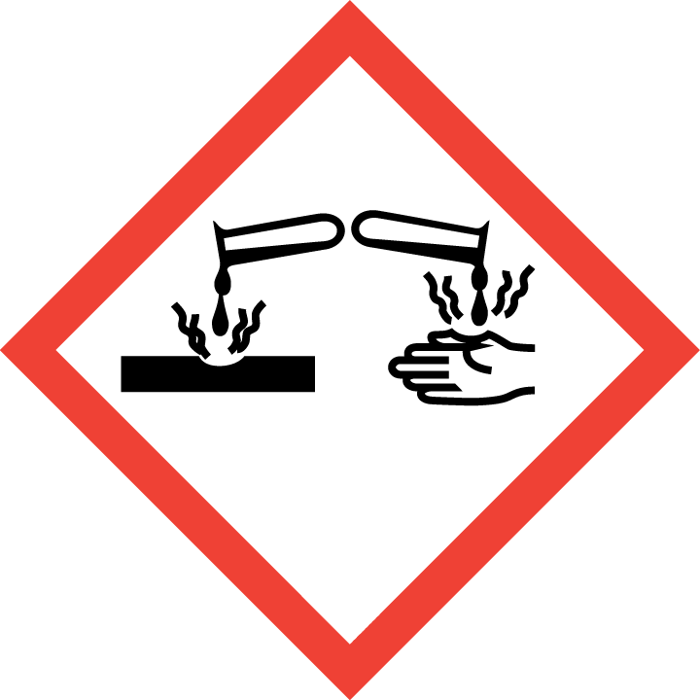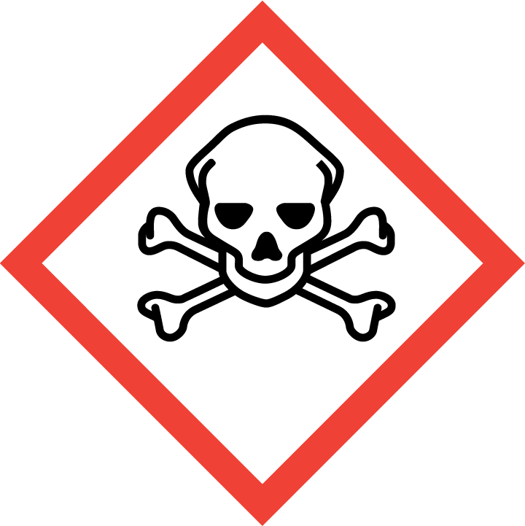
Section 3 – Engineering Controls and Personal Protective Equipment (PPE)
Engineering Controls: Use of FDTS should be conducted in a properly functioning chemical fume hood whenever possible. Avoid inhalation of vapor or mist. The chemical fume hood must be approved and certified by REM and have a face velocity between 80 – 125 feet per minute. Depending on the specific procedure being conducted, a glove box may be necessary.
Hygiene Measures: Avoid contact with skin, eyes, and clothing. Wash hands before breaks and immediately after handling the product.
Hand Protection: Chemical-resistant gloves must be worn, nitrile gloves are recommended. NOTE: Consult with your preferred glove manufacturer to ensure that the gloves you plan on using are compatible with the specific chemical being used.
Eye Protection: ANSI approved properly fitting safety glasses or chemical splash goggles are required. A face shield may also be appropriate depending on the specific application.
Skin and Body Protection: Laboratory coats must be worn and be appropriately sized for the individual and buttoned to their full length. Personnel must also wear full length pants, or equivalent, and close-toed shoes. Full length pants and close-toed shoes must be worn at all times by all individuals that are occupying the laboratory area. The area of skin between the shoe and ankle must not be exposed.
Respiratory Protection: If FDTS is being used outside of a chemical fume hood, respiratory protection may be required. If this activity is necessary, contact REM (4-6371) so a respiratory protection analysis can be performed.

Section 4 – Special Handling and Storage Requirements
- Do not over purchase; only purchase what can be safely stored in the laboratory.
- Avoid contact with skin and eyes. Avoid formation or inhalation of vapor or mist.
- Ensure there is sufficient ventilation of the area. Do not handle in a confined space.
- Always use inside a chemical fume hood. Decomposition products include hydrogen fluoride and hydrogen chloride, both highly corrosive and toxic. Use extreme caution.
- Do not allow water to get into the container because of a reaction. Store under Argon.
- Do not use with metal spatula or other metal items.
- Avoid heat, moist air, and humidity.
- Use in the smallest practical quantities for the experiment being performed.
- Keep container upright & tightly closed in a dry and well-ventilated place.
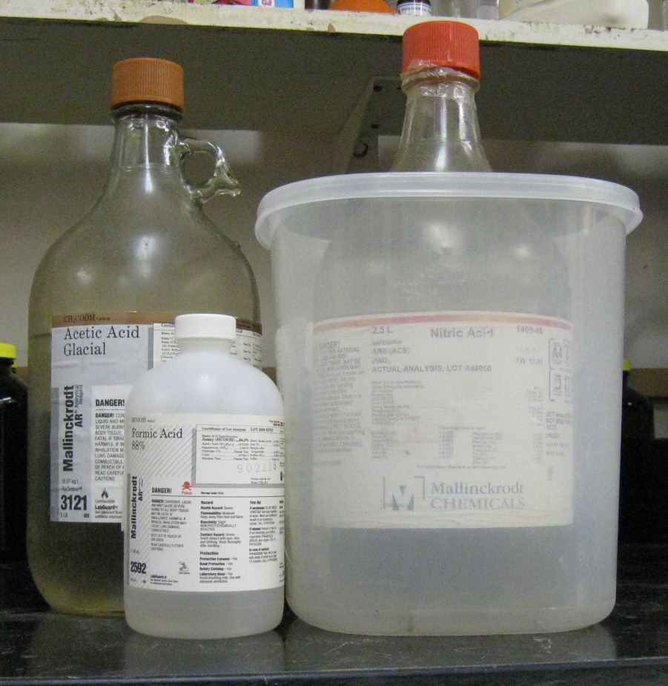
- Containers which are opened must be carefully resealed and kept upright to prevent leakage.
- Store in original container.
- FDTS must be segregated from incompatible materials, such as strong oxidizing agents and strong acids.
- Containers should be labeled appropriately; the original manufacturer’s label is acceptable. Label should indicate the name of the chemical(s) in the container. Avoid using chemical abbreviations (acceptable if a legend is present in the lab) and formulae.
- Transport all corrosives in secondary containment, such as polyethylene or other non-reactive acid/solvent bottle carrier.
Section 5 – Spill and Accident Procedures
Immediately evacuate area and ensure others are aware of the spill. If there is an imminent threat of a fire, pull the nearest fire alarm station to evacuate the building and dial 911. If personnel have become exposed and need medical assistance, dial 911. If the spill is minor and does not pose a threat to personnel, contact REM at 49-40121 during normal business hours (Monday – Friday, 7 AM – 4 PM) for spill cleanup assistance (dial 911 if spill occurs after hours and assistance is needed).

Section 6 – Waste Disposal Procedures
FDTS waste cannot be disposed of down the drain. When possible, do not mix acidic and basic waste streams. Store hazardous waste in closed containers that are properly labeled, and in a designated area (flammable cabinet is recommended) away from incompatible chemicals such as oxidizers and bases. Complete a Chemical Waste Pickup Request Form to arrange for disposal by REM; detailed instructions are provided at the following link: http://www.purdue.edu/ehps/rem/hmm/chemwaste.htm.

Section 7 – Protocol (Additional lab protocol may be added here)
Click here to enter text.
NOTE: Any deviation from this SOP requires approval from PI.

Section 8 – Documentation of Training (signature of all users is required)
Prior to conducting any work with FDTS, the Principal Investigator must ensure that all laboratory personnel receive training on the content of this SOP.
I have read and understand the content of this SOP:
Name | Signature | Date
Click here to enter text. |  | Click here to enter a date.
Click here to enter text. |  | Click here to enter a date.
Click here to enter text. |  | Click here to enter a date.
Click here to enter text. |  | Click here to enter a date.
Click here to enter text. |  | Click here to enter a date.
Click here to enter text. |  | Click here to enter a date.
Click here to enter text. |  | Click here to enter a date.
Click here to enter text. |  | Click here to enter a date.
Click here to enter text. |  | Click here to enter a date.
Click here to enter text. |  | Click here to enter a date.

