Standard Operating Procedure
Osmium Tetroxide
This is an SOP template and is not complete until: 1) lab specific information is entered into the box below 2) lab specific protocol/procedure is added to the protocol/procedure section and
3) SOP has been signed and dated by the PI and relevant lab personnel.
Print a copy and insert into your Lab-Specific Chemical Hygiene Plan.
Section 1 – Lab-Specific Information
Building/Room(s) covered by this SOP: | Click here to enter text.
Department: | Click here to enter a date.
Principal Investigator Name: | Click here to enter text.
Principal Investigator Signature: | Click here to enter text.
Section 2 – Hazards
Osmium tetroxide is highly toxic and can be fatal if swallowed. It causes severe skin burns and eye damage. Eye exposure symptoms generally begin with eye irritation, lacrimation, and a gritty feeling. It may cause allergy or asthma symptoms or breathing difficulties if inhaled. Osmium tetroxide is an oxidizer.
Exposure Limit:
ACGIH TLV/TWA: 0.0002 ppm
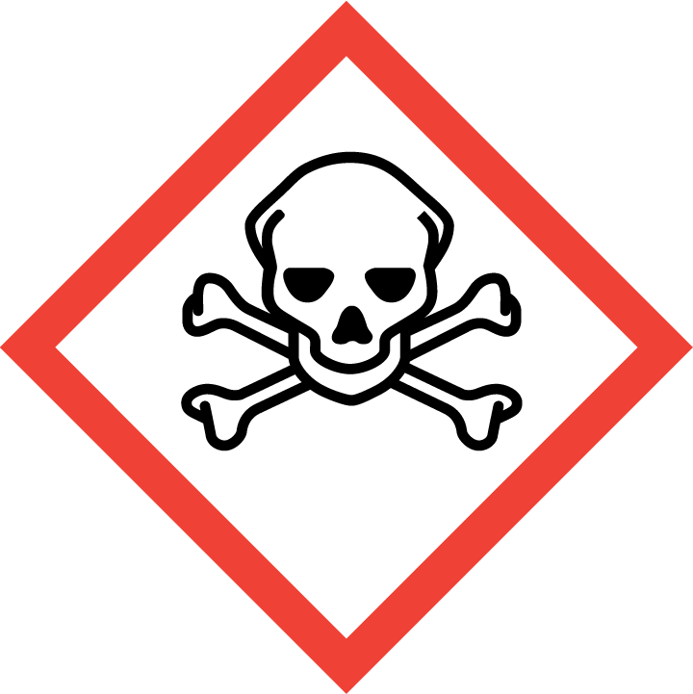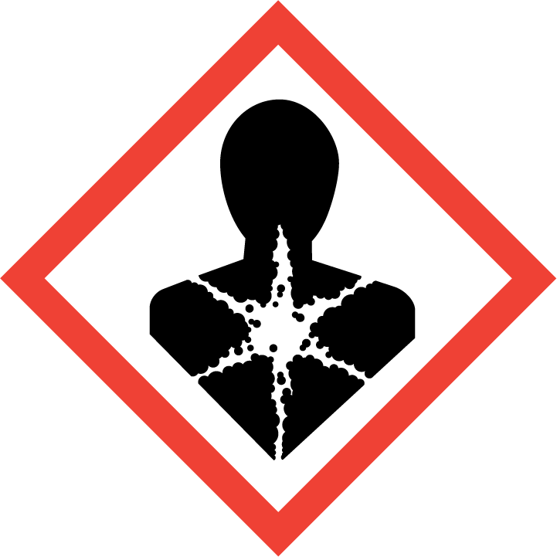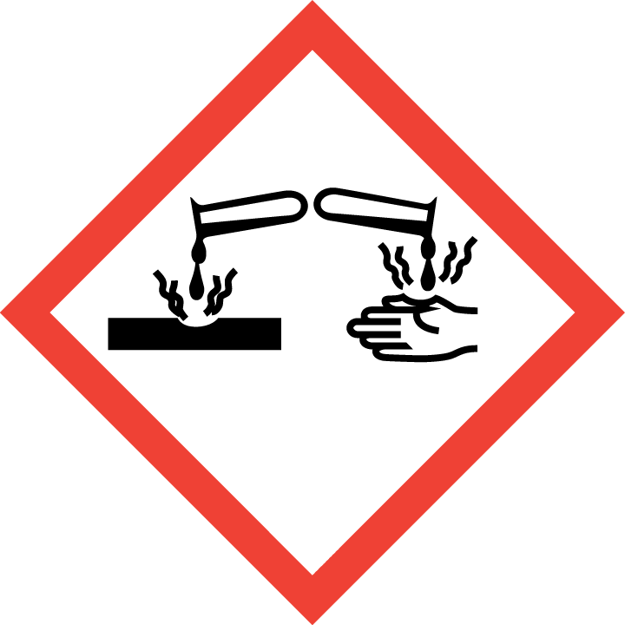
Section 3 – Engineering Controls and Personal Protective Equipment (PPE)
Engineering Controls: Use of osmium tetroxide must be conducted in a properly functioning chemical fume hood. The chemical fume hood must be approved and certified by REM and have a face velocity between 80 – 125 feet per minute.
Hygiene Measures: Avoid contact with skin, eyes, and clothing. Wash hands before breaks and immediately after handling the product.
Hand Protection: Chemical-resistant gloves must be worn, nitrile or neoprene NOTE: Consult with your preferred glove manufacturer to ensure that the gloves you plan on using are compatible with the specific chemical being used.
Eye Protection: ANSI approved properly fitting safety glasses or chemical splash goggles are required. A face shield is also recommended if there is a high probability of a splash hazard.
Skin and Body Protection: Laboratory coats must be worn and be appropriately sized for the individual and buttoned to their full length. Personnel must also wear full length pants, or equivalent, and close-toed shoes. Full length pants and close-toed shoes must be worn at all times by all individuals that are occupying the laboratory area. The area of skin between the shoe and ankle must not be exposed.
Respiratory Protection: If osmium tetroxide is being used outside of a chemical fume hood, respiratory protection may be required. If this activity is necessary, contact REM (4-6371) so a respiratory protection analysis can be performed.
Section 4 – Special Handling and Storage Requirements
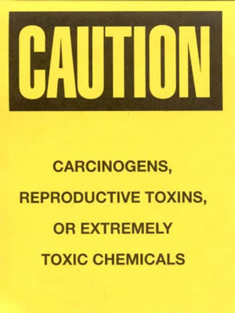
- A designated storage area must be established for osmium tetroxide and the area should be posted with a “Caution, Carcinogen, Reproductive Toxins, or Extremely Toxic Chemicals” label provided by REM (as shown to the right).
- Recommended storage temperature is between 2 – 8 ºC.
- Avoid contact with skin and eyes and inhalation.
- Avoid formation of vapors, mists, or gas.
- Keep containers tightly closed.
- Store in a cool, dry and well-ventilated area away from incompatible substances such as organic materials, strong reducing agents, powdered metals, and hydrochloric acid.
- A suitable storage location is a lab safe refrigerator that is labeled with a caution sign noting the presence of osmium tetroxide and its hazards.
- Store pure osmium tetroxide and its concentrated solutions in appropriate, sealed containers with appropriate secondary containment.
- When moving osmium tetroxide to a chemical fume hood, do not remove it from the secondary containment until it is in the hood.
- All work with osmium tetroxide must be conducted in a properly functioning chemical fume hood.
- Prepare the smallest amount of solution necessary for the procedure, typically 50 mL or less.
- All lab ware that has contacted osmium tetroxide must be decontaminated (see detailed decontamination procedures below).
Osmium Tetroxide Decontamination Procedures:
A 2% solution of osmium tetroxide can be fully neutralized by twice its volume of vegetable oil (corn oil is preferred because of its high percentage of unsaturated bonds). For every 10 mL of 2% osmium tetroxide solution, 20 mL of corn oil is recommended. The following decontamination procedures must be followed to reduce the hazards of osmium tetroxide:
- Pour corn oil into the osmium tetroxide solution.
- Wait for the oil to completely turn black.
- To test if osmium tetroxide is fully neutralized, hold a piece of filter paper soaked in corn oil over the solution. Blackening of the filter paper indicates that osmium tetroxide is still present and more corn oil should be added.
- Aqueous solutions contaminated with osmium tetroxide can be fully neutralized by adding sodium sulfite to reduce osmium tetroxide to a less hazardous form.
- Containerize the decontamination solution and dispose of as hazardous waste. Also collect all debris used in the process of decontamination, containerize in a bucket or bag, label, and dispose of as hazardous waste.
Section 5 – Spill and Accident Procedures
Immediately evacuate area and ensure others are aware of the spill. If there is an imminent threat of a fire, pull the nearest fire alarm station to evacuate the building and dial 911. If personnel have become exposed and need medical assistance, dial 911. If the spill is minor and does not pose a threat to personnel, contact REM at 49-40121 during normal business hours (Monday – Friday, 7 AM – 4 PM) for spill cleanup assistance (dial 911 if spill occurs after hours and assistance is needed).
Section 6 – Waste Disposal Procedures
Store hazardous waste in closed containers that are properly labeled, and in a designated area (flammable cabinet is recommended) away from incompatible chemicals such as those listed above. Complete a Chemical Waste Pickup Request Form to arrange for disposal by REM; detailed instructions are provided at the following link: http://www.purdue.edu/ehps/rem/hmm/chemwaste.htm.
Section 7 – Protocol (Add lab specific Protocol here)
Click here to enter text.
NOTE: Any deviation from this SOP requires approval from Principal Investigator.
Section 8 – Documentation of Training (signature of all users is required)
Prior to conducting any work with osmium tetroxide, the Principal Investigator must ensure that all laboratory personnel receive training on the content of this SOP.
I have read and understand the content of this SOP:
Name | Signature | Date
Click here to enter text. |  | Click here to enter a date.
Click here to enter text. |  | Click here to enter a date.
Click here to enter text. |  | Click here to enter a date.
Click here to enter text. |  | Click here to enter a date.

