Standard Operating Procedure
Nitrate Compounds
This is an SOP template and is not complete until: 1) lab specific information is entered into the box below 2) lab specific protocol/procedure is added to the protocol/procedure section and
3) SOP has been signed and dated by the PI and relevant lab personnel.
Print a copy and insert into your Lab-Specific Chemical Hygiene Plan.

Section 1 – Lab-Specific Information
Building/Room(s) covered by this SOP: | Click here to enter text.
Department: | Click here to enter a date.
Principal Investigator Name: | Click here to enter text.
Principal Investigator Signature: | Click here to enter text.

Section 2 – Hazards
Nitrate compounds are a class of potentially explosive chemicals. These chemicals can release a destructive amount of pressure, gas, or heat when subjected to certain conditions such as high temperatures or sources of ignition. Nitrate salts, such as ammonium nitrate, sodium nitrate, and potassium nitrate, are often used as agricultural fertilizers. Nitrate compounds may also be used as oxidizing agents, especially in explosives. Keep away from heat, clothing, and other combustible materials. Take any precaution to avoid mixing with combustibles. Store nitrate compounds away from combustibles. These compounds are harmful if ingested, inhaled, or absorbed through the skin. They can causes irritation to the gastrointestinal tract, respiratory tract, skin, and eyes and may be carcinogenic.

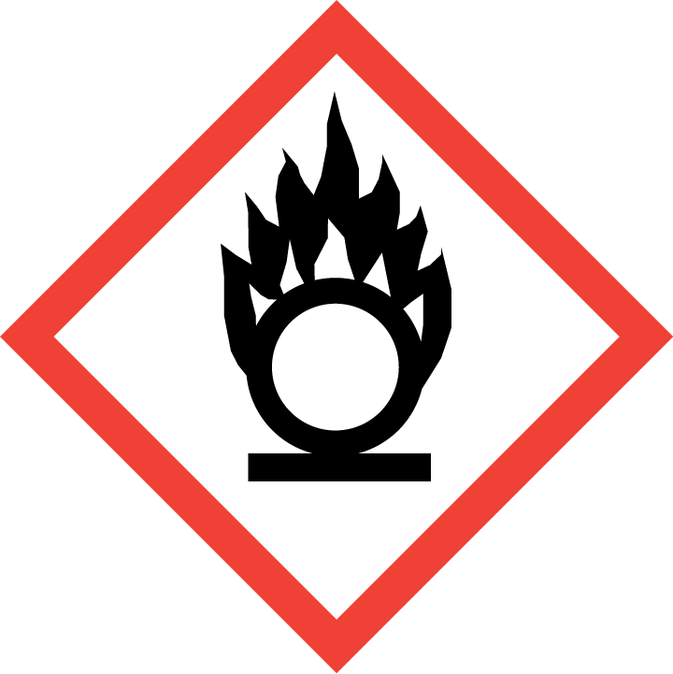

Section 3 – Engineering Controls and Personal Protective Equipment (PPE)
Engineering Controls: Use of nitrate salts should be conducted in a properly functioning chemical fume hood whenever possible. The chemical fume hood must be approved and certified by REM and have a face velocity between 80 – 125 feet per minute.
Hygiene Measures: Avoid contact with skin, eyes, and clothing. Wash hands before breaks and immediately after handling the product.
Hand Protection: Chemical-resistant gloves must be worn, nitrile gloves are recommended for low volume applications. Wearing two pairs of nitrile gloves is recommended. NOTE: Consult with your preferred glove manufacturer to ensure that the gloves you plan on using are compatible with the specific chemical being used.
Eye Protection: ANSI approved properly fitting safety glasses or chemical splash goggles are required. A face shield may also be appropriate depending on the specific application.
Skin and Body Protection: Laboratory coats must be worn and be appropriately sized for the individual and buttoned to their full length. Personnel must also wear full length pants, or equivalent, and close-toed shoes. Full length pants and close-toed shoes must be worn at all times by all individuals that are occupying the laboratory area. The area of skin between the shoe and ankle must not be exposed.
Respiratory Protection: If nitrates are being used outside of a chemical fume hood, respiratory protection may be required. If this activity is necessary, contact REM (4-6371) so a respiratory protection analysis can be performed.

Section 4 – Special Handling and Storage Requirements
- Do not over purchase; only purchase what can be safely stored in the laboratory.
- Avoid contact with skin, eyes, and inhalation. Avoid inhalation and ingestion. Avoid formation of dust.
- Provide adequate ventilation.
- Keep away from combustible materials. Keep away from heat and sources of ignition - No smoking.
- Use spark-proof tools and explosion-proof equipment. Prevent build-up of electrostatic charge.
- Keep containers tightly closed. Store in a cool, dry, and well-ventilated area away from incompatible substances such as flammable and combustible liquids.
- Opened containers must be carefully resealed and kept upright to prevent leakage.
- Keep cool and protected from sunlight.
- Store segregated from incompatible chemicals.
- Use in the smallest practical quantities for the experiment being performed.
- Work must be conducted in a chemical fume hood if the chemical is irritating to the eyes or respiratory system, and/or is toxic by inhalation.
- Avoid using ignition sources (flame burners or any open flame source, hot plates, electrical equipment with frayed or cracked wiring, etc.) and/or creating static electricity in areas where nitrate salts are being used.
- Transport all nitrate compounds in secondary containment, such as polyethylene or other non-reactive acid/solvent bottle carrier.
- Nitrates must be segregated from incompatible materials such as flammable and combustible materials. Incompatibilities will be noted in Section 10 of the SDS, “Stability and Reactivity”.

Section 5 – Spill and Accident Procedures
Immediately evacuate area and ensure others are aware of the spill. If there is an imminent threat of a fire, pull the nearest fire alarm station to evacuate the building and dial 911. If personnel have become exposed and need medical assistance, dial 911. If the spill is minor and does not pose a threat to personnel, contact REM at 49-40121 during normal business hours (Monday – Friday, 7 AM – 4 PM) for spill cleanup assistance (dial 911 if spill occurs after hours and assistance is needed).

Section 6 – Waste Disposal Procedures
Store hazardous waste in closed containers that are properly labeled, and in a designated area away from incompatible chemicals such as flammable or combustible waste. Complete a Chemical Waste Pickup Request Form to arrange for disposal by REM; detailed instructions are provided at the following link: http://www.purdue.edu/ehps/rem/hmm/chemwaste.htm.

Section 7 – Protocol (Add lab specific Protocol here)
Click here to enter text.
NOTE: Any deviation from this SOP requires approval from PI.

Section 8 – Documentation of Training (signature of all users is required)
Prior to conducting any work with nitrates, the Principal Investigator must ensure that all laboratory personnel receive training on the content of this SOP.
I have read and understand the content of this SOP:
Name | Signature | Date
Click here to enter text. |  | Click here to enter a date.
Click here to enter text. |  | Click here to enter a date.
Click here to enter text. |  | Click here to enter a date.
Click here to enter text. |  | Click here to enter a date.
Click here to enter text. |  | Click here to enter a date.
Click here to enter text. |  | Click here to enter a date.
Click here to enter text. |  | Click here to enter a date.
Click here to enter text. |  | Click here to enter a date.
Click here to enter text. |  | Click here to enter a date.
Click here to enter text. |  | Click here to enter a date.

