Standard Operating Procedure
Mercury (II) Iodide

This is an SOP template and is not complete until: 1) lab specific information is entered into the box below 2) lab specific protocol/procedure is added to the protocol/procedure section and
3) SOP has been signed and dated by the PI and relevant lab personnel.
Print a copy and insert into your Lab-Specific Chemical Hygiene Plan.
Section 1 – Lab-Specific Information
Building/Room(s) covered by this SOP: | Click here to enter text.
Department: | Click here to enter a date.
Principal Investigator Name:
Principal Investigator Signature: | Click here to enter text.
Section 2 –Hazards
Mercury iodide can be fatal if swallowed and when in contact with skin. It may also be fatal if inhaled. It may damage organs through prolonged or repeated exposures. Mercury iodide causes serious irritation to the skin as well as eyes. In severe cases it may cause respiratory irritation as well. It is suspected to affect fertility and damage the health of the unborn child.
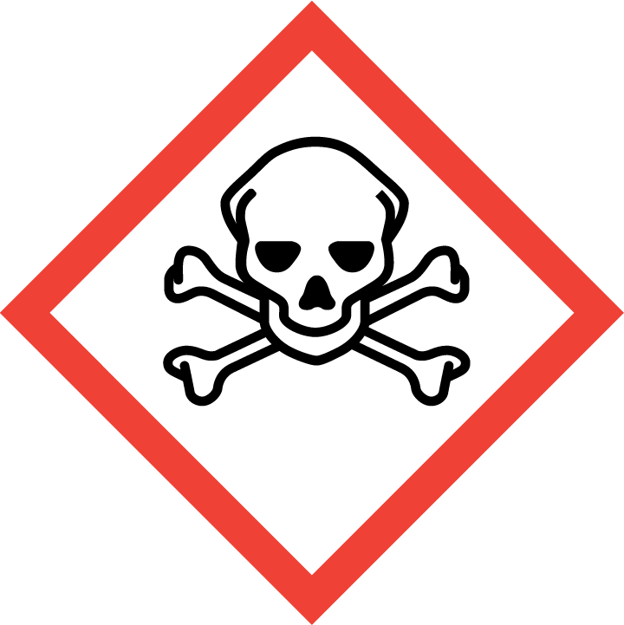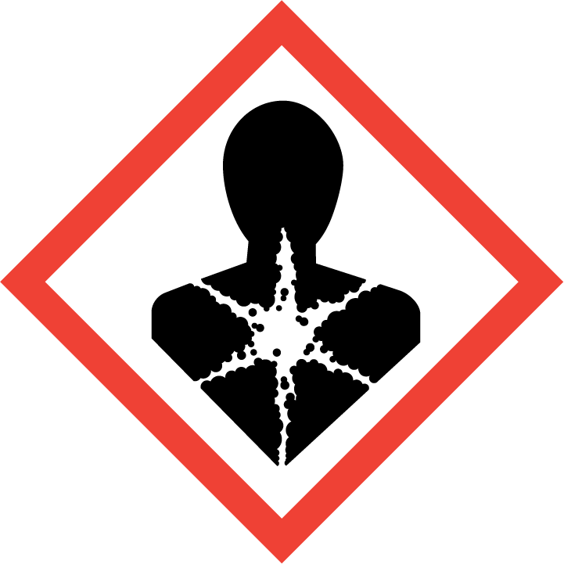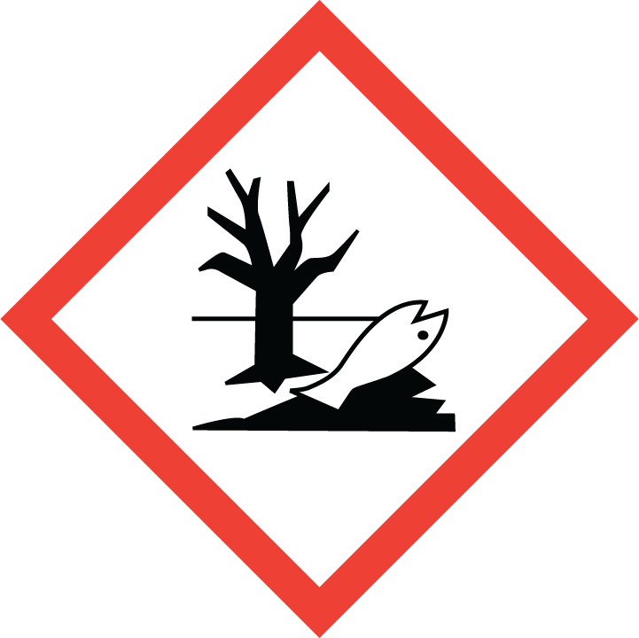
Section 3 – Engineering Controls and Personal Protective Equipment (PPE)
Engineering Controls: Use of Mercury iodide must be conducted in a properly functioning chemical fume hood. The chemical fume hood must be approved and certified by REM and have a face velocity between 80 – 125 feet per minute. Emergency eye wash fountains should be available in immediate vicinity (2). Use adequate general or local explosion proof ventilation to keep airborne levels to acceptable limits (3).
Respirator Protection: Wear respiratory protection. Recommended- NISOH certified respirator. Avoid dust formation. Avoid breathing vapors, mist or gas. Ensure adequate ventilation.
Hand Protection: Gloves must be worn. Use proper glove removal technique to avoid any skin contact. Nitrile or neoprene gloves are recommended. Wearing two pair of gloves is recommended. Check with lab safety in-charge for a more suitable glove. NOTE: Consult with your preferred glove manufacturer to ensure that the gloves you plan on using are compatible with Mercury iodide.
Eye Protection: ANSI approved properly fitting safety glasses or chemical splash goggles.
Skin and Body Protection: Lab coats must be worn and be appropriately sized for the individual and buttoned to their full length. Laboratory coat sleeves must be of sufficient length to prevent skin exposure while wearing gloves. Personnel must also wear full length pants, or equivalent, and close-toed shoes. Full length pants and close-toed shoes must be worn at all times by all individuals that are occupying the laboratory area. The area of skin between the shoe and ankle must not be exposed. Wearing a face shield is highly recommended.
Hygiene Measures: Wash thoroughly and immediately after handling. Remove any contaminated clothing and wash before reuse. Follow proper glove removal technique.
Section 4 – Special Handling and Storage Requirements
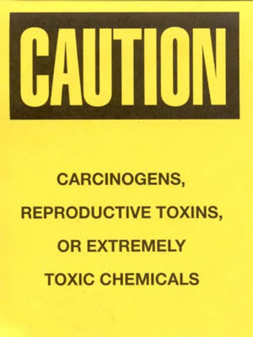
- Ensure Mercury iodide is stored in the designated storage area established for Mercury and the area should be posted with a “Caution, Carcinogen, Reproductive Toxins, or Extremely Toxic Chemicals” label provided by REM (as shown to the right).
- Avoid inhalation and contact with the skin or eyes.
- Ensure that the containers are tightly closed.
- Store in a cool, dry and well-ventilated area away from incompatible substances such as bromides, chlorides, ammonia, alkalis, cyanides copper and lead salts, iodoform, hydrogen peroxide.
- A suitable storage location is a flammable storage cabinet or lab cabinet that does not contain incompatibles.
- Purdue University has a Mercury Reduction Policy (see link below). The use of mercury iodide should be extremely limited and only used when absolutely necessary. (http://www.purdue.edu/rem/home/booklets/HgPolicy.pdf)
Section 5 – Spill and Accident Procedures
Do not touch damaged containers or spilled material unless wearing appropriate protective clothing. DO NOT attempt to clean the spill unless sufficiently trained. Contact REM immediately. Prevent entry into waterways, sewers, basements or confined areas. Cover with plastic sheet to prevent spreading. Absorb or cover with dry earth, sand or other non-combustible material and transfer to containers. DO NOT GET WATER INSIDE CONTAINERS.
Section 6- Waste Disposal Procedures
Store hazardous waste in closed containers that are properly labeled, and in a designated area. Do not keep in vicinity of incompatible chemicals such as bromides, chlorides, ammonia, alkalis, cyanides copper and lead salts, iodoform, hydrogen peroxide. Do not throw in dustbins/ sewers, contact REM to dispose off hazardous waste.
Generators of waste (equal to or greater than 100 kg/month) containing this contaminant, EPA hazardous waste number D009, must conform with USEPA regulations in storage, transportation, treatment and disposal of waste.
Section 7 – Protocol/Procedure (Add lab specific Protocol/Procedure here)

NOTE: Any deviation from this SOP requires approval from PI.
Section 8 – Documentation of Training (signature of all users is required)
Prior to conducting any work with mercury iodide, the Principal Investigator must ensure that all laboratory personnel receive training on the content of this SOP.
I have read and understand the content of this SOP:
Name | Signature | Date
Click here to enter text. |  | Click here to enter a date.
Click here to enter text. |  | Click here to enter a date.
Click here to enter text. |  | Click here to enter a date.
Click here to enter text. |  | Click here to enter a date.
Click here to enter text. |  | Click here to enter a date.
Click here to enter text. |  | Click here to enter a date.
Click here to enter text. |  | Click here to enter a date.

