Standard Operating Procedure
Mercury
This is an SOP template and is not complete until: 1) lab specific information is entered into the box below 2) lab specific protocol/procedure is added to the protocol/procedure section and
3) SOP has been signed and dated by the PI and relevant lab personnel.
Print a copy and insert into your Lab-Specific Chemical Hygiene Plan.
Section 1 – Lab-Specific Information
Building/Room(s) covered by this SOP: | Click here to enter text.
Department: | Click here to enter a date.
Principal Investigator Name: | Click here to enter a date.
Principal Investigator Signature: | Click here to enter text.
Section 2 –Hazards
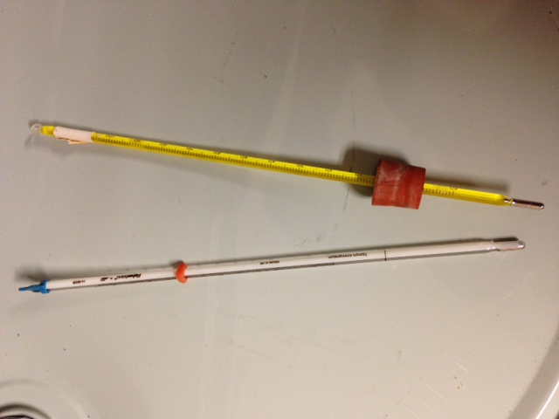
Mercury is toxic by inhalation and a teratogen. It can be fatal if inhaled and may damage fertility or the unborn child. Mercury causes damage to organs through prolonged or repeated exposure. It may cause skin rash and cold and clammy skin with cyanosis or pale skin color. It may cause perforation of the digestive tract and causes chemical burns to the respiratory tract. Prolonged or repeated exposure may cause inflammation of the mouth and gums, excessive salivation, and loosening of the teeth. Mercury is very toxic to aquatic life with long lasting effects.
Exposure Limits:
OSHA PEL (8 HR. TWA): 0.1 mg/m³
ACGIH TLV/TWA: 0.025 mg/m³
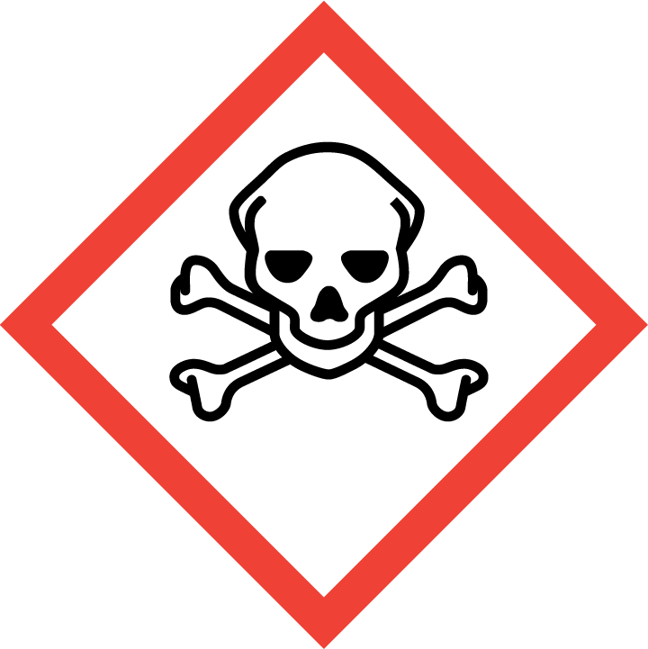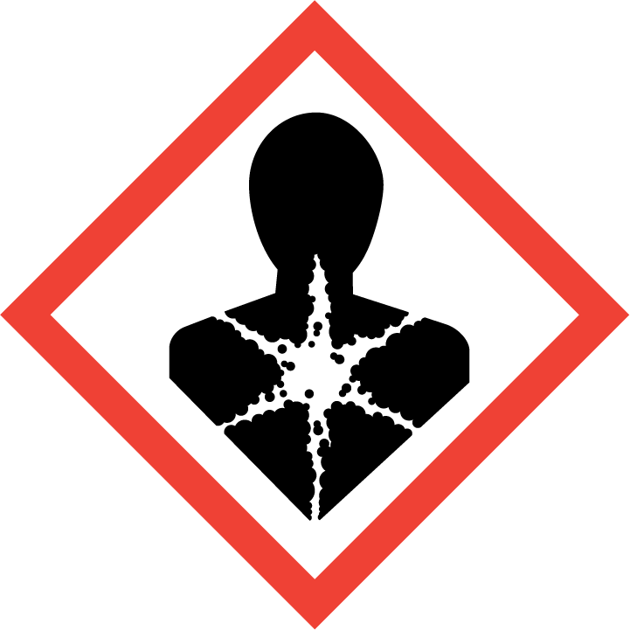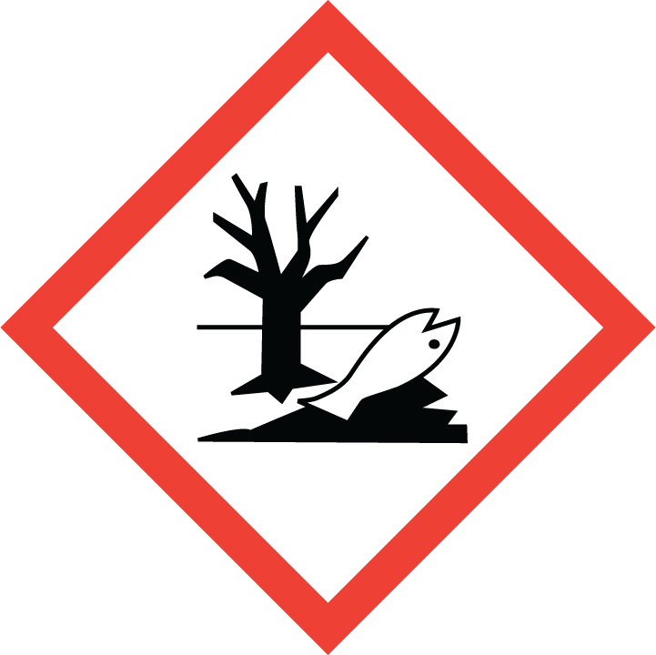
Section 3 – Personal Protective Equipment (PPE)
Engineering Controls: Use of Mercury must be conducted in a properly functioning chemical fume hood. The chemical fume hood must be approved and certified by REM and have a face velocity between 80 – 125 feet per minute.
Respirator Protection: If mercury is being used outside of a chemical fume hood, respiratory protection may be required. If this activity is necessary, contact REM (49-46371) so a respiratory protection analysis can be performed.
Hand Protection: Gloves must be worn. Use proper glove removal technique to avoid any skin contact. Nitrile or neoprene gloves are recommended. Wearing two pair of gloves is recommended. Check the resources below for a more suitable glove. NOTE: Consult with your preferred glove manufacturer to ensure that the gloves you plan on using are compatible with Mercury.
Eye Protection: ANSI approved properly fitting safety glasses or chemical splash goggles.
Skin and Body Protection: Lab coats must be worn and be appropriately sized for the individual and buttoned to their full length. Laboratory coat sleeves must be of sufficient length to prevent skin exposure while wearing gloves. Personnel must also wear full length pants, or equivalent, and close-toed shoes. Full length pants and close-toed shoes must be worn at all times by all individuals that are occupying the laboratory area. The area of skin between the shoe and ankle must not be exposed.
Hygiene Measures: Wash thoroughly and immediately after handling. Remove any contaminated clothing and wash before reuse.
Section 4 – Special Handling and Storage Requirements
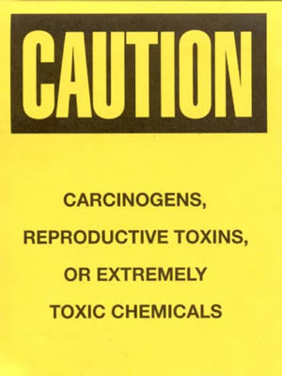
- A designated storage area must be established for Mercury and the area should be posted with a “Caution, Carcinogen, Reproductive Toxins, or Extremely Toxic Chemicals” label provided by REM (as shown to the right).
- Avoid contact with skin and eyes and inhalation.
- Keep containers tightly closed.
- Store in a cool, dry and well-ventilated area away from incompatible substances such as strong oxidizing agents, ammonia, azide compounds, nitrate compounds, chlorate compounds, and copper compounds.
- Containers which are opened must be carefully resealed and kept upright to prevent leakage.
- A suitable storage location is a flammable storage cabinet or lab cabinet that does not contain incompatibles.
- Purdue University has a Mercury Reduction Policy (see link below). The use of Mercury should be extremely limited and only used when absolutely necessary (i.e., extremely accurate or high temperature measurements are necessary. (http://www.purdue.edu/rem/home/booklets/HgPolicy.pdf)
Section 5 – Spill and Accident Procedures
Immediately evacuate area and ensure others are aware of the spill. If there is an imminent threat of a fire, pull the nearest fire alarm station to evacuate the building and dial 911. If personnel have become exposed and need medical assistance, dial 911. If the spill is minor and does not pose a threat to personnel, contact REM at 49-40121 during normal business hours (Monday – Friday, 7 AM – 4 PM) for spill cleanup assistance (dial 911 if spill occurs after hours and assistance is needed).
Section 6 – Waste Disposal Procedures
Store hazardous waste in closed containers that are properly labeled, and in a designated area (flammable cabinet is recommended) away from incompatible chemicals such as THIS. Complete a Chemical Waste Pickup Request Form to arrange for disposal by REM; detailed instructions are provided at the following link: http://www.purdue.edu/ehps/rem/hmm/chemwaste.htm.

Section 7 – Protocol/Procedure (Add lab specific Protocol/Procedure here)
Click here to enter text.
NOTE: Any deviation from this SOP requires approval from PI.
Section 8 – Documentation of Training (signature of all users is required)
Prior to conducting any work with mercury, the Principal Investigator must ensure that all laboratory personnel receive training on the content of this SOP.
I have read and understand the content of this SOP:
Name | Signature | Date
Click here to enter text. |  | Click here to enter a date.
Click here to enter text. |  | Click here to enter a date.
Click here to enter text. |  | Click here to enter a date.
Click here to enter text. |  | Click here to enter a date.
Click here to enter text. |  | Click here to enter a date.
Click here to enter text. |  | Click here to enter a date.
Click here to enter text. |  | Click here to enter a date.
Click here to enter text. |  | Click here to enter a date.
Click here to enter text. |  | Click here to enter a date.
Click here to enter text. |  | Click here to enter a date.

