Standard Operating Procedure
Liquid Nitrogen
This is an SOP template and is not complete until: 1) lab specific information is entered into the box below 2) lab specific protocol/procedure is added to the protocol/procedure section and
3) SOP has been signed and dated by the PI and relevant lab personnel.
Print a copy and insert into your Lab-Specific Chemical Hygiene Plan.

Section 1 – Lab-Specific Information
Building/Room(s) covered by this SOP: | Click here to enter text.
Department: | Click here to enter a date.
Principal Investigator Name: | Click here to enter text.
Principal Investigator Signature: | Click here to enter text.
Section 2 –Hazards
Liquid nitrogen is a cryogenic liquid that may cause severe frostbite or eye damage upon contact. It is an extremely cold liquid and gas under pressure and expands by a factor of 700 upon vaporization. Liquid nitrogen can cause rapid suffocation due to displacement of oxygen. Substances may become brittle upon contact and shatter. It may cause an explosion of a sealed container. Symptoms to exposure included frostbite, dizziness, salivation, nausea, vomiting, or loss of mobility and/or consciousness.
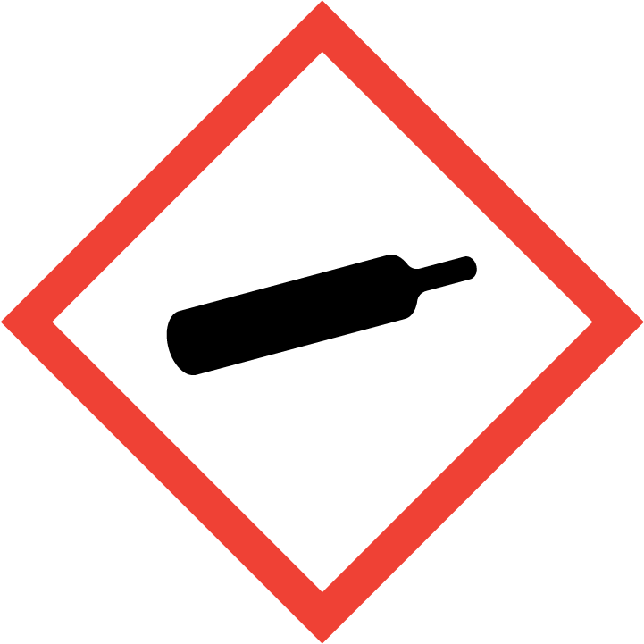
Section 3 – Personal Protective Equipment (PPE)
For quantities less than 100 mL, safety glasses, lab gloves, long pants, and close-toe shoes are adequate (Figure 1). For intermediate quantities (100 mL – 1 L), also use splash goggles, face shield, and cryogenic gloves (Figure 2). For quantities greater than 1 L or filling a secondary Dewar, a cryogenic apron should be used in addition to the general use intermediate requirements (Figure 3).
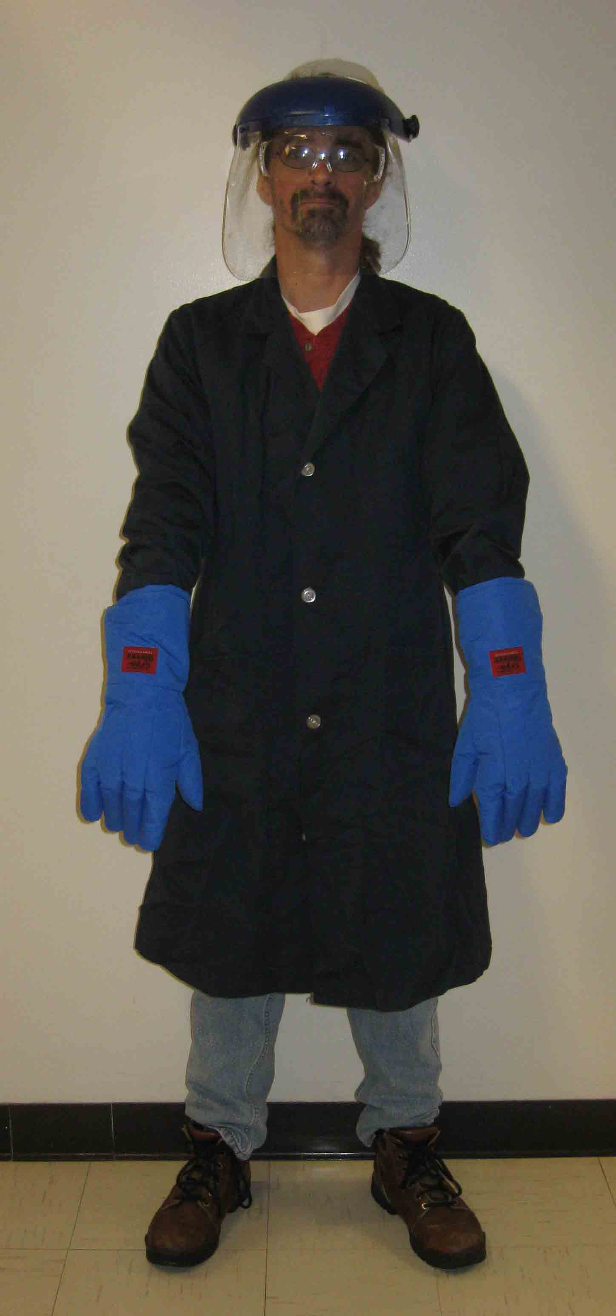
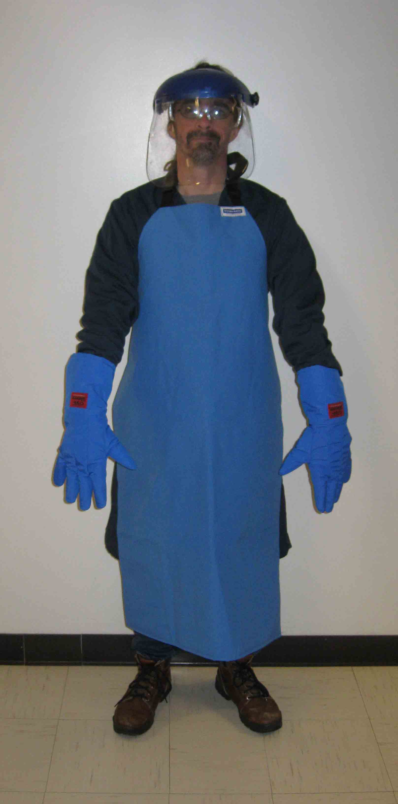
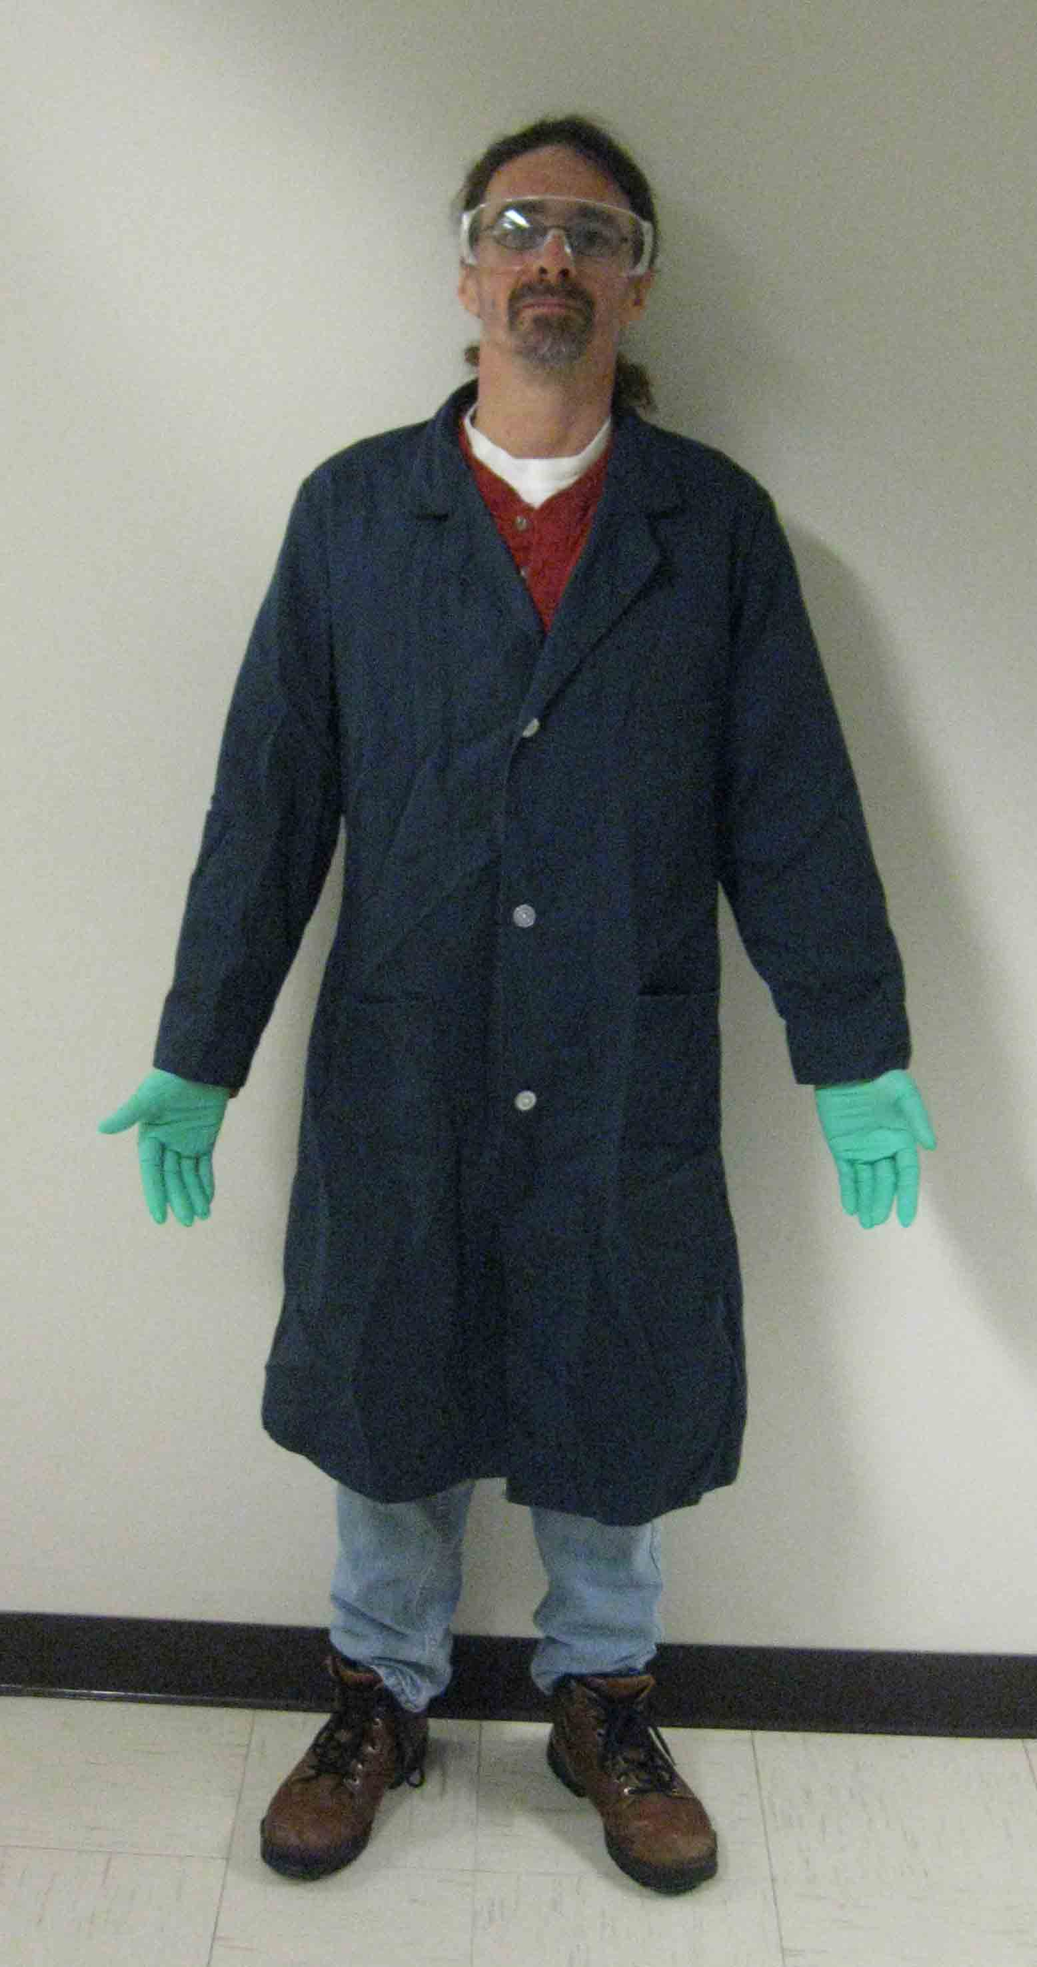

Figure 3 – Large quantity PPE requirements
Figure 2 – Intermediate quantity PPE requirements
Figure 1 – Small quantity PPE requirements

Section 4 – Engineering Controls
Liquid nitrogen must only be used in a well-ventilated area or in a properly functioning chemical fume hood whenever possible. Liquid nitrogen should never be used in a poorly ventilated enclosed area where oxygen displacement is a possibility.
Section 5 – Liquid Nitrogen Containers
Vacuum Insulated Containers:
Vacuum insulated containers are used for storing and dispensing liquid nitrogen. They are either sealed (capable of holding 20 psig – 240 psig with pressure relief valve) or ambient pressure (covered loosely with a cap, cork, or stopper and are referred to as Dewars (due’-werz). There are two primary types of Dewars, benchtop and large Dewars. Benchtop Dewars (Figure 4) are typically for small-scale laboratory use and the lid is the only pressure-relief device. Large Dewars (Figure 5) are typically used for storage of lab samples, movement of samples between campus locations, or to fill other secondary containers. Large Dewars may have a secure seal and pressure relief vent. Liquid nitrogen exposure is a risk when handling Dewars. Therefore, the PPE illustrated in Figure 2 should be worn when working with a Dewar.
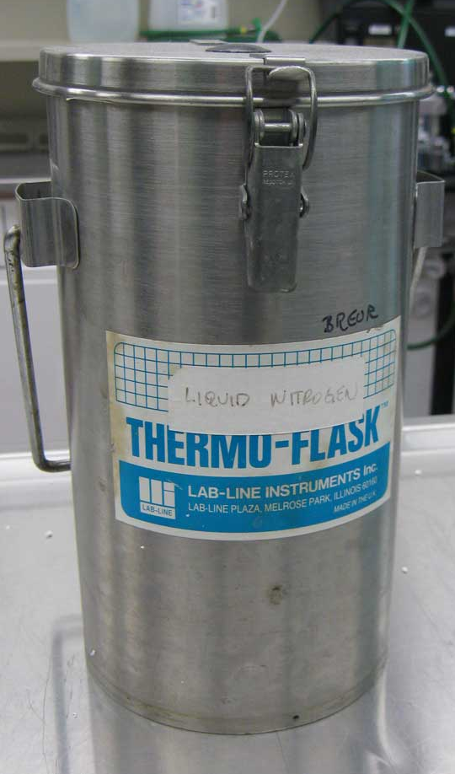

Figure 4 – Benchtop Dewar
Figure 5 – Large Dewar
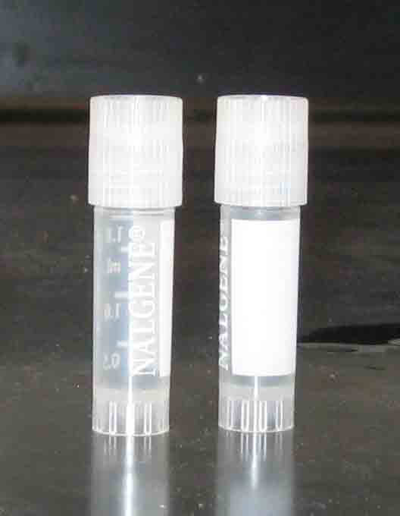
Cryogenic Tubes:
Cryogenic tubes are typically used for storage samples, movement of samples between campus locations, or for shipments off campus for collaborative research (Figure 6). There is no pressure-relief device on a cryogenic tube other than the lid. Consequently, cryogenic tubes can explode without warning. Explosions are likely caused by trapped nitrogen expanding inside of the tube during the thawing process. As the temperature increases, the tube may become over-pressurized and explode and may result in serious injuries. Because of this risk, the PPE illustrated in Figure 2 should be worn when directly handling a sealed cryogenic tube.
Figure 6 – Cryo Tubes
Self-Pressurizing Tanks
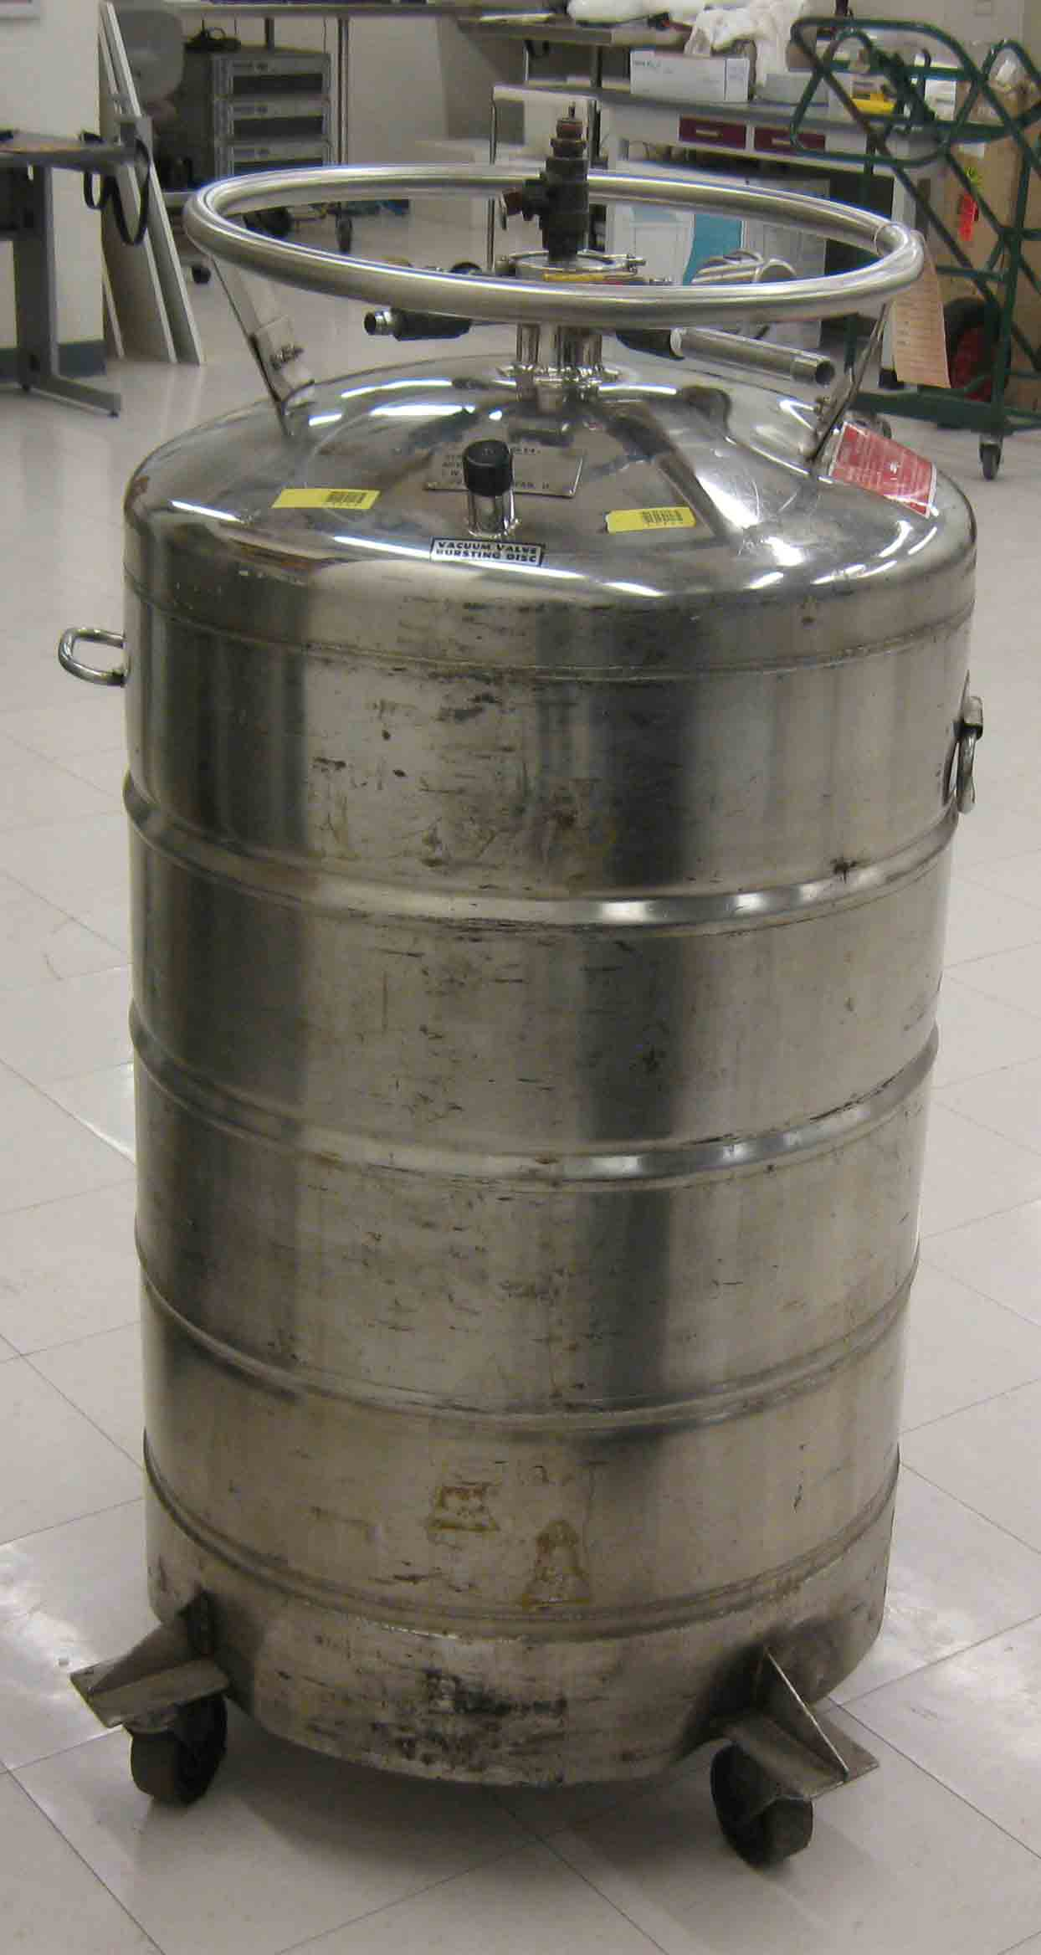
Self-pressurizing tanks (Figure 7) are generally a 140 – 260 L double wall, stainless steel tank used to fill other liquid nitrogen containers such as Dewars. These tanks are equipped with pressure relief valves and a backup rupture disk. A loud hissing sound is commonly heard when the pressure relief valve opens. Exposure to liquid nitrogen can occur when connecting and disconnecting equipment, during the filling process, from a leaking valve, or from condensate ice buildup on valves and hoses. Because of these risks, the PPE illustrated in Figure 3 should always be worn when working with a self-pressurized tank.
Section 6 – General Safe Handling Practices and Storage Requirements
Figure 7 – Self-Pressurizing Tank
- Only trained personnel should work with liquid nitrogen.
- Use only in well ventilated and low traffic areas.
- Caution signs should be posted in the area warning others that liquid nitrogen is being stored and used.
- Always wear the appropriate PPE.
- Liquid nitrogen should only be stored in approved containers.
- All liquid nitrogen containers must be labeled. Large containers (e.g., Dewars, Self-Pressurizing Tanks) must be labeled with the REM-provided label illustrated in Figure 8. Smaller containers such as cryogenic tubes should be labeled “Liquid Nitrogen, Cryogenic Hazard” or with similar words that convey the hazards.
- Avoid breathing liquid nitrogen vapors.
- Carry containers away from body and face.
- Never drop a liquid nitrogen container. Damage to a container may result in over-pressurization or container failure.
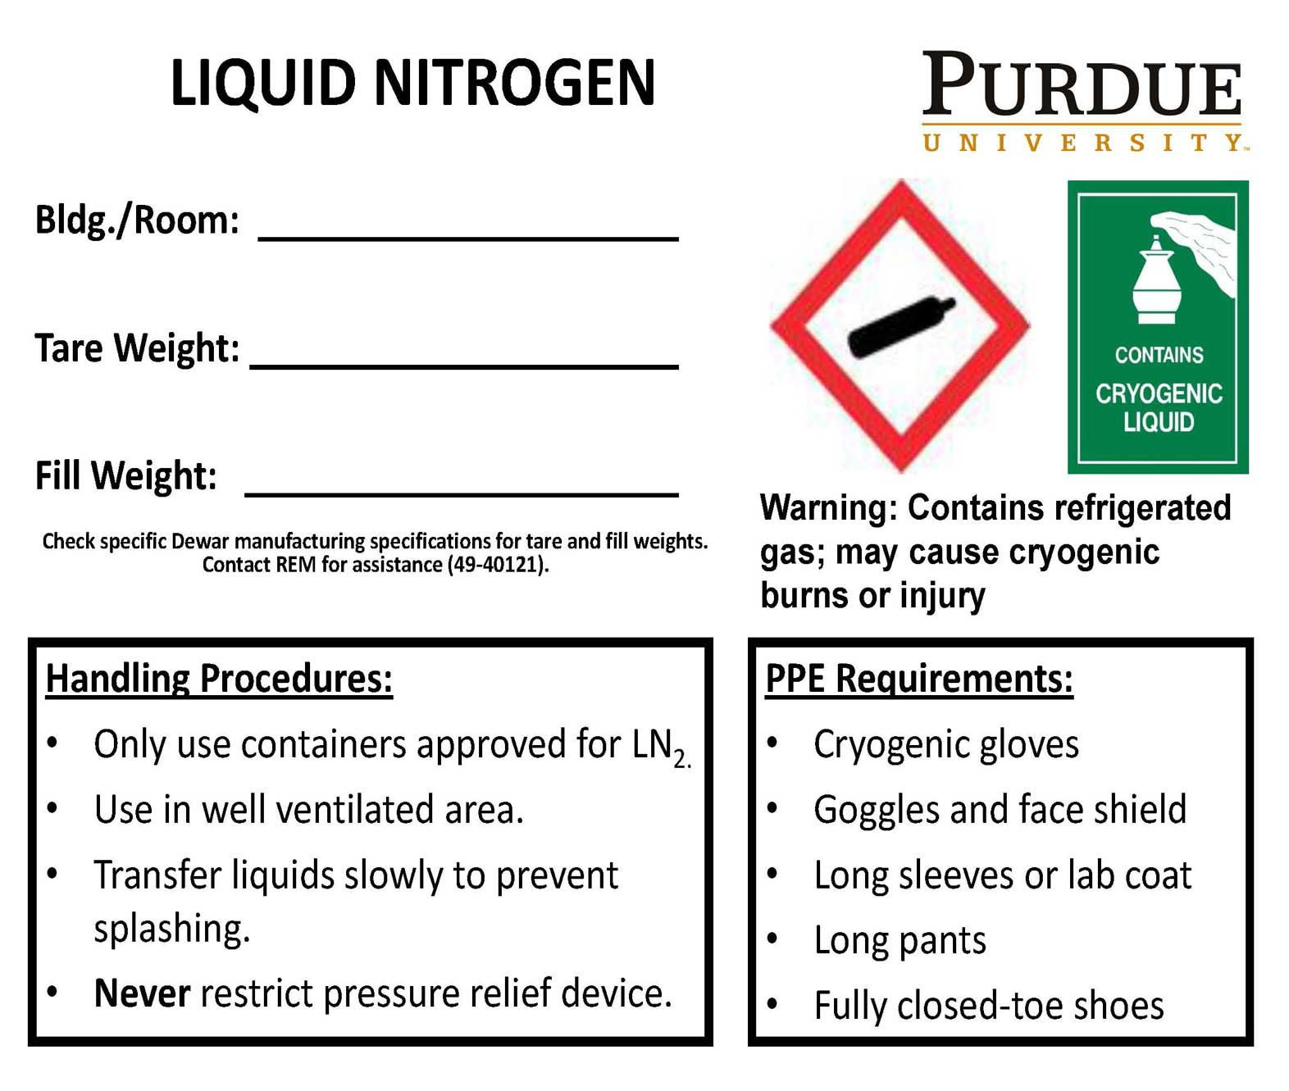
- Dewars more than 100 pounds require two people to move safely.
- Always use a specially designed cylinder cart to transport liquid nitrogen containers that are too heavy to be hand carried.
- Use the freight elevator whenever possible.
- Do not leave open containers unattended.
- Liquid nitrogen containers should be stored in cool, dry, and well ventilated areas.
- Do not store in a cold room or other controlled environment without air supply.
Figure 8 – Liquid Nitrogen Label
- Liquid nitrogen containers should be stored out of direct sunlight.

Section 7 – Spill and Accident Procedures
- Immediately evacuate area and ensure others are aware of the spill. If there is an imminent threat of a fire, pull the nearest fire alarm station to evacuate the building and dial 911. If personnel have become exposed and need medical assistance, dial 911.
Section 8 – Waste Disposal Procedures
- Store hazardous waste in closed containers that are properly labeled, and in a designated area (flammable cabinet is recommended) away from incompatible chemicals such as aqueous solutions. Complete a Chemical Waste Pickup Request Form to arrange for disposal by REM; detailed instructions are provided at the following link: https://www.purdue.edu/ehps/rem/documents/forms/HMM001.pdf.
Section 9 – Protocol (Add lab specific Protocol here)
Click here to enter text.
NOTE: Any deviation from this SOP requires approval from Principal Investigator.
Section 10 – Documentation of Training (signature of all users is required)
Prior to conducting any work with nitrogen gas, the Principal Investigator must ensure that all laboratory personnel receive training on the content of this SOP.
I have read and understand the content of this SOP:
Name | Signature | Date
Click here to enter text. |  | Click here to enter a date.
Click here to enter text. |  | Click here to enter a date.
Click here to enter text. |  | Click here to enter a date.
Click here to enter text. |  | Click here to enter a date.
Click here to enter text. |  | Click here to enter a date.
Click here to enter text. |  | Click here to enter a date.

