Standard Operating Procedure
Hydrogen Gas
This is an SOP template and is not complete until: 1) lab specific information is entered into the box below 2) lab specific protocol/procedure is added to the protocol/procedure section and
3) SOP has been signed and dated by the PI and relevant lab personnel.
Print a copy and insert into your Lab-Specific Chemical Hygiene Plan.
Section 1 – Lab-Specific Information
Building/Room(s) covered by this SOP: | Click here to enter text.
Department: | Click here to enter a date.
Principal Investigator Name: | Click here to enter text.
Principal Investigator Signature: | Click here to enter text.
Section 2 – Hazards
Hydrogen gas is an extremely flammable compressed gas and can combust in the presence of any oxidizing agent. Containers may rupture or explode if exposed to heat. It is highly recommended that oxygen cylinders in storage be separated from hydrogen or other fuel-gas cylinders or combustible materials (especially oil or grease) by a minimum distance of 20 feet or by a non-combustible barrier at least five feet high and with a fire resistance rating of least one-half hour. Furthermore, the barrier should be at least 18 inches above the tallest cylinder. In simple words, DO NOT store Hydrogen & Oxygen/other oxidizing gases, oxidizing materials together.
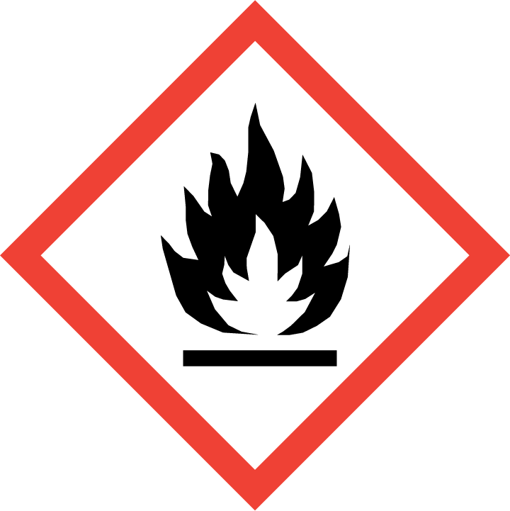
Section 3 – Engineering Controls and Personal Protective Equipment (PPE)
Engineering Controls: Use of hydrogen gas must be conducted in a properly functioning gas cabinet or chemical fume hood. The chemical fume hood must be approved and certified by REM and have a face velocity between 80 – 125 feet per minute.
Hygiene Measures: Avoid contact with skin, eyes, and clothing. Wash hands before breaks and immediately after handling the product.
Hand Protection: Chemical-resistant gloves must be worn, nitrile gloves are recommended. Wearing two pairs of nitrile gloves is recommended. NOTE: Consult with your preferred glove manufacturer to ensure that the gloves you plan on using are compatible with the specific chemical being used.
Eye Protection: ANSI approved properly fitting safety glasses or chemical splash goggles are required. A face shield may also be appropriate depending on the specific application.
Skin and Body Protection: Flame resistant laboratory coats must be worn and be appropriately sized for the individual and buttoned to their full length. Personnel must also wear full length pants, or equivalent, and close-toed shoes. Full length pants and close-toed shoes must be worn at all times by all individuals that are occupying the laboratory area. The area of skin between the shoe and ankle must not be exposed.
Respiratory Protection: Hydrogen gas should never be used outside of a contained unit (i.e., glove box, chemical fume hood, or gas cabinet); therefore respiratory protection should not be required.
Section 4 – Special Handling and Storage Requirements
Safety can be achieved while handling hydrogen gas by adhering to the below mentioned protocols, but not limited to the following;
- If compressed gas cylinder holding metal rack is used to restrain the cylinders, the rack must be bolted to the floor and the chains or rods must be at 1/3rd from the bottom and 1/3rd from the top of the cylinders. Clam shell (a cylindrical metal casing bolted to the floor) can be used to secure cylinders that need to be stored and used next to the experimental set-up.
- Always use Stainless Steel (SS) tubing to convey hydrogen gas. Teflon tubing is okay if specified by the manufacturer.
- Remove the regulator and place the safety cap on, when the cylinder is not in constant use.
- Hydrogen gas leak detector installation is recommended.
- Prevent hydrogen leaks by meticulously connecting gas regulator and tubing.
- Keep constant vigilance to immediately detect accidental leaks.
- Prevent accumulations of leaked hydrogen using plentiful ventilation.
- Eliminate likely ignition sources, and suspect unknown ignition sources.
- Store hydrogen gas cylinders away from electrical panels and emergency eyewash & safety shower.
- Always assume hydrogen is present, and verify the system has been purged to less than 1 percent when performing system maintenance on a hydrogen system. Inert gases such as Nitrogen & Argon can be used for purging.
- Always assume oxygen is present, and verify the system has been purged to the appropriate level when reintroducing hydrogen into a system.
- Have a lab buddy system in place when working with highly flammable gases such as Hydrogen
- All users must have had hands-on training to work with highly flammable gases. The training must be documented.
- Lab personnel handling highly flammable gases must have easy access to an Emergency Eyewash & Safety Shower within 10 seconds (i.e., travel distance no greater than 100 feet).
Section 5 – Spill and Accident Procedures
Immediately evacuate area and ensure others are aware of the spill. If there is an imminent threat of a fire, pull the nearest fire alarm station to evacuate the building and dial 911. If personnel have become exposed and need medical assistance, dial 911.
Section 6 – Waste Disposal Procedures
Store hazardous waste in closed containers that are properly labeled, and in a designated area (flammable cabinet is recommended) away from incompatible chemicals such as aqueous solutions. Complete a Chemical Waste Pickup Request Form to arrange for disposal by REM; detailed instructions are provided at the following link: http://www.purdue.edu/ehps/rem/hmm/chemwaste.htm.
Section 7 – Protocol (Add lab specific Protocol here)
Click here to enter text.
NOTE: Any deviation from this SOP requires approval from Principal Investigator.
Section 8 – Documentation of Training (signature of all users is required)
Prior to conducting any work with hydrogen gas, the Principal Investigator must ensure that all laboratory personnel receive training on the content of this SOP.
I have read and understand the content of this SOP:
Name | Signature | Date
Click here to enter text. |  | Click here to enter a date.
Click here to enter text. |  | Click here to enter a date.
Click here to enter text. |  | Click here to enter a date.
Click here to enter text. |  | Click here to enter a date.
Click here to enter text. |  | Click here to enter a date.
Click here to enter text. |  | Click here to enter a date.
Click here to enter text. |  | Click here to enter a date.
Click here to enter text. |  | Click here to enter a date.

