Standard Operating Procedure
Diethyl Ether
This is an SOP template and is not complete until: 1) lab specific information is entered into the box below 2) lab specific protocol/procedure is added to the protocol/procedure section and
3) SOP has been signed and dated by the PI and relevant lab personnel.
Print a copy and insert into your Lab-Specific Chemical Hygiene Plan.
Section 1 – Lab-Specific Information
Building/Room(s) covered by this SOP: | Click here to enter text.
Department: | Click here to enter a date.
Principal Investigator Name: | Click here to enter text.
Principal Investigator Signature: | Click here to enter text.
Section 2 – Hazards
Diethyl ether is an extremely flammable liquid and vapor, forming explosive mixtures with air. The auto-ignition temperature of diethyl ether is 160ºC; therefore it can be ignited by a hot surface without flame or spark. If not stored and handled properly, diethyl ether can pose a serious threat to the health and safety of personnel. Diethyl ether is peroxide forming and has the potential to form explosive peroxides; therefore it is a time-sensitive chemical. Refer to REM’s Time-Sensitive Chemicals webpage for more specific information (http://www.purdue.edu/rem/hmm/timesensitive.htm).
Section 3 – Engineering Controls and Personal Protective Equipment (PPE)
Engineering Controls: Use of diethyl ether should be conducted in a properly functioning chemical fume hood whenever possible. The chemical fume hood must be approved and certified by REM and have a face velocity between 80 – 125 feet per minute.
Hygiene Measures: Avoid contact with skin, eyes, and clothing. Wash hands before breaks and immediately after handling the product.
Hand Protection: Chemical-resistant gloves must be worn, nitrile gloves are recommended for low volume applications. Wearing two pairs of nitrile gloves is recommended. If handling a high volume (> 1 liters) of flammable or combustible liquid, then disposable gloves are likely not suitable; a more heavy duty glove such as a butyl rubber is required.
Eye Protection: ANSI approved properly fitting safety glasses or chemical splash goggles are required. A face shield may also be appropriate depending on the specific application.
Skin and Body Protection: Laboratory coats must be worn and be appropriately sized for the individual and buttoned to their full length. Flame resistant lab coats must be worn when handling volumes greater than 1 liter. Personnel must also wear full length pants, or equivalent, and close-toed shoes. Full length pants and close-toed shoes must be worn at all times by all individuals that are occupying the laboratory area. The area of skin between the shoe and ankle must not be exposed.
Respiratory Protection: If diethyl ether is being used outside of a chemical fume hood, respiratory protection may be required. If this activity is necessary, contact REM (49-46371) so a respiratory protection analysis can be performed.
Section 4 – Special Handling and Storage Requirements
- Conduct the procedure only after a supervisor has observed the user performing the proper technique unassisted.
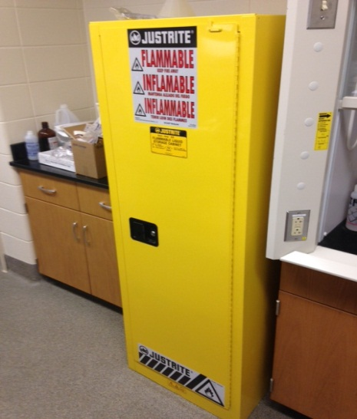
- Label all diethyl ether containers with the purchase date and the date opened. Storage time should never exceed the manufacturer’s recommendations. The general storage time limit for diethyl ether is 12 months.
- Keep away from sources of ignition. Avoid heat and shock or friction when handling.
- Keep containers tightly closed. Store in a cool, dry and well-ventilated area away from incompatible substances. Store away from light.
- Avoid contact with skin, eyes, and inhalation.
- Diethyl ether must be segregated from incompatible materials such as oxidizers, strong acids, halogens, and sulfur compounds.
- The amount of diethyl ether stored should be kept at an absolute minimum.
- Prevent electric static build-up with a grounding cable when transferring diethyl ether.
- Suitable storage locations include flammable storage cabinets or intrinsically safe refrigerators or freezers.
- Store diethyl ether away from light. Limit exposure to air and other contaminants, specifically heavy metals.
- If possible, only use diethyl ether with inhibitors.
Section 5 – Spill and Accident Procedures
Immediately evacuate area and ensure others are aware of the spill. If there is an imminent threat of a fire, pull the nearest fire alarm station to evacuate the building and dial 911. If personnel have become exposed and need medical assistance, dial 911. If the spill is minor and does not pose a threat to personnel, contact REM at 49-40121 during normal business hours (Monday – Friday, 7 AM – 4 PM) for spill cleanup assistance (dial 911 if spill occurs after hours and assistance is needed).
Section 6 – Waste Disposal Procedures
Store hazardous waste in closed containers that are properly labeled, and in a designated area (flammable cabinet is recommended). Flammable and combustible liquid waste should be segregated from all incompatibles such as oxidizers. No flammable or combustible liquids (including alcohols) are permitted to be poured down the drain. Complete a Chemical Waste Pickup Request Form to arrange for disposal by REM; detailed instructions are provided at the following link: http://www.purdue.edu/ehps/rem/hmm/chemwaste.htm.
Section 7 – Protocol (Additional lab protocol may be added here)
Click here to enter text.
NOTE: Any deviation from this SOP requires approval from the Principal Investigator.
Section 8 – Documentation of Training (signature of all users is required)
Prior to conducting any work with diethyl ether, the Principal Investigator must ensure that all laboratory personnel receive training on the content of this SOP.
I have read and understand the content of this SOP:
Name | Signature | Date
Click here to enter text. |  | Click here to enter a date.
Click here to enter text. |  | Click here to enter a date.
Click here to enter text. |  | Click here to enter a date.
Click here to enter text. |  | Click here to enter a date.
Click here to enter text. |  | Click here to enter a date.
Click here to enter text. |  | Click here to enter a date.
Click here to enter text. |  | Click here to enter a date.
Click here to enter text. |  | Click here to enter a date.
Click here to enter text. |  | Click here to enter a date.

