Standard Operating Procedure
Compressed Gases
This is an SOP template and is not complete until: 1) lab specific information is entered into the box below 2) lab specific protocol/procedure is added to the protocol/procedure section and
3) SOP has been signed and dated by the PI and relevant lab personnel.
Print a copy and insert into your Lab-Specific Chemical Hygiene Plan.
Section 1 – Lab-Specific Information
Building/Room(s) covered by this SOP: | Click here to enter text.
Department: | Click here to enter a date.
Principal Investigator Name: | Click here to enter text.
Principal Investigator Signature: | Click here to enter text.
Section 2 – Hazards
Contains gas under pressure; may explode if heated. Protect from sunlight. Gases may displace oxygen and present an asphyxiation hazard. Many gases present other hazards (i.e., flammable, reactive, cryogenic, etc.); make sure that all of the potential hazards are understood before handling any chemical. Compresses gas cylinders are often very heavy and present physical hazards such as crushing of feet, hands, etc. Extreme care must be used when handling compressed gas cylinders.
Section 3 – Engineering Controls and Personal Protective Equipment (PPE)
Engineering Controls: Use of compressed gases must be conducted in well ventilated areas that are appropriate for chemical use. Contact REM for information regarding specific handling requirements when work with toxic, highly toxic, corrosive, and reactive gases. Generally, these types of gases need to be stored and used with local exhaust ventilation (e.g., fume hood or gas cylinder cabinet).
Hygiene Measures: Avoid contact with skin, eyes, and clothing. Wash hands before breaks and immediately after handling. Take precautions to avoid exposure, both acute and chronic. Ensure that all gas handling protocols are being followed when handling.
Hand Protection: Chemical-resistant gloves must be worn. Disposable nitrile gloves are recommended. If moving large compressed gas cylinders, leather gloves or something comparable should be worn. If handling cryogenic gases, appropriate cryogenic gloves must be worn. Use proper glove removal technique (without touching glove’s outer surface) to avoid skin contact. Gloves should be changed prior to touching paperwork or common work surfaces (i.e., keyboards, phones, doorknobs, etc.) or paperwork. NOTE: Consult with your preferred glove manufacturer to ensure that the gloves you plan on using are compatible with the specific chemical being used.
Eye Protection: ANSI approved properly fitting safety glasses or chemical splash goggles are required.
Skin and Body Protection: Laboratory coats must be worn and be appropriately sized for the individual and buttoned to their full length (flame resistant lab coats must be worn if handling flammable gases such as hydrogen). Laboratory coat sleeves must be of sufficient length to prevent skin exposure while wearing gloves. Personnel must also wear full length pants, or equivalent, and close-toed shoes. Full length pants and close-toed shoes must be worn at all times by all individuals that are occupying the laboratory area. The area of skin between the shoe and ankle must not be exposed.
Respiratory Protection: Respiratory protection is not generally required when working with compressed gases. However, if working with an acutely toxic gas, even if it is being used in a chemical fume hood, contact REM(49-46371) so a respiratory protection evaluation can be performed.
Section 4 – Special Handling and Storage Requirements
- Compressed gas cylinders should be stored in a secure, well ventilated location, and in an upright position at all times.
- All compressed gas cylinders should be handled as if full and should never be completely emptied.
- Cylinders that are not in use (meaning that the regulator is not attached) must be secured and the safety cap must be on the cylinder and are permitted to be chained together as shown below in Figure 1.
- Cylinders that are in use, meaning there is a regulator attached, must be individually secured by a chain or strap as shown below in Figure 2.
- Cylinder valves and regulators must be protected from impact or damage.
- A designated storage area must be established for compressed gases.
- Toxic, highly toxic, corrosive, and reactive gases should be stored in a gas cylinder cabinet as shown in Figure 3.
- Do not over purchase; only purchase what can be safely stored in the laboratory.
- Avoid contact with skin, eyes, and inhalation.
- Keep away from sources of ignition if the gas is flammable.
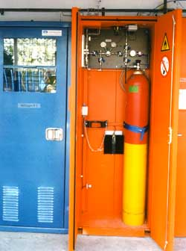
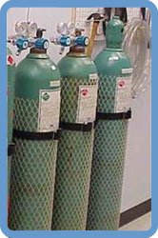
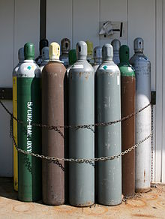

Figure 1: Not In-Use Cylinders
Figure 2: In-Use Cylinders
Figure 3: Gas Cylinder Cabinet
- Follow laboratory supervisor’s instructions for PPE, which may differ depending on the type and/or quantity of compressed gas being used.
- Use in the smallest practical quantities for the experiment being performed.
- Work must be conducted in a chemical fume hood if air concentrations above 10% of the LEL could be created, if the chemical is irritating to the eyes or respiratory system, and/or is toxic by inhalation.
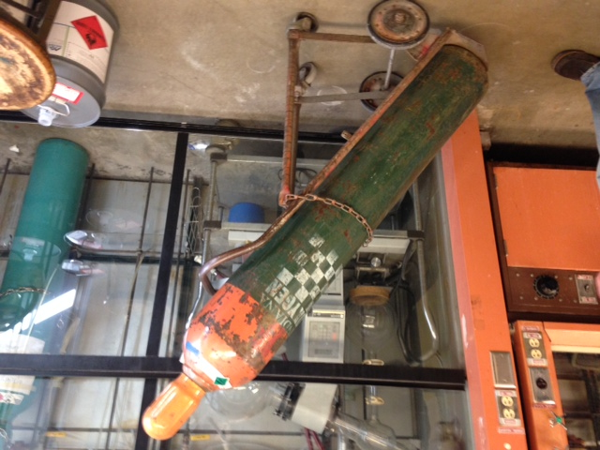
- Gas cylinder connections and fittings must be inspected frequently for deterioration and must never be used without a regulator.
- Never use a leaking, corroded, or damaged cylinder and never refill compressed gas cylinders.
- When stopping a leak between cylinder and regulator, always close the valve before tightening the union nut.
- The regulator should be replaced with a safety cap when the cylinder is not in use.
- The safety cap must be in place when a gas cylinder is moved.
- For large gas cylinders (>27 inches), an approved gas cylinder cart should be used. The cylinder must be strapped to the cart and the protective cap must be in place before moving the cylidner. A cylinder should never be moved or transported without the protective cap. The proper way to move a large gas cylinder is illustrated in Figure 4.
Figure 4: Cylinder Cart
- A few compressed gas cylinders have a shelf-life and can become more hazardous as time goes on. It is extremely important that these chemicals are identified and managed properly. If any time-sensitive gases are found to be past the manufacturer’s expiration date, they must be submitted to REM for hazardous waste disposal immediately. The following is a list of time-sensitive compressed gases:
- Hydrogen fluoride, anhydrous
- Hydrogen bromide, anhydrous
- Hydrogen sulfide, anhydrous
- Hydrogen cyanide, anhydrous
- Hydrogen chloride, anhydrous
Section 5 – Spill and Accident Procedures
Immediately evacuate area and ensure others are aware of the release. If there is an imminent threat of a fire, pull the nearest fire alarm station to evacuate the building and dial 911. If personnel have become exposed and need medical assistance, dial 911. If the release is minor and does not pose a threat to personnel, contact REM at 49-40121 during normal business hours (Monday – Friday, 7 AM – 4 PM) for assistance (dial 911 if release occurs after hours and assistance is needed).
Section 6 – Waste Disposal Procedures
Before submitting compressed gas waste to REM, ensure that the cylinder cannot be returned to the manufacturer or distributor. Many gas vendors charge demurrage for gas storage. Most lecture bottles cannot be returned to the manufacturer and must be treated as waste. Store hazardous waste in closed containers that are properly labeled, and in a designated area. Complete a Chemical Waste Pickup Request Form to arrange for disposal by REM (even if the compressed gas cylinder is empty – never remove the valve from a cylinder for disposal purposes); detailed instructions are provided at the following link: http://www.purdue.edu/ehps/rem/hmm/chemwaste.htm.
Section 7 – Protocol/Procedure (Add lab specific Protocol/Procedure here)
Click here to enter text.
NOTE: Any deviation from this SOP requires approval from PI.

Section 8 – Documentation of Training (signature of all users is required)
Prior to conducting any work with compressed gases, the Principal Investigator must ensure that all laboratory personnel receive training on the content of this SOP.
I have read and understand the content of this SOP:
Name | Signature | Date
Click here to enter text. |  | Click here to enter a date.
Click here to enter text. |  | Click here to enter a date.
Click here to enter text. |  | Click here to enter a date.
Click here to enter text. |  | Click here to enter a date.
Click here to enter text. |  | Click here to enter a date.
Click here to enter text. |  | Click here to enter a date.
Click here to enter text. |  | Click here to enter a date.
Click here to enter text. |  | Click here to enter a date.
Click here to enter text. |  | Click here to enter a date.
Click here to enter text. |  | Click here to enter a date.

