Standard Operating Procedure
Chlorine Gas
This is an SOP template and is not complete until: 1) lab specific information is entered into the box below 2) lab specific protocol/procedure is added to the protocol/procedure section and
3) SOP has been signed and dated by the PI and relevant lab personnel.
Print a copy and insert into your Lab-Specific Chemical Hygiene Plan.
Section 1 – Lab-Specific Information
Building/Room(s) covered by this SOP: | Click here to enter text.
Department: | Click here to enter a date.
Principal Investigator Name: | Click here to enter text.
Principal Investigator Signature: | Click here to enter text.
Section 2 – Hazards
Chlorine gas is severely corrosive to the eyes, skin, and causes severe burns to the respiratory system if inhaled. Chlorine gas is a strong oxidizer and should be kept away from flammable materials. Containers may rupture or explode if exposed to heat. Chlorine gas has a greenish-yellow color and has an irritating odor (strong bleach smell).
Exposure Limits:
OSHA PEL (8 HR. TWA): 0.5 ppm
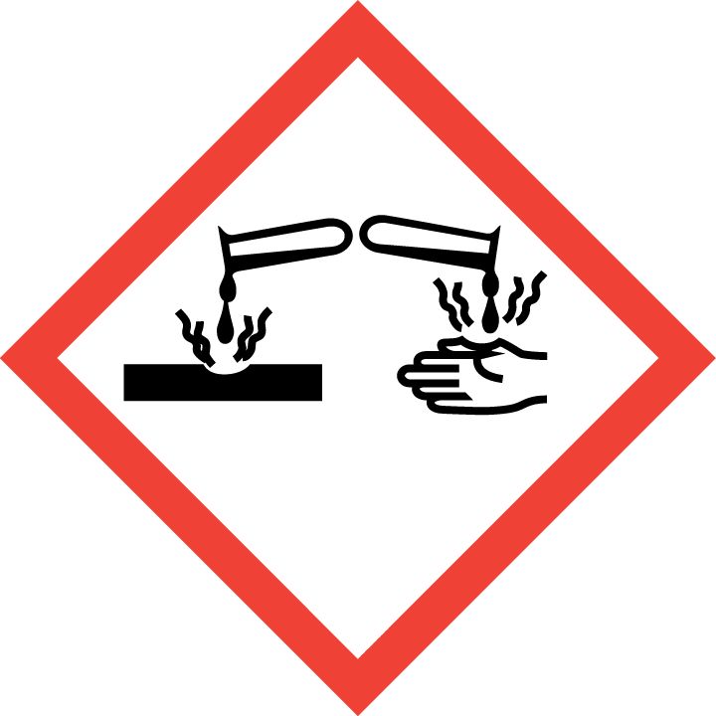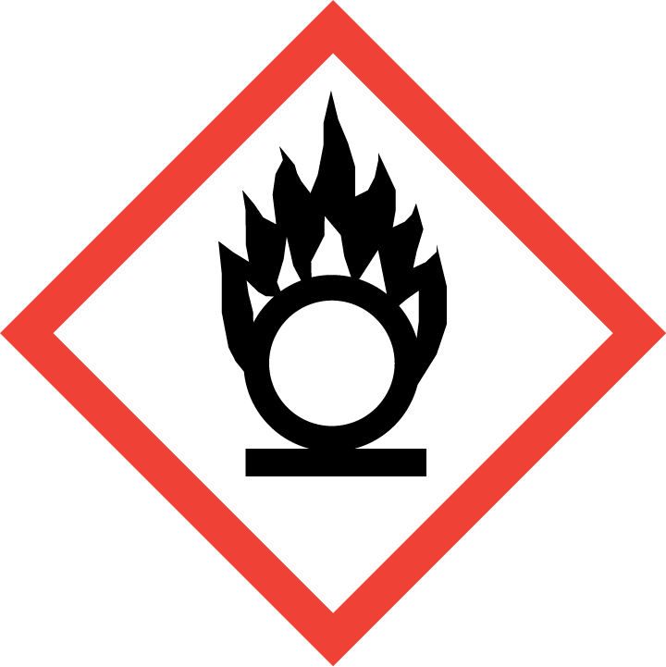
Section 3 – Engineering Controls and Personal Protective Equipment (PPE)
Engineering Controls: Use of chlorine gas must be conducted in a properly functioning chemical fume hood. The chemical fume hood must be approved and certified by REM and have a face velocity between 80 – 125 feet per minute.
Hygiene Measures: Avoid contact with skin, eyes, and clothing. Wash hands before breaks and immediately after handling the product.
Hand Protection: Chemical-resistant gloves must be worn, nitrile gloves are recommended. Wearing two pairs of nitrile gloves is recommended. NOTE: Consult with your preferred glove manufacturer to ensure that the gloves you plan on using are compatible with the specific chemical being used.
Eye Protection: ANSI approved properly fitting safety glasses or chemical splash goggles are required. A face shield may also be appropriate depending on the specific application.
Skin and Body Protection: Flame resistant laboratory coats must be worn and be appropriately sized for the individual and buttoned to their full length. Personnel must also wear full length pants, or equivalent, and close-toed shoes. Full length pants and close-toed shoes must be worn at all times by all individuals that are occupying the laboratory area. The area of skin between the shoe and ankle must not be exposed.
Respiratory Protection: Chlorine gas should never be used outside of a chemical fume hood or glove box; therefore respiratory protection should not be required.
Section 4 – Special Handling and Storage Requirements
- Keep containers tightly closed. Store in a cool, dry and well-ventilated area.
- Extremely reactive or incompatible with the following materials: reducing materials, combustible materials, organic materials, and alkalis.
- Contents under pressure
- Store cylinders upright and keep secured
- Keep valves and fittings free from oil and grease
Section 5 – Spill and Accident Procedures
Immediately evacuate area and ensure others are aware of the spill. If there is an imminent threat of a fire, pull the nearest fire alarm station to evacuate the building and dial 911. If personnel have become exposed and need medical assistance, dial 911.
Section 6 – Waste Disposal Procedures
Store hazardous waste in closed containers that are properly labeled, and in a designated area (flammable cabinet is recommended) away from incompatible chemicals such as aqueous solutions. Complete a Chemical Waste Pickup Request Form to arrange for disposal by REM; detailed instructions are provided at the following link: http://www.purdue.edu/ehps/rem/hmm/chemwaste.htm.
Section 7 – Protocol (Add lab specific Protocol here)
Click here to enter text.
NOTE: Any deviation from this SOP requires approval from Principal Investigator.
Section 8 – Documentation of Training (signature of all users is required)
Prior to conducting any work with chlorine gas, the Principal Investigator must ensure that all laboratory personnel receive training on the content of this SOP.
I have read and understand the content of this SOP:
Name | Signature | Date
Click here to enter text. |  | Click here to enter a date.
Click here to enter text. |  | Click here to enter a date.
Click here to enter text. |  | Click here to enter a date.
Click here to enter text. |  | Click here to enter a date.
Click here to enter text. |  | Click here to enter a date.
Click here to enter text. |  | Click here to enter a date.
Click here to enter text. |  | Click here to enter a date.
Click here to enter text. |  | Click here to enter a date.
Click here to enter text. |  | Click here to enter a date.
Click here to enter text. |  | Click here to enter a date.
Click here to enter text. |  | Click here to enter a date.
Click here to enter text. |  | Click here to enter a date.
Click here to enter text. |  | Click here to enter a date.

