Standard Operating Procedure
Base Baths (Alcoholic Hydroxide Solutions)
This is an SOP template and is not complete until: 1) lab specific information is entered into the box below 2) lab specific protocol is added to the protocol section and
3) SOP has been signed and dated by the PI and relevant lab personnel.
Print a copy and insert into your Lab-Specific Chemical Hygiene Plan.

Section 1 – Lab-Specific Information
Building/Room(s) covered by this SOP: | Click here to enter text.
Department: | Click here to enter a date.
Principal Investigator Name: | Click here to enter text.
Principal Investigator Signature: | Click here to enter text.

Section 2 – Hazards
Base baths are highly concentrated alcoholic hydroxide solutions used to clean glassware after use. The solutions consist of Ethanol or Isopropanol and Sodium or Potassium hydroxide. The glassware is cleaned by chemically dissolving contaminated surfaces. Base baths are flammable and corrosive. They may be harmful if inhaled, ingested, or absorbed through the skin. Inhalation may cause irritation to the respiratory tract with burning pain in the nose and throat, coughing, wheezing, shortness of breath and pulmonary edema. It is destructive to the tissue of the mucous membranes and upper respiratory tract. Inhalation of solvent vapors may cause chronic toxic effects in the liver or kidney. Contact with skin causes burns and irritation. Prolonged or repeated skin exposure may cause skin defatting or dermatitis. Eye contact causes burns, irritation, and may cause blindness. Ingestion may cause permanent damage to the digestive tract. Flash fires may occur in the presence of ignition sources.
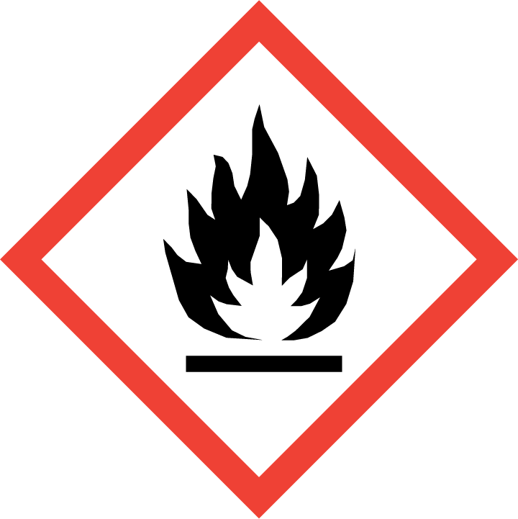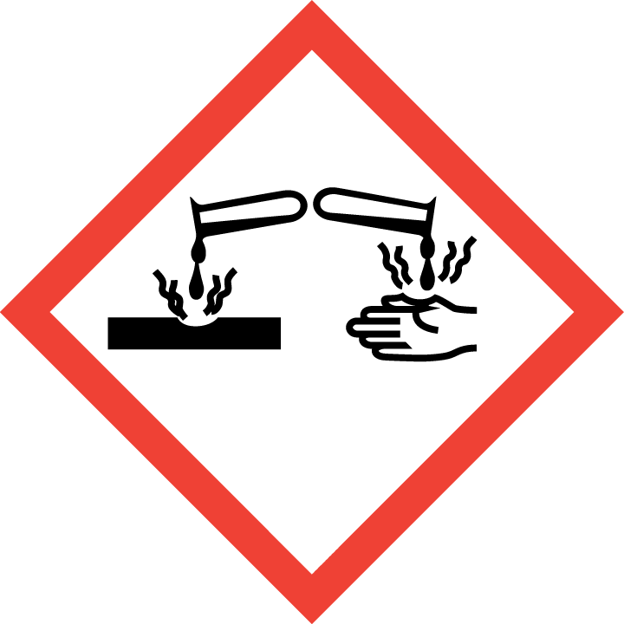

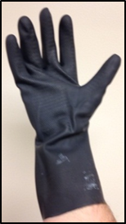
Section 3 – Engineering Controls and Personal Protective Equipment (PPE)
Engineering Controls: Use of a base bath must be conducted in a properly functioning chemical fume hood. The chemical fume hood must be approved and certified by REM and have a face velocity between 80 – 125 feet per minute.
Hygiene Measures: Avoid contact with skin, eyes, and clothing. Wash hands before breaks and immediately after handling the product.
Hand Protection: Gloves must be worn. Use proper glove removal technique to avoid any skin contact. Nitrile gloves layered underneath butyl rubber gauntlet-style gloves are recommended. NOTE: Consult with your preferred glove manufacturer to ensure that the gloves you plan on using are compatible with the specific chemical being used.
Eye Protection: ANSI approved properly fitting chemical splash goggles and a face shield are required.
Skin and Body Protection: Flame resistant laboratory coats must be worn and be appropriately sized for the individual and buttoned to their full length. Additional protection such as chemical-resistant apron may be appropriate as well. Personnel must also wear full length pants, or equivalent, and close-toed shoes. Full length pants and close-toed shoes must be worn at all times by all individuals that are occupying the laboratory area. The area of skin between the shoe and ankle must not be exposed.
Respirator Protection: If base baths are being used outside of a chemical fume hood, respiratory protection may be required. If this activity is absolutely necessary, contact REM (49-46371) so a respiratory protection analysis can be performed.

Section 4 – Special Handling and Storage Requirements
- Do not make excessive amounts of base bath solution; only make what can be safely stored in the laboratory.
- A current copy of the SDS for the specific base bath solution being used must be made available to all personnel working in the laboratory at all times.
- Containers should be labeled appropriately. Label should indicate the name of the chemical(s) in the container. Avoid using chemical abbreviations (acceptable if a legend is present in the lab) and formulae.
- Glassware with excessive grime should first be rinsed with an appropriate solvent (such as water and a little acetone). Collect the rinsate in a separate container, label with all constituents, and submit to REM as waste.
- If the glassware is greased, excess grease should be removed with a paper towel.
- Do not place broken glassware in the base bath as this may break the glass completely and produce glass shards. Check all items before placing in the bath.
- Do not leave glassware in the base bath for more than one overnight period. Prolonged soaking in the bath will lead to degradation and consequent thinning of the glass.
- Always use inside a chemical fume hood. Take care not to cause the bath to overflow. The base bath should be placed in a tray capable of containing the full bath volume in the event that the bath container fails.
- Keep container upright & closed in a dry and well-ventilated place.
- Base baths solutions must be stored in appropriate containers such as a heavy duty HDPE Nalgene container. Do not store base bath solutions in metal containers. Do not store base bath solutions Rubbermaid containers or other non-chemical approved storage containers.
- Avoid contact with skin and eyes. Avoid inhalation of vapor or mist.
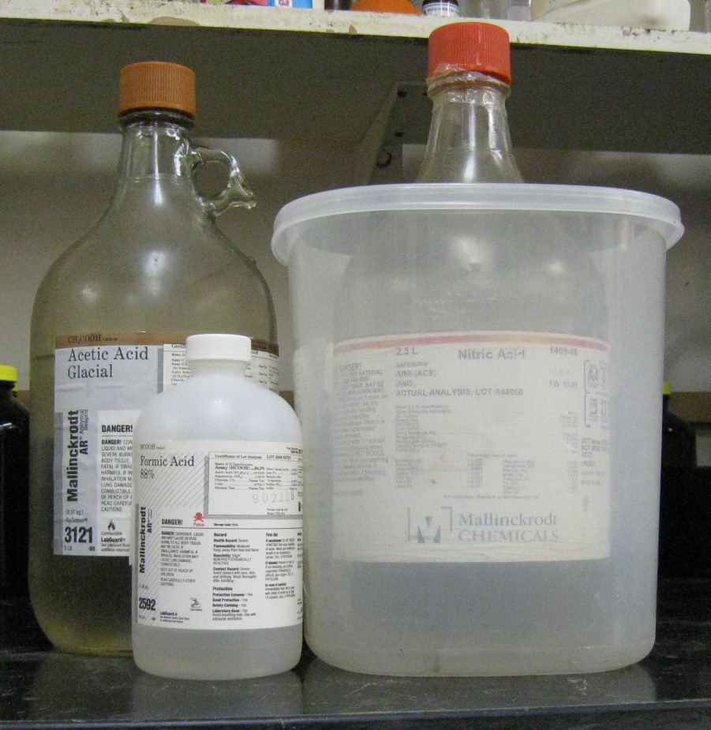
- Keep away from incompatible materials such as acids and oxidizing materials. Keep away from sources of ignition. Avoid heat and shock or friction when handling.
Organic acid
Oxidizing acid
- Containers should remain closed when not in use.

Section 5 – Spill and Accident Procedures
Immediately evacuate area and ensure others are aware of the spill. If there is an imminent threat of a fire, pull the nearest fire alarm station to evacuate the building and dial 911. If personnel have become exposed and need medical assistance, dial 911. If the spill is minor and does not pose a threat to personnel, contact REM at 49-40121 during normal business hours (Monday – Friday, 7 AM – 4 PM) for spill cleanup assistance (dial 911 if spill occurs after hours and assistance is needed).

Section 6 – Waste Disposal Procedures
Store hazardous waste in closed containers that are properly labeled, and in a designated area. After the base bath has lost its cleaning effectiveness, transfer the solution to a heavy duty container (such as Nalgene bottle/carboy). Base bath solutions cannot be disposed of down the drain. Do not mix base bath solutions with acidic waste streams. Complete a Chemical Waste Pickup Request Form to arrange for disposal by REM; detailed instructions are provided at the following link: http://www.purdue.edu/ehps/rem/hmm/chemwaste.htm.
Section 7 – Protocol (Add lab specific Protocol here)
Click here to enter text.
NOTE: Any deviation from this SOP requires approval from Principal Investigator.
Section 8 – Documentation of Training (signature of all users is required)
Prior to conducting any work with base bath solutions, the Principal Investigator must ensure that all laboratory personnel receive training on the content of this SOP.
I have read and understand the content of this SOP:
Name | Signature | Date
Click here to enter text. |  | Click here to enter a date.
Click here to enter text. |  | Click here to enter a date.
Click here to enter text. |  | Click here to enter a date.
Click here to enter text. |  | Click here to enter a date.
Click here to enter text. |  | Click here to enter a date.
Click here to enter text. |  | Click here to enter a date.
Click here to enter text. |  | Click here to enter a date.

