Standard Operating Procedure
Aqua Regia
This is an SOP template and is not complete until: 1) lab specific information is entered into the box below 2) lab specific protocol/procedure is added to the protocol/procedure section and
3) SOP has been signed and dated by the PI and relevant lab personnel.
Print a copy and insert into your Lab-Specific Chemical Hygiene Plan.
Section 1 – Lab-Specific Information
Building/Room(s) covered by this SOP: | Click here to enter text.
Department: | Click here to enter a date.
Principal Investigator Name: | Click here to enter text.
Principal Investigator Signature: | Click here to enter text.
Section 2 – Hazards
Aqua regia is a strong corrosive and oxidizer. It must be kept away from flammable materials such as organic solvents. It decomposes rapidly and forms toxic gases such as nitrosyl chloride, nitrogen dioxide, and chlorine. Aqua regia is best used immediately after preparation and should not be stored in a closed container. Sealed containers of aqua regia have been known to over pressurize and rupture. Aqua regia is harmful if inhaled, ingested, or absorbed through the skin. It is extremely destructive to the tissue of the mucous membranes and upper respiratory tract. It can cause severe skin and eye burns and may cause blindness and permanent eye damage. Inhalation may cause spasms, inflammation and edema of the bronchi or larynx. Other symptoms include burning sensation, coughing, wheezing, shortness of breath, headache, nausea, vomiting, and pulmonary edema. Effects may be delayed. Large doses may conversion of hemoglobin to methemoglobin, producing cyanosis or a drastic fall in blood pressure, leading to collapse, coma, and possibly death. Chronic exposure may cause erosion of the teeth, jaw necrosis, and kidney damage.
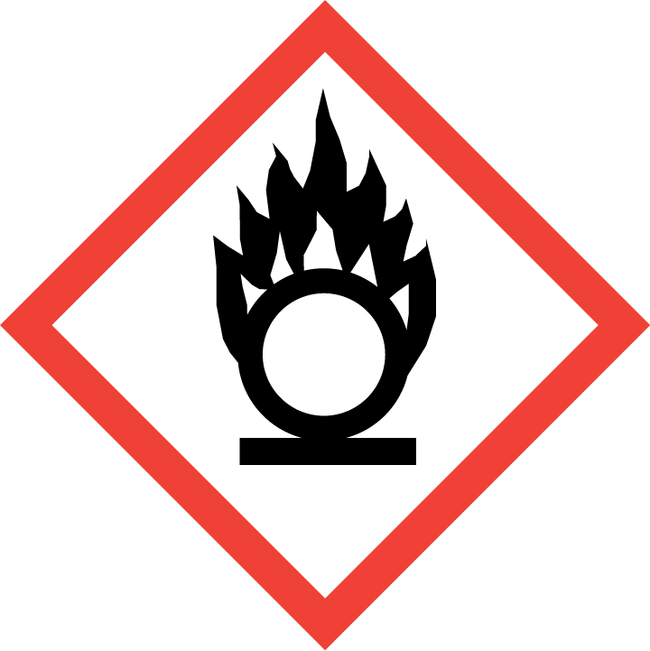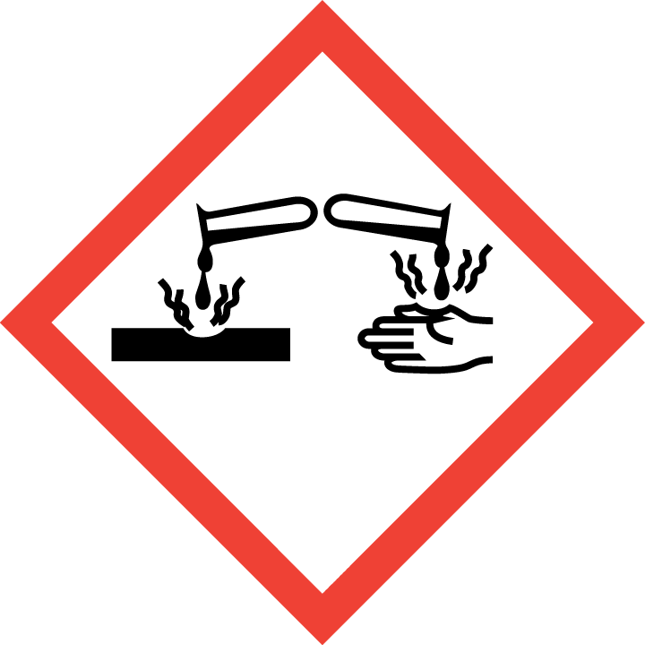
Section 3 – Engineering Controls and Personal Protective Equipment (PPE)
Engineering Controls: Use of aqua regia should be conducted in a properly functioning chemical fume hood whenever possible. The chemical fume hood must be approved and certified by REM and have a face velocity between 80 – 125 feet per minute.
Hygiene Measures: Avoid contact with skin, eyes, and clothing. Wash hands before breaks and immediately after handling the product.
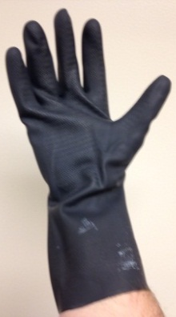
Hand Protection: Gloves must be worn. Use proper glove removal technique to avoid any skin contact. Nitrile gloves layered underneath butyl rubber gauntlet-style gloves are recommended. NOTE: Consult with your preferred glove manufacturer to ensure that the gloves you plan on using are compatible with the specific chemical being used.
Eye Protection: ANSI approved properly fitting chemical splash goggles and a face shield are required.
Skin and Body Protection: Flame resistant laboratory coats must be worn and be appropriately sized for the individual and buttoned to their full length. Additional protection such as chemical-resistant apron may be appropriate as well. Personnel must also wear full length pants, or equivalent, and close-toed shoes. Full length pants and close-toed shoes must be worn at all times by all individuals that are occupying the laboratory area. The area of skin between the shoe and ankle must not be exposed.
Respirator Protection: If aqua regia is being used outside of a chemical fume hood, respiratory protection may be required. If this activity is absolutely necessary, contact REM (49-46371) so a respiratory protection analysis can be performed.
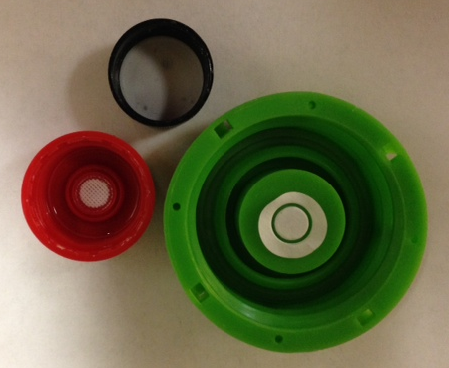
Section 4 – Special Handling and Storage Requirements
- After preparing the aqua regia solution, allow the solution to sit for a period of time before closing the container with a vented cap. Examples of vented caps are illustrated in Figure 1.
- Prepare small amounts of aqua regia solution to be used for each application. Mix the solution in a fume hood with the sash between you and the solution.
- Due to aqua regia’s rapid decomposition, use immediately after preparation. Do not store for long periods of time; do not maintain a stock solution of aqua regia.
Figure 1: Example of vented caps.
- Never seal containers containing aqua regia. Avoid using airtight containers as pressure can build up inside of them causing them to suddenly and very violently rupture.
- After use, it is recommended to neutralize to a neutral pH (6-9) with an appropriate base such as sodium hydroxide. Allow the neutralized solution to vent and cool to room temperature before sealing in a hazardous waste container.
- Utilize secondary containment when preparing and handling aqua regia.
- Avoid contact with skin, eyes, and clothing.

Section 5 – Spill and Accident Procedures
Immediately evacuate area and ensure others are aware of the spill. If there is an imminent threat of a fire, pull the nearest fire alarm station to evacuate the building and dial 911. If personnel have become exposed and need medical assistance, dial 911. If the spill is minor and does not pose a threat to personnel, contact REM at 49-40121 during normal business hours (Monday – Friday, 7 AM – 4 PM) for spill cleanup assistance (dial 911 if spill occurs after hours and assistance is needed).

Section 6 – Waste Disposal Procedures
Store hazardous waste in closed containers that are properly labeled, and in a designated area. After the base bath has lost its cleaning effectiveness, transfer the solution to a heavy duty container (such as Nalgene bottle/carboy). Aqua regia cannot be disposed of down the drain. Do not mix aqua regia with acidic waste streams. Complete a Chemical Waste Pickup Request Form to arrange for disposal by REM; detailed instructions are provided at the following link: http://www.purdue.edu/ehps/rem/hmm/chemwaste.htm.
Section 7 – Protocol (Add lab specific Protocol here)
Click here to enter text.
NOTE: Any deviation from this SOP requires approval from Principal Investigator.
Section 8 – Documentation of Training (signature of all users is required)
Prior to conducting any work with base bath solutions, the Principal Investigator must ensure that all laboratory personnel receive training on the content of this SOP. I have read and understand the content of this SOP:
Name | Signature | Date
Click here to enter text. |  | Click here to enter a date.
Click here to enter text. |  | Click here to enter a date.
Click here to enter text. |  | Click here to enter a date.
Click here to enter text. |  | Click here to enter a date.
Click here to enter text. |  | Click here to enter a date.
Click here to enter text. |  | Click here to enter a date.
Click here to enter text. |  | Click here to enter a date.

