Standard Operating Procedure
Ammonium bifluoride
This SOP template is not complete until: 1) Lab specific information is entered into the box below.
2) Lab specific protocol is added to the protocol section.
3) SOP has been signed/dated by the PI and lab personnel
Print a copy and insert into your Lab-Specific Chemical Hygiene Plan.
Section 1 – Lab-Specific Information
Building/Room(s) covered by this SOP: | Click here to enter text.
Department: | Click here to enter a date.
Principal Investigator Name: | Click here to enter text.
Principal Investigator Signature: | Click here to enter text.
Section 2 – Hazards
Ammonium bifluoride or ammonium hydrogen difluoride, also known as etching powder, is a white crystalline solid commonly used in the metal plating process and surface pretreatment. It is corrosive to tissue, toxic if swallowed, and causes severe skin burns and eye damage. Breathing ammonium bifluoride dusts or mists can be extremely destructive to tissue of the mucous membranes and upper respiratory tract. Ammonium bifluoride is soluble in water to form hydrofluoric acid, a very corrosive acid which can cause severe corrosion of the skin, nose, throat, and eyes. Upon heating or exposure to strong acids or strong bases, ammonium bifluoride may release hydrogen fluoride, ammonia, and nitrogen oxide gases.
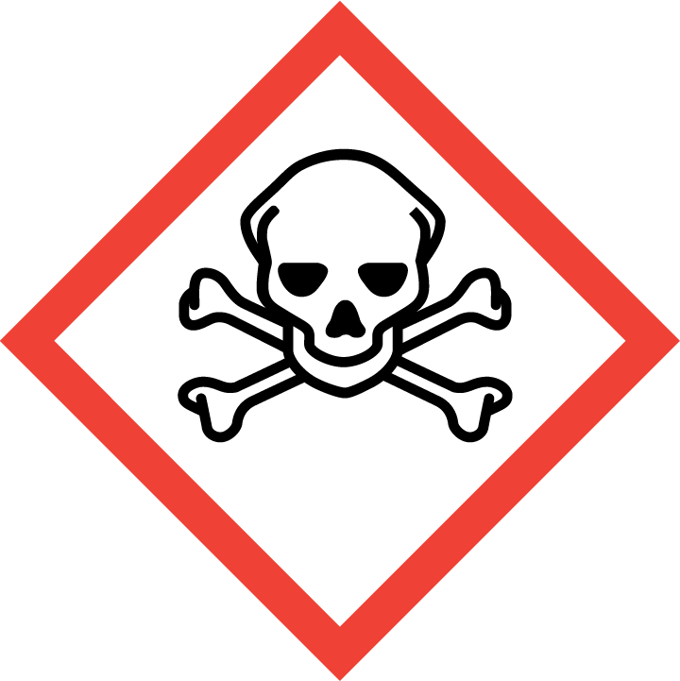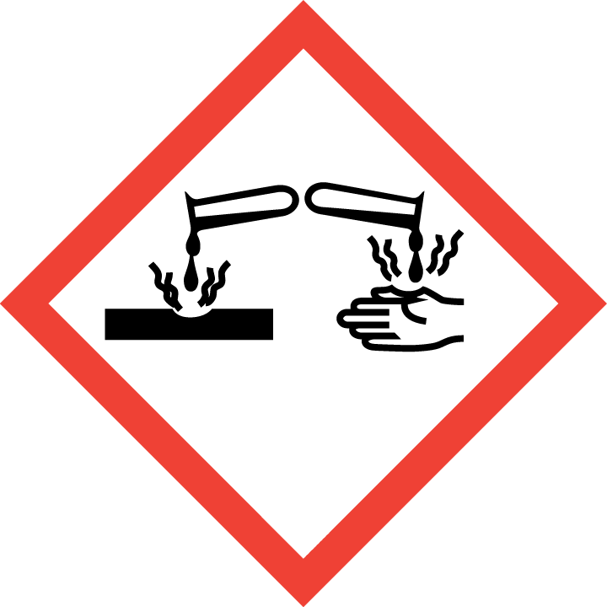
OSHA Hazards: Acute toxicity, Oral (Category 3). Skin corrosion (Category 1B). Serious eye damage (Category 1).
Section 3 – Engineering Controls and Personal Protective Equipment (PPE)
Engineering Controls: Use of ammonium bifluoride should be conducted in a properly functioning chemical fume hood. The chemical fume hoods must be approved and certified by REM and have a face velocity between 80 – 125 feet per minute.
Hygiene Measures: Avoid contact with skin, eyes, and clothing. Wash hands thoroughly with warm water and soap before breaks and immediately after handling the product.
Hand Protection: Chemical-resistant gloves must be worn. Gloves must be inspected prior to use. Wearing two pairs of gloves is recommended. Use proper glove removal technique (without touching outer surface of the gloves) to avoid skin contact with ammonium bifluoride on the contaminated gloves. Dispose of gloves after use as hazardous waste. Wash and dry hands.
Eye/face Protection: ANSI-approved properly fitting safety glasses or chemical splash goggles are required. A face shield may also be appropriate depending on the specific application.
Skin and Body Protection: Laboratory coats (preferably with front snap closures) must be worn and be appropriately sized for the individual and buttoned to their full length. Personnel must also wear full length pants, or equivalent, and close-toed shoes. Full length pants and close-toed shoes must be worn at all times by all individuals that are occupying the laboratory area. The area of skin between the shoe and ankle must not be exposed. Additional protection may be required depending on the application and amount of ammonium bifluoride being used.
Respiratory Protection: Ammonium bifluoride should never be used outside of a chemical fume hood or glove box; therefore, respiratory protection should not be required.
Section 4 – First Aid Procedures
If inhaled:
Dial 911. Move to fresh air. If the person is not breathing, give artificial respiration. Avoid mouth to mouth contact.
In case of skin contact:
Dial 911. Immediately (within seconds) flush affected area for at least 5 minutes. Remove all contaminated clothing. Wearing compatible gloves, massage calcium gluconate 2.5% gel into the affected area. Re-apply every 15 minutes until medical help arrives.

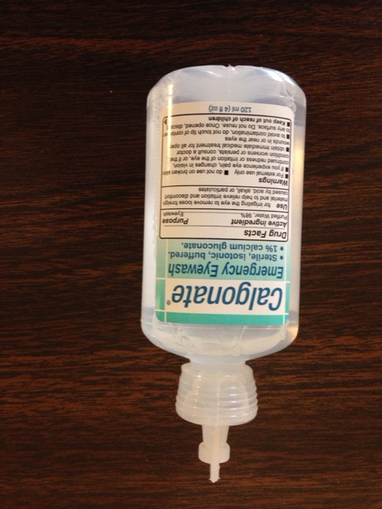
In case of eye contact:
Dial 911. Flush eyes with copious water for at least 15 minutes. If 1% Calcium Gluconate emergency eyewash solution is available, water flushing may be limited to 5 minutes, then use 1% Calcium Gluconate solution. NOTE: Do not open the emergency eyewash solution seal unless it needs to be used. Use the entire 120 ml content during an emergency (eye exposure). Emergency eyewash solution is for single use only.

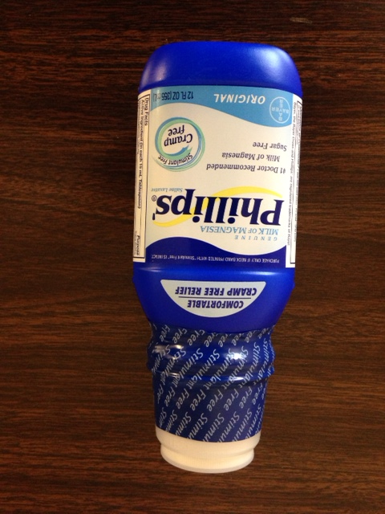
If swallowed:
Dial 911. Do not induce vomiting. Drink large quantities of water then drink 12 ounces of milk of magnesia. Never give anything by mouth to unconscious person.

NOTE: All three of these products expire and must be maintained (annual purchases must be made to keep the kit current).
Section 5 – Special Handling and Storage Requirements
- Do not over purchase; only purchase what can be safely stored in the laboratory.
- Always handle in a properly functioning chemical fume hood and wear appropriate PPE at all times.
- Avoid contact with skin, eyes, and inhalation. Avoid formation of dust and aerosols. Do not breathe vapors, mist or gas. Ensure adequate ventilation.
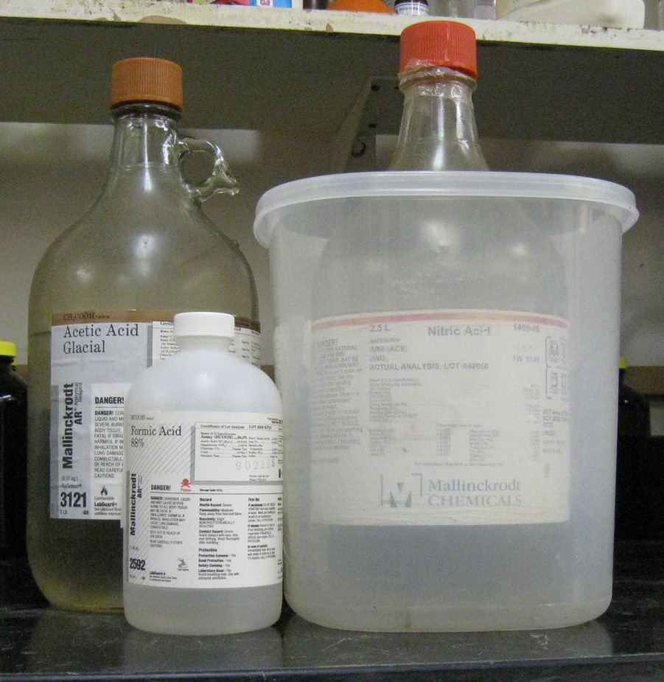
- Solids should be dispensed/weighed in the chemical fume hood. Ensure that the hood sash is positioned at the proper operating height as indicated by the operating sash label. Do not handle, store, or open ammonium bifluoride near an open flame, sources of heat or sources of ignition.
- Keep containers tightly closed at all times. Store in a cool, dry and well-ventilated area away from incompatible substances.
- A suitable storage location is a corrosive/acid/lab storage cabinet within a secondary containment (Nalgene/polypropylene tray or tub).
- Do not store in the top most shelf of the storage cabinet. In general, do not store chemicals at or above eye level.
- Do not store with oxides, organic chemicals, bases or metals.
- Keep away from sources of ignition. Avoid heat and shock or friction when handling.
Organic acid
Oxidizing acid
- A current copy of the ammonium bifluoride SDS must be made available to all personnel working in the laboratory at all times.
- Containers should be labeled appropriately. Label should indicate the name of the chemical in the container. Avoid using chemical abbreviations and formulae.
- Conduct the procedure only after a supervisor has observed the user performing the proper technique unassisted.
Section 6 – Spill and Accident Procedures
Immediately evacuate area and ensure others are aware of the spill. If there is an imminent threat of a fire, pull the nearest fire alarm station to evacuate the building and dial 911. If personnel have become exposed and need medical assistance, dial 911. If the spill is minor, avoid dust formation and contact REM at 49-40121 during normal business hours (Monday – Friday, 7 AM – 4 PM) for spill cleanup assistance (dial 911 if spill occurs after hours and assistance is needed).
Chemical specific Instructions: Wear respiratory protection. Avoid dust formation. Avoid breathing vapors, mist or gas. Ensure adequate ventilation. Evacuate personnel to safe areas. Avoid breathing dust. Pick up and arrange disposal without creating dust. Sweep up and shovel. Keep in suitable, closed containers for disposal.
Section 7 – Waste Disposal Procedures
Store hazardous waste in closed containers that are properly labeled and in a designated area (flammable cabinet is recommended) away from incompatible chemicals, such as aqueous solutions. Complete a Chemical Waste Pickup Request Form to arrange for disposal by REM; detailed instructions are provided at the following link: https://www.purdue.edu/ehps/rem/waste/hazwaste.html#HMPR.
Section 8 – Protocol (Add lab specific Protocol here)
Click here to enter text.
NOTE: Any deviation from this SOP requires approval from Principal Investigator.
Section 9 – Documentation of Training (signature of all users is required)
Prior to conducting any work with ammonium bifluoride, the Principal Investigator must ensure that all laboratory personnel receive training on the content of this SOP.
I have read and understand the content of this SOP:
Name | Signature | Date
Click here to enter text. |  | Click here to enter a date.
Click here to enter text. |  | Click here to enter a date.
Click here to enter text. |  | Click here to enter a date.
Click here to enter text. |  | Click here to enter a date.
Click here to enter text. |  | Click here to enter a date.
Click here to enter text. |  | Click here to enter a date.
Click here to enter text. |  | Click here to enter a date.
Click here to enter text. |  | Click here to enter a date.
Click here to enter text. |  | Click here to enter a date.
Click here to enter text. |  | Click here to enter a date.
Click here to enter text. |  | Click here to enter a date.

