Standard Operating Procedure
Acutely Toxic Materials, Reproductive Toxic Materials, Target Organ Toxics, and Carcinogens
This is an SOP template and is not complete until: 1) lab specific information is entered into the box below 2) lab specific protocol is added to the protocol section and
3) SOP has been signed and dated by the PI and relevant lab personnel.
Print a copy and insert into your Lab-Specific Chemical Hygiene Plan.

Section 1 – Lab-Specific Information
Building/Room(s) covered by this SOP: | Click here to enter text.
Department: | Click here to enter a date.
Principal Investigator Name: | Click here to enter a date.
Principal Investigator Signature: | Click here to enter text.
Section 2 – Important Definitions
- Lethal Dose-50 (LD50): The amount of a substance that, when administered to a group of experimental animals, will kill 50% of the group in a specified time.
- Lethal Concentration-50 (LC50): The concentration of a substance that, when administered to a group of experimental animals, will kill 50% of the group in a specified time.
- Permissible Exposure Limit (PEL): The maximum amount or concentration of a chemical that a worker may be exposed to under OSHA regulations. PELs are based on an 8-hour time weighted average (TWA) exposure.
- Immediately Dangerous to Life and Health (IDLH): The airborne concentration of a contaminant that poses an immediate threat to life and health likely to cause death of immediate or delayed permanent adverse health effects or prevent escape from such an environment.
- Acutely Toxic Material: Substances that may be fatal or cause damage to target organs as the result of a single exposure or exposure of short duration. Acute toxins are quantified by substance’s LD50 or LC50.
- Reproductive Toxic Material: Substances that may affect the reproductive capabilities, including chromosomal damage (mutations) and effects on fetuses (teratogens).
- Target Organ Toxic Material: Substances that pose adverse health effects to specific organs such as the liver, kidneys, lungs, etc.
- Carcinogen: A chemical is considered to be a carcinogen if:
  - It has been evaluated by the International Agency for Research on Cancer (IARC), and found to be a carcinogen or potential carcinogen; or
  - It is listed as a carcinogen or potential carcinogen in the Annual Report on Carcinogens published by the National Toxicology Program (NTP) (Latest edition); or
  - It is regulated by OSHA as a carcinogen.
- Toxic Chemical: A chemical falling within any of the following categories:
  - A chemical that has a median lethal dose (LD50) of more than 50 milligrams per kilogram but not more than 500 milligrams per kilogram of body weight when administered orally to albino rats weighing between 200 and 300 grams each.
  - A chemical that has a median lethal dose (LD50) of more than 200 milligrams per kilogram but not more than 1,000 milligrams per kilogram of body weight when administered by continuous contact for 24 hours (or less if death occurs within 24 hours) with the bare skin of albino rabbits weighing between two and three kilograms each.
  - A chemical that has a median lethal concentration (LC50) in air of more than 200 parts per million but not more than 2,000 parts per million of gas or vapor, or more than two milligrams per liter but not more than 20 milligrams per liter of mist, fume, or dust, when administered by continuous inhalation for one hour (or less if death occurs within one hour) to albino rats weighing between 200 and 300 grams each.
Section 3 – Hazards
These substances are highly toxic by inhalation, ingestion, or skin absorption. Many acutely toxic chemicals are also carcinogenic and may have other hazards such as target organ effect, pose an environmental hazard, and/or corrosivity, etc. Make sure that all of the potential hazards are clearly understood before handling any toxic chemical.
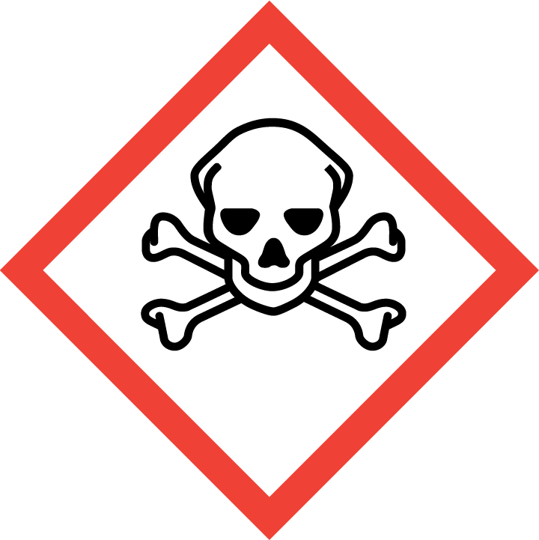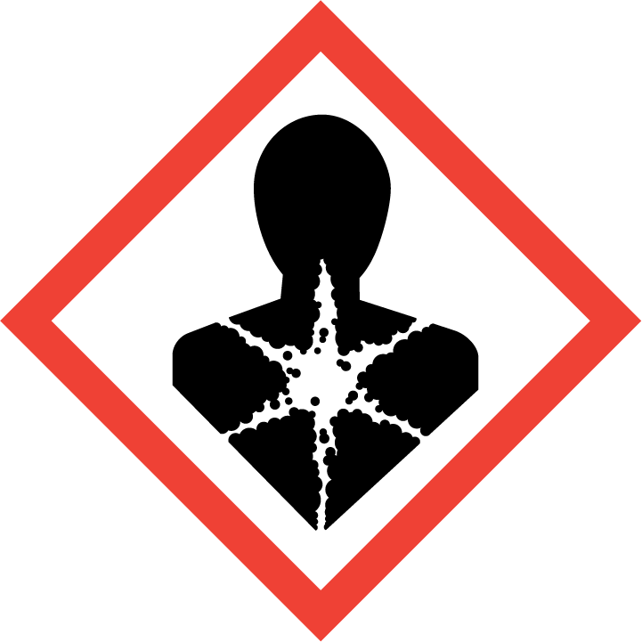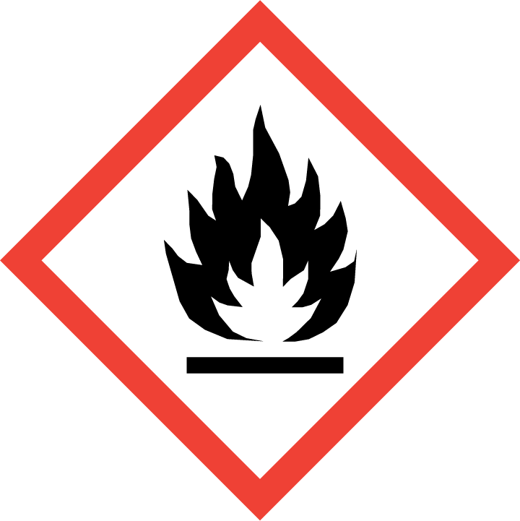
Section 4 – Engineering Controls and Personal Protective Equipment (PPE)
Engineering Controls: Use of acutely toxic materials must be conducted in a properly functioning chemical fume. The chemical fume hood must be approved and certified by REM and have a face velocity between 80 – 125 feet per minute.
Hygiene Measures: Avoid contact with skin, eyes, and clothing. Wash hands before breaks and immediately after handling the product.
Hand Protection: Chemical-resistant gloves must be worn, nitrile gloves are recommended for low volume applications. Wearing two pairs of nitrile gloves is recommended. It is critical that the glove being worn is resistant to the particular acutely toxic chemical. NOTE: Consult with your preferred glove manufacturer to ensure that the gloves you plan on using are compatible with the specific chemical being used.
Eye Protection: ANSI approved properly fitting safety glasses or chemical splash goggles are required. A face shield may also be appropriate depending on the specific application.
Skin and Body Protection: Laboratory coats must be worn and be appropriately sized for the individual and buttoned to their full length. Flame resistant lab coats must be worn when handling volumes greater than 1 liter. Personnel must also wear full length pants, or equivalent, and close-toed shoes. Full length pants and close-toed shoes must be worn at all times by all individuals that are occupying the laboratory area. The area of skin between the shoe and ankle must not be exposed.
Respiratory Protection: If toxic materials are being used outside of a chemical fume hood, respiratory protection may be required. If this activity is necessary, contact REM (49-46371) so a respiratory protection analysis can be performed.
Section 5 – Special Handling and Storage Requirements
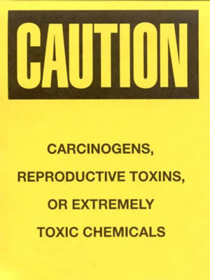
- A designated storage area must be established for acutely toxic chemicals and the area should be posted with a “Caution, Carcinogen, Reproductive Toxins, or Extremely Toxic Chemicals” label provided by REM (as shown to the right).
- Suitable storage locations include lab cabinets, desiccators, glove boxes, flammable storage cabinets that do not contain incompatible chemicals (primarily strong acids), or non-domestic refrigerators or freezers.
- Acutely toxic materials should be stored in secondary containment at all times as a precautionary measure. If possible, store all acutely toxic materials in a dedicated cabinet. Consider placing all acutely toxic chemicals in secondary containment (e.g., plastic bin). Signs should be posted to indicate their presence and unique hazards.
- A current copy of the SDS for the specific acutely toxic chemical(s) being used must be made available to all personnel working in the laboratory at all times.
- The amount of acutely toxic material stored in the lab should be kept at a minimum. Any expired or unnecessary materials should be properly disposed of as hazardous waste.
- All acutely toxic materials should be clearly labeled with the original manufacturer’s label, which should have the chemical name, hazard labels, and pictograms. The label should not be defaced in any way.
- Do not over purchase; only purchase what can be safely stored in the laboratory.
- Avoid contact with skin, eyes, and inhalation.
- Keep away from sources of ignition.
- Keep containers tightly closed. Store in a cool, dry, and well-ventilated area away from incompatible substances such as strong acids.
Section 6 – Spill and Accident Procedures
Immediately evacuate area and ensure others are aware of the spill. If there is an imminent threat of a fire, pull the nearest fire alarm station to evacuate the building and dial 911. If personnel have become exposed and need medical assistance, dial 911. If the spill is minor and does not pose a threat to personnel, contact REM at 49-40121 during normal business hours (Monday – Friday, 7 AM – 4 PM) for spill cleanup assistance (dial 911 if spill occurs after hours and assistance is needed).
Section 7 – Waste Disposal Procedures
All acutely toxic chemical waste must be collected for proper waste disposal by REM (sink disposal is not permitted). Store hazardous waste in closed containers that are properly labeled, and in a designated area (flammable cabinet is recommended). No toxic materials are permitted to be poured down the drain. Complete a Chemical Waste Pickup Request Form to arrange for disposal by REM; detailed instructions are provided at the following link: http://www.purdue.edu/ehps/rem/hmm/chemwaste.htm.
Section 8 – Protocol/Procedure (Additional lab protocol may be added here)
Click here to enter text.
NOTE: Any deviation from this SOP requires approval from Principal Investigator.
Section 9 – Documentation of Training (signature of all users is required)
Prior to conducting any work with acutely toxic materials, the Principal Investigator must ensure that all laboratory personnel receive training on the content of this SOP.
I have read and understand the content of this SOP:
Name | Signature | Date
Click here to enter text. |  | Click here to enter a date.
Click here to enter text. |  | Click here to enter a date.
Click here to enter text. |  | Click here to enter a date.
Click here to enter text. |  | Click here to enter a date.
Click here to enter text. |  | Click here to enter a date.
Click here to enter text. |  | Click here to enter a date.
Click here to enter text. |  | Click here to enter a date.
Click here to enter text. |  | Click here to enter a date.
Click here to enter text. |  | Click here to enter a date.
Click here to enter text. |  | Click here to enter a date.

