Standard Operating Procedure
Acrolein (2-Propenal)
This is an SOP template and is not complete until: 1) lab specific information is entered into the box below 2) lab specific protocol/procedure is added to the protocol/procedure section and
3) SOP has been signed and dated by the PI and relevant lab personnel.
Print a copy and insert into your Lab-Specific Chemical Hygiene Plan.
Section 1 – Lab-Specific Information
Building/Room(s) covered by this SOP: | Click here to enter text.
Department: | Click here to enter a date.
Principal Investigator Name: | Click here to enter text.
Principal Investigator Signature: | Click here to enter text.
Section 2 – Hazards
Acrolein is a highly flammable liquid, acutely toxic by oral ingestion, inhalation, and skin absorption. It is also corrosive, likely to be carcinogenic, and a reproductive toxin. Acrolein is fatal if swallowed or inhaled; and if in contact with skin or eyes, acrolein causes severe skin burns and eye damage. Symptoms of exposure are cough, shortness of breath, headache, and nausea.
Exposure Limits:
OSHA PEL (8 HR. TWA): 0.1 ppm
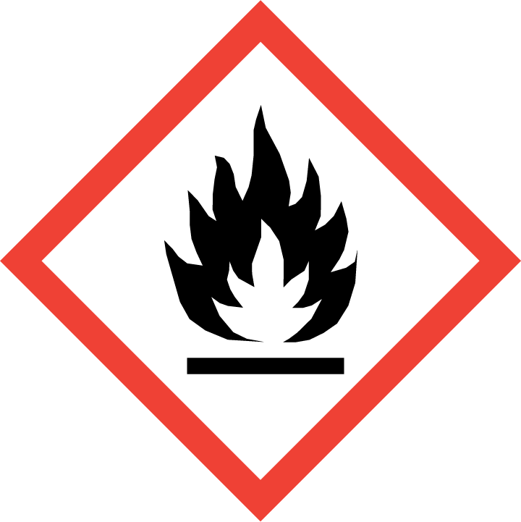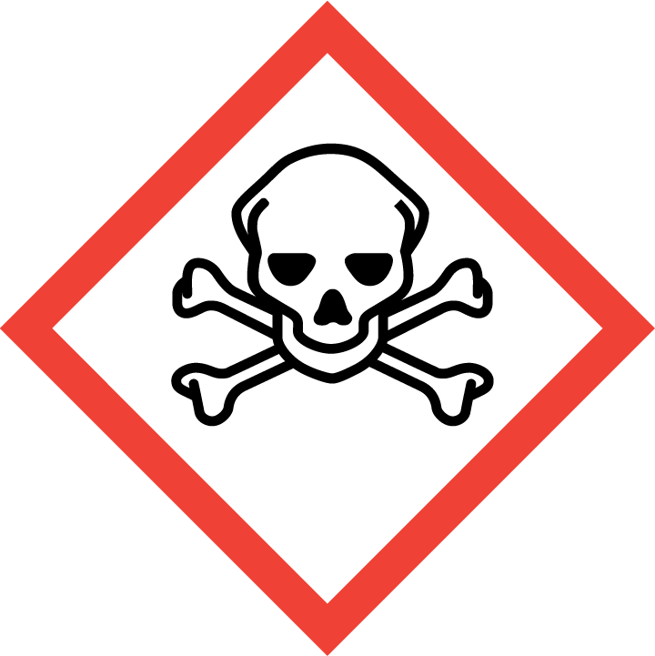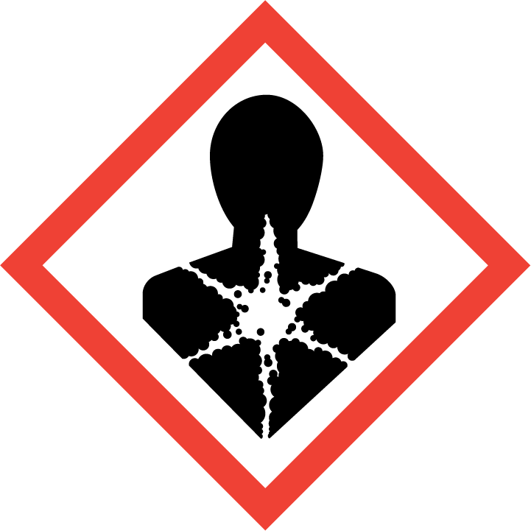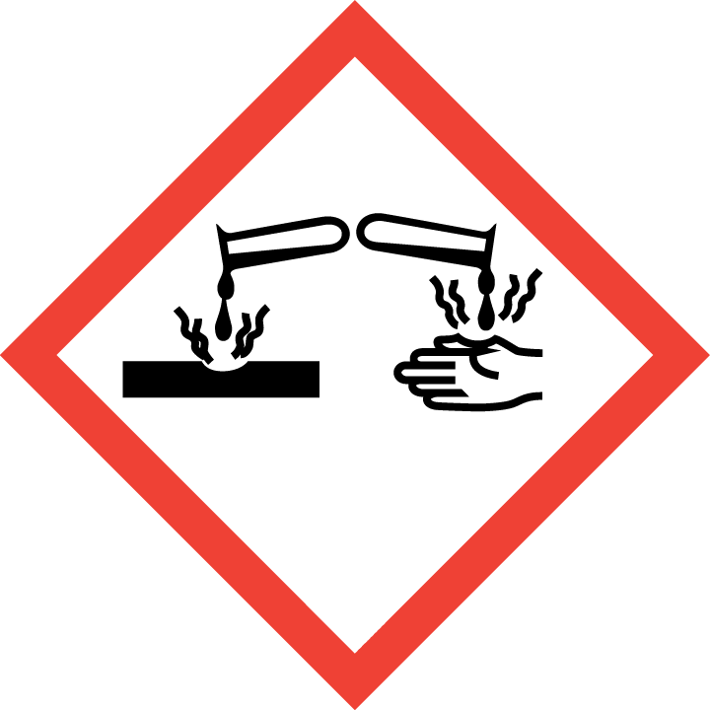

Section 3 – Engineering Controls and Personal Protective Equipment (PPE)
Engineering Controls: Acrolein must be used in a properly functioning chemical fume hood or glove box. The chemical fume hood must be approved and certified by REM and have a face velocity between 80 – 125 feet per minute.
Hygiene Measures: Avoid contact with skin, eyes, and clothing. Wash hands before breaks and immediately after handling the product.
Hand Protection: Chemical-resistant gloves must be worn, butyl-rubber gloves are recommended for handling acrolein. NOTE: Consult with your preferred glove manufacturer to ensure that the gloves you plan on using are compatible with the specific chemical being used.
Eye Protection: ANSI approved properly fitting safety glasses or chemical splash goggles are required.
Skin and Body Protection: Laboratory coats must be worn and be appropriately sized for the individual and buttoned to their full length. Flame resistant lab coats must be worn when handling volumes greater than 1 liter. Personnel must also wear full length pants, or equivalent, and close-toed shoes. Full length pants and close-toed shoes must be worn at all times by all individuals that are occupying the laboratory area. The area of skin between the shoe and ankle must not be exposed.
Respiratory Protection: If acrolein is being used outside of a chemical fume hood, respiratory protection is required. If the respirator is the sole means of protection, use a full-face supplied air respirator. If this activity is necessary, contact REM (49-46371) so a respiratory protection analysis can be performed.
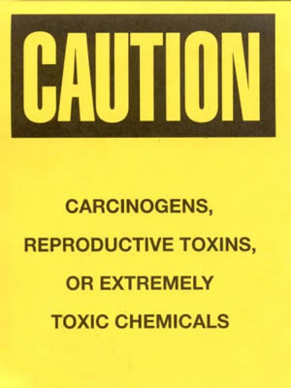
Section 4 – Special Handling and Storage Requirements
- A designated storage area must be established for acrolein and the area should be posted with a “Caution, Carcinogen, Reproductive Toxins, or Extremely Toxic Chemicals” label provided by REM (as shown to the right).
- Do not over purchase; only purchase what can be safely stored in the laboratory.
- Avoid contact with skin, eyes, and inhalation.
- Keep away from sources of ignition.
- Keep containers tightly closed.
- Store in a cool, dry and well-ventilated area away from incompatible substances such as oxidizers.
- A suitable storage location is a flammable storage cabinet that does not contain incompatibles such as oxidizing agents, and strong acids or bases.
Section 5 – Spill and Accident Procedures
Immediately evacuate area and ensure others are aware of the spill. If there is an imminent threat of a fire, pull the nearest fire alarm station to evacuate the building and dial 911. If personnel have become exposed and need medical assistance, dial 911. If the spill is minor and does not pose a threat to personnel, contact REM at 49-40121 during normal business hours (Monday – Friday, 7 AM – 4 PM) for spill cleanup assistance (dial 911 if spill occurs after hours and assistance is needed).
Section 6 – Waste Disposal Procedures
All acrolein waste must be collected for proper waste disposal by REM (sink disposal is not permitted). Store hazardous waste in closed containers that are properly labeled, and in a designated area (flammable cabinet is recommended). Complete a Chemical Waste Pickup Request Form to arrange for disposal by REM; detailed instructions are provided at the following link: http://www.purdue.edu/ehps/rem/hmm/chemwaste.htm.
Section 7 – Protocol/Procedure (Add lab specific Protocol/Procedure here)
Click here to enter text.
NOTE: Any deviation from this SOP requires approval from PI.
Section 8 – Documentation of Training (signature of all users is required)
Prior to conducting any work with acrolein, the Principal Investigator must ensure that all laboratory personnel receive training on the content of this SOP.
I have read and understand the content of this SOP:
Name | Signature | Date
Click here to enter text. |  | Click here to enter a date.
Click here to enter text. |  | Click here to enter a date.
Click here to enter text. |  | Click here to enter a date.
Click here to enter text. |  | Click here to enter a date.
Click here to enter text. |  | Click here to enter a date.
Click here to enter text. |  | Click here to enter a date.
Click here to enter text. |  | Click here to enter a date.
Click here to enter text. |  | Click here to enter a date.
Click here to enter text. |  | Click here to enter a date.
Click here to enter text. |  | Click here to enter a date.

