Standard Operating Procedure
Acetic anhydride
This is an SOP template and is not complete until: 1) lab specific information is entered into the box below 2) lab specific protocol/procedure is added to the protocol/procedure section and
3) SOP has been signed and dated by the PI and relevant lab personnel.
Print a copy and insert into your Lab-Specific Chemical Hygiene Plan.
Section 1 – Lab-Specific Information
Building/Room(s) covered by this SOP: | Click here to enter text.
Department: | Click here to enter a date.
Principal Investigator Name: | Click here to enter text.
Principal Investigator Signature: | Click here to enter text.
Section 2 – Hazards
Acetic anhydride is a flammable liquid which can react violently with water. Caution should be use when to avoid heat, sources of ignition, and buildup of electrostatic charge when working with acetic anhydride. It is harmful is swallowed or inhaled and can cause skin burns and eye damage. If inhaled, it may cause digestive and respiratory tract burn as well as central nervous system depression and mucous membranes.
Exposure Limits:
OSHA PEL (8 HR. TWA): 1 ppm
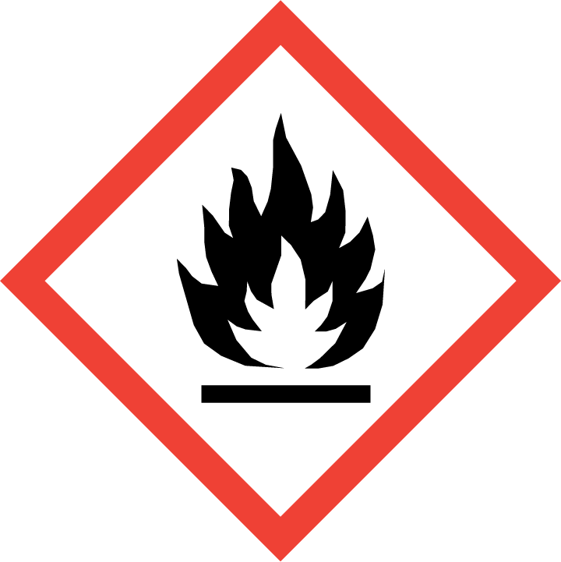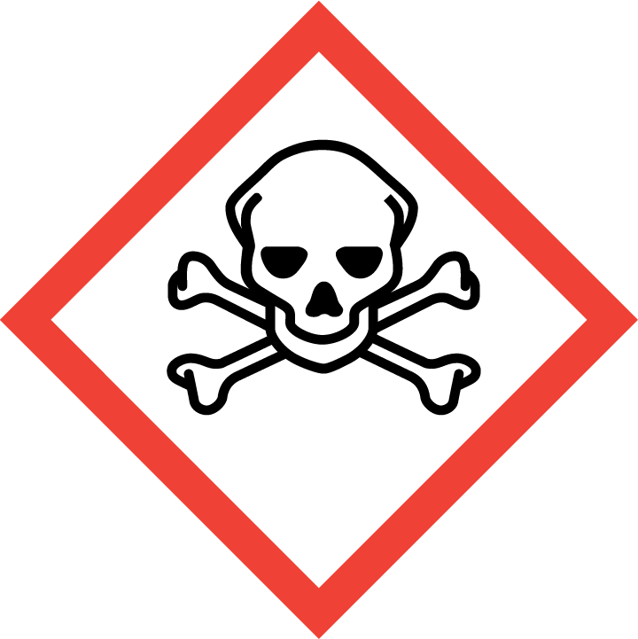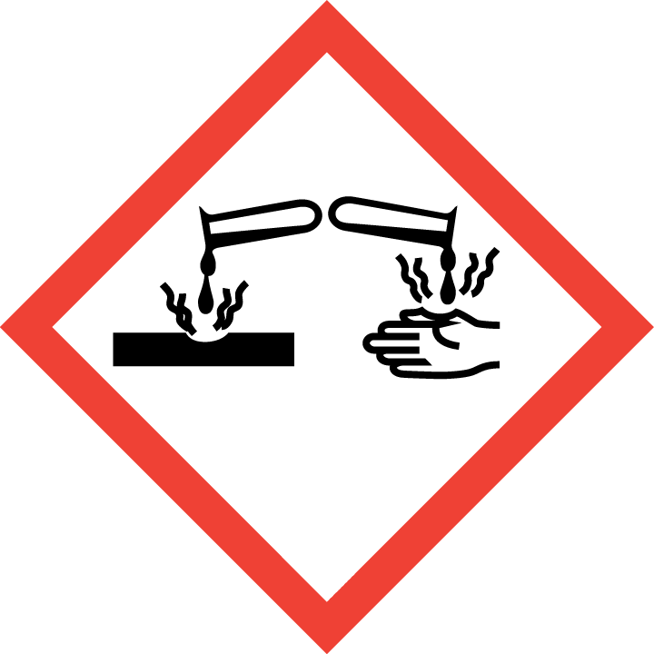
Section 3 – Engineering Controls and Personal Protective Equipment (PPE)
Engineering Controls: Use of acetic anhydride should be conducted in a properly functioning chemical fume hood whenever possible. The chemical fume hood must be approved and certified by REM and have a face velocity between 80 – 125 feet per minute.
Hygiene Measures: Avoid contact with skin, eyes, and clothing. Wash hands before breaks and immediately after handling the product.
Hand Protection: Chemical-resistant gloves must be worn, nitrile gloves are recommended. Butyl-rubber gloves may be preferable when working with large amounts of acetic anhydride. NOTE: Consult with your preferred glove manufacturer to ensure that the gloves you plan on using are compatible with the specific chemical being used.
Eye Protection: ANSI approved properly fitting safety glasses or chemical splash goggles are required. A face shield may also be appropriate depending on the specific application.
Skin and Body Protection: Laboratory coats must be worn and be appropriately sized for the individual and buttoned to their full length. Flame retardant lab coats must be used when working with >1L of acetic anhydride. Personnel must also wear full length pants, or equivalent, and close-toed shoes. Full length pants and close-toed shoes must be worn at all times by all individuals that are occupying the laboratory area. The area of skin between the shoe and ankle must not be exposed.
Respiratory Protection: If acetic anhydride is being used outside of a chemical fume hood, respiratory protection may be required. If this activity is necessary, contact REM (4-6371) so a respiratory protection analysis can be performed.
Section 4 – Special Handling and Storage Requirements
- Do not over purchase; only purchase what can be safely stored in the laboratory.
- Avoid contact with skin and eyes. Avoid inhalation of vapor or mist.
- Always use inside a chemical fume hood.
- Do not allow water to get into the container because of violent reaction.
- Do not use with metal spatula or other metal items.
- Use in the smallest practical quantities for the experiment being performed.
- Keep container upright & tightly closed in a dry and well-ventilated place.
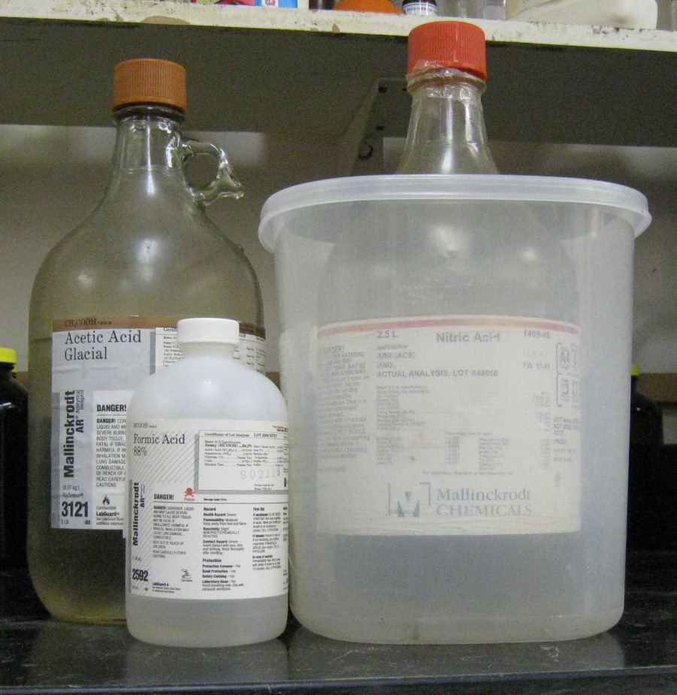
- Containers which are opened must be carefully resealed and kept upright to prevent leakage.
- Use explosion-proof electrical/ ventilating/ lighting/ equipment and only non-sparking tools when working with acetic anhydride.
- Segregate from incompatible materials: acids, bases, alcohols, oxidizing agents, reducing agents, and powdered metals
Organic acid
Oxidizing acid
- Containers should be labeled appropriately; the original manufacturer’s label is acceptable. Label should indicate the name of the chemical(s) in the container. Avoid using chemical abbreviations (acceptable if a legend is present in the lab) and formulae.
Section 5 – Spill and Accident Procedures
Immediately evacuate area and ensure others are aware of the spill. If there is an imminent threat of a fire, pull the nearest fire alarm station to evacuate the building and dial 911. If personnel have become exposed and need medical assistance, dial 911. If the spill is minor and does not pose a threat to personnel, contact REM at 49-40121 during normal business hours (Monday – Friday, 7 AM – 4 PM) for spill cleanup assistance (dial 911 if spill occurs after hours and assistance is needed).
Section 6 – Waste Disposal Procedures
Store hazardous waste in closed containers that are properly labeled, and in a designated area (flammable cabinet is recommended) away from incompatible chemicals such as those listed above. Complete a Chemical Waste Pickup Request Form to arrange for disposal by REM; detailed instructions are provided at the following link: http://www.purdue.edu/ehps/rem/hmm/chemwaste.htm.
Section 7 – Protocol (Add lab specific Protocol here)
Click here to enter text.
NOTE: Any deviation from this SOP requires approval from Principal Investigator.
Section 8 – Documentation of Training (signature of all users is required)
Prior to conducting any work with acetic anhydride, the Principal Investigator must ensure that all laboratory personnel receive training on the content of this SOP.
I have read and understand the content of this SOP:
Name | Signature | Date
Click here to enter text. |  | Click here to enter a date.
Click here to enter text. |  | Click here to enter a date.
Click here to enter text. |  | Click here to enter a date.
Click here to enter text. |  | Click here to enter a date.
Click here to enter text. |  | Click here to enter a date.
Click here to enter text. |  | Click here to enter a date.
Click here to enter text. |  | Click here to enter a date.
Click here to enter text. |  | Click here to enter a date.

