Standard Operating Procedure
Phenylmethanesulfonyl fluoride (PMSF)
This is an SOP template and is not complete until: 1) lab specific information is entered into the box below 2) lab specific protocol/procedure is added to the protocol/procedure section and
3) SOP has been signed and dated by the PI and relevant lab personnel.
Print a copy and insert into your Lab-Specific Chemical Hygiene Plan.
Section 1 – Lab-Specific Information
Building/Room(s) covered by this SOP: | Click here to enter text.
Department: | Click here to enter a date.
Principal Investigator Name: | Click here to enter text.
Principal Investigator Signature: | Click here to enter text.
Section 2 – Hazards
Phenylmethanesulfonyl fluoride (PMSF) is an acutely toxic and corrosive compound. Toxic if swallowed; has a lethal dose of 50% of the population (LD-50 oral, mouse) of 200 mg/kg. It causes severe eye damage, including potential blindness. Causes severe skin burns, irritation, inflammation, and/or blistering. Inhalation of dust will produce irritation to gastrointestinal or respiratory tract, characterized by burning, sneezing, and coughing. Severe over-exposure can produce lung damage, choking, unconsciousness, or death. PMSF hydrolyzes upon exposure to water liberating a toxic, acidic gas which in contact with metal surfaces can generate flammable and/or explosive hydrogen gas. Forms hydrofluoric acid upon exposure to water, which is extremely toxic.
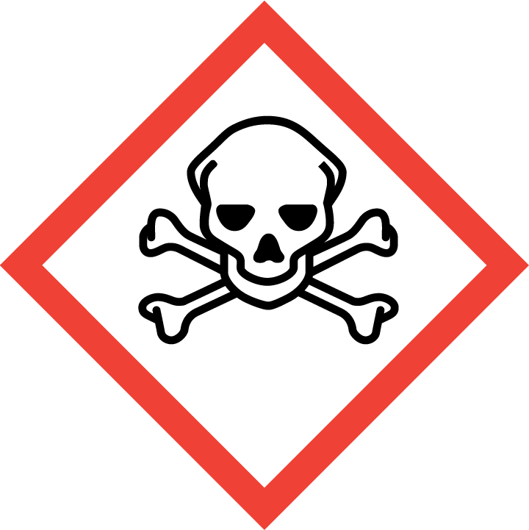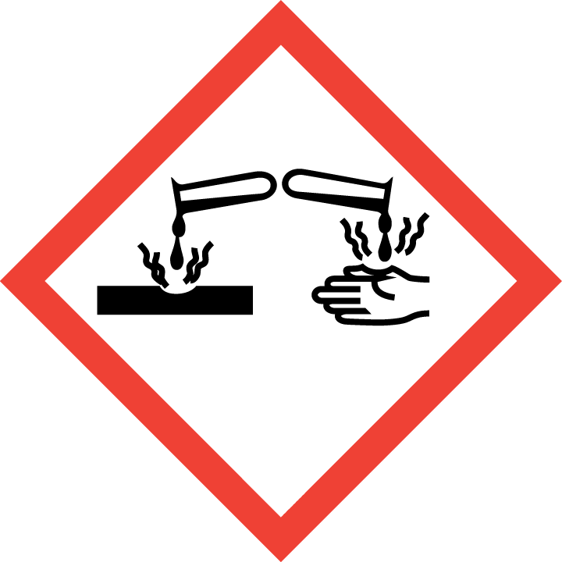
Section 3 – Engineering Controls and Personal Protective Equipment (PPE)
Engineering Controls: PMSF should always be used in a properly functioning chemical fume hood whenever possible. The chemical fume hood must be approved and certified by REM and have a face velocity between 80 – 125 feet per minute.
Hygiene Measures: Avoid contact with skin, eyes, and clothing. Wash hands before breaks and immediately after handling the product. Take precautions to avoid exposure, both acute and chronic, to PMSF; routinely decontaminate surfaces and limit the location where used.
Hand Protection: Chemical-resistant gloves must be worn. Nitrile gloves have been shown to provide good protection (breakthrough time > 480 minutes). Use proper glove removal technique (without touching glove’s outer surface) to avoid skin contact. NOTE: Consult with your preferred glove manufacturer to ensure that the gloves you plan on using are compatible with the specific chemical being used.
Eye Protection: ANSI approved properly fitting safety glasses or chemical splash goggles are required. Safety glasses are acceptable if PMSF is being used in conjunction with a chemical fume hood sash that is positioned at a level that adequately protects the user’s face.
Skin and Body Protection: Laboratory coats must be worn and be appropriately sized for the individual and buttoned to their full length. Personnel must also wear full length pants, or equivalent, and close-toed shoes. Full length pants and close-toed shoes must be worn at all times by all individuals that are occupying the laboratory area. The area of skin between the shoe and ankle must not be exposed.
Respiratory Protection: If PMSF is being used outside of a chemical fume hood, respiratory protection is required. If the respirator is the sole means of protection, use a full-face supplied air respirator. If this activity is necessary, contact REM (49-46371) so a respiratory protection analysis can be performed.
Section 4 – Special Handling and Storage Requirements
- Do not over purchase; only purchase what can be safely stored in the laboratory.
- Avoid contact all direct contact with PMSF; always handle in a properly functioning chemical fume hood and wear appropriate PPE at all times.
- A designated storage area should be established for PMSF such as chemical storage cabinet and everyone in the lab should be made aware of its storage location. Keep containers tightly closed.
- PMSF may corrode/etch glass; therefore do not store aqueous solutions of PMSF in glass containers.
- Store in a cool, dry, and well-ventilated area away from incompatible chemicals such as aqueous solutions, strong oxidizing agents, strong bases, and acids.
- PMSF hydrolyzes upon exposure to water liberating acidic gas which in contact with metal surfaces can generate flammable and/or explosive hydrogen gas.
- Avoid formation of dust and aerosols. Further processing of solid PMSF may result in the formation of combustible dusts. The potential for combustible dust formation should be taken into consideration before additional processing occurs.
- A current copy of the PMSF safety data sheet must be made available to all personnel working in the laboratory at all times.
Section 5 – Spill and Accident Procedures
Immediately evacuate area and ensure others are aware of the spill. If there is an imminent threat of a fire, pull the nearest fire alarm station to evacuate the building and dial 911. If personnel have become exposed and need medical assistance, dial 911. If the spill is minor and does not pose a threat to personnel, contact REM at 49-40121 during normal business hours (Monday – Friday, 7 AM – 4 PM) for spill cleanup assistance (dial 911 if spill occurs after hours and assistance is needed).
Section 6 – Waste Disposal Procedures
Store hazardous waste in closed containers that are properly labeled, and in a designated area. PMSF waste should be collected separately if at all possible; do not place PMSF waste into waste solutions that contain incompatible chemicals such as oxidizing agents, strong bases, acids, and aqueous solutions. All PMSF waste, including grossly contaminated debris should be collected for waste disposal. Any debris and/or PPE that is not grossly contaminated can be discarded as normal lab trash. Complete a Chemical Waste Pickup Request Form to arrange for disposal by REM; detailed instructions are provided at the following link: http://www.purdue.edu/ehps/rem/hmm/chemwaste.htm.
Section 7 – Protocol/Procedure (Add lab specific Protocol/Procedure here)
Click here to enter text.
NOTE: Any deviation from this SOP requires approval from PI.
Section 8 – Documentation of Training (signature of all users is required)
I have read and understand the content of this SOP:
Name | Signature | Date
Click here to enter text. |  | Click here to enter a date.
Click here to enter text. |  | Click here to enter a date.
Click here to enter text. |  | Click here to enter a date.
Click here to enter text. |  | Click here to enter a date.
Click here to enter text. |  | Click here to enter a date.
Click here to enter text. |  | Click here to enter a date.
Click here to enter text. |  | Click here to enter a date.
Click here to enter text. |  | Click here to enter a date.
Click here to enter text. |  | Click here to enter a date.

