Standard Operating Procedure
GSK-1322322B (GSK)
This is an SOP template and is not complete until: 1) lab specific information is entered into the box below 2) lab specific protocol/procedure is added to the protocol/procedure section and
3) SOP has been signed and dated by the PI and relevant lab personnel.
Print a copy and insert into your Lab-Specific Chemical Hygiene Plan.
Section 1 – Lab-Specific Information
Building/Room(s) covered by this SOP: | Click here to enter text.
Department: | Click here to enter a date.
Principal Investigator Name: | Click here to enter text.
Principal Investigator Signature: | Click here to enter text.
Section 2 – Hazards
The chemical name for GSK-1322322B is [(2R)-2-(cyclopentylmethyl)-3-(2-{5-fluoro-6-[(9AS0- hexahydropyrazino[2,1-C][1,4]oxazin-8(1H)-yl]-2-methyl-4-pyrimidinyli}hydrazino)-3-oxopropylformamide and is referred to as GSK in this document. GSK is a Category 2 reproductive toxin that is suspected of damaging fertility or the unborn child. GSK dust will support combustion. GSK dust clouds are very sensitive to electrostatic ignition and can produce an explosion hazard.
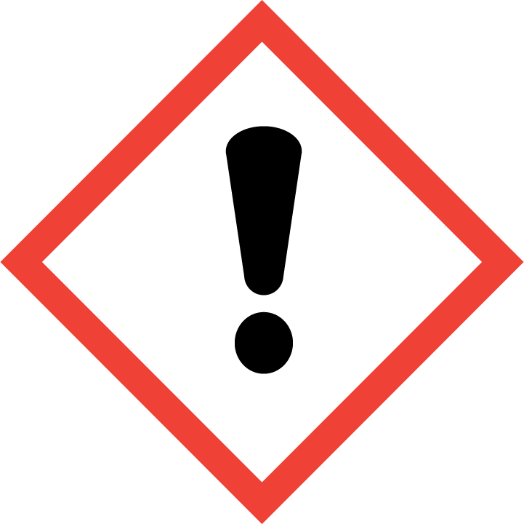
Section 3 – Engineering Controls and Personal Protective Equipment (PPE)
Engineering Controls: GSK should always be used in a properly functioning chemical fume hood. The chemical fume hood must be approved and certified by REM and have a face velocity between 80 – 125 feet per minute. Good general ventilation (6-10 air exchanges per hour) should be used. Only use in a laboratory that operates under negative pressure conditions (all Purdue labs are designed as such).
Hygiene Measures: Avoid contact with skin, eyes, and clothing. Wash hands before breaks and immediately after handling the product. Take precautions to avoid exposure, both acute and chronic, to GSK; routinely decontaminate surfaces and limit the location where used (isolate work to one area if at all possible).
Hand Protection: Chemical-resistant gloves must be worn. Disposable nitrile gloves are recommended. Consider wearing two pairs of nitrile gloves for added protection. Gloves should be changed prior to touching paperwork or common work surfaces (i.e., keyboards, phones, doorknobs, etc.) or paperwork. NOTE: Consult with your preferred glove manufacturer to ensure that the gloves you plan on using are compatible with the specific chemical being used.
Eye Protection: ANSI approved properly fitting safety glasses or chemical splash goggles are required. Safety glasses are acceptable if GSK is being used in conjunction with a chemical fume hood sash that is positioned at a level that adequately protects the user’s face.
Skin and Body Protection: Laboratory coats must be worn and be appropriately sized for the individual and buttoned to their full length. Disposable sleeve covers should be worn if gaps occur at the wrist. Personnel must also wear full length pants, or equivalent, and close-toed shoes. Full length pants and close-toed shoes must be worn at all times by all individuals that are occupying the laboratory area. The area of skin between the shoe and ankle must not be exposed.
Respiratory Protection: GSK should always be used in a chemical fume hood to avoid inhalation exposure. If GSK is being used outside of a chemical fume hood, respiratory protection is required. If the respirator is the sole means of protection, use a half-face air purifying respirator. If this activity is necessary, contact REM (49-46371) so a respiratory protection analysis can be performed.
Section 4 – Special Handling and Storage Requirements
- Do not over purchase; only purchase what can be safely stored in the laboratory.
- Avoid all direct contact with GSK; always handle in a properly functioning chemical fume hood and wear appropriate PPE at all times.
- Keep containers tightly closed and store in a cool, dry, and well-ventilated area that is protected from sunlight.
- A designated storage area should be established for GSK such as chemical storage cabinet and everyone in the lab should be made aware of its storage location. Unauthorized access to GSK is not permitted; everyone handling GSK must have appropriate training before use begins.
- A designated chemical fume hood should be established for work with GSK. Ensure that the hood sash is positioned at the proper operating height as indicated by the operating sash label.
- Before work begins, consider lining the work activity area (i.e., fume hood deck) with disposable absorbent pads to ease cleaning or capture material in the event of a spill. Make sure the work area is free from unnecessary equipment and/or chemical containers, beakers, flasks, etc. The work area should be smooth, non-porous, and easily decontaminated.
- Routinely decontaminate the GSK container, equipment, and surfaces using techniques to minimize airborne substances. Decontamination should be accomplished by wet-wiping surfaces with an appropriate solvent that will dissolve GSK. The absorbent materials used in the process must be collected and containerized as hazardous waste.
- Solids should be dispensed/weighed in the fume hood. Do not allow high concentrations of GSK dust to form during storage or use, as this can lead to a combustible dust explosion. Working with small quantities of GSK in a chemical fume hood will drastically minimize this risk. Do not handle, store, or open GSK near an open flame, sources of heat or sources of ignition.
- A current copy of the GSK safety data sheet must be made available to all personnel working in the laboratory at all times. This SDS must be reviewed by all personnel working with GSK before work begins. Special consideration should be given to the toxicological information included in the SDS.
Section 5 – Spill and Accident Procedures
Immediately evacuate area and ensure others are aware of the spill. If there is an imminent threat of a fire, pull the nearest fire alarm station to evacuate the building and dial 911. If personnel have become exposed and need medical assistance, dial 911. If the spill is minor and does not pose a threat to personnel, contact REM at 49-40121 during normal business hours (Monday – Friday, 7 AM – 4 PM) for spill cleanup assistance (dial 911 if spill occurs after hours and assistance is needed). If the spill is small and occurs in the chemical fume hood, lab personnel can clean the spill without the assistance of the Purdue Fire Department or REM. Wearing the appropriate PPE, the dry material should be carefully collected/absorbed and containerized.
Section 6 – Waste Disposal Procedures
Store hazardous waste in closed containers that are properly labeled, and in a designated area. GSK waste either be collected separately or placed in an organic waste stream (i.e., lab organic solvent waste container). All GSK waste, including contaminated debris should be collected for waste disposal. Complete a Chemical Waste Pickup Request Form to arrange for disposal by REM; detailed instructions are provided at the following link: http://www.purdue.edu/ehps/rem/hmm/chemwaste.htm.
Section 7 – Protocol/Procedure (Add lab specific Protocol/Procedure here)
Click here to enter text.
NOTE: Any deviation from this SOP requires approval from PI.
Section 8 – Documentation of Training (signature of all users is required)
I have read and understand the content of this SOP:
Name | Signature | Date
Click here to enter text. |  | Click here to enter a date.
Click here to enter text. |  | Click here to enter a date.
Click here to enter text. |  | Click here to enter a date.
Click here to enter text. |  | Click here to enter a date.
Click here to enter text. |  | Click here to enter a date.
Click here to enter text. |  | Click here to enter a date.

