Minutes Equity Meeting 6-2-16
We discussed three things at this meeting:
- Introduced X-Rays of Immunity to change and adopted it to be used in conjunction with the 4 frames.
- Continued discussions of the loop lesson by Guity Ravai
- Started discussing the linguistics lesson proposed by Elena
1. Immunity X-Ray. We started the meeting with an introduction to Kegan & Haley’s “immunity to change.” In their book Immunity to Change, Kegan and Haley examine the reasons why we often have a hard time changing a habitual behavior ---even when our lives depend on it. Their “theory” is that we have hard-wired survival behaviors that often conflict with explicit commitments we make. Their framework has 4 elements:
The Visible Commitments: These are the explicitly-stated commitments. They are often noble aspirational commitments that are consistent with published value statements; for example, the commitment to create equitable and inclusive learning environments.

The Actions Needed to Honor the Visible Commitments: This is the technical component of the solution. This is the easiest component to address, the technical component of the solution.

Most of the efforts at changing behavior are limited to these two layers and fail to take hold. This is true even when the consequences are dire (patients continue to smoke even when their lives are at risk). The reason lies in the Competing Commitments and Big Assumptions.

Competing Commitments: Immunity to change stems from a competition between the stated visible commitments and other tacit (autoimmune) commitments. While the visible commitments are aspirational, the autoimmune commitments capture deep fears. For example, the commitment for equity may compete with the commitment of maintaining an image of a rigorous and demanding professor. They may also compete with the notion that a person believes they have succeeded thanks mostly to their talent and hard work, not to any unearned privilege.

The paucity of recognized competing commitments stems in part from the fact that they are implicit and not directly accessible to rational arguments.

Big Assumptions: The stated goals and implicit competing assumptions are not inherently conflicting. The tension between them is conditioned by some deeply held assumptions. The faculty member seeking a more welcoming education may hold the following tacit assumptions:
- The current higher education is a meritocracy, (if not, what merit do I have in my success?)
- There is no rigor and no institutional prestige without exclusion
- Investment in diversity and equity is not respected and not valued in my institution
- Investment in diversity and equity is not respected and not valued in my discipline

Several examples from the book were shared. The following is a made up one:
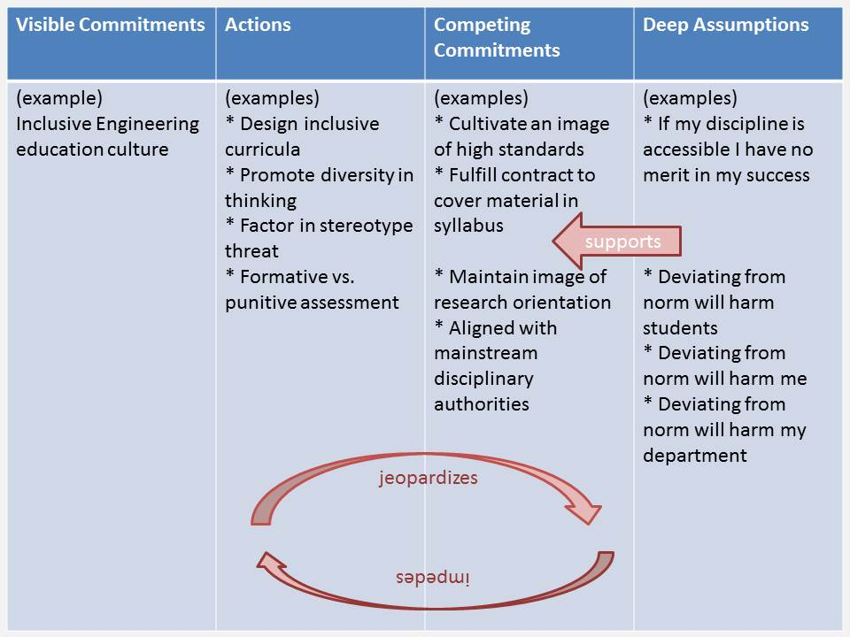

There was general interest in adding this to our toolbox. The book is:
Kegan, Robert; Lahey, Lisa Laskow. Immunity to Change: How to Overcome It and Unlock the Potential in Yourself and Your Organization (Leadership for the Common Good). Harvard Business Review Press. Kindle Edition.
The resolution is to augment the frames.
For each frame, we will
- Adapt and augment the set of actions under the frame
- Examine any conflicting commitments
- Identify underlying assumptions
- Create a plan of action for testing the assumption

2. We then proceeded with a discussion of Guity Ravai’s lesson on Loops with the effort to identify ways in which the faculty can encourage diversity in models.
This is a continuation of the discussion last week. The following points were made:
- In programming, syntax is very rigid. We spend more time in syntax because it is rigid and students must get it. Yet, students struggle not with the syntax but with the concepts.
- While loops are an excellent example, faculty underestimate how much students struggle with it.
- This is an excellent context for supporting different models.
- There are many models of repetition. Not all of them capture correctly a ‘while’ loop or a ‘counted’ loop.
- Those “models” that do not are as important as those that do. They provide an excellent context to show what is and what is not. What is the correct way to use ‘while’ loops and the ways in which things can go wrong
- Giving students more time to think through examples of repletion and having them classify them in different categories and even name them maybe helpful.
- Examples may come from experience (what we do repeatedly), legends, poems, literature, quotation, paintings (Esher), … this opens the door for a diversity of thinking and diversity of problem solving.

C. We then turned to the course materials of ENG 328 submitted by Elena B.
- One of the challenges that students and faculty face is that much of what the course introduces contradicts/conflicts with what the students have learned so far in K-12.
- It was suggested that presenting it as a contradiction may be very unsettling for the students. An alternative way is to present every discipline as a progression of increasingly complex models.
- Every new model maintains some things but introduces a higher resolution on some concepts.
- Higher resolutions finer concepts or finer definitions of the concepts.
- Invite students to reflect on this and give examples
- This was a very quick discussion. To be revisited at next meeting.

